Exercise:Dependancy Management using Gradle

1.Add a gradle dependency and its related repository url.

Build.gradle file:

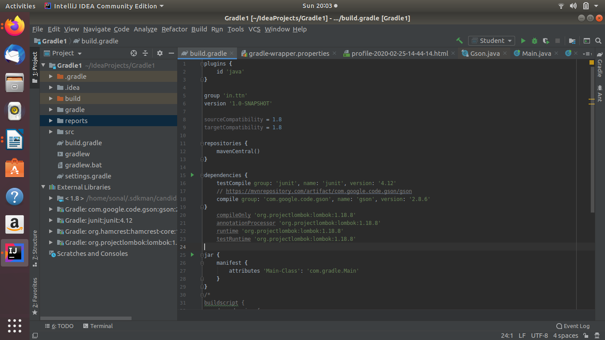

2.Using java plugin, make changes in the manifest to make the jar executable. Using java -jar JAR_NAME, the output should be printed as "Hello World"

Main.java source file:
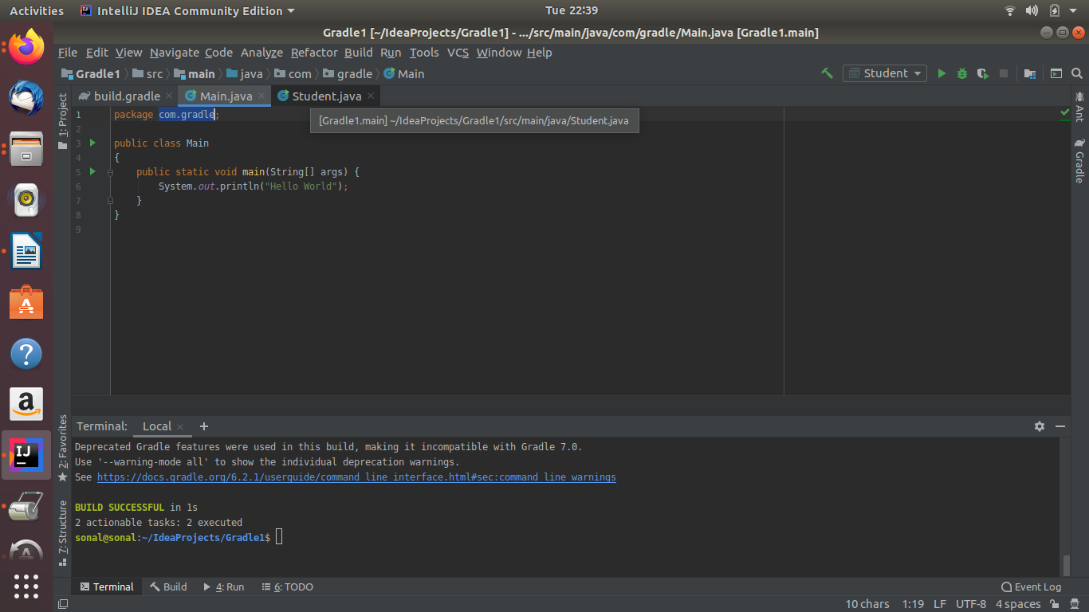

build.gradle file:
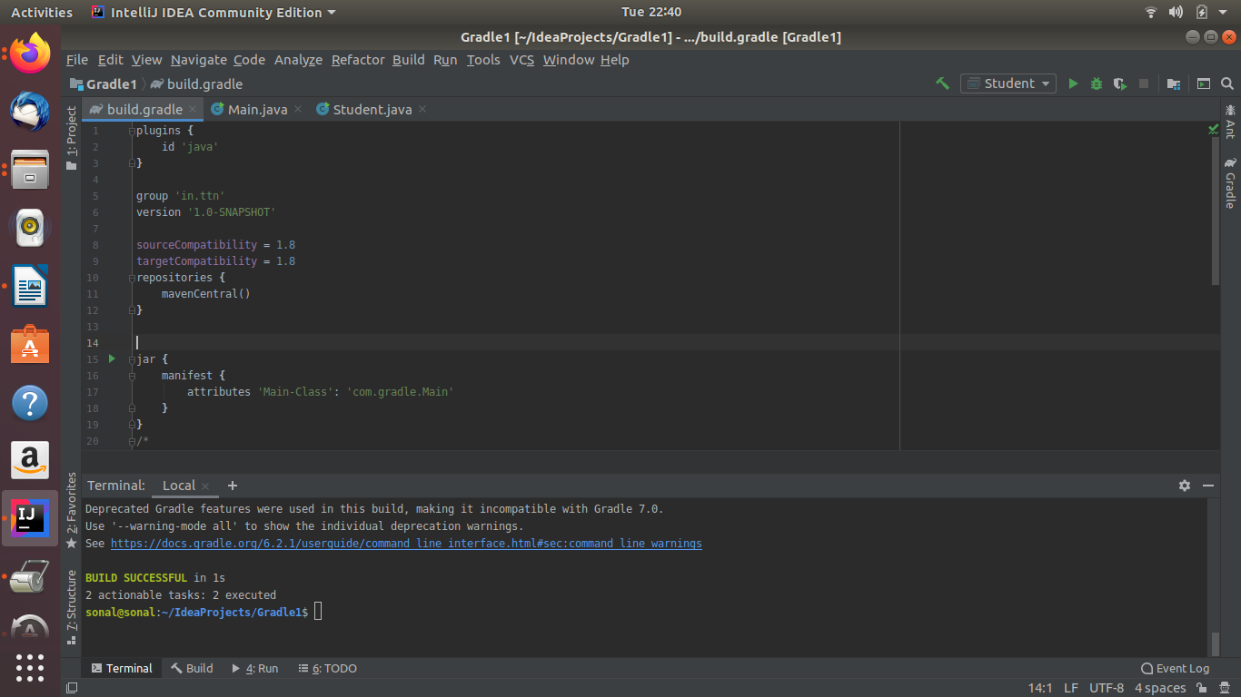

Output:

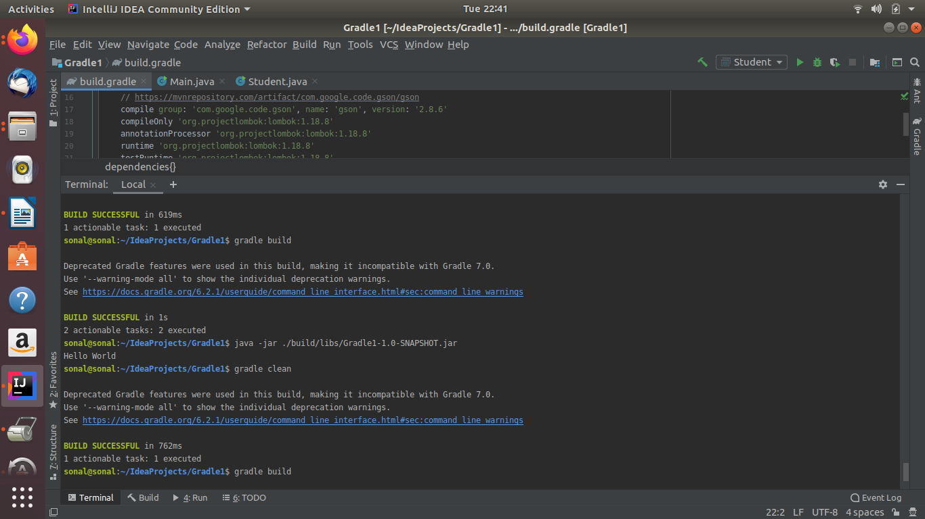

3.Differentiate between the different dependency scopes: compile, runtime, testCompile, testRuntime using different dependencies being defined in your build.gradle.

These are the plugins(dependencies) taken from maven central repository which are included in dependencies section and defined in build.gradle file

a)Complie: It is the dependency used to compile the source code and build the application.It is mainly used for production and for our Main classes.

b)Runtime: It is the dependency used to run the application and it is exposed to the consumers.It is in runtime and test classpath.

c)testCompile: It is a group of dependencies that you need only for testing.A junit is the testing framework just required for testing.Since it's not needed at runtime, it's not going to be included in the released package.It is used for testing classes.

d)testRuntime:It is used to declare test runtime dependencies.This type of dependencies are required to run the test cases at run time.By default, it includes runtime and test compile dependencies.
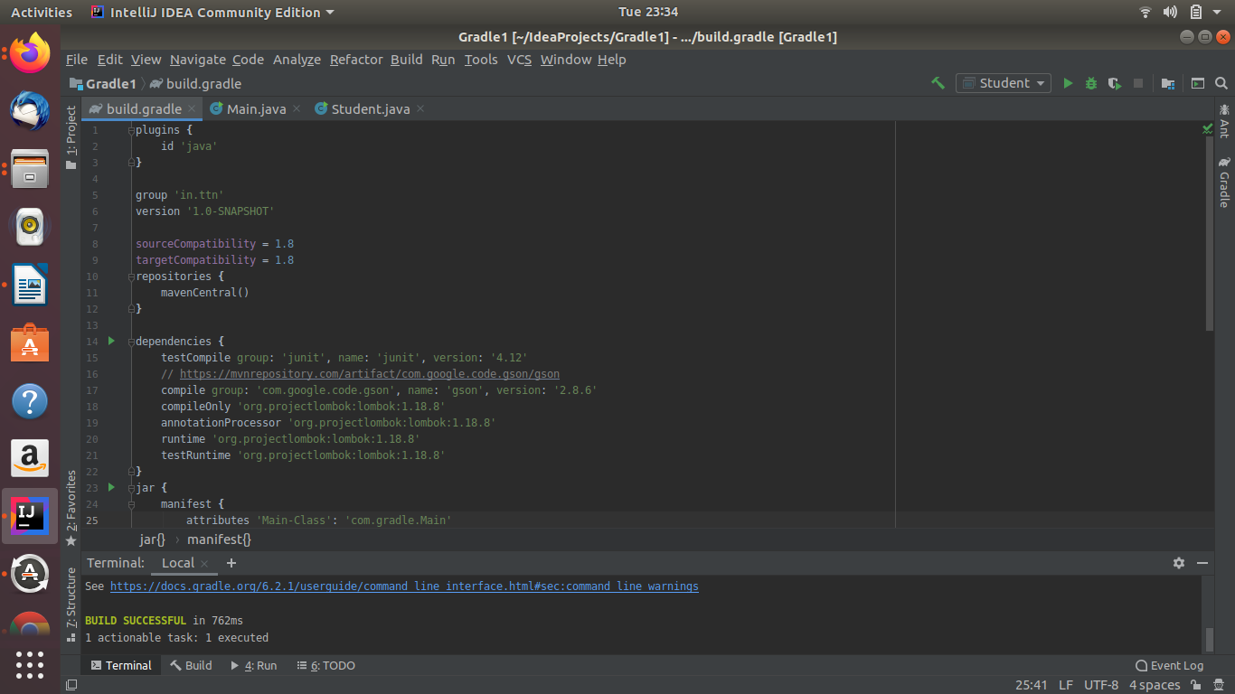

4.Create a custom plugin which contains a custom task which prints the current date-time. Using that plugin in your project, execute that task after the jar task executes.

Custom Plugin:
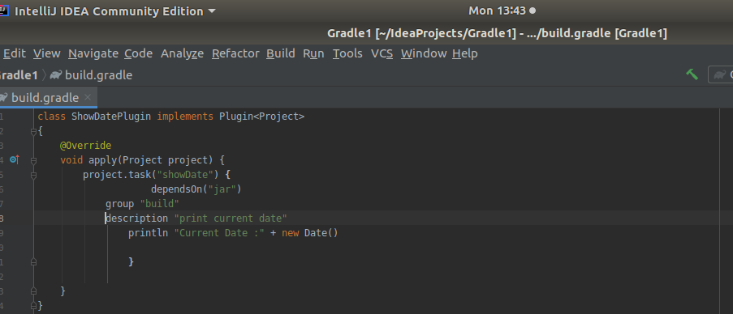

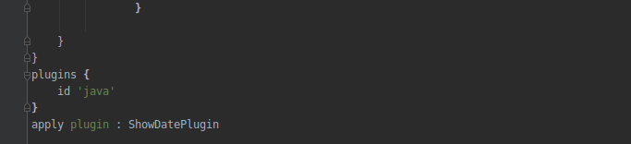
Applying Custom plugin to root project:ShowDatePlugin

Executing the above plugin after the jar task:

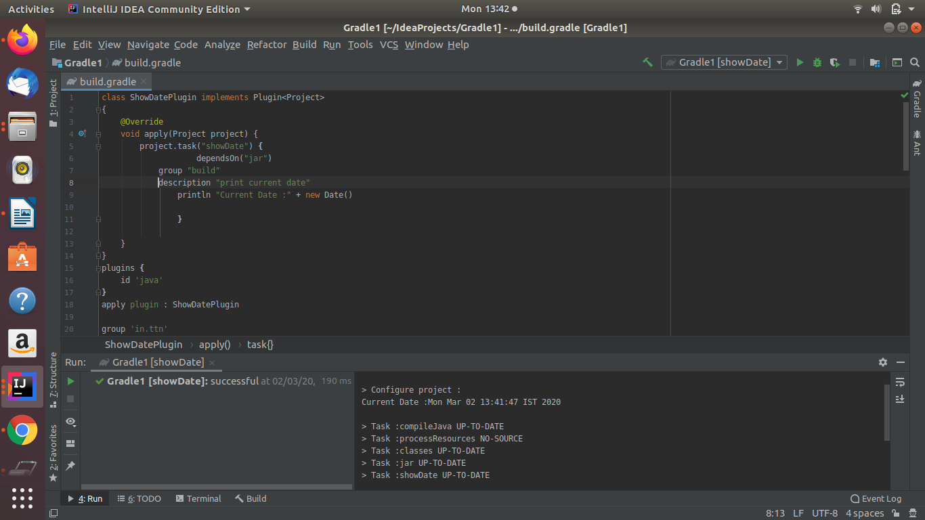

5.Instead of using default source set, use src/main/javaCode1, src/main/javaCode2 to betakenas code source. Make sure that the JAR created contains files from both the directories and not from src/main/java.

2 directories created:

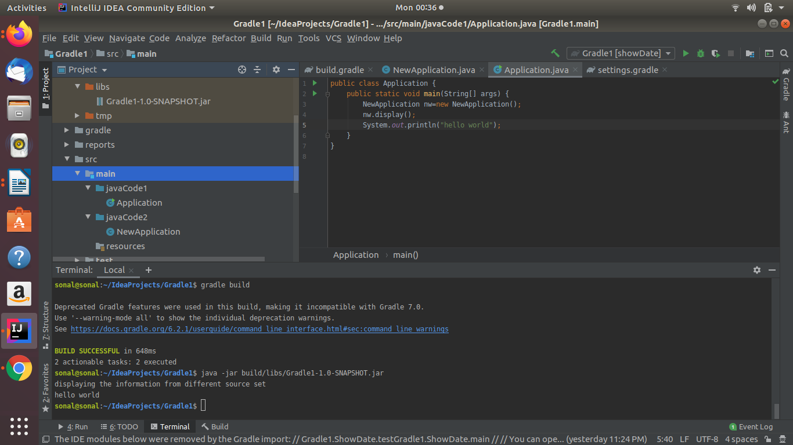

Main file :

Output:

6.Override the Gradle Wrapper task to install a different version of gradle. Make sure thatthetask written in Q4 also executes with it.

Before running the command the version of wrapper being used is 5.2.1

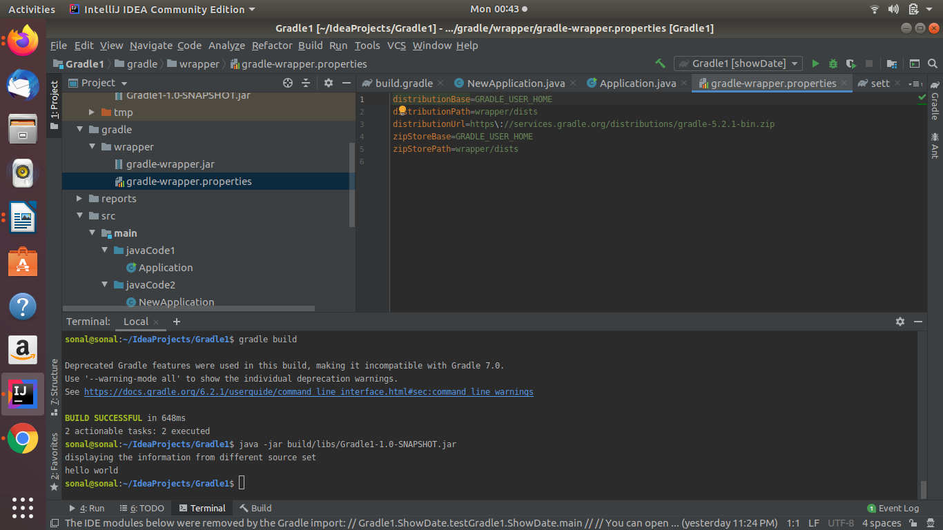

Command Snapshot:
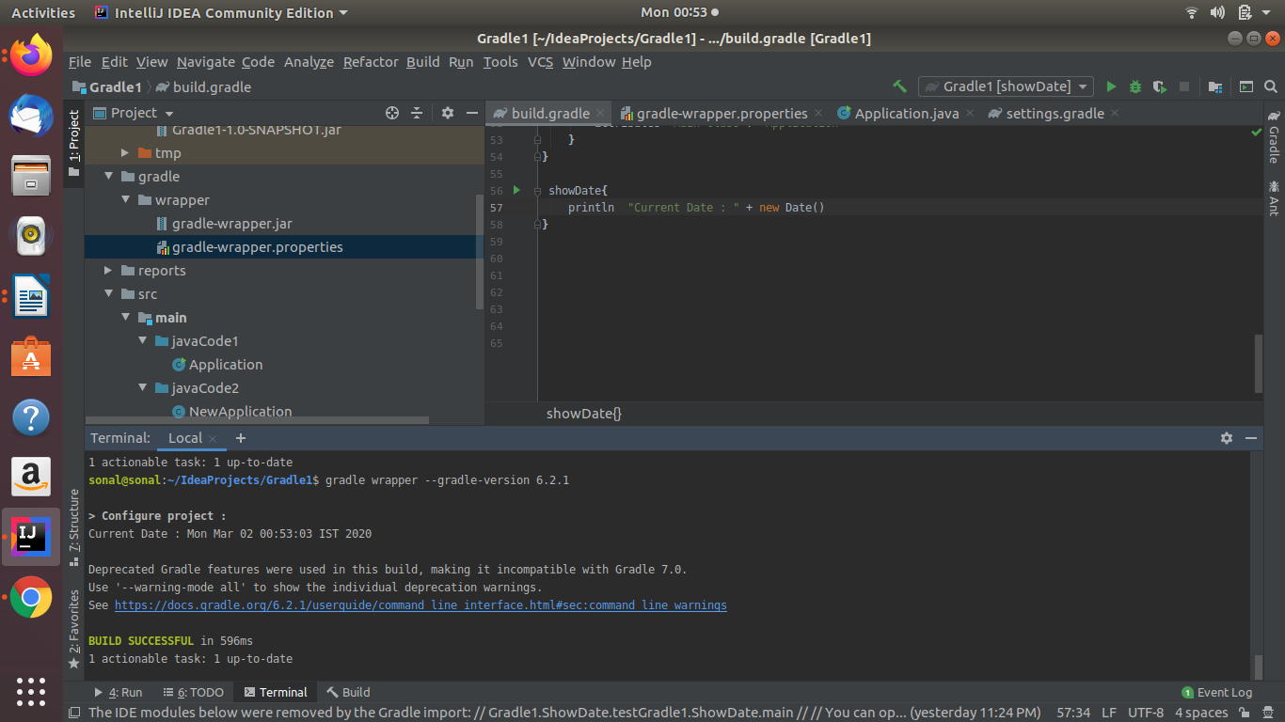

After running the command the version of wrapper being used is 6.2.1
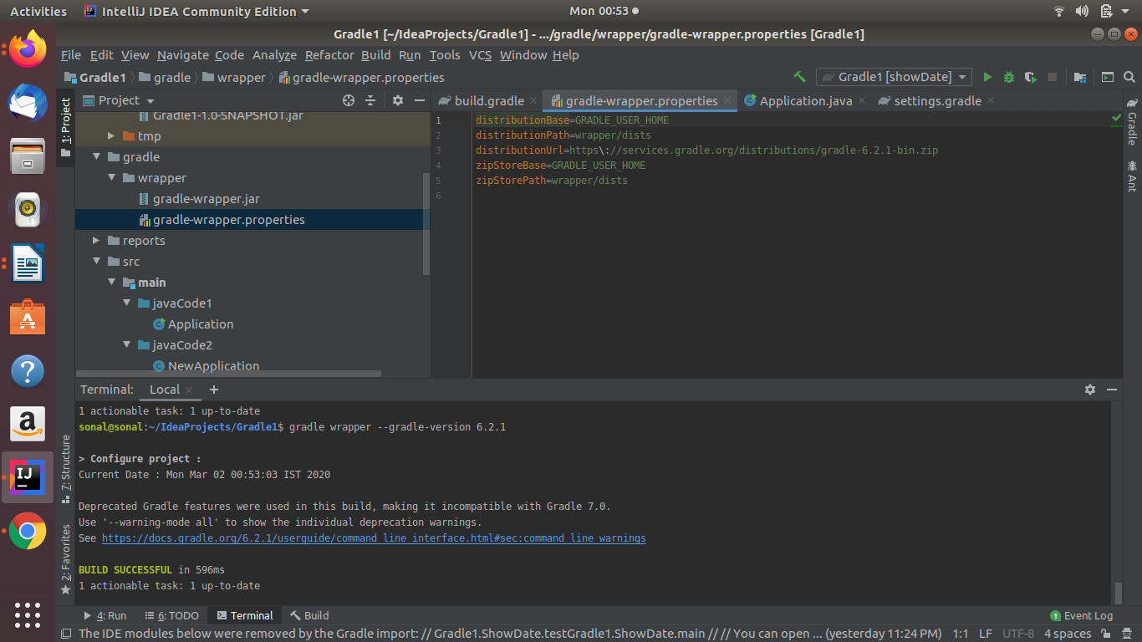

7.Run the gradle profile command and attach the resulting files.

Files:///home/sonal/IdeaProjects/Gradle1/build/reports/profile/profile-2020-03-02-01-05-05.html

Output in idea:
<!DOCTYPE html>
<html>
<head>
<meta http-equiv="Content-Type" content="text/html; charset=utf-8"/>
<meta http-equiv="x-ua-compatible" content="IE=edge"/>
<title>Profile report</title>
<link href="css/base-style.css" rel="stylesheet" type="text/css"/>
<link href="css/style.css" rel="stylesheet" type="text/css"/>
<script src="js/report.js" type="text/javascript"></script>
</head>
<body>
<div id="content">
<h1>Profile report</h1>
<div id="header">
<p>Profiled build: build </p>
<p>Started on: 2020/03/02 - 00:59:33</p>
</div>
<div id="tabs">
<ul class="tabLinks">
<li>
<a href="#tab0">Summary</a>
</li>
<li>
<a href="#tab1">Configuration</a>
</li>
<li>
<a href="#tab2">Dependency Resolution</a>
</li>
<li>
<a href="#tab3">Artifact Transforms</a>
</li>
<li>
<a href="#tab4">Task Execution</a>
</li>
</ul>
<div class="tab" id="tab0">
<h2>Summary</h2>
<table>
<thead>
<tr>
<th>Description</th>
<th class="numeric">Duration</th>
</tr>
</thead>
<tr>
<td>Total Build Time</td>
<td class="numeric">0.761s</td>
</tr>
<tr>
<td>Startup</td>
<td class="numeric">0.570s</td>
</tr>
<tr>
<td>Settings and buildSrc</td>
<td class="numeric">0.003s</td>
</tr>
<tr>
<td>Loading Projects</td>
<td class="numeric">0s</td>
</tr>
<tr>
<td>Configuring Projects</td>
<td class="numeric">0.012s</td>
</tr>
<tr>
<td>Artifact Transforms</td>
<td class="numeric">0s</td>
</tr>
<tr>
<td>Task Execution</td>
<td class="numeric">0.121s</td>
</tr>
</table>
</div>
<div class="tab" id="tab1">
<h2>Configuration</h2>
<table>
<thead>
<tr>
<th>Project</th>
<th class="numeric">Duration</th>
</tr>
</thead>
<tr>
<td>All projects</td>
<td class="numeric">0.012s</td>
</tr>
<tr>
<td>:</td>
<td class="numeric">0.012s</td>
</tr>
</table>
</div>
<div class="tab" id="tab2">
<h2>Dependency Resolution</h2>
<table>
<thead>
<tr>
<th>Dependencies</th>
<th class="numeric">Duration</th>
</tr>
</thead>
<tr>
<td>All dependencies</td>
<td class="numeric">0.004s</td>
</tr>
<tr>
<td>:compileClasspath</td>
<td class="numeric">0.004s</td>
</tr>
<tr>
<td>:annotationProcessor</td>
<td class="numeric">0s</td>
</tr>
</table>
</div>
<div class="tab" id="tab3">
<h2>Artifact Transforms</h2>
<table>
<thead>
<tr>
<th>Transform</th>
<th class="numeric">Duration</th>
</tr>
</thead>
<tr>
<td>All transforms</td>
<td class="numeric">0s</td>
</tr>
</table>
</div>
<div class="tab" id="tab4">

<h2>Task Execution</h2>
<table>
<thead>
<tr>
<th>Task</th>
<th class="numeric">Duration</th>
<th>Result</th>
</tr>
</thead>
<tr>
<td>:</td>
<td class="numeric">0.121s</td>
<td>(total)</td>
</tr>
<tr>
<td class="indentPath">:compileJava</td>
<td class="numeric">0.106s</td>
<td></td>
</tr>
<tr>
<td class="indentPath">:jar</td>
<td class="numeric">0.010s</td>
<td></td>
</tr>
<tr>
<td class="indentPath">:processResources</td>
<td class="numeric">0.002s</td>
<td>NO-SOURCE</td>
</tr>
<tr>
<td class="indentPath">:test</td>
<td class="numeric">0.002s</td>
<td>NO-SOURCE</td>
</tr>
<tr>
<td class="indentPath">:compileTestJava</td>
<td class="numeric">0.001s</td>
<td>NO-SOURCE</td>
</tr>
<tr>
<td class="indentPath">:assemble</td>
<td class="numeric">0s</td>
<td>Did No Work</td>
</tr>
<tr>
<td class="indentPath">:build</td>
<td class="numeric">0s</td>
<td>Did No Work</td>
</tr>
<tr>
<td class="indentPath">:check</td>
<td class="numeric">0s</td>
<td>UP-TO-DATE</td>
</tr>
<tr>
<td class="indentPath">:classes</td>
<td class="numeric">0s</td>
<td>Did No Work</td>
</tr>
<tr>
<td class="indentPath">:processTestResources</td>
<td class="numeric">0s</td>
<td>NO-SOURCE</td>
</tr>
<tr>
<td class="indentPath">:testClasses</td>
<td class="numeric">0s</td>
<td>UP-TO-DATE</td>
</tr>
</table>
</div>
</div>
<div id="footer">
<p>
<div>
<label class="hidden" id="label-for-line-wrapping-toggle" for="line-wrapping-toggle">Wrap lines
<input id="line-wrapping-toggle" type="checkbox" autocomplete="off"/>
</label>
</div>Generated by
<a href="http://www.gradle.org">Gradle 6.2.1</a> at 2 Mar, 2020 12:59:33 AM</p>
</div>
</div>
</body>
</html>
Profile Report:
