GPT

Chat Link - <https://chatgpt.com/c/7d563889-f15b-45fe-8242-d1c8d27f454b>

How to get username and home directory?

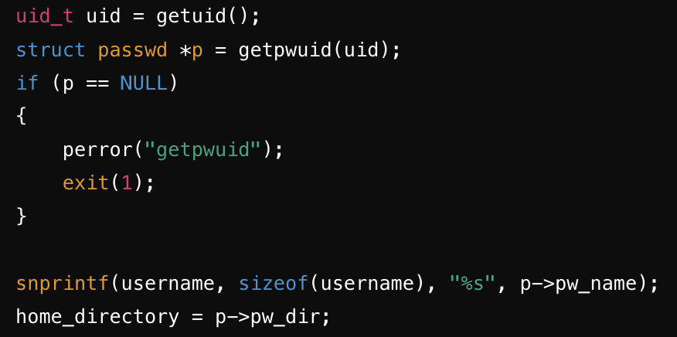



Your shell should support a ‘;’ or ‘&’ separated list of commands.

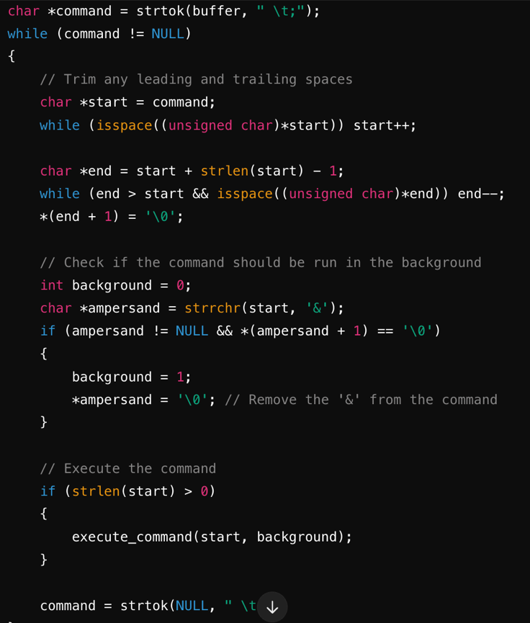

Hop command

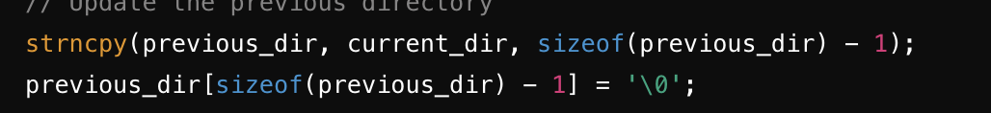

~/mini-project-1 handle this

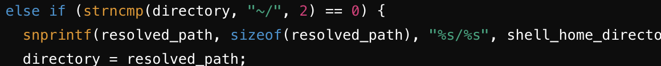

Reveal Command

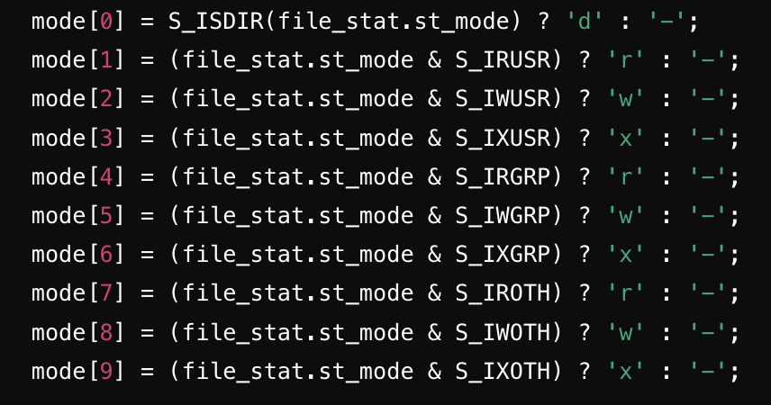

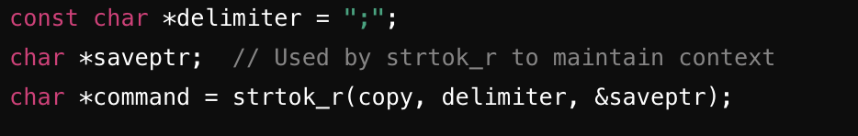

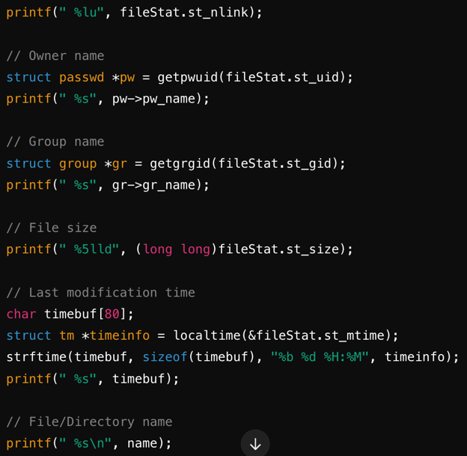 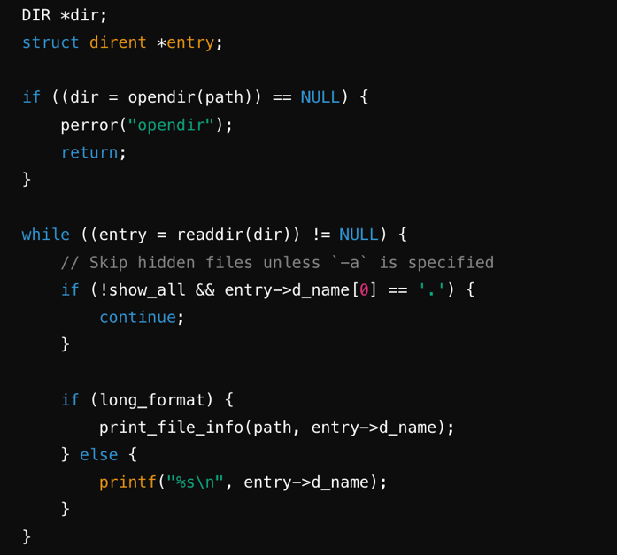

Log Command

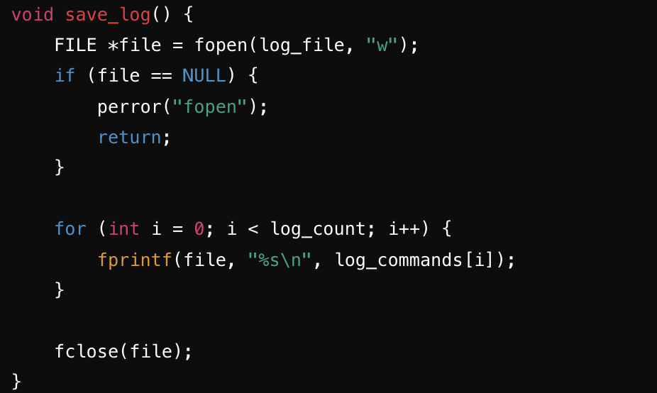 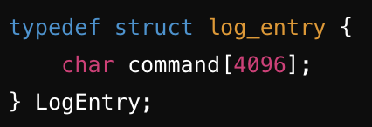

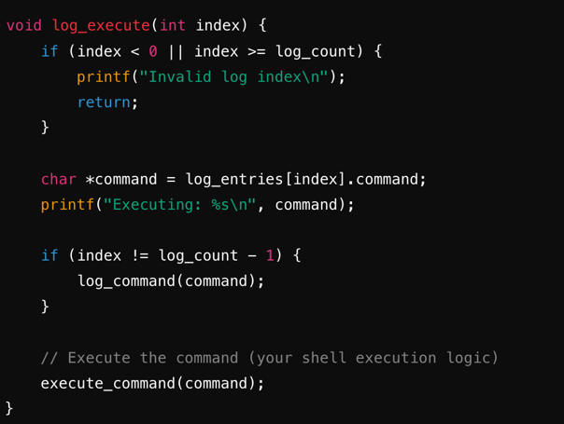

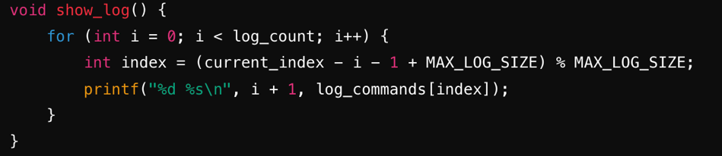

Foreground and Background

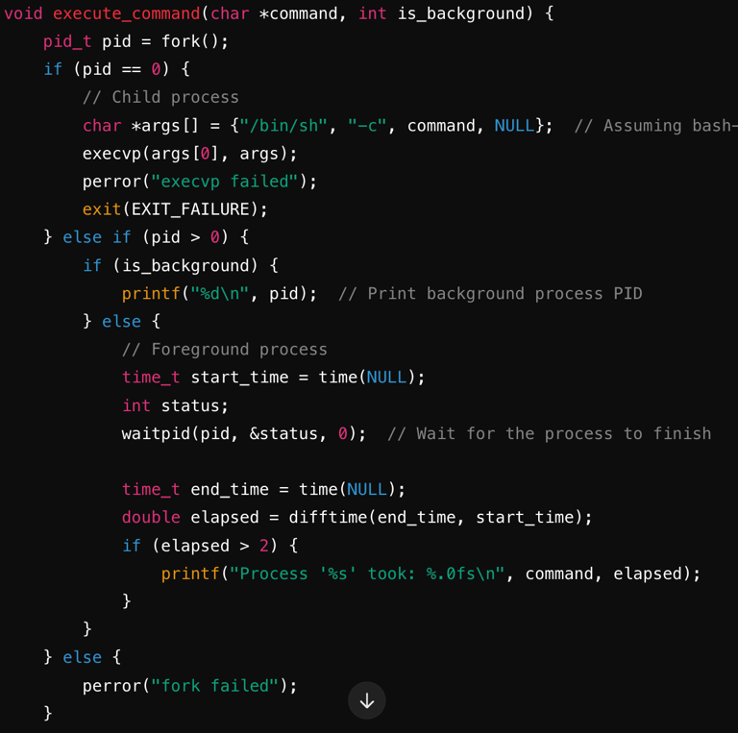 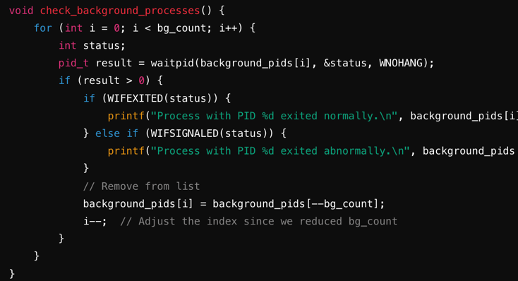

Proclore

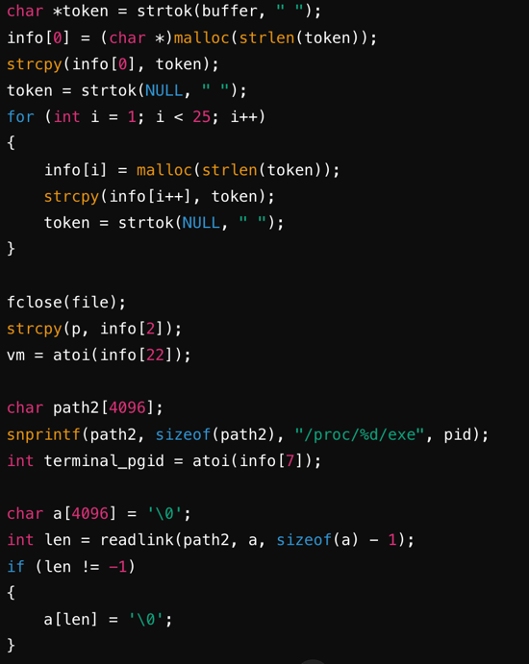

Seek

