1. Install Power BI Desktop and share the final screenshot of the report view page which appears when power desktop starts.

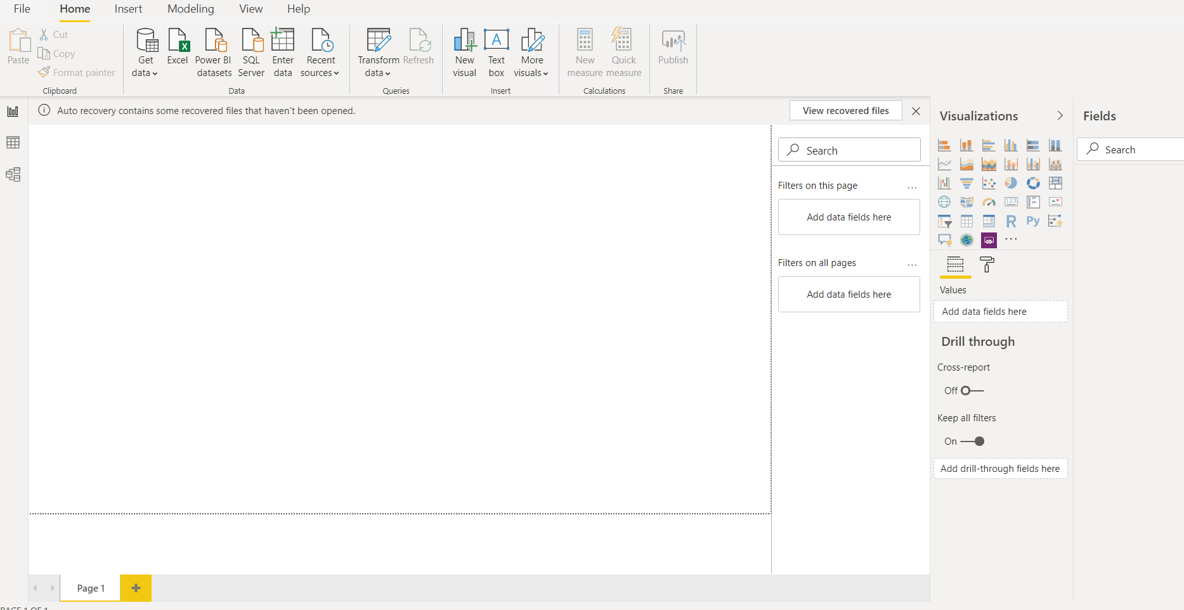

1. Prepare a document and with the following screenshot

− Report View

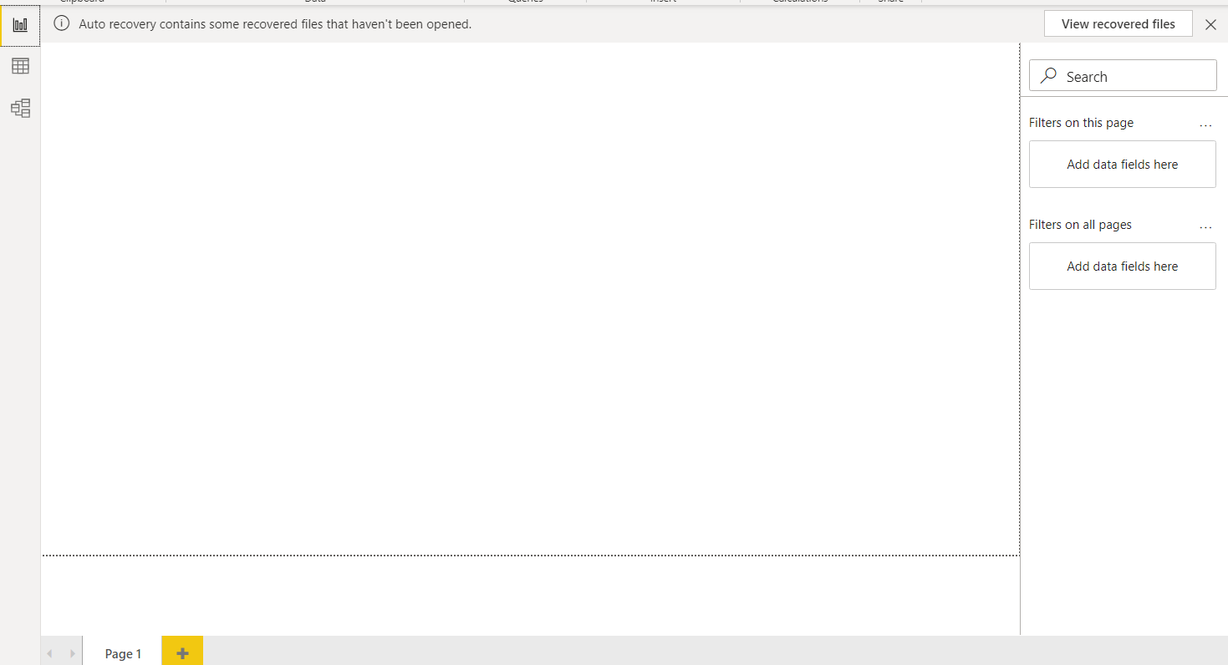

**− Data View**

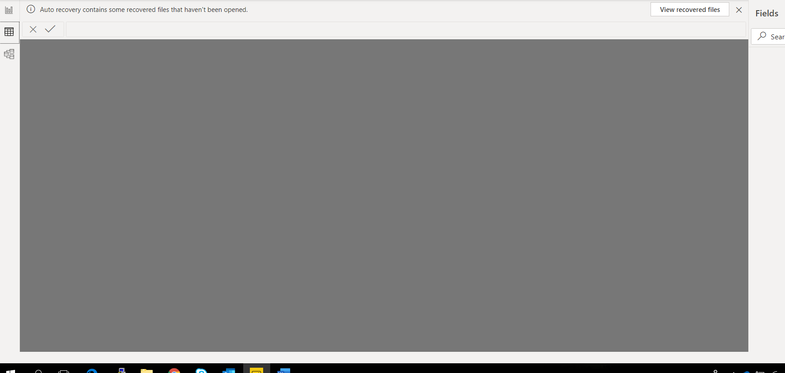

**− Model View**

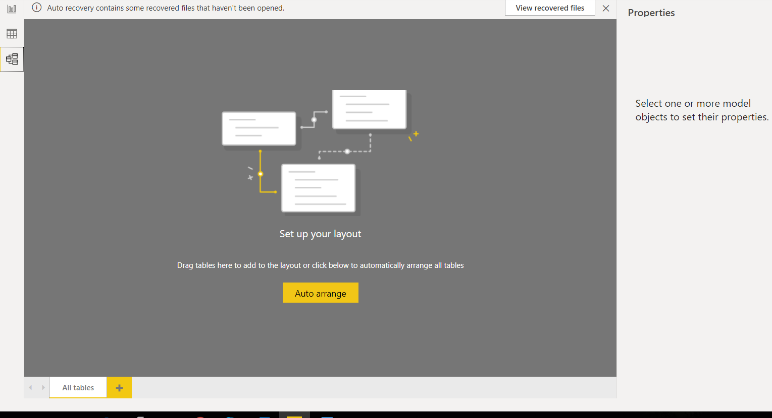

**Power Query Editor**

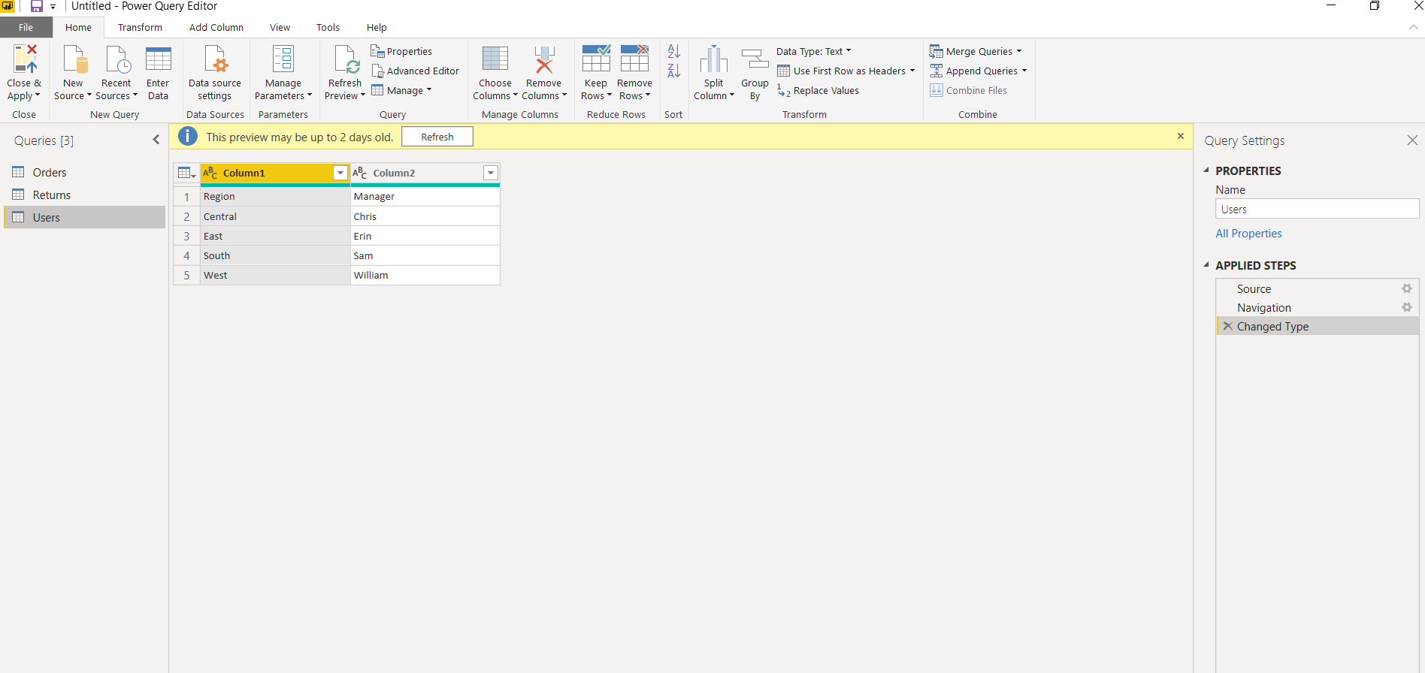

− **Advance Editor**

