**SEAT MAP DISPLAY**

Report submittedin fulfillment of the requirements for the certificate of completion of

Internship in **PRS** group

By

**SONALI SINGH**

(Enrollment number-07815002715, Maharaja Surajmal Institue of Technology)

And

**SWATI SINGH**

(Enrollment number-20814802716, Maharaja Agrasen Institue of Technology)

To



**CENTRE FOR RAILWAY INFORMATION SYSTEMS**

Chanakyapuri, New Delhi-21

January ,2018

**ACKNOWLEDGEMENT**

We extend our sincerest gratitude to our respected mentors of PRS group Mr. Ranjeet and Mrs.Deepti under whose supervision this project has been undertaken. They have been the guiding force and prime inspiration to lift us from the initialization state to the successful completion of the project. Their friendly guidance and discussions over the complexities of a real-time project have invoked a deep thought in us.

I would also like to thank Sinha sir and Director sir of CRIS for providing this opportunity of making this project and learning from it.

Last but not the least, undertaking a project such as this, places an equal if not greater pressure on friends and family members closest to us. Hence, We express our gratitude to our parents for being a constant support throughout this project and helping us in every possible way they could. Thanks to all those who helped me in one-way or other, and to all, whose names go unmentioned.

**CONTENT**

|  |  |
| --- | --- |
| TOPICS | PAGE NUMBER |
|  |  |
| ABSTRACT | 4 |
|  |  |
| INTRODUCTION | 5 |
|  |  |
| DATABASE | 6 |
|  |  |
| FRONTEND | 7 |
|  |  |
| BACKEND | 9 |
|  |  |
| LAYOUTS | 11 |
|  |  |
| CONCLUSION | 14 |
|  |  |
| BIBLIOGRAPHY | 15 |

**ABSTRACT**

The project entitled ‘Seat Map Display’, as the name suggests visualizes the Berth layout of a particular train which will help railway passengers to view the Seats availability in individual coaches of a train and book seats of their choice.

Through this Seat Map Display, customers do not have to wait in line and they will be able to get their answers in just a click. Through this system, an online form will be available by which passengers will be able to fill the journey details.

The form contains three fields – Train number, Class and Start date of the journey. To view the seats of choice, users will have to first search the trains as per their requirements and after getting correct train they will have to provide the Train number and the class type i.e.1AC, 2AC, 3AC or SL in required field of the form. After pressing the submit button, it will render a layout page where the user can view the coaches of the selected class they entered in the form. The user can see the seat availability by clicking on the coach type. To book the seats after viewing the seat availability, the user needs to click on the coach type and then click the seat of their choice. The user can select multiple seats. After booking the seats, the response message will automatically forward to the customer.

**INTRODUCTION**

This project is completely modular and is built upon MVC structure using jsp files, html files and java files controlled by a servlet. The project is a dynamic web project which also includes css files, js files and connection to MySQL database from where the data is retrieved. The layout is generated dynamically by the resultset obtained from the query. Also the numbers on the seat button and coach id on the button is displayed by retrieving from database.

On clicking a particular coach button, the layout is visible and available for seat selection. Clicking on the same coach button toggles the visibility of layout generated. On clicking the a seat, a prompt is displayed which asks for confirmation of seat selection. If yes is typed, then that seat becomes disabled and is unavailable for selection and the status of seat is updated in database as well.

**DATABASE**

A database is a collection of [information](http://searchsqlserver.techtarget.com/definition/information) that is organized so that it can be easily accessed, managed and updated. Data is organized into rows, columns and tables, and it is indexed to make it easier to find relevant information. Data gets updated, expanded and deleted as new information is added. Databases process workloads to create and update themselves, querying the data they contain and running applications against it.

The database system used in this project is MySQL. It is an open relational database management system (RDMS). The data in a MySQL database system is stored in tables which consist of rows and columns. It runs on server and is ideal for both small and large applications. MySQL compiles on a number of platforms.

We have created five tables in the database PRSDB which are as follows:

1. **berthcategory**(varchar(20) code, varchar(20) name)
2. **coachmaster**(varchar(20) class, varchar(20) coach_type, int(4) total_berth)
3. **master_coach_layout**(varchar(20) class, varchar(20) coach_type, int(10) Berth_number, varchar(20) Berth_Category)
4. **trainlayout**(int(10) Train_no, varchar(10) class, varchar(20) coach_id, varchar(20) coach_type)
5. **userinfo**(int(20) Train_no, date Journey_date, varchar(30) Class, varchar(20) Coach_id, int(20) Berth_id, varchar(20) Berth_Availabilit

**FRONTEND**

The frontend of this project is based on html, css, js, jquery and bootstrap.

HTML

HTML is the standard markup language for creating Web pages. HTML stands for Hyper Text Markup Language. HTML describes the structure of Web pages using markup. HTML elements are the building blocks of HTML pages. HTML elements are represented by tags. HTML tags label pieces of content such as "heading", "paragraph", "table", and so on. Browsers do not display the HTML tags, but use them to render the content of the page

CSS

CSS stands for Cascading Style Sheets. CSS describes how HTML elements are to be displayed on screen, paper, or in other media. CSS saves a lot of work. It can control the layout of multiple web pages all at once. External stylesheets are stored in CSS files

JS

JavaScript is most commonly used as a client side scripting language. This means that JavaScript code is written into an HTML page. When a user requests an HTML page with JavaScript in it, the script is sent to the browser and it's up to the browser to do something with it.

BOOTSTRAP

JavaScript is most commonly used as a client side scripting language. This means that JavaScript code is written into an HTML page. When a user requests an HTML page with JavaScript in it, the script is sent to the browser and it's up to the browser to do something with it

JQUERY

The purpose of jQuery is to make it much easier to use JavaScript on your website. jQuery takes a lot of common tasks that require many lines of JavaScript code to accomplish, and wraps them into methods that you can call with a single line of code. jQuery also simplifies a lot of the complicated things from JavaScript, like AJAX calls and DOM manipulation.

This project comprise of html pages like header.html which displays navigation bar on all the layout pages , form.html which displays a form where user enters journey details like train number, class & journey date to generate the layout of the class entered and footer.html which displays legend on all the layout pages.

This project also includes css files like form.css which provide styling to form.html, layout.css which provide styling to all other html & jsp pages and js file layout.js which provide functionality of toggle of visibility of layout and disable of seat button to all the jsp pages.

The different berth category are represented by different colours such as lower berth is depicted by green colour, middle berth with dark blue, upper berth with red, side lower with mustard yellow and side upper with light blue.

**BACKEND**

This project is completely modular and is built upon MVC (Model-View-Controller) framework using jsp files, html files and java files controlled by a servlet.

MVC

The Model-View-Controller (MVC) is an architectural pattern that separates an application into three main logical components: the model, the view, and the controller. Each of these components are built to handle specific development aspects of an application. MVC is one of the most frequently used industry-standard web development framework to create scalable and extensible projects.

COMPONENTS OF MVC

Model: The Model component corresponds to all the data-related logic that the user works with.

View: The View component is used for all the UI logic of the application.

### Controller: Controllers act as an interface between Model and View components to process all the business logic and incoming requests, manipulate data using the Model component and interact with the Views to render the final output.

SERVLET

Servlet is a technology i.e. used to create web application. It is an API that provides many interfaces and classes including documentations. It is an interface that must be implemented for creating any servlet. It is a class that extend the capabilities of the servers and respond to the incoming request. It can respond to any type of requests. It is a web component that is deployed on the server to create dynamic web page.

JSP

JSP technology is used to create web application just like Servlet technology. It can be thought of as an extension to servlet because it provides more functionality than servlet such as expression language, jstl etc.

A JSP page consists of HTML tags and JSP tags. The jsp pages are easier to maintain than servlet because we can separate designing and development. It provides some additional features such as Expression Language, Custom Tag etc.

This project comprise of servlet LayoutServlet1 which controls the display of layout in accordance with the class entered by the user such as if the user selects AC 2 Tier (2A) from dropdown menu of class then sleeper.jsp is executed. Similarly the respective jsp files are executed for other classes as well.

**LAYOUTS**

1. Form to enter Journey Details

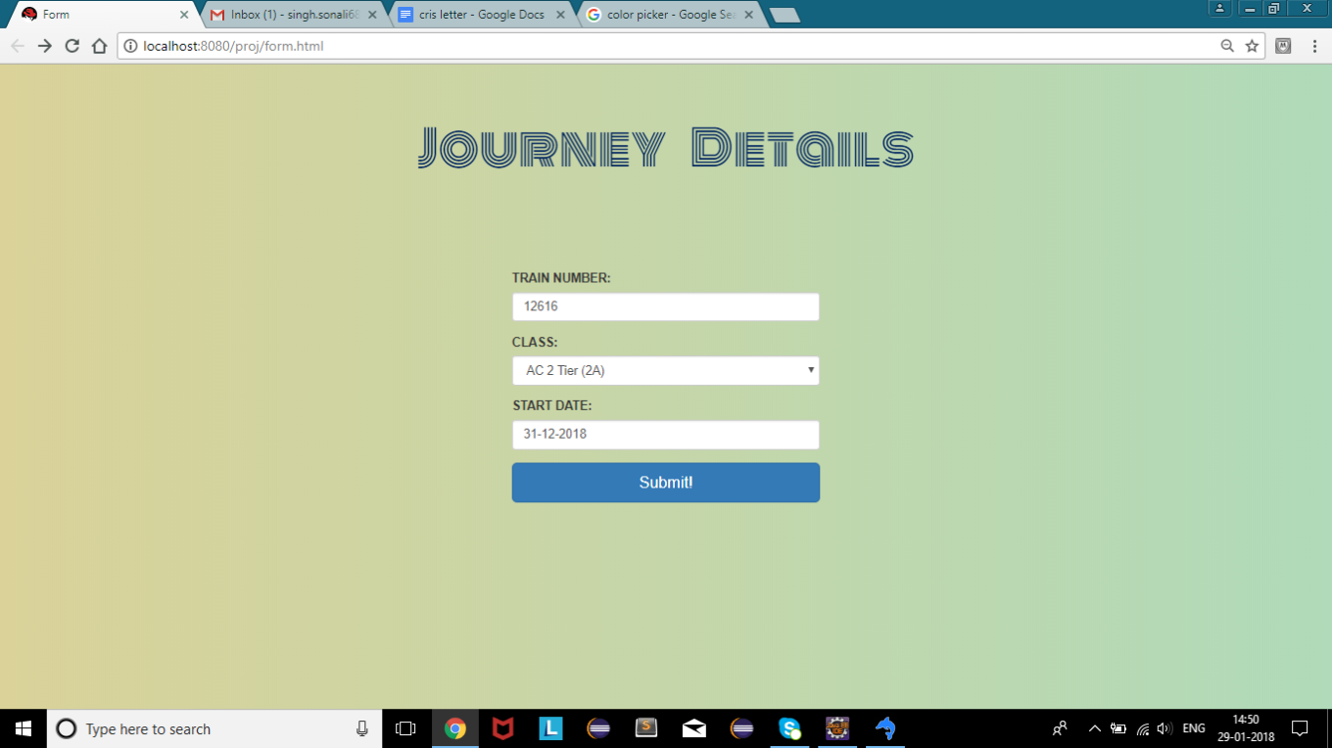

1. Coach Layout

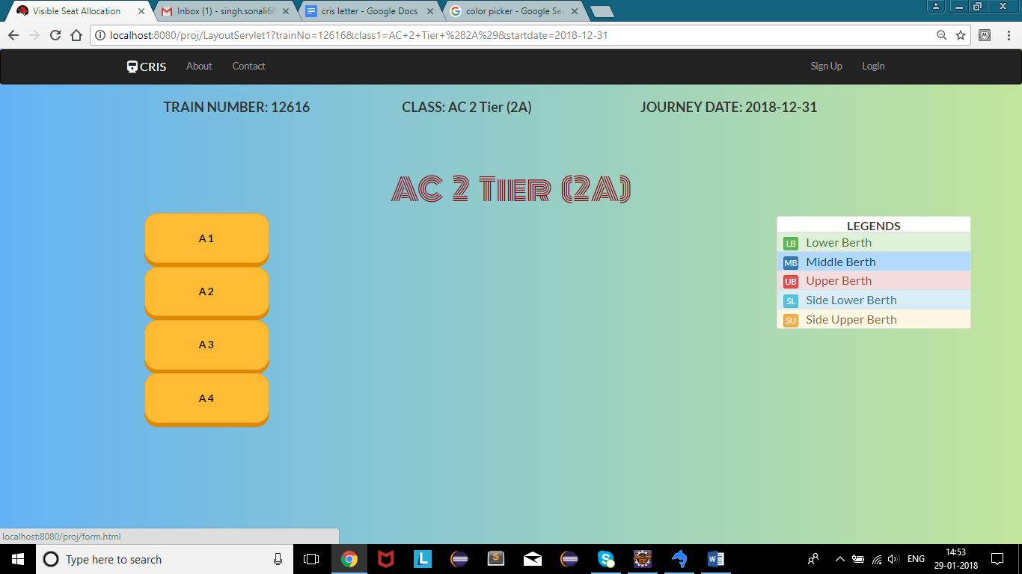

1. First Class AC (1A) Layout

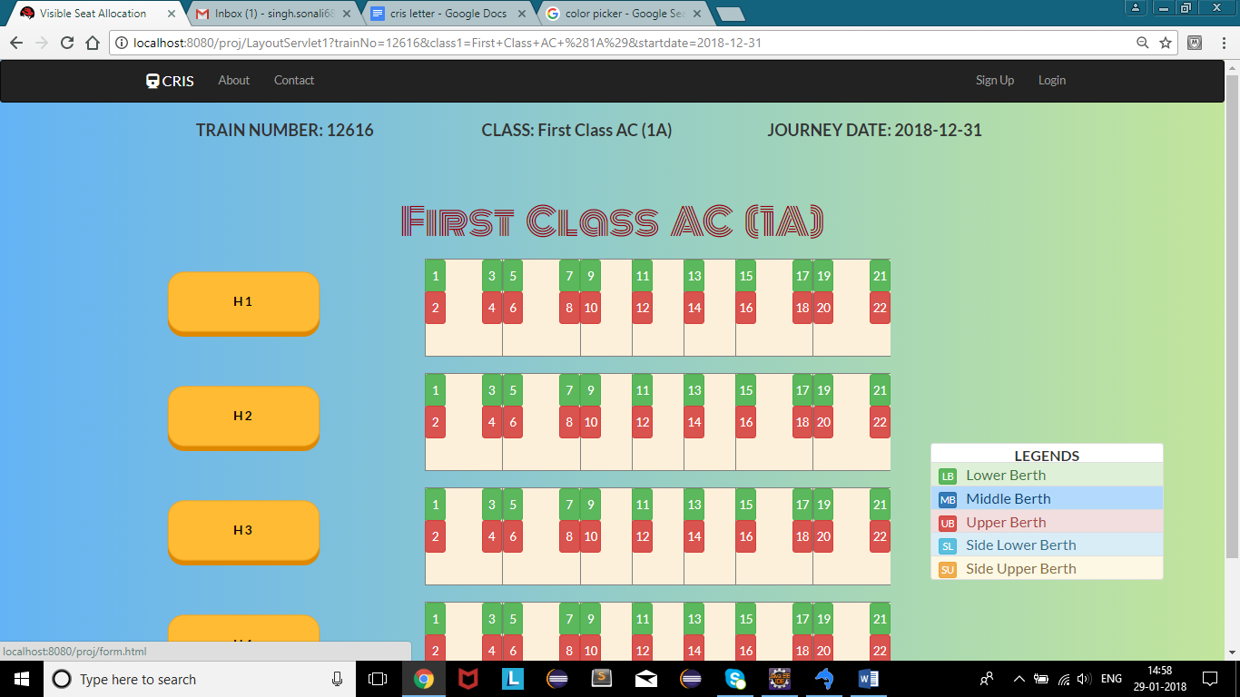

1. AC 2 Tier (2A)

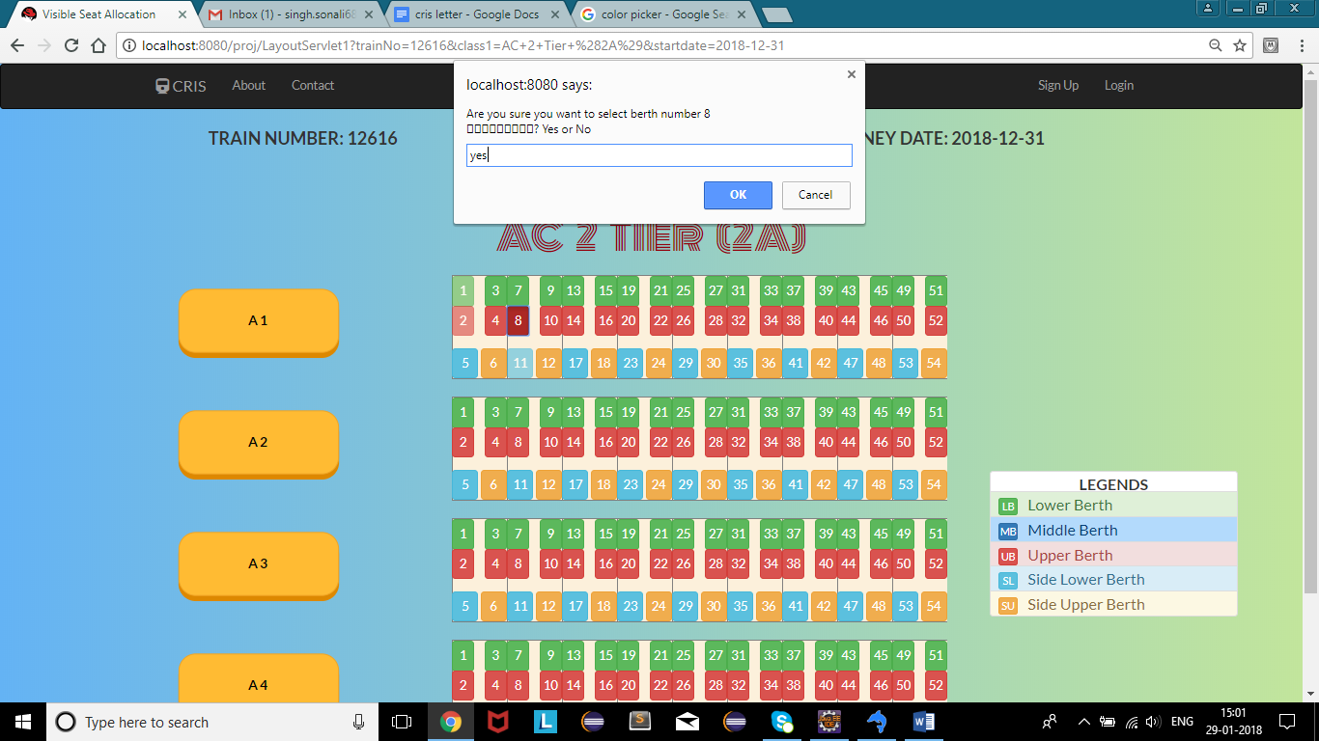

Here, Seat number 1, 2 and 11 of coach A1 are disabled and prompt is displayed for seat number 8.

1. AC 3 Tier (3A)

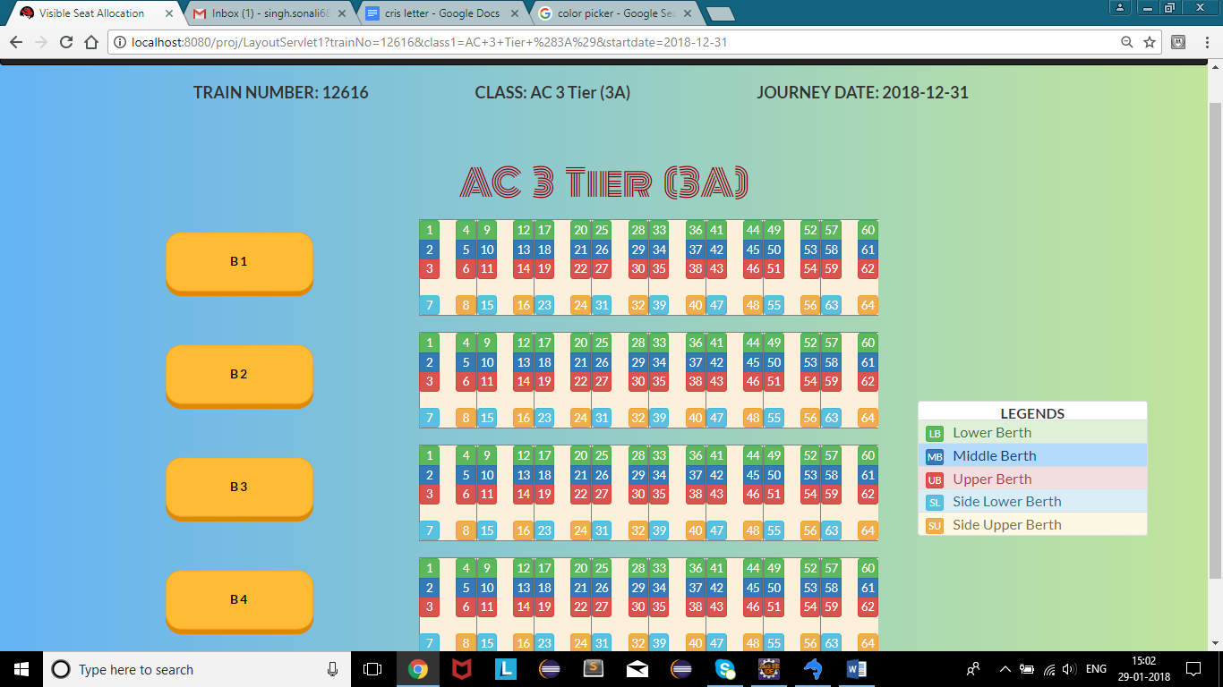

1. Sleeper Class ( SL)

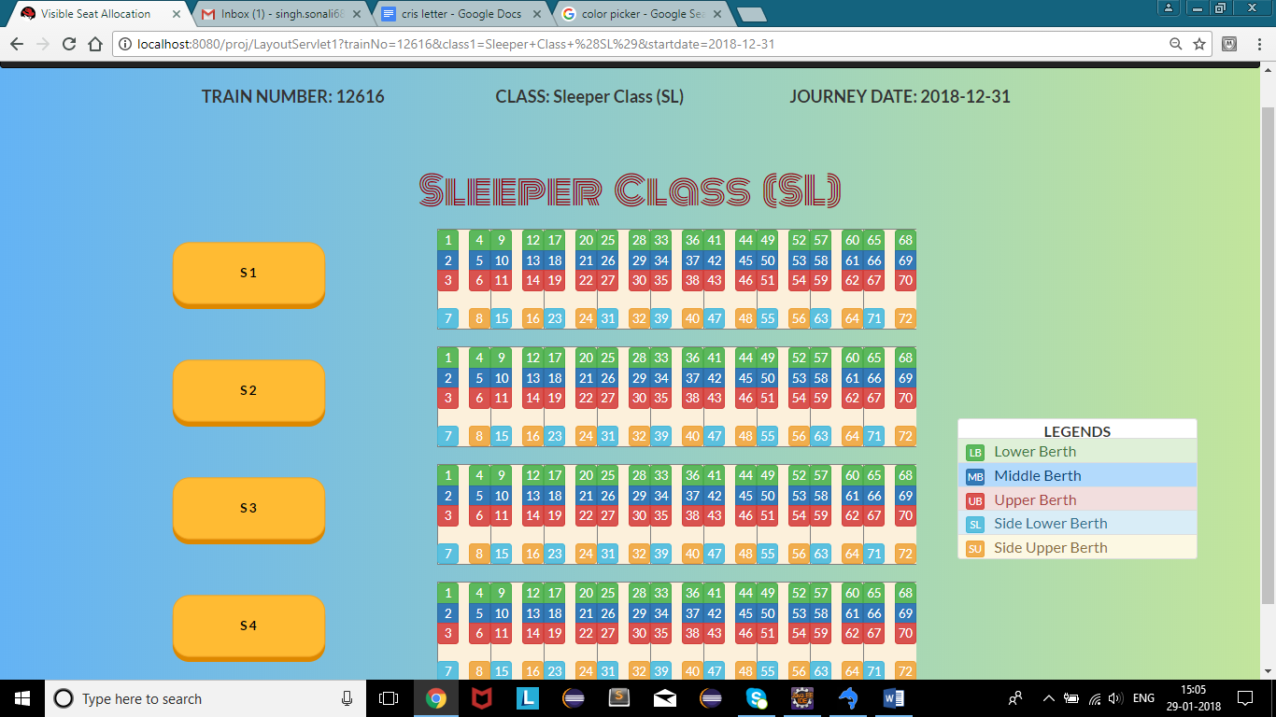

**CONCLUSION**

From this project report, we conclude that visualizing of seat map will help railway passengers to view the Seats availability in individual coaches of a train and book seats of their choice.

Through this Seat Map Display, customers do not have to wait in line and they will be able to get their answers in just a click. Through this system, an online form will be available by which passengers will be able to fill the journey details.

This project is an implementation of all the concepts web such as HTML, CSS, javascript, bootstrap, jQuery, java, JSP, MySQL database, JDBC, MVC framework.

The scope of this project can further be extended by adding more functionality to the existing ones. For example, serializability can be integrated to update the database automatically for all users in real-time . Also various seats can be reserved for different quota.

**BIBLIOGRAPHY**

1. <https://www.javatpoint.com/servlet-tutorial>
2. <https://www.javatpoint.com/jsp-tutorial>
3. <https://www.tutorialspoint.com/mvc_framework/mvc_framework_introduction.htm>
4. <https://www.w3schools.com/jquery/jquery_intro.asp>
5. <https://www.quirksmode.org/js/intro.html>
6. <https://www.w3schools.com/css/css_intro.asp>
7. <https://www.w3schools.com/css/css_intro.asp>