**HTML ASSESSMENT ~By Nikhil 8th April 2021**

*Syed Ali Hasan (INT060)*

1. **HTTP REQUEST AND RESPOSE HEADER**

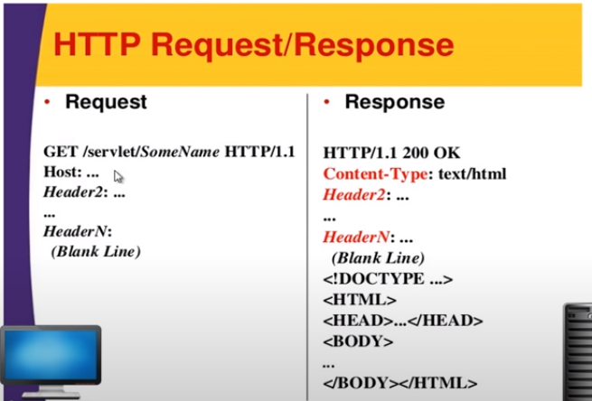

**HTTP Request**: An HTTP request is an action to be performed on a resource identified by a given Request-URL.

**HTTP Response Header:** A response header is an HTTP header that can be used in an HTTP response and that doesn't relate to the content of the message. Response headers, like Age , Location or Server are used to give a more detailed context of the response

2. **HTTP REQUEST METHOD**

* GET
* PUT
* POST
* PATCH
* DELETE
* OPTIONS

3. **HTTP STATUS CODE**

* 1xx Informational
* 2xx Success
* 3xx Redirection
* 4xx Client Error
* 5xx Server Error

4. **RESOURCES ON THE WEB**

* **Authority**
* **Port**
* **Path**
* **Query**
* **Fragment**