**Module-3: Cloud Testing Hands-on**  
**Hands-on Assignments :**  **(any 3 mandatory)**  
1. Create a VM and install docker and test the images inside the container with the commands  
2. Install ansible and connect the nodes to master and execute the adhoc commands on ansible masternode vm and test the packages installed or not  
3. Launch minikube cluster and execute the commands to test the pod, container with the kubectl commands  
4. Create the poc on open shift architecture and its components and commands used on cluster

--------------------------------------------------------------------------------------------------------------------------------

SOLUTION:

Create a VM and install docker and test the images inside the container with the commands

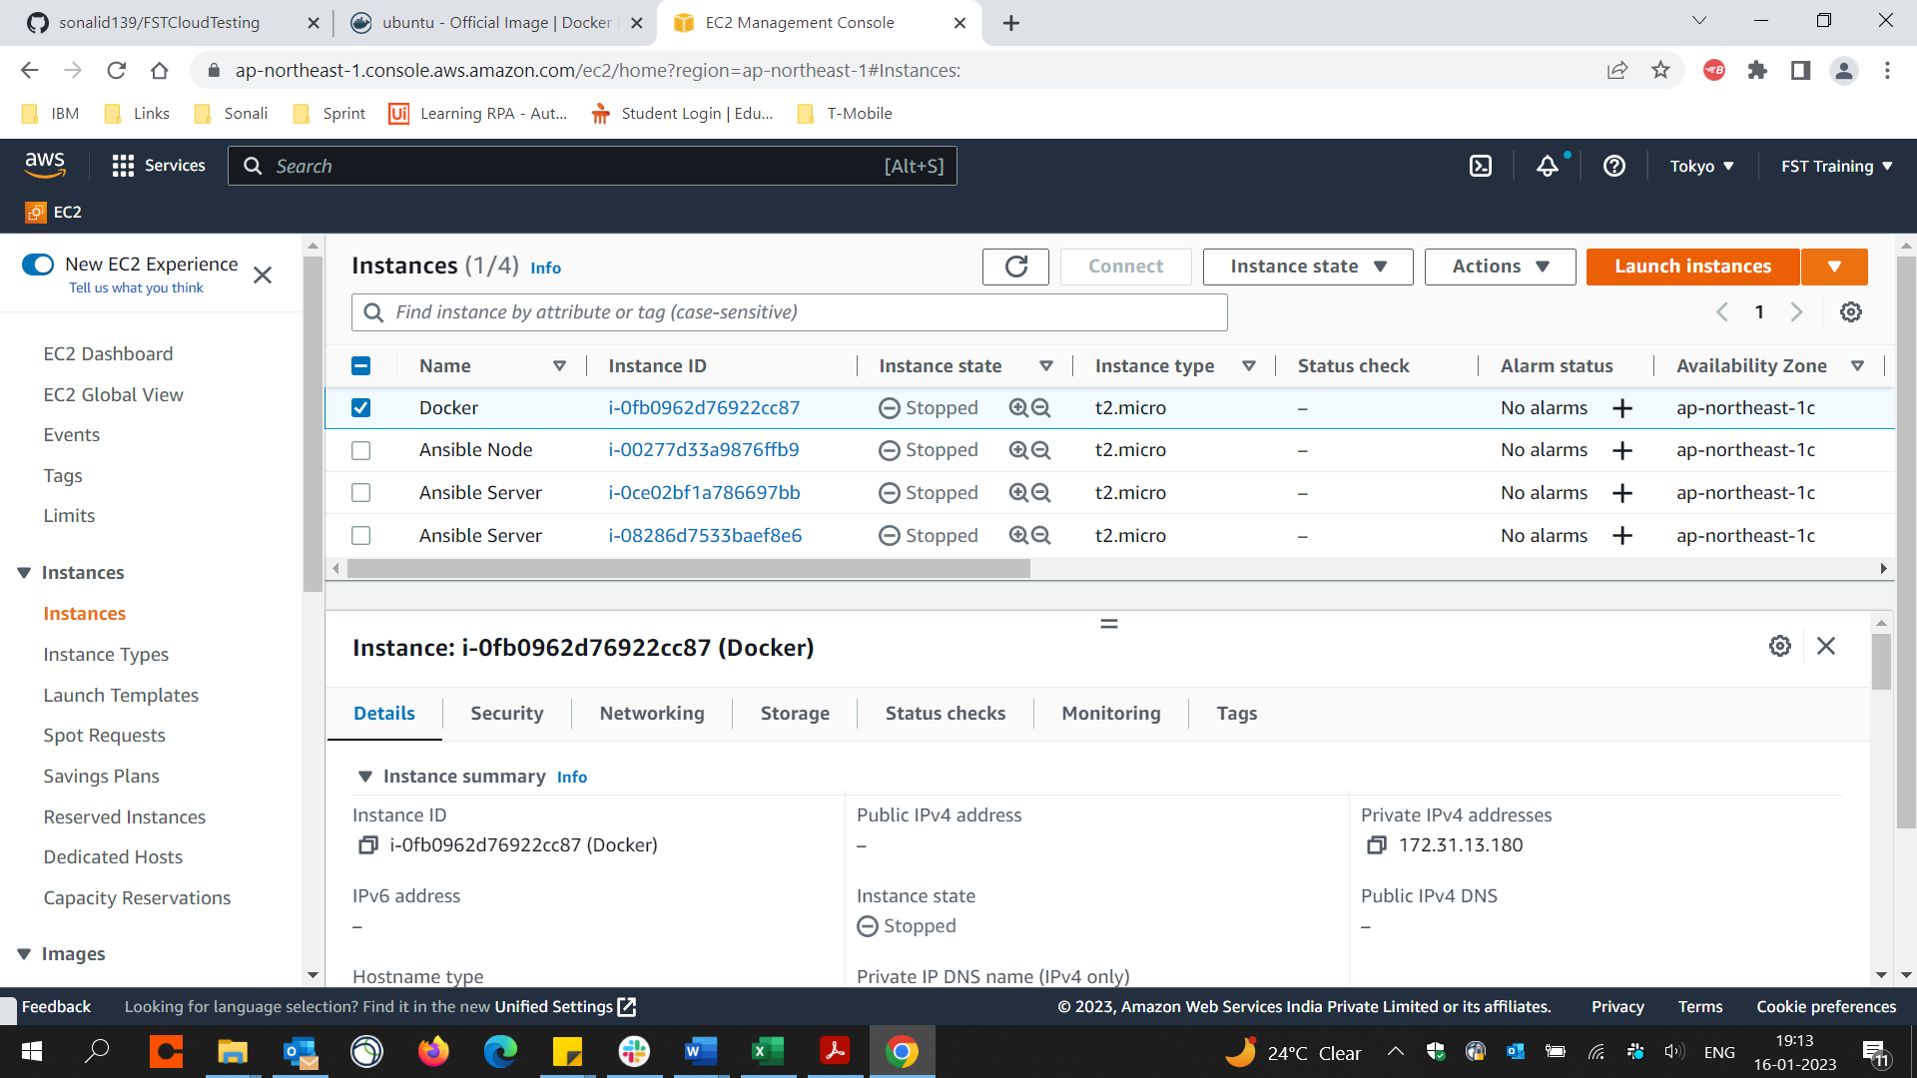

Launch instance

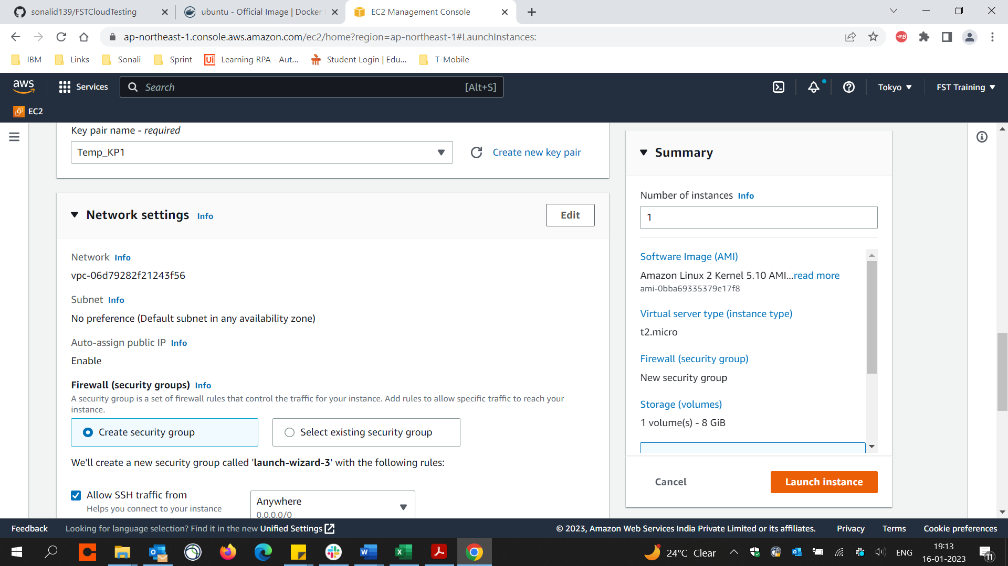

Select instance & click connect

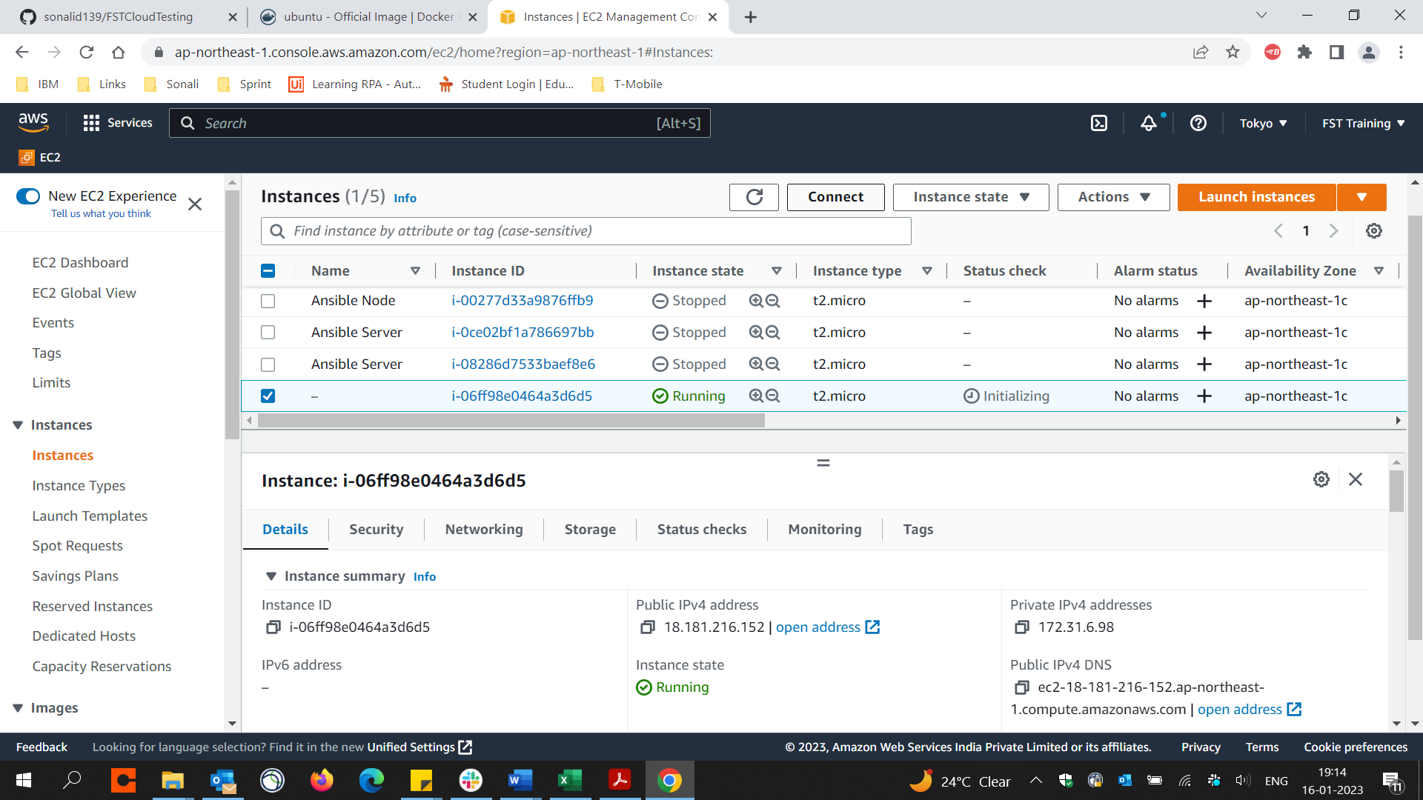

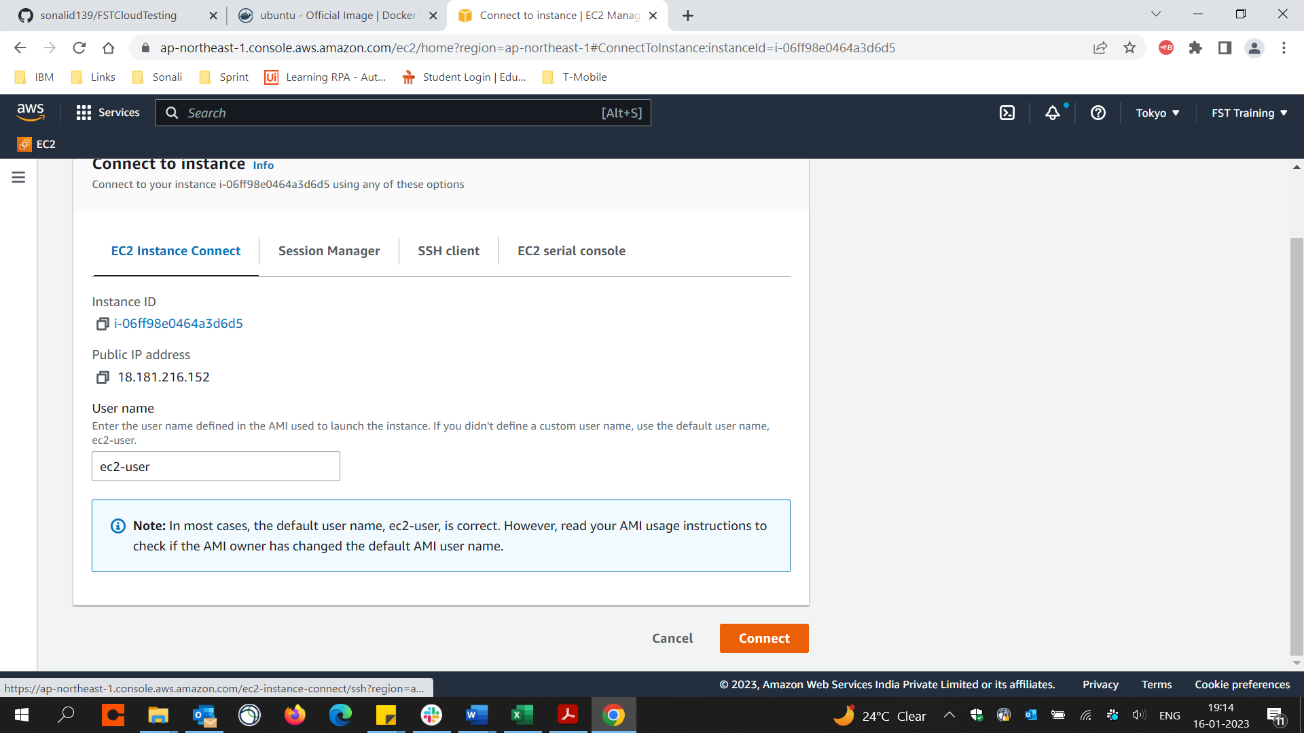

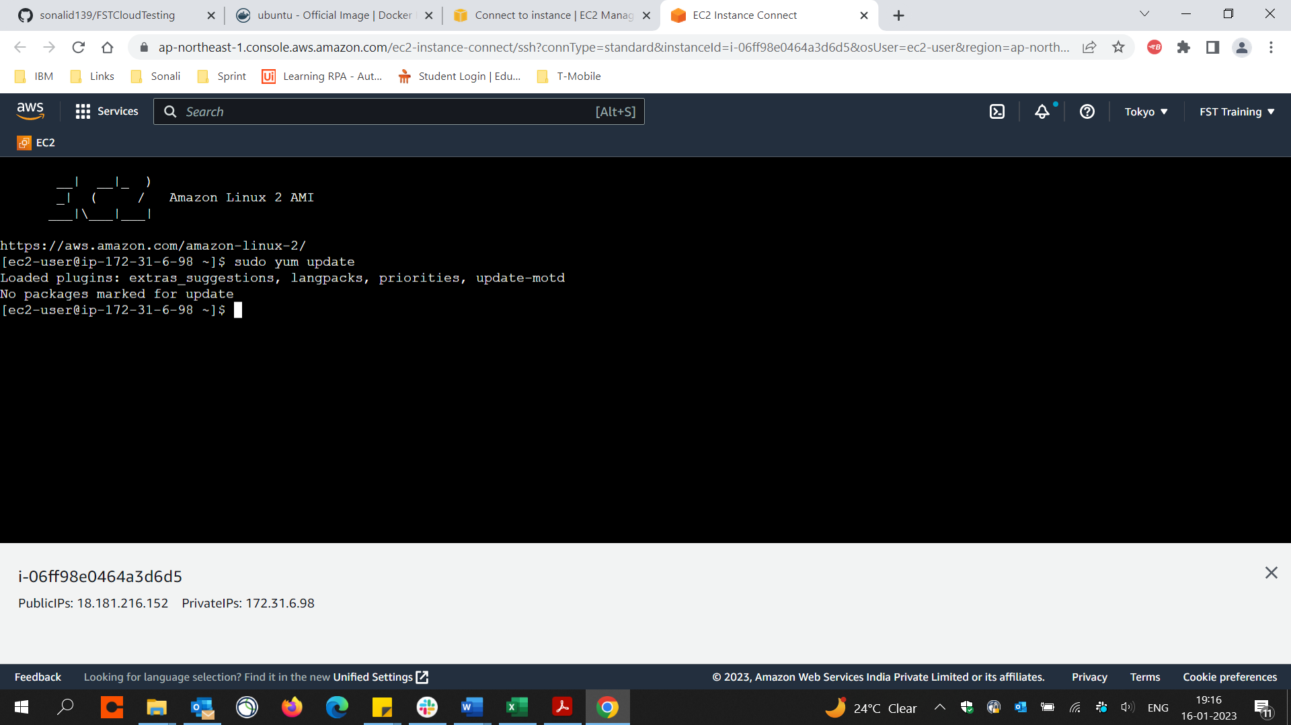

sudo amazon-linux-extras install docker

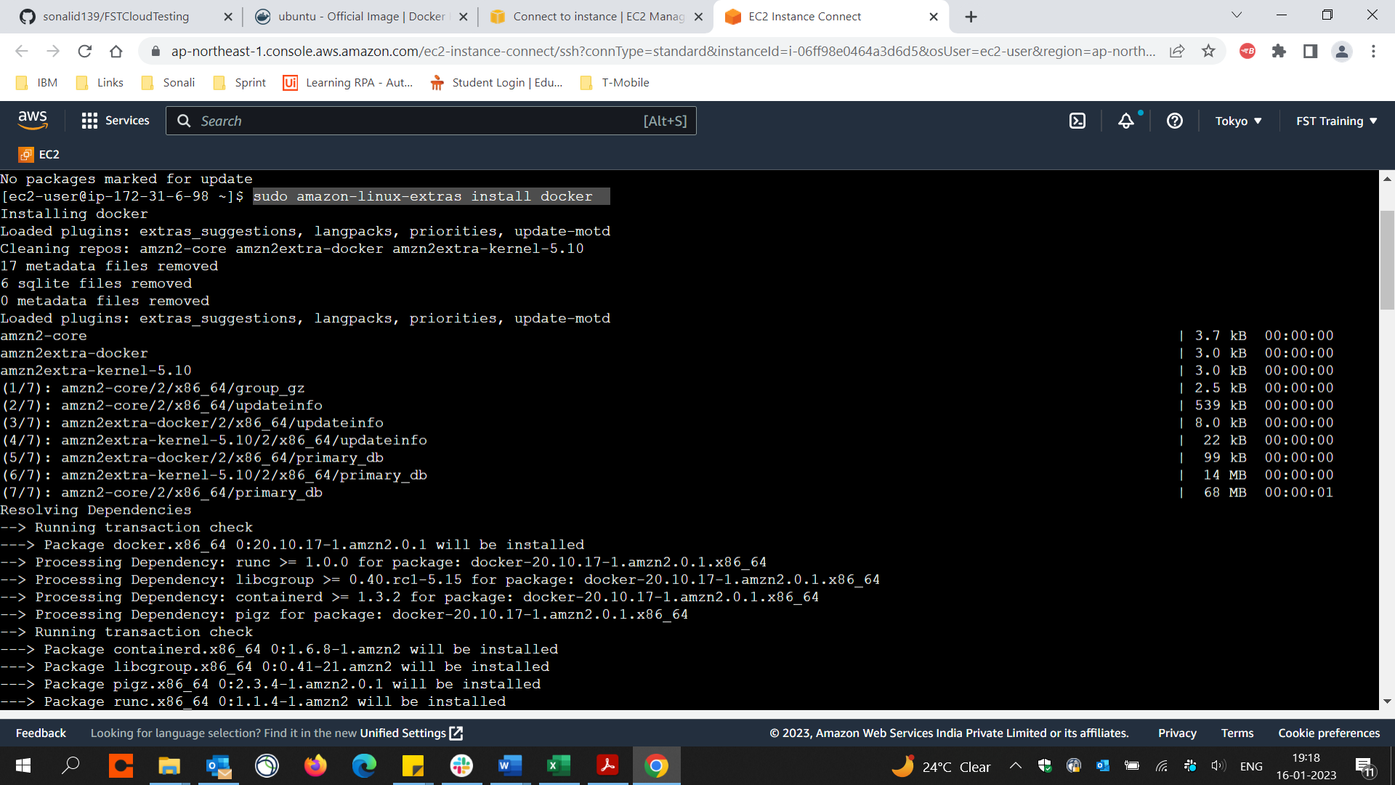

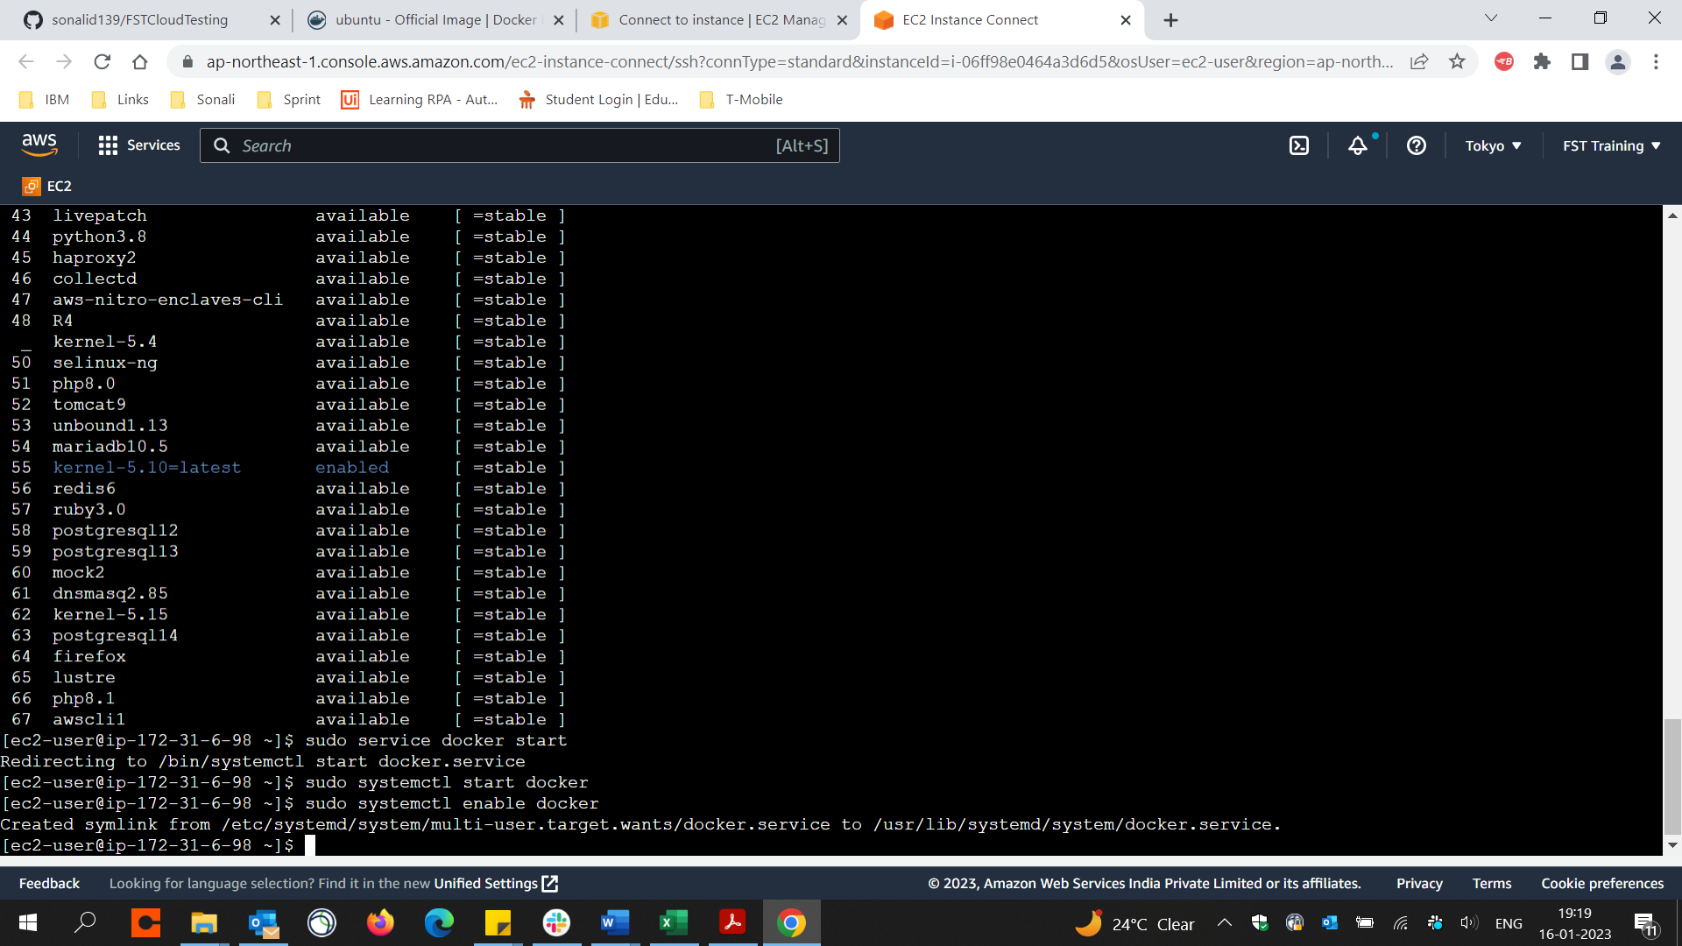

See docker version

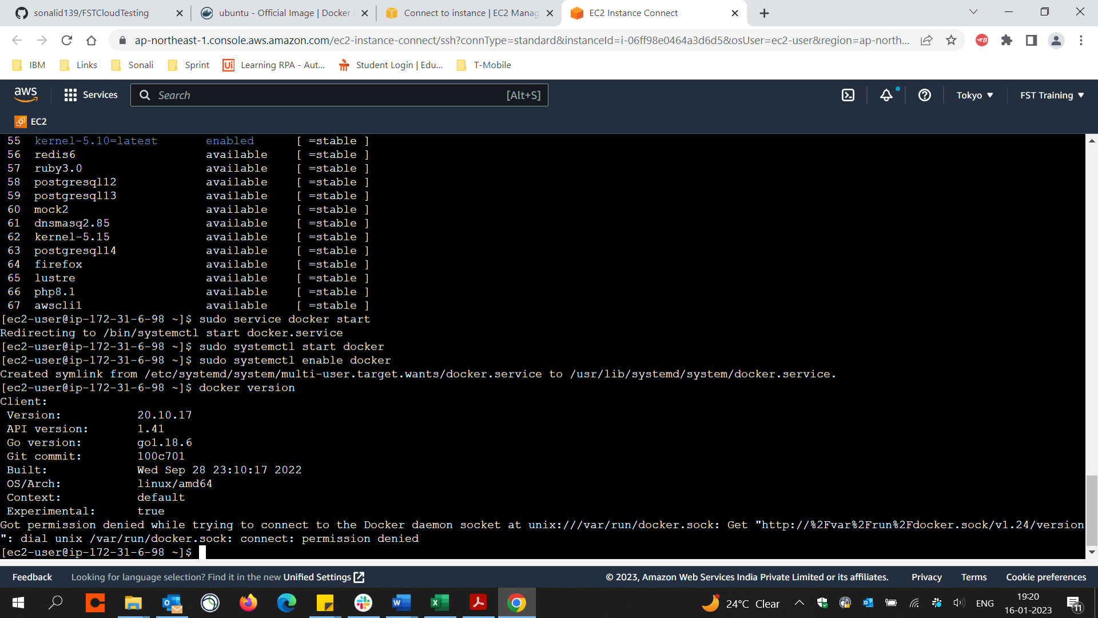

Download ubuntu from ‘https://hub.docker.com/_/ubuntu’ using - docker pull ubuntu

Check version by command - docker version

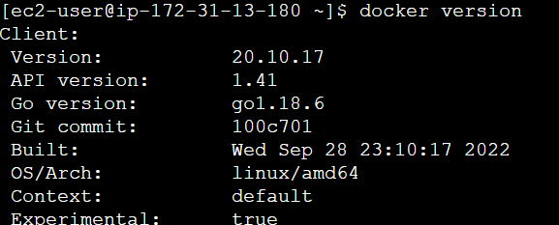

Goto docker hub -> Select image to download -> check/copy the command

On docker instance – run the command and Download image from docker hub on VM docker e.g. docker pull nginx

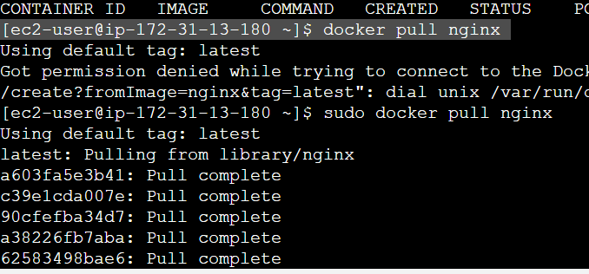

Check images installed by command– docker images

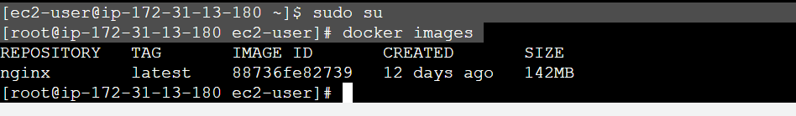

Installed ubuntu – docker pull ubuntu

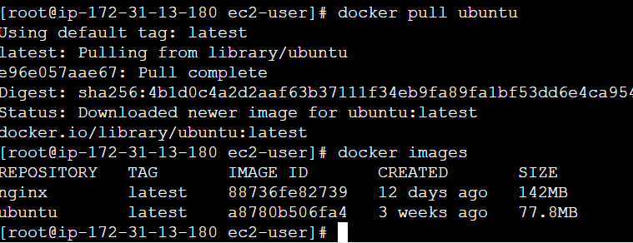

Installed Mongo – docker pull mongo, check images

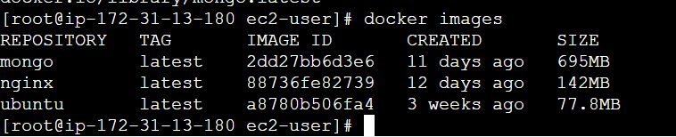

Check containers installed by command – sudo docker ps

**docker ps -a** => Lists all container instances (running & exited)

**docker ps** => Lists running containers only



Container creation

**docker run -itd <image name>** e.g. docker run -itd ubuntu (docker to run in detached mode, instance will not be terminated when Ctrl+C is pressed)

**docker run -it <image name>** (docker will not run in detached mode so terminates when Ctrl+C is pressed)

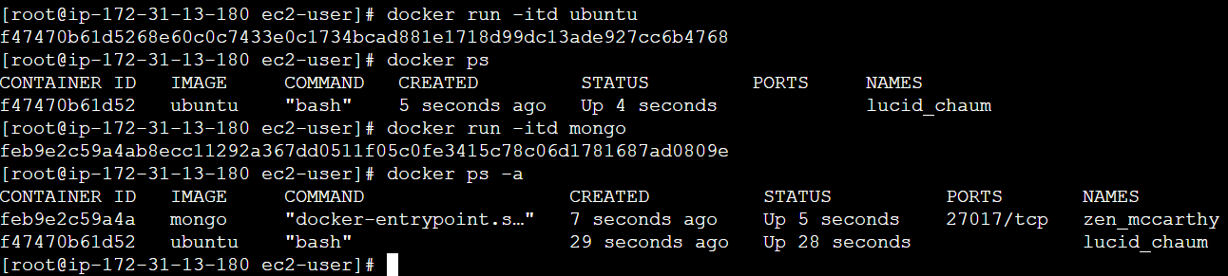

Container instance can be terminated by command – **docker stop <container_id>** or **docker stop <names>**

