

**Basic Linux Commands Assignments**

Assignment-1

Connect and disconnect with login Access

* What happens when you login a non-existent users or username?
  + Provide Screenshot and What you understand, explain in short brief?

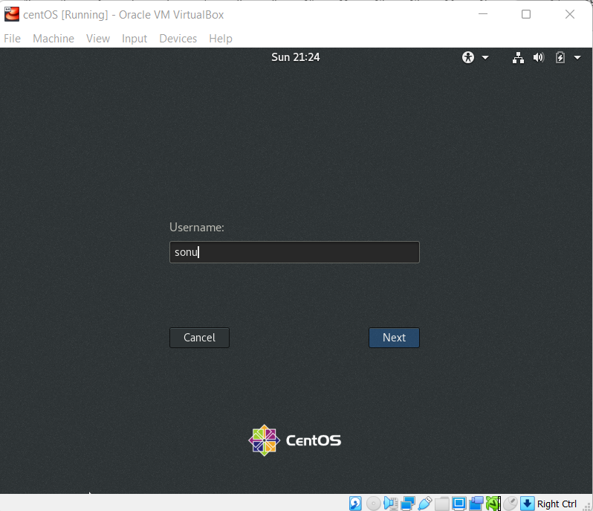 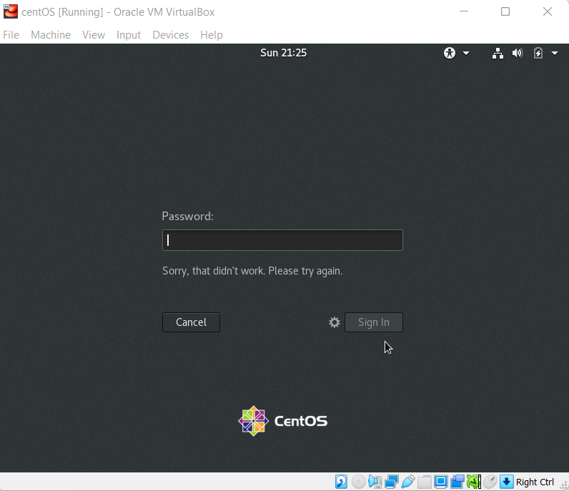

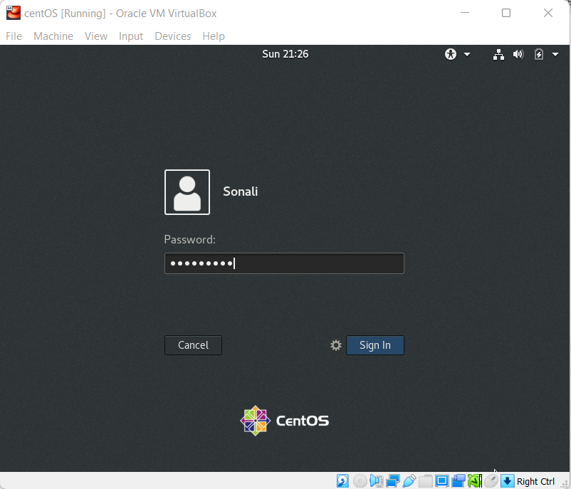 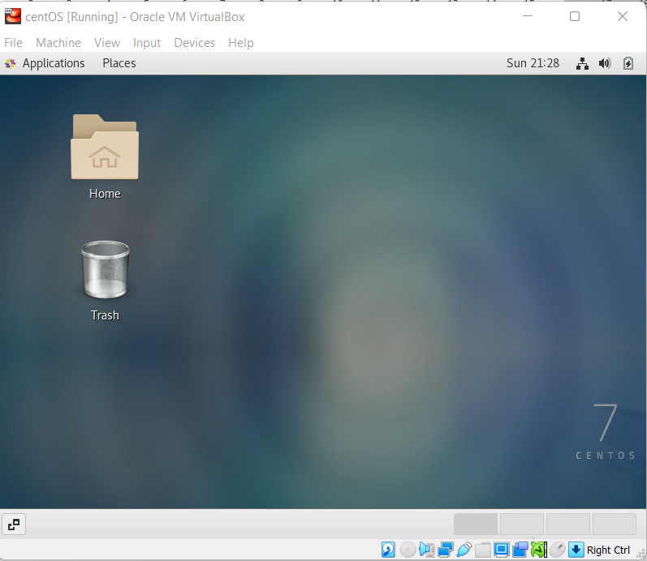

* Here, I understood that , “Sonali” user I have created has been successfully logged in whereas non user “Sonu” didn’t able to login , when I check with command “id sonu” there were no such user with this user name and whereas “Id sonali” gives me output with user information.
* I referred this article for more cool commands to find user utility “[How Do I Find My User ID in Linux (linuxhint.com)](https://linuxhint.com/find-user-id-linux/)”

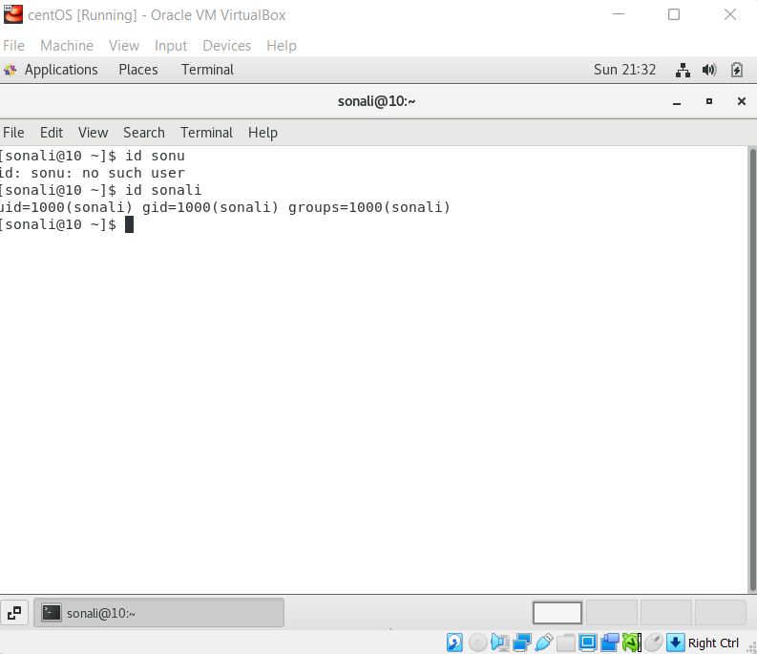

Assignment-2

Password changing

* Login into your account and then change password?
  + Change your password into **IneuR0n#42** and hit the **Enter** key
    - Explain what happen and give screenshot?
* User password information is stored in /etc/shadow file.
* Initially I was not able to switch root using sudo su because username “sonali” was not added in sudoers file and I was unable to make changes with user sonali due to lack of sudo priviledge – I understand by sudo privilege mean it allows user to take root privileges temporaliy taking root control I added “sonali” in sudoers file to get sudo priviledge.
* “usermod -aG wheel sonali” – added in sonali in sudoers
* Text

  Description automatically generated with medium confidence
* Password changed successfully
  + Try again to change password but use like password ***1234*** or ***abcd***
    - Explain what happen and give screenshot?
* Graphical user interface, text, application

  Description automatically generated
* Password was updated but was shorter and wasn’t strong enough.
  + Try again to change password but now don’t use any password just hit **Enter** key
    - Explain what happen and give screenshot?
* Blank pwd is not getting accepted.Something has to be typed or given as a password
* Graphical user interface, text, application, email

  Description automatically generated

Assignment-3

Working with Directories

* Enter the command **cd /** and then **ls** and then hit **Enter** key
  + Take screenshot and explain what output we got?
* Graphical user interface, text, application

  Description automatically generated
* I am able to see all directories.
* Enter the command now **cd /home** and then hit **Enter** key
  + Do **ls,** provide screenshot and explain what is **/home** directory used for?
* Text

  Description automatically generated
* I can see current user in home directory , home directory is allocated to every user to store their personal information ,scripts and user information.
* Enter **cd ..** and hit **Enter** key [ *Note: here we have space after cd then use double dot*]
  + Check what happen and give screenshot?
* A picture containing chart

  Description automatically generated
* It comes out of home directory to parent directory, that “/” directory we also call it as root directory
* Now enter **cd /var/www/html** and then type **cd** and hit **Enter** key
  + Explain what happen and give screenshot?

There is no such directory name with www and html

* Text

  Description automatically generated
* Now type **cd /root** and then hit **Enter** key
  + Do **ls,** check any output we have on screen if yes then take screenshot?
* Graphical user interface, text, application

  Description automatically generated
* When I did cd /root from user permission was denied and when I switched to root I am able to following directories and files.

Assignment-4

Working with File Listing

* Go to **cd /etc** and type **ls**
  + Take screenshot and explain what files you have seeing?
* Graphical user interface, application

  Description automatically generated Graphical user interface

  Description automatically generated
* /etc folder shows system configuration related files, directory and database
  + Take screenshot and explain what different output you found compare to previous command you used?
* Then type **ls -al** and hit **Enter** key
  + Take screenshot and explain what new file or directory you found?
* Table

  Description automatically generated
* I can permissions of files and directory and it gives list of all entries from single dot.
* Then use **ls -i** and hit **Enter** key
  + Now see what different output its shows and take screenshot?

* It gives i-node number of all files and directories, a unique number.
* Then use **ls –help** and see other options about **ls** command
  + Explore it and try with other attribute we can use with **ls** command
* Graphical user interface, text, application

  Description automatically generated
* It gives details of all attributes and help user to use such attributes as per requirement.

Assignment-5

Know where you are and where you working

*Here we use* ***pwd, cd and ls*** *as combine task to understand where you working on terminal and how you can switch from one directory to another one.*

* Open terminal after restart the linux
  + Check which location you working, type **pwd** and take screenshot
* Now use **cd /var** and hit **Enter** key
  + Do **ls,** and see what output comes, give screenshot?
* Do explore other help options of each command to learn more other things we can do with these commands
* Attaching one screenshot for all sub tasks and also refer this document for more other cool commands.

“ https://sites.ualberta.ca/dept/chemeng/AIX-43/share/man/info/C/a_doc_lib/cmds/aixcmds3/ls.htm#:~:text=The%20ls%20command%20writes%20to,contents%20of%20the%20current%20directory.”

Assignment-6

Install dependency to make centos GUI full screen

* Graphical user interface, text, application

  Description automatically generated
* I have installed all dependencies and made it full screen
* Yum update
* **yum install dkms gcc make kernel-devel bzip2 binutils patch libgomp glibc-headers glibc-devel kernel-headers -y**
* **I have rebooted the machine and done**

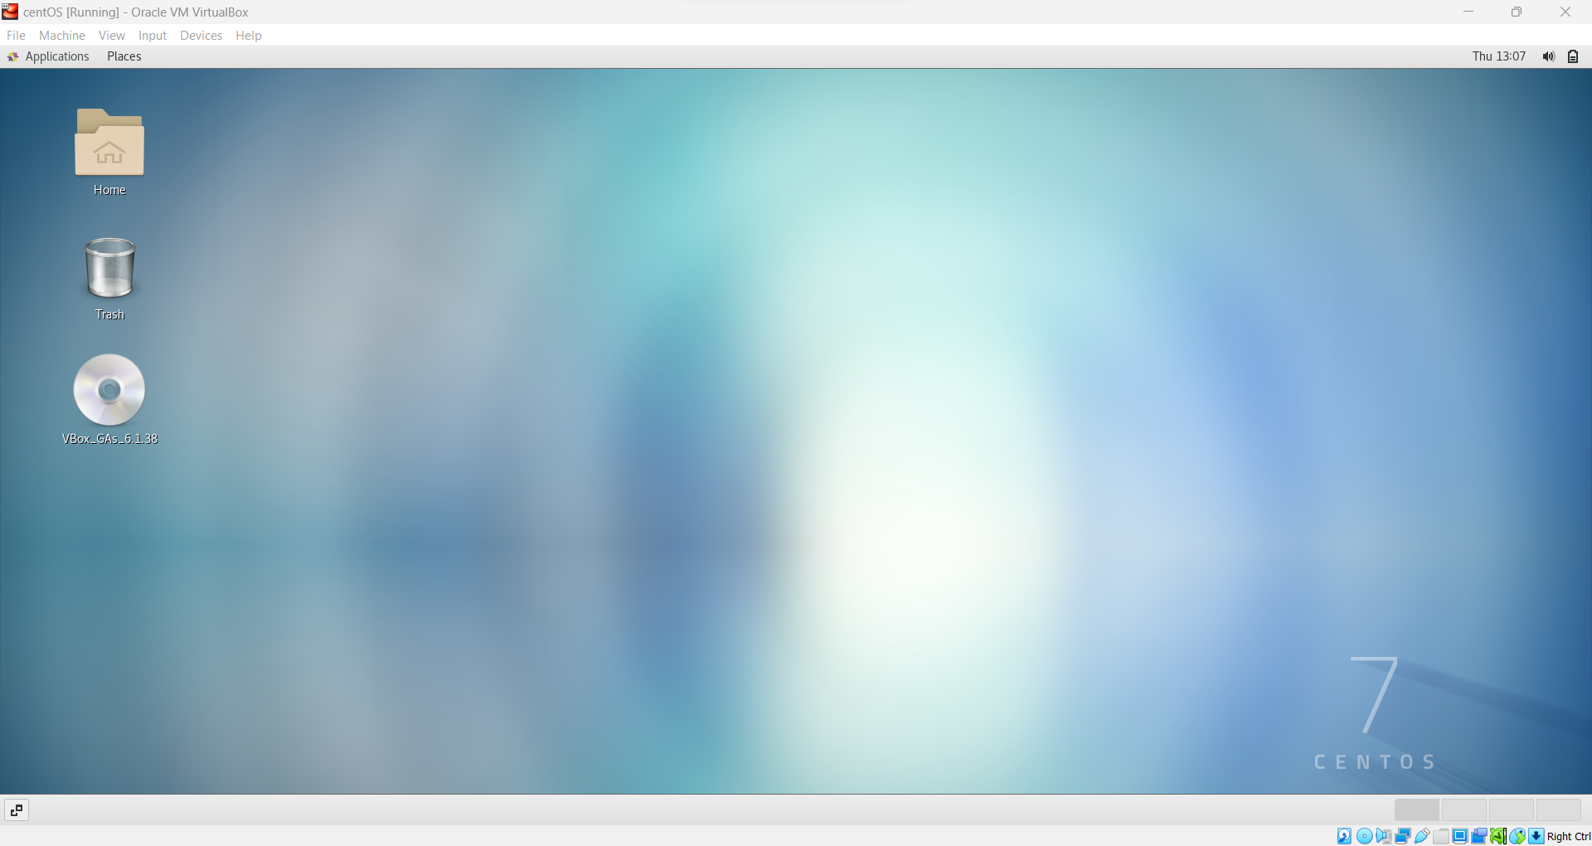

Assignment No. 7

Create directory ineuron in desktop directory then create devops.txt file and give 461 permission

