### **Hospital DataBase Management System**

The SQL script defines the structure of a relational database for a healthcare management system. It includes tables to store information about doctors, patients, appointments within a healthcare facility.

**Key Components:**

1. Physician: Stores details of physicians including their employee ID, name, position, and social security number (SSN).
2. Patient: Stores patient information including SSN, name, address, phone number, insurance ID, and primary care physician (PCP).
3. Appointment: Stores details of patient appointments including appointment ID, patient, preparing nurse, physician, start and end date/time, and examination room.

**Why Do We Need It?**

A healthcare management system is essential for efficiently organizing and managing various aspects of healthcare delivery within a healthcare facility. It helps in:

1. Streamlining administrative tasks such as appointment scheduling, doctor attendance , and
2. Enhancing patient care by providing quick access to accurate patient information.
3. Ensuring compliance with regulatory standards by maintaining accurate records and documentation..

**ER Diagram of the tables which are used in this data**

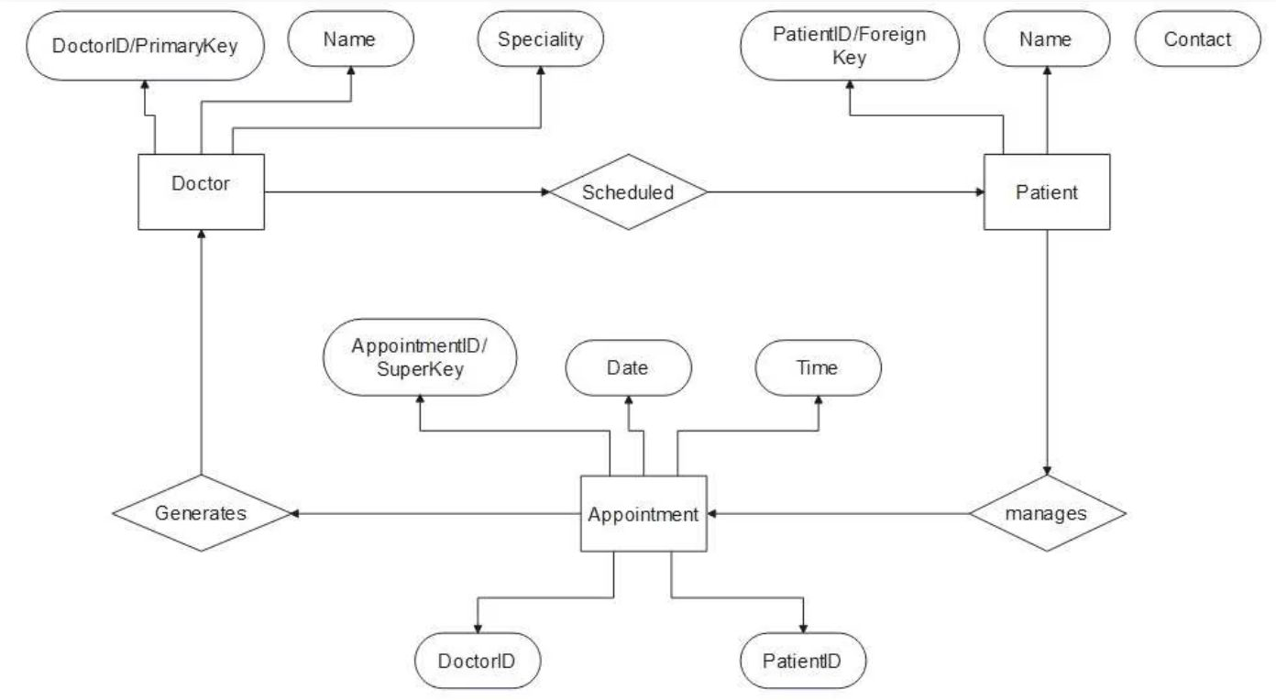

**TABLES AND DATA POPULATIONS**

**Patient Table**

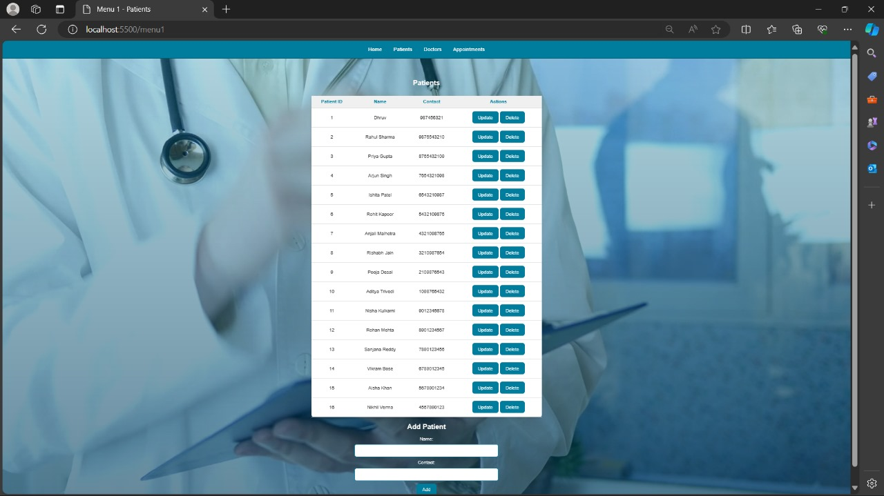

**Doctor Table**

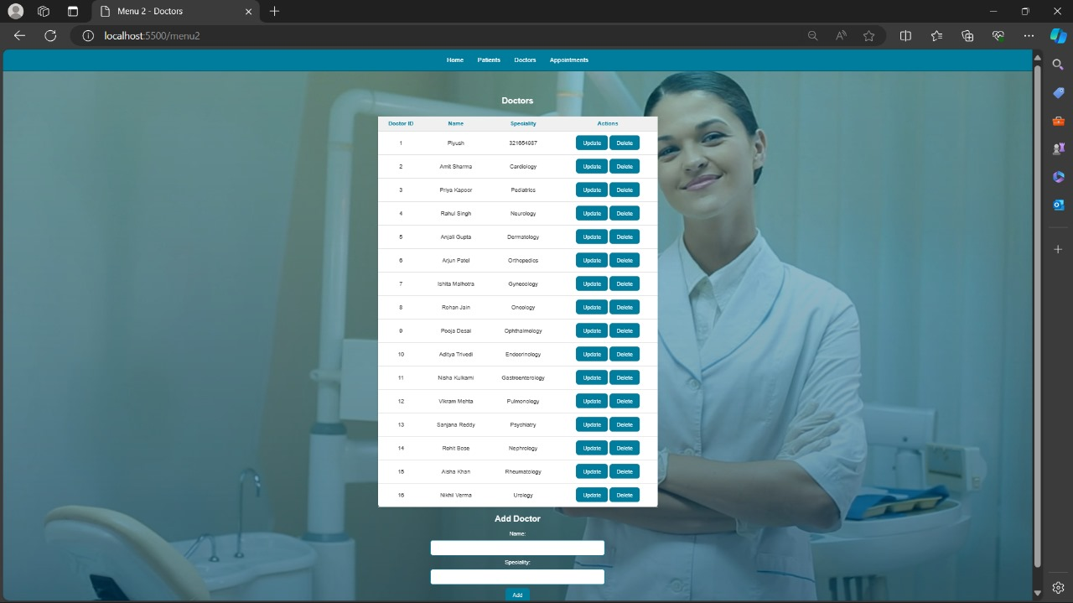

**Appointment Table**

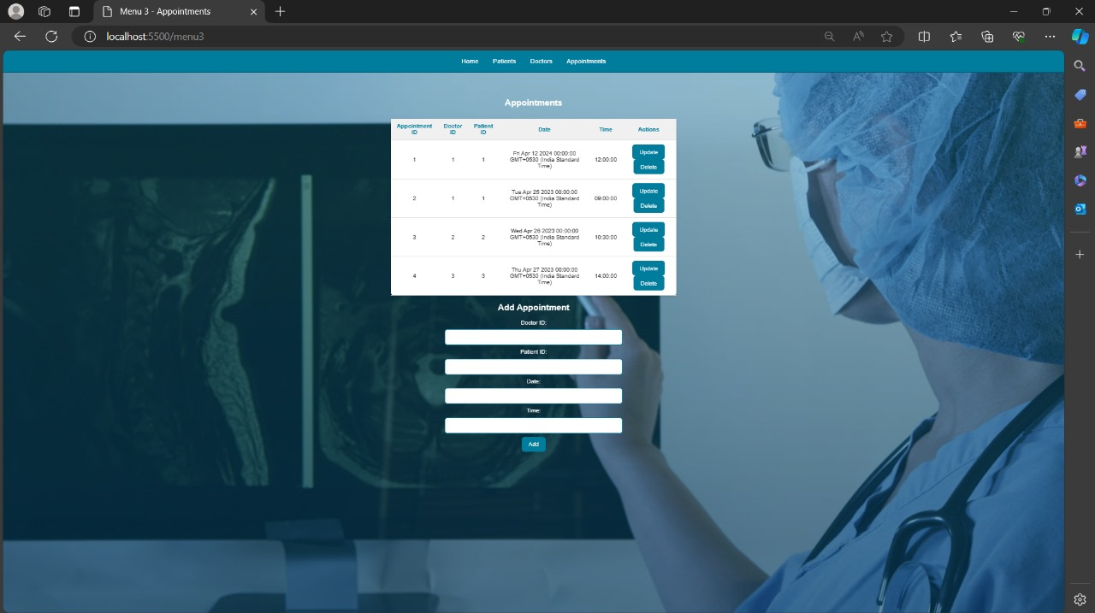

**DataBase Contivity**

**Patient Table**

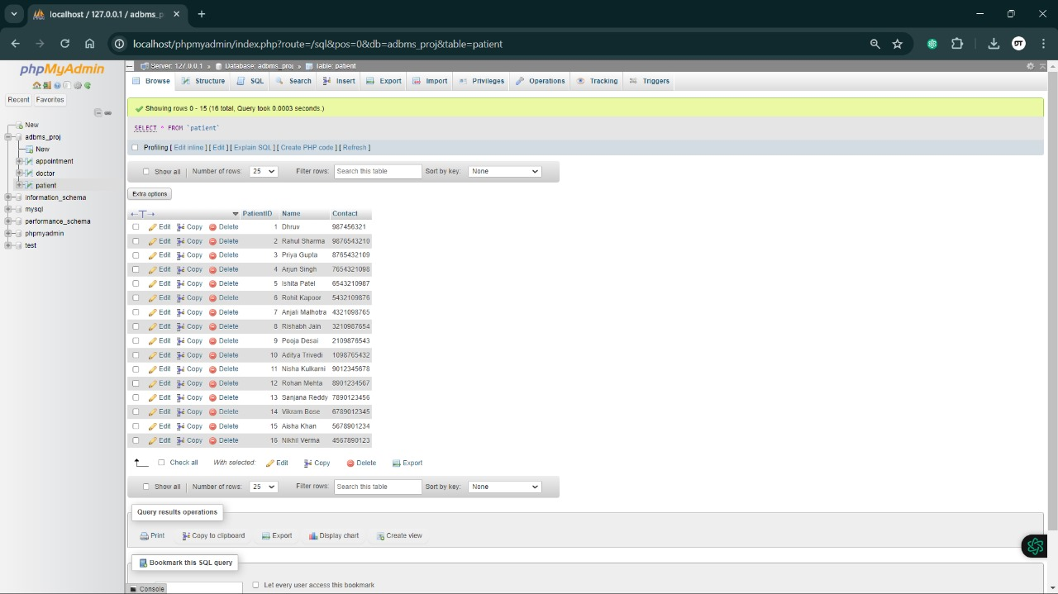

**Doctor Table**

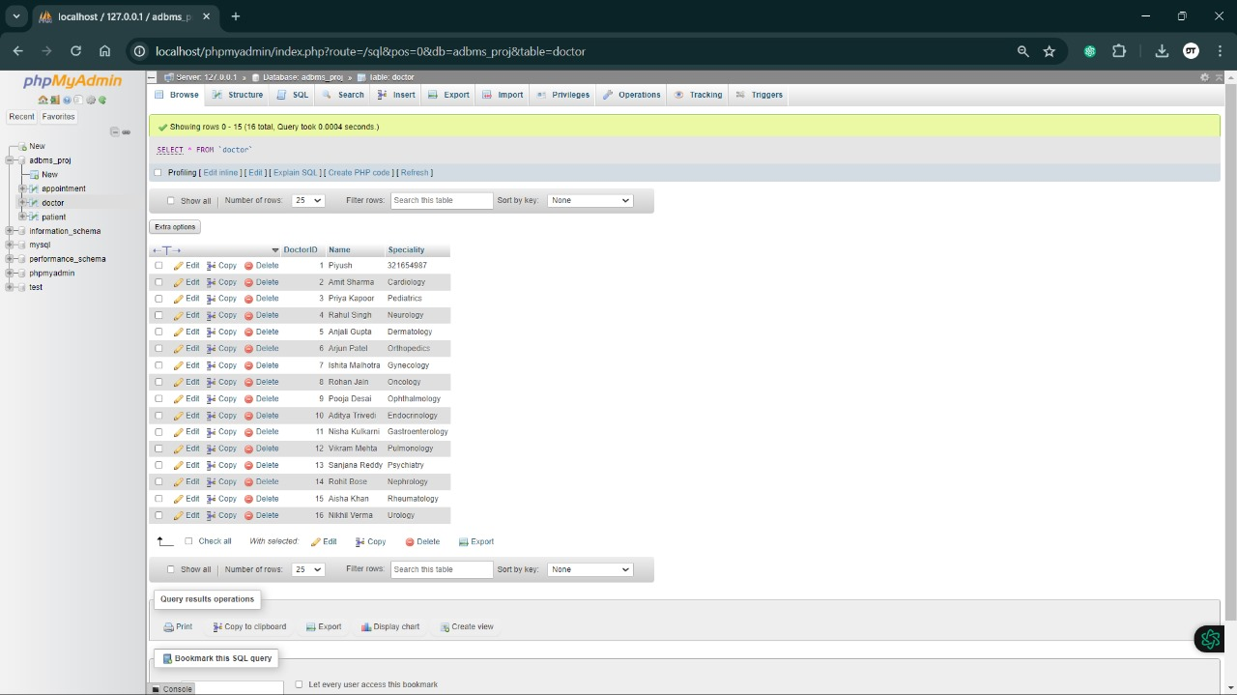

**Appointment Table**

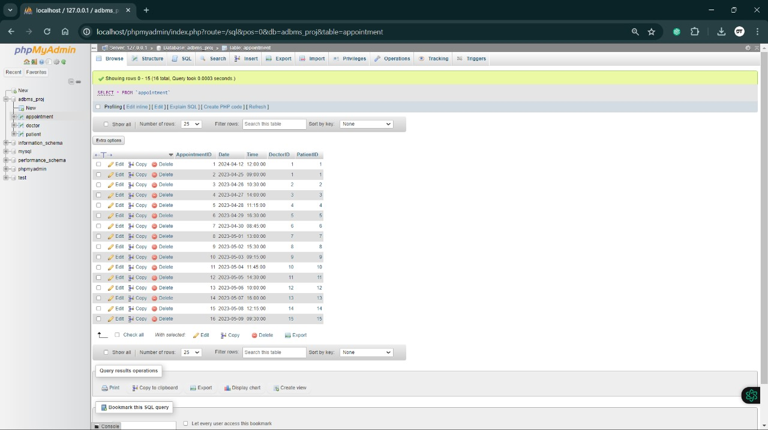

**WebPage**

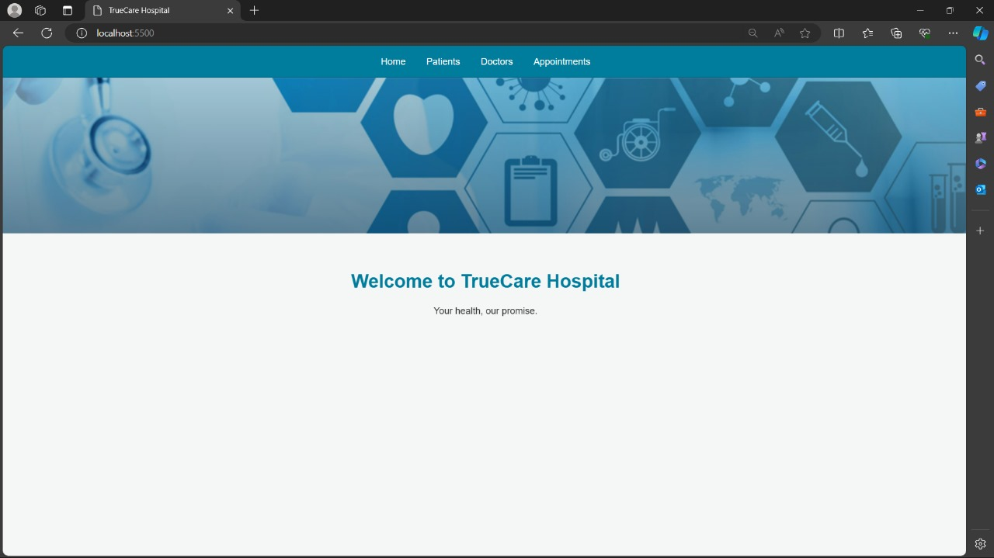

**Summary**

In summary, the SQL script defines the database schema for a healthcare management system, facilitating efficient management of patient care and administrative processes within a healthcare facility. This system encompasses tables to store essential information about, patients, and appointments, ensuring comprehensive management of healthcare services. The physician table records details such as employee ID, name, position, and social security number (SSN), enabling effective tracking of healthcare providers. Patient information, including SSN, name, address, phone number, insurance ID, and primary care physician (PCP), is stored in the patient table, facilitating personalized care delivery and administrative tasks such as billing and insurance management. The appointment table captures crucial details of patient appointments, including appointment ID, patient, preparing nurse, physician, start and end date/time, and examination room, enabling efficient scheduling and coordination of healthcare services. Overall, the SQL script lays the foundation for a comprehensive healthcare management system, which streamlines administrative tasks, enhances patient care, ensures regulatory compliance, and optimizes resource allocation within healthcare facilities.