ReadMe:

The following is the ER diagram from SQL

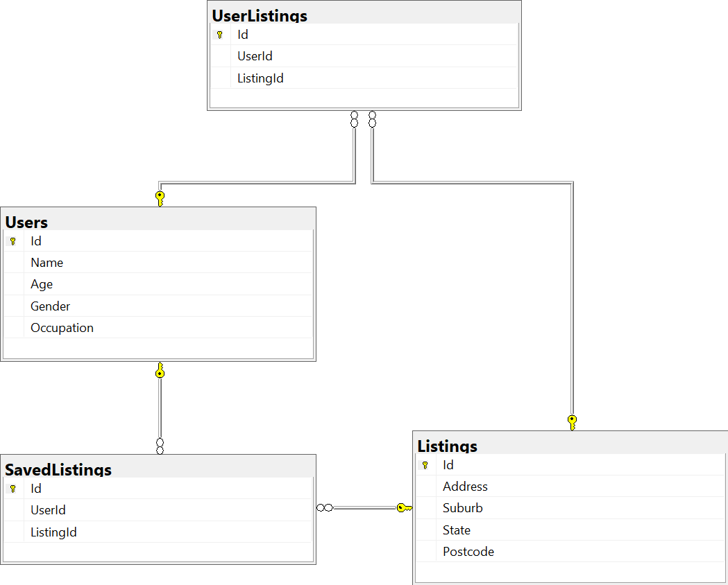

1. Public and deploy the db project to create the databases
2. Change the connection string in appSettings to connect to db.
3. Run the DomainAPI solution and it has swagger enabled which can be used to test the APIs.