
CAPSTONE PROJECT DOCUMENTATION
Information Technology · Summer 2026 Virtual Showcase
Project name: Secure Clinic IT Infrastructure: Implementation, Deployment, and Security Validation
Team members (final roster):
- Sonali Mohammed
- Justin Barroso
- Demetrius Smith
- Santiago Ferreira Rolon
- David Alonso

Team leader: Sonali Mohammed
Product owner / mentor: Prof. Masoud Sadjadi
Instructor: Prof. Masoud Sadjadi, Knight Foundation School of Computing and Information Sciences, FIU
Version / date: July 2026

Contents
Contents 1
1 Executive Summary 1
2 Problem & Stakeholders (SO1) 1
2.1 Problem Statement 1
2.2 Stakeholders & User Needs 1
2.3 Constraints & Assumptions 1
3 Requirements Specification (SO1, SO2) 1
3.1 Functional Requirements 1
3.2 Non-Functional Requirements 1
4 Solution Design & Architecture (SO2) 1
4.1 Solution Overview 1
4.2 Architecture 1
5 Implementation (SO2, SO6) 1
6 Testing, Verification & Evaluation (SO2, SO6) 1
7 Systems & Operations Evidence (SO6) 1
7.1 DevOps Roles & Responsibilities 1
7.2 Database Design & Maintenance 1
7.3 Deployment Diagram 1
7.4 Version Control (Git) Workflow 1
7.5 CI/CD Pipeline 1
7.6 User Manual 1
7.7 Maintenance Document 1
8 Professional, Ethical & Legal Considerations (SO4) 1
9 Team & Process (SO5) 1
10 Communication Artifacts (SO3) 1
Appendix A — Student Outcomes & IT Evidence Map 1
Appendix B — Revision History 1

1 Executive Summary
The Secure Clinic IT Infrastructure: Implementation, Deployment, and Security Validation project was developed to create a secure, reliable, and scalable IT environment for a small healthcare clinic. The project addresses the need to protect sensitive patient and financial information by implementing centralized identity management, role-based access control (RBAC), secure remote access through VPN with Multi-Factor Authentication (MFA), firewall protection, endpoint security, and continuous monitoring. These security measures help reduce cybersecurity risks while supporting HIPAA security requirements and ensuring that only authorized users can access clinic resources.
The completed infrastructure integrates Active Directory, Microsoft Entra ID, Microsoft Intune, Windows Defender Firewall, pfSense, and OpenVPN into a unified security solution. Through deployment and security validation, the team confirmed the effectiveness of password policies, account lockout settings, firewall rules, VPN connectivity, audit logging, and backup procedures. The result is a secure and manageable infrastructure that improves operational efficiency, strengthens data protection, and provides a foundation for future growth within the clinic.

2 Problem & Stakeholders (SO1)

2.1 Problem Statement
Small healthcare clinics often operate without centralized identity management, secure remote access, or consistent security policies. These limitations increase the risk of unauthorized access, cyberattacks, and exposure of electronic Protected Health Information (ePHI).
The goal of this project was to implement a secure, scalable, and manageable IT infrastructure that protects clinic resources while supporting daily healthcare operations.

2.2 Stakeholders & User Needs
Stakeholders
- Clinic Manager
- Receptionist
- Nurses
- Medical Assistants
- Billing Specialists
- Accountants
- Compliance Officers
- IT Administrators
- Patients
User Needs
- Secure authentication
- Role-based access to resources
- Secure remote access
- Protected patient information
- Reliable system availability
- Easy administration
- Audit logging
- Device management
These needs were identified through project requirements, user stories, sprint planning, and security best practices.

2.3 Constraints & Assumptions
Constraints
- Limited budget
- Cloud-hosted infrastructure
- Microsoft Azure Student subscription
- HIPAA security considerations
- Semester timeline
- Small project team
Assumptions
- Authorized staff receive MFA devices.
- Internet connectivity is available.
- Windows-based workstations are used.
- Azure services remain available.

3 Requirements Specification (SO1, SO2)

3.1 Functional Requirements
The system shall:
- Authenticate users through Active Directory.
- Synchronize identities with Microsoft Entra ID.
- Require Multi-Factor Authentication.
- Implement Role-Based Access Control.
- Provide secure VPN access.
- Protect endpoints using Microsoft Intune.
- Apply Group Policy Objects.
- Log authentication events.
- Enforce password complexity.
- Enforce account lockout policies.
- Protect servers using Windows Defender Firewall.
- Maintain audit logs.
- Support backup procedures.
- Manage users centrally.

3.2 Non-Functional Requirements
Security
- AES-256 VPN encryption
- Default-deny firewall policy
- MFA
- Audit logging
Reliability
- Secure cloud infrastructure
- Backup validation
- Stable remote access
Maintainability
- Centralized administration
- Group Policy management
- Automated PowerShell administration
Scalability
Infrastructure supports future users and additional Azure resources.

4 Solution Design & Architecture (SO2)

4.1 Solution Overview
The project uses a layered security approach combining cloud identity management, centralized authentication, secure networking, and endpoint protection.
Key design decisions included:
- Active Directory for centralized authentication
- Microsoft Entra ID for cloud identity
- Microsoft Intune for endpoint management
- OpenVPN for encrypted remote access
- Windows Defender Firewall
- Azure Virtual Network
- Role-Based Access Control
- Defense-in-Depth security

4.2 Architecture
Architecture diagram(s) and a walkthrough of the components and how they interact.
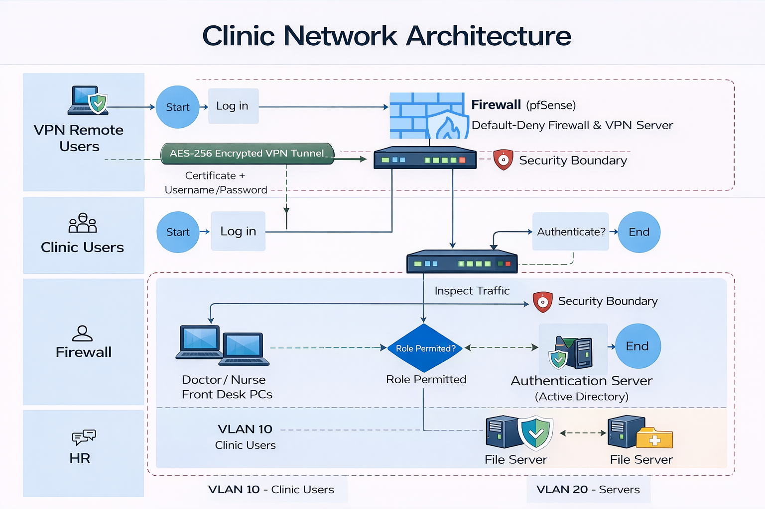

5 Implementation (SO2, SO6)
This project was implemented using Microsoft Azure and Microsoft enterprise security services to create a secure, scalable, and cloud-managed healthcare IT environment. Azure Virtual Machines hosted the Windows Server environment, where Active Directory Domain Services provided centralized authentication, user management, and Role-Based Access Control. Microsoft Entra ID (formerly Azure Active Directory) was integrated to provide cloud identity management and Multi-Factor Authentication, while Microsoft Intune was used to enforce endpoint security policies and device compliance. Additional security controls, including Windows Defender Firewall, Azure networking, and OpenVPN, were configured to protect clinic resources and support secure remote access.
Microsoft Azure | Cloud platform used to host the clinic’s virtual infrastructure, networking, and virtual machines.
Azure virtual machines | Hosted Windows Server 2022 and provide infrastructure for Active Directory and network services.
Windows Server 2022 | Provide centralized server management, active directory domain services, and network administration.
Active Directory Domain Services | Manage user authentication, security groups, and role-based access control.
Microsoft Entra ID | Provide cloud identity management, single sign-on, and multi-factor authentication.
Microsoft Intune | Manage endpoint security, device compliance, bit locked encryption, and windows security policies.
OpenVPN | Provide encrypted remote access for authorized clinic employees.
Windows Defender Firewall | Protect servers and workstations by filtering inbound and outbound network traffic.
Azure Virtual Network | Connect Azure resources securely and isolate network traffic within the cloud environment.
Group Policy Management | Enforce password policies, account lockout settings, windows security configurations, and administrative restrictions.
PowerShell | Automated admin tasks and simplified server configuration and management.
Windows Event Viewer | Recorded authentication events, policy changes, and security logs for monitoring and auditing.

Repository links:
- GitHub Repository
- Documentation Repository

6 Testing, Verification & Evaluation (SO2, SO6)
This project was tested to verify that all security controls and system configurations function as intended. Testing focuses on authentication, role-based access control, firewall protection, VPN connectivity, endpoint security, and audit logging. Each feature was validated to ensure that authorized users could access required resources while unauthorized access attempts were blocked. Testing was performed throughout deployment to identify and resolve configuration issues. Security validation confirmed that the infrastructure met the project’s functional and security requirements. Audit logs generated through windows event viewers were reviewed to confirm login attempts, policy changes, and security events were recorded correctly. With the successful completion of the tests the infrastructure provides a secure and manageable environment for clinic operations.

Test Summary
Test Case | Expected Result | Outcome
Active Directory User Login | Authorized users successfully authenticate | Passed
Role-Based Access Control | Users access only assigned resources | Passed
Password Complexity Policy | Weak passwords are rejected | Passed
Account Lockout Policy | Account locks after repeated failed login attempts | Passed
Multi-Factor Authentication | Second authentication factor required | Passed
VPN Connectivity | Authorized users establish secure remote connection | Passed
Windows Defender Firewall | Unauthorized traffic is blocked | Passed
Audit Logging | Security events recorded in Event Viewer | Passed
Backup Verification | Backup process completes successfully | Passed

Evaluation
The completed results have met the projects objectives by providing centralized identity management, secure remote access, layered network protection, and comprehensive security monitoring. Testing results confirmed that the implemented security controls effectively protected sensitive information while maintaining reliable access for authorized users, demonstrating the projects readiness for deployment in a small healthcare environment.

7 Systems & Operations Evidence (SO6)

7.1 DevOps Roles & Responsibilities

Team & Contributions
Team Member | Primary Contributions
Sonali Mohammed | Led the implementation of the Microsoft Azure environment, including Azure Virtual Machines, Active Directory Domain Services (AD DS), Microsoft Entra ID, Microsoft Intune, and OpenVPN. Developed the Configuration Documentation, Deployment Guide, project artifacts, architecture diagrams, presentation slides, poster, and live demonstration materials. Coordinated system validation and ensured project documentation met capstone requirements.
Justin Barroso | Focused on identity and access management by configuring Active Directory users, Organizational Units (OUs), security groups, and Role-Based Access Control (RBAC). Assisted with configuring Group Policy Objects (GPOs), firewall policies, and validating security controls during system testing.
Demetrius Smith | Supported system implementation by assisting with infrastructure configuration, deployment testing, and troubleshooting. Contributed to project documentation, sprint artifacts, presentation preparation, and validation of system functionality to ensure all project objectives were achieved.
David Alonso | Assisted with system deployment, testing, and quality assurance by validating user authentication, VPN connectivity, firewall rules, password policies, and audit logging. Contributed to project documentation, sprint reviews, and verification that functional and security requirements were successfully implemented.
Santiago Ferreira Rolon | lead by coordinating sprint activities, managing project planning, and ensuring deliverables were completed on schedule. Assisted with system design, Azure infrastructure deployment, security testing, and reviewing technical documentation to ensure consistency across the project.

7.2 Database Design & Maintenance
This project did not include a traditional relational database. Identity information was managed through Active Directory Domain Services and Microsoft Entra ID. User accounts, Organizational Units, security groups, and policies served as the centralized directory service.
System integrity was maintained through:
- Active Directory replication
- Azure backups
- User account management
- Policy enforcement
- Security auditing

7.3 Deployment Diagram
The deployment architecture includes:
- Microsoft Azure
- Azure Virtual Network
- Windows Server 2022 VM
- Active Directory
- Microsoft Entra ID
- Microsoft Intune
- OpenVPN Server
- Windows Defender Firewall
- Clinic Workstations
- Remote Users
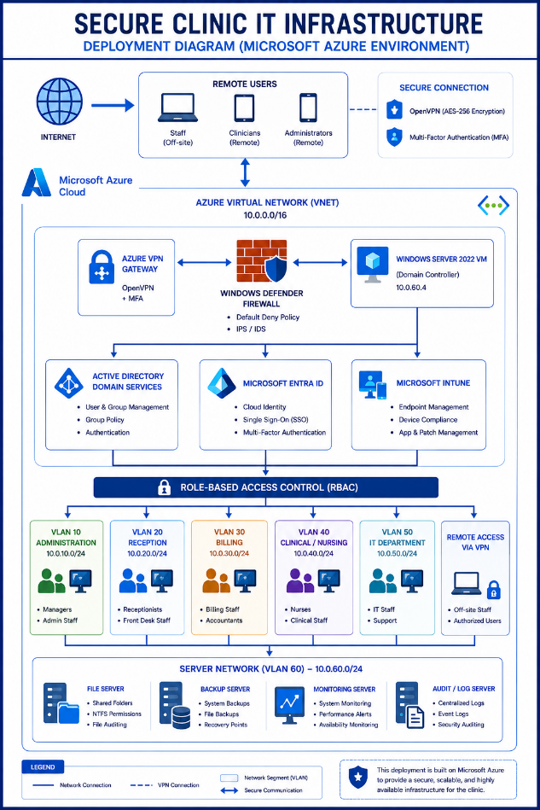

7.4 Version Control (Git) Workflow
The team used GitHub for source control.
Workflow included:
- Main branch
- Feature branches
- Commit history
- Merge reviews
- Final release
GitHub maintained documentation, diagrams, and configuration files.

7.5 CI/CD Pipeline
Pipeline stages included:
- Push to GitHub
- GitHub Actions workflow
- Validation checks
- Documentation verification
- Build success
- Deployment readiness

7.6 User Manual
Users:
- Sign in with Active Directory credentials.
- Complete Multi-Factor Authentication.
- Access authorized applications and shared folders.
- Remote users connect through OpenVPN before accessing internal resources.

7.7 Maintenance Document
System administrators:
- Create and remove users.
- Manage security groups.
- Configure Group Policies.
- Monitor audit logs.
- Manage Microsoft Intune.
- Maintain Azure resources.
- Verify backups.
- Troubleshoot VPN connectivity.
- Update Windows Server and Azure services.

8 Professional, Ethical & Legal Considerations (SO4)
The project was designed to protect healthcare information through multiple layers of security.
Professional responsibilities included:
- Least privilege
- Data confidentiality
- Secure authentication
- Ethical system administration
Legal considerations included:
- HIPAA Security Rule
- User privacy
- Audit logging
- Secure identity management
Only sample data was used during testing.

9 Team & Process (SO5)
The project followed an Agile Scrum methodology.
Activities included:
- Sprint Planning
- Daily Scrums
- Sprint Reviews
- Sprint Retrospectives
- User Story Development
- Deployment Validation
- Final Demonstration
Each team member contributed to infrastructure deployment, documentation, testing, and presentation preparation.

10 Communication Artifacts (SO3)
Links to the website: https://github.com/sonalililah/Secure_clinic_IT/tree/main/secure-clinic-it-infrastructure
Project deliverables include:
- Project Poster
- PowerPoint Presentation
- Introduction Video
- Live Demonstration Video
- Configuration Documentation
- Deployment Guide
- Capstone Report
- Architecture Diagram
- Deployment Diagram
- Sprint Documentation
- GitHub Repository

Appendix A — Student Outcomes & IT Evidence Map
Student outcomes assessed in this program:
SO | Outcome (verbatim — ABET CAC criteria, as adopted in the KFSCIS SLO assessment framework)
1 | Analyze complex computing problem and apply principles of computing and other relevant disciplines to identify solutions.
2 | Design, implement, and evaluate a computing-based solution to meet a given set of computing requirements in the context of the program's discipline.
3 | Communicate effectively in a variety of professional contexts.
4 | Recognize professional responsibilities and make informed judgments in computing practice based on legal and ethical principles.
5 | Function effectively as a member or leader of a team engaged in activities appropriate to the program's discipline.
6 | Use systemic approaches to select, develop, apply, integrate, and administer secure computing technologies to accomplish user goals. [Information Technology]
SO6 evidence questions (KPRs) for Information Technology — complete the “where evidenced” column:
KPR | Evidence question (verbatim) | Where evidenced (section §)
1 | Students identified DevOps roles and responsibilities. | 7.1
2 | Students created a database. | 7.2
3 | Students maintained a database. | 7.2
4 | Students developed a deployment diagram. | 7.3
5 | Students used Git and s how proficiency in using it. | 7.4
6 | Students defined a CI/CD pipeline. | 7.5
7 | Students developed a user manual. | 7.6
8 | Students developed a maintenance document. | 7.7

Appendix B — Revision History
Version | Date | Changes
0.1 | June 2026 | Initial draft
0.5 | July 2026 | Added implementation and testing
0.9 | July 2026 | Added deployment and operations
1.0 | July 2026 | Final Capstone submission

