
Secure Clinic IT Infrastructure: Implementation, Deployment, and Security Validation
Program: Information Technology
Capstone Project Documentation — Summer 2026
Team Members
Name | Role | Email | LinkedIn
Sonali Mohammed | Team Lead | smoha094@fiu.edu | linkedin.com/in/sonali-lilah
Justin Barroso | Identity & Access Management | jbarr327@fiu.edu | www.linkedin.com/in/justin-barroso-7a9756228
Demetrius Smith | Infrastructure & Testing | dsmit332@fiu.edu | https://www.linkedin.com/in/ds3065______
Santiago Ferreira Rolon | Project Coordinator | Sferr109@fiu.edu | https://www.linkedin.com/in/santiago-ferreira-77a489231/
David Alonso | Quality Assurance & Security Testing | dalon065@fiu.edu | _https://www.linkedin.com/in/david-alonso-8345423a3

Executive Summary
The Secure Clinic IT Infrastructure: Implementation, Deployment, and Security Validation project was developed to create a secure, reliable, and scalable IT environment for a small healthcare clinic. The project addresses the need to protect sensitive patient and financial information by implementing centralized identity management, role-based access control (RBAC), secure remote access through VPN with Multi-Factor Authentication (MFA), firewall protection, endpoint security, and continuous monitoring. These security measures help reduce cybersecurity risks while supporting HIPAA security requirements and ensuring that only authorized users can access clinic resources.
The completed infrastructure integrates Active Directory, Microsoft Entra ID, Microsoft Intune, Windows Defender Firewall, pfSense, and OpenVPN into a unified security solution. Through deployment and security validation, the team confirmed the effectiveness of password policies, account lockout settings, firewall rules, VPN connectivity, audit logging, and backup procedures. The result is a secure and manageable infrastructure that improves operational efficiency, strengthens data protection, and provides a foundation for future growth within the clinic.

Problem Statement & Requirements
Healthcare clinics manage sensitive patient and financial information, making them frequent targets for cyber threats and unauthorized access. Many small clinics operate with limited IT resources and lack centralized identity management, secure remote access, network segmentation, and consistent security policies. These gaps increase the risk of data breaches, unauthorized access to electronic protected health information (ePHI), and operational disruptions. The goal of this project was to design and implement a secure, scalable IT infrastructure that protects clinic resources while supporting the daily needs of healthcare staff.
The project requirements focused on implementing centralized user authentication through Active Directory, Role-Based Access Control, secure VPN access with Multi-Factor Authentication, firewall protection using a default-deny security model, endpoint management, audit logging, and backup procedures. Additional requirements included enforcing password complexity and account lockout policies, securing shared resources, monitoring system activity, and validating all security controls through deployment testing. The infrastructure was designed to provide a reliable, manageable, and secure environment that aligns with healthcare security best practices while supporting the clinic's current operations and future growth.

System Architecture & Design

Architecture Diagram
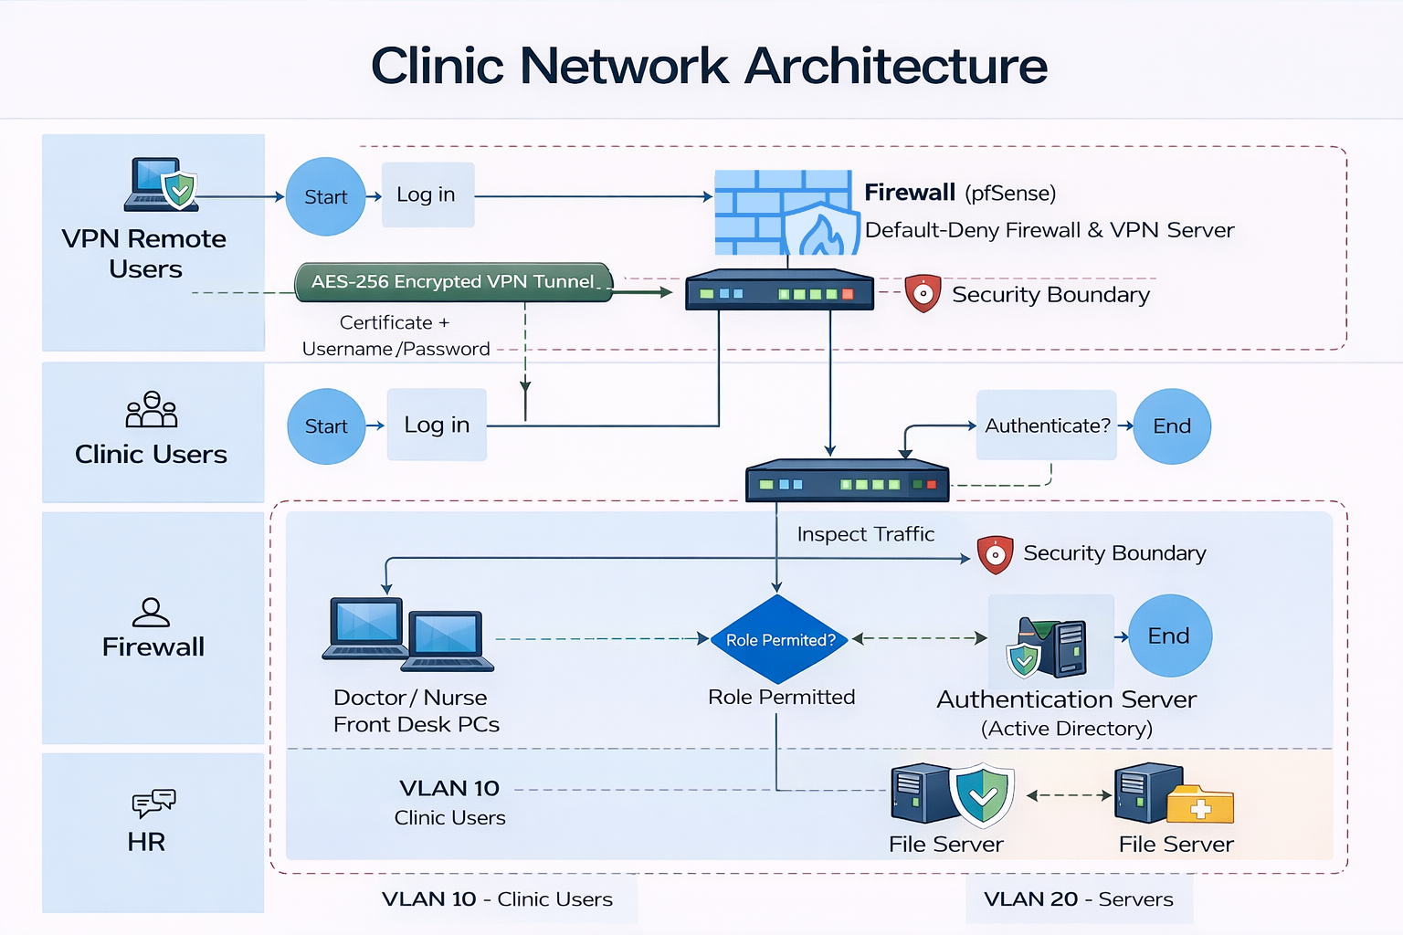This diagram illustrates the overall architecture of the Secure Clinic IT Infrastructure. Remote users securely connect to the clinic network through AES-256 encrypted OpenVPN tunnel, which terminates at the pfSense firewall. The firewall enforces a default deny policy and filters incoming traffic before allowing access to the internal network. Internal clinic users also authenticate through the secure network before accessing organizational resources. Authorized users are granted access only to the systems and shared resources required for their roles. The infrastructure separates workstations and servers into dedicated VLANS, improving network security by limiting unnecessary communication between devices.

Key Design Decisions
- Role-Based Access Control: Access permissions are assigned according to employee responsibilities, ensuring users can access only resources necessary to perform their job functions.
- Centralized Identity Management: Windows Server Active Directory provides centralized authentication, user management, and policy enforcement for all clinic employees.
- Network Segmentation: Separate VLANS for clinic workstations and servers reduce the attack surface, improve performance, and prevent unauthorized lateral movement across the network.
- Secure Remote Access: OpenVPN provides encrypted remote connectivity for authorized personal, allowing secure access to clinic resources while maintaining data confidentiality.
- Defense in Depth Security: Multiple security controls include VPN encryption, pfSense firewall, windows defender firewall, password policies, and account lockout work togethor to provide layer protection against cyber threats.

Implementation
This project was implemented using Microsoft Azure and Microsoft enterprise security services to create a secure, scalable, and cloud-managed healthcare IT environment. Azure Virtual Machines hosted the Windows Server environment, where Active Directory Domain Services provided centralized authentication, user management, and Role-Based Access Control. Microsoft Entra ID (formerly Azure Active Directory) was integrated to provide cloud identity management and Multi-Factor Authentication, while Microsoft Intune was used to enforce endpoint security policies and device compliance. Additional security controls, including Windows Defender Firewall, Azure networking, and OpenVPN, were configured to protect clinic resources and support secure remote access.

Technology Stack
Microsoft Azure | Clould platform used to host the clinic’s virtual infrastructure, networking, and virtual machines.
Azure virtual machines | Hosted Windows Server 2022 and provide infrastructure for Active Directory and network services.
Windows Server 2022 | Provide centralized server management, active directory domain services, and network administration.
Active Directory Domain Services | Manage user authentication, security groups, and role based access control.
Microsoft Entra ID | Provide cloud identity management, single sign-on, and multi-factor authentication.
Microsoft Intune | Manage endpoint security, device compliance, bitlocked encryption, and windows security policies.
OpenVPN | Provide encrypted remote access for authorized clinic employees.
Windows Defender Firewall | Protect servers and workstations by filtering inbound and outbound network traffic.
Azure Virtual Network | Connect Azure resources securely and isolate network traffic within the cloud environment.
Group Policy Management | Enforce password policies, account lockout settings, windows security configurations, and administrative restrictions.
PowerShell | Automated admin tasks and simplified server configuration and management.
Windows Event Viewer | Recored authentication events, policy changes, and security logs for monitoring and auditing.

Notable Challenges
Challenge 1: Configuring a Secure Azure Environment
One of the primary challenges was configuring the azure virtual machine and networking components to securely host the clinic infrastructure. The team configured azure virtual networks, network security settings, and virtual machine connectivity to ensure secure communication while allowing authorized remote administration. With testing, it confirmed that the cloud environment was accessible only through approved connections.
Challenge 2: Integrating Active Directory with Microsoft Entra ID
Another challenge involved integrating Active Directory Domain Services with Microsoft Entra ID to provide centralized identity management and secure authentication. The team configured users accounts, security groups, and multi-factor authentication to ensure users could securely access clinic resources while maintaining the principle of least privilege.
Challenge 3: Securing Remote Access and Validating Security Controls
Implementing secure remote access required configuring openVpn, windows defender firewall, password policies, account lockout settings, and endpoint security while maintaining usability for clinic staff. Extensive validation testing was performed to verify VPN connectivity, authentication, firewall rules, audit logging, and backup procedures. These tests were confirmed that the infrastructure provided secure access to clinic resources while protesting sensitive healthcare information.

Testing & Evaluation
This project was tested to verify that all security controls and system configurations function as intended. Testing focus on authentication, role based access control, firewall protection, VPN connectivity, endpoint security, and audit logging, Each feature was validated to ensure that authorized users could access required resources while unauthorized access attempts were blocked. Testing was performed throughout deployment to identify and resolve configuration issues. Security validation confirmed that the infrastructure met the projects functional and security requirements. Audit logs generated through windows event viewer were reviewed to confirm login attempts, policy changes, and securiy events were recorded correctly. With the successful completion of the tests the infrastructure provides a secure and manageable environement for clinic operations.

Test Summary
Test Case | Expected Result | Outcome
Active Directory User Login | Authorized users successfully authenticate | Passed
Role-Based Access Control | Users access only assigned resources | Passed
Password Complexity Policy | Weak passwords are rejected | Passed
Account Lockout Policy | Account locks after repeated failed login attempts | Passed
Multi-Factor Authentication | Second authentication factor required | Passed
VPN Connectivity | Authorized users establish secure remote connection | Passed
Windows Defender Firewall | Unauthorized traffic is blocked | Passed
Audit Logging | Security events recorded in Event Viewer | Passed
Backup Verification | Backup process completes successfully | Passed

Evaluation
The completed results has met the projects objectives by providing centralized identity management, secure remote access, layered network protection, and comprehensive security monitoring. Testing results confirmed that the implemented security controls effectively protected sensitive information while maintaining reliable access for authorized users, demonstrating the projects readiness for deployment in a small healthcare environment.

Deployment & Operations
The Secure Clinic Infrastructure is deployed in Microsoft Azure using azure virtualmachhines running windows server 2022. The environment includes Active Directory Domain Services for centralized authentication, microsfot entra ID for cloud identity management and multi-factor authentication, OpenVPN for secure remote access, and windows defender firewall to protect network resources. These components work together to provide a secure and reliable infrastructure for clinic operations.
Detailed installation, configuration, and deployment procedures are provided in the Deployment Guide included in the project ZIP package, allowing admins to deploy the infrastructure from a clean environment without repeating those steps in this document.

User Guide Summary
Clinic employees access the system by signing in with their assigned Active Directory credentials. Based on their role, users are granted secure access to the applications, shared folders, and network resources necessary to perform their job responsibilities. Authorized remote users connect to the clinic network through OpenVPN and complete Multi-Factor Authentication before accessing internal resources, ensuring secure communication and protecting sensitive patient information.
System administrators manage user accounts, security groups, password policies, and endpoint security through Active Directory, Microsoft Entra ID, and Microsoft Intune. A complete walkthrough of system features, administrative tasks, and user workflows is provided in the Configuration Doc included in the project ZIP package.

Security, Privacy & Ethics Considerations
This project was esigned to protect sensitive healthcare data through multiple layers of security. User authentication is managed through Active Directory Domain Services and Microsoft Entra ID, with Multi-Factor Authentication providing an additional layer of protection for remote access. Role-Based Access Control ensures that employees can access only the applications, files, and resources required for their job responsibilities. While Windows Defender Firewall, OpenVPN, and Microsoft Intune help secure the network, devices, and remote connections. Audit logs are maintained to record authentication attempts and security events, supporting accountability and system monitoring.
To protect privacy, the project was developed and tested using sample data only, with no real patient records or personally identifiable information. The system was designed with healthcare security best practices in mind, including support for HIPAA Security Rule requirements related to access control, data confidentiality, and audit logging. Ethical considerations included applying the principle of least privilege, safeguarding sensitive information from unauthorized access, and ensuring secure management of user accounts and devices. The infrastructure also supports accessibility through standard Windows authentication and management tools, allowing authorized users to securely access resources while maintaining compliance with organizational security policies.

Team & Contributions
Team Member | Primary Contributions
Sonali Mohammed | Led the implementation of the Microsoft Azure environment, including Azure Virtual Machines, Active Directory Domain Services (AD DS), Microsoft Entra ID, Microsoft Intune, and OpenVPN. Developed the Configuration Documentation, Deployment Guide, project artifacts, architecture diagrams, presentation slides, poster, and live demonstration materials. Coordinated system validation and ensured project documentation met capstone requirements.
Justin Barroso | Focused on identity and access management by configuring Active Directory users, Organizational Units (OUs), security groups, and Role-Based Access Control (RBAC). Assisted with configuring Group Policy Objects (GPOs), firewall policies, and validating security controls during system testing.
Demetrius Smith | Supported system implementation by assisting with infrastructure configuration, deployment testing, and troubleshooting. Contributed to project documentation, sprint artifacts, presentation preparation, and validation of system functionality to ensure all project objectives were achieved.
David Alonso | Assisted with system deployment, testing, and quality assurance by validating user authentication, VPN connectivity, firewall rules, password policies, and audit logging. Contributed to project documentation, sprint reviews, and verification that functional and security requirements were successfully implemented.
Santiago Ferreira Rolon | lead by coordinating sprint activities, managing project planning, and ensuring deliverables were completed on schedule. Assisted with system design, Azure infrastructure deployment, security testing, and reviewing technical documentation to ensure consistency across the project.

Appendices
The following supporting documents are included in the Documents folder of the project ZIP package. These documents provide additional technical details and supporting information for the Secure Clinic IT Infrastructure project.
Appendix A - Deployment Guide
The Deployment Guide provides the complete deployment process for the Secure Clinic IT Infrastructure. It includes system prerequisites, Azure Virtual Machine deployment, Active Directory configuration, Microsoft Entra ID integration, OpenVPN setup, firewall configuration, security validation procedures, rollback procedures, and post-deployment maintenance recommendations.
Appendix B - Configuration Documentation
The Configuration Documentation contains detailed configuration settings for the project's infrastructure components, including Microsoft Azure, Windows Server 2022, Active Directory Domain Services (AD DS), Microsoft Entra ID, Microsoft Intune, Group Policy Objects (GPOs), Windows Defender Firewall, OpenVPN, and security policies. It serves as the primary technical reference for configuring and maintaining the environment.
Appendix C - Capstone II Report
The Capstone II Report summarizes the planning, design, implementation, deployment, testing, and evaluation of the Secure Clinic IT Infrastructure project. It documents the system architecture, technology stack, deployment strategy, security considerations, testing results, team contributions, and overall project outcomes, providing a comprehensive overview of the completed capstone project.

