Bug Reports
Single Bet Placement • 19 defects • Tested 12–14 Oct 2026
Environment (all bugs): https://qae-assignment-tau.vercel.app, Version 1.0.0, Chrome desktop, user candidate-xSp96raeSVIF
Severity = how bad the impact is. Priority = how soon it should be fixed (P1 first).

Bug Summary
Bug ID | Title | Module | Severity | Priority | Test Case
BUG-01 | User can bet more than their balance; balance goes negative | Place Bet API / Bet Slip | Critical | P1 | TC-11, TC-12
BUG-02 | Negative stake is accepted and adds money to balance | Place Bet API | Critical | P1 | TC-28
BUG-03 | Clicking Place Bet quickly places the same bet more than once | Bet Slip | High | P1 | TC-08
BUG-17 | Rebet after a lost response charges the user twice | Error Popup | High | P1 | TC-35
BUG-06 | Past matches are shown as upcoming and accept bets | Match List / Place Bet API | High | P1 | TC-36, TC-37, TC-38
BUG-04 | Receipt shows wrong potential payout | Success Receipt | High | P2 | TC-04
BUG-05 | Receipt shows team names in reverse order | Success Receipt | High | P2 | TC-04
BUG-07 | Reset balance response does not match saved balance | Reset Balance API | High | P2 | TC-54
BUG-08 | Header balance not updated after placing a bet | Header / Bet Slip | Medium | P2 | TC-06
BUG-16 | Server payout is rounded down, does not match bet slip | Place Bet API | Medium | P2 | TC-09
BUG-09 | Place bet response shows currency USD instead of EUR | Place Bet API | Medium | P3 | TC-53
BUG-10 | Odds filter allows Min greater than Max | Odds Filter | Medium | P3 | TC-39
BUG-11 | Odds filter does not include the Min value | Odds Filter | Medium | P3 | TC-40, TC-41
BUG-12 | Broken JSON body returns 500 instead of 400 | Place Bet API | Medium | P3 | TC-51
BUG-13 | Match count does not change after filtering | Match List | Low | P4 | TC-42
BUG-14 | GET /api/place-bet returns 200 instead of 405 | Place Bet API | Low | P4 | TC-50
BUG-15 | Receipt does not show selection; bet slip hides balance | Success Receipt / Bet Slip | Low | P4 | TC-04
BUG-18 | Stake field accepts very long numbers | Bet Slip | Low | P4 | TC-21
BUG-19 | Negative balance shown as "€-42.00" | Header | Low | P4 | TC-12

All API steps below use these values:
BASE=https://qae-assignment-tau.vercel.app
USER=candidate-xSp96raeSVIF
Use any upcoming match id from GET $BASE/api/matches. The ids below are the ones used during testing.

BUG-01: User can bet more than their balance; balance goes negative
Bug ID | BUG-01
Module | Place Bet API, Bet Slip
Severity | Critical
Priority | P1
Status | Open
Pre-condition | Balance is €30.00
Steps to Reproduce (API) | 1. Reset balance and place bets until GET /api/balance shows 30  2. Send a bet with stake 40:  curl -X POST $BASE/api/place-bet -H "x-user-id: $USER" -H "Content-Type: application/json" -d '{"matchId":"ligue-1-monaco-lyon-2026-10-14","selection":"HOME","stake":40}'  3. Check GET /api/balance
Steps to Reproduce (UI) | 1. Reset balance and open the app in Tab A (shows €120.00)  2. In Tab B (or by API) spend €112, so the real balance is €8  3. In Tab A select LAFC vs Inter Miami "2", enter stake 50  4. Click Place Bet
Expected Result | Bet rejected with "Insufficient balance". Balance stays the same.
Actual Result | API: 200 "Bet placed successfully", balance becomes −€10.00.  UI: Place Bet button is enabled, bet is placed (receipt #B-77201), balance becomes −€42.00.
Impact | Users can bet money they do not have. The business loses money. The UI check alone is not enough because it uses an old balance and can be bypassed.
Attachments | evidence/05_ui_insufficient_balance.jpg (UI blocks it when balance is fresh)  evidence/08_ui_bet_accepted_with_stale_balance.jpg (bet accepted with €8 balance)
Screenshots | 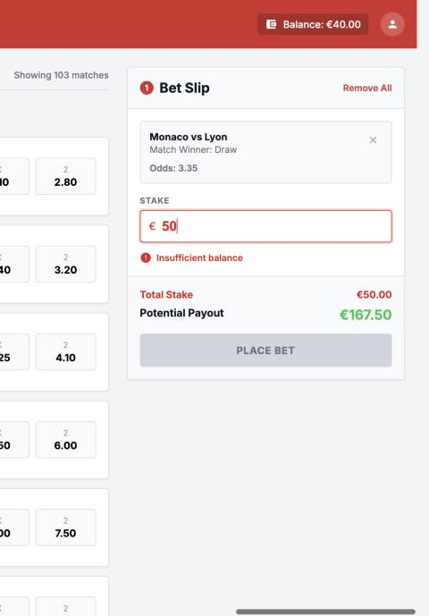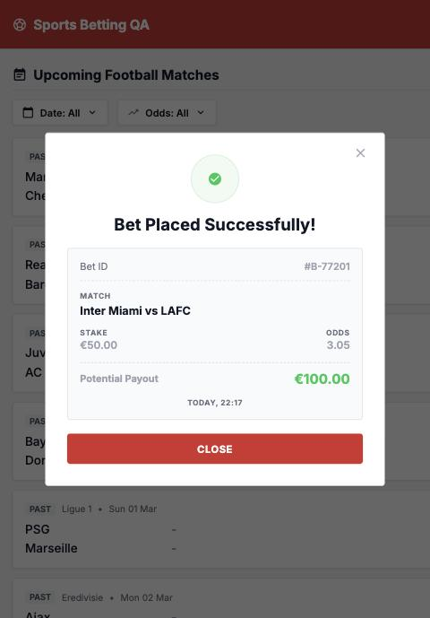  05_ui_insufficient_balance.jpg | 08_ui_bet_accepted_with_stale_balance.jpg

BUG-02: Negative stake is accepted and adds money to balance
Bug ID | BUG-02
Module | Place Bet API
Severity | Critical
Priority | P1
Status | Open
Pre-condition | Balance is €120.00
Steps to Reproduce | 1. curl -X POST $BASE/api/place-bet -H "x-user-id: $USER" -H "Content-Type: application/json" -d '{"matchId":"ligue-1-monaco-lyon-2026-10-14","selection":"HOME","stake":-5}'  2. Check GET /api/balance
Expected Result | 422 invalid_stake_min. Balance stays €120.00.
Actual Result | 200 "Bet placed successfully", "payout": -10.75. Balance becomes €125.00 (increased by €5). Stake -0.5 is also accepted.
Impact | Anyone can add unlimited money to their balance by sending negative stakes.
Attachments | Response: {"stake":-5,"payout":-10.75,"balance":125,...}

BUG-03: Clicking Place Bet quickly places the same bet more than once
Bug ID | BUG-03
Module | Bet Slip
Severity | High
Priority | P1
Status | Open
Pre-condition | Balance €27.00
Steps to Reproduce | 1. Select Feyenoord vs PSV "1"  2. Enter stake 2  3. Open DevTools > Network  4. Click Place Bet 3 times very quickly  5. Check Network tab and balance
Expected Result | Button is disabled after the first click. Only one bet is placed. Balance €25.00.
Actual Result | Button stays clickable while showing "Placing...". 3 requests sent: 200, 200, 409. Two bets placed. Balance €23.00. Only one receipt is shown.  Re-test on 14 Oct: 3 quick clicks placed 3 bets (€6 taken, balance €120 → €114), still only one receipt.
Impact | User is charged twice and does not see the second bet.
Attachments | evidence/10_bug03_quick_clicks_multiple_bets.jpg (3 requests all 200, one receipt shown)
Screenshots | 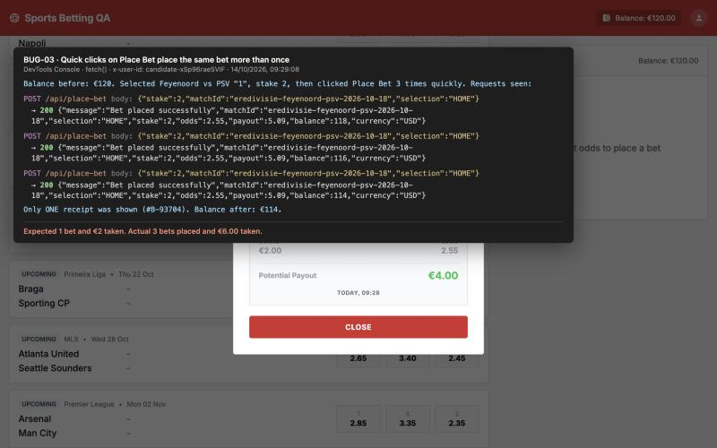  10_bug03_quick_clicks_multiple_bets.jpg

BUG-17: Rebet after a lost response charges the user twice
Bug ID | BUG-17
Module | Error Popup / Place Bet API
Severity | High
Priority | P1
Status | Open
Pre-condition | Note the starting balance. A way to replace the response (DevTools "Override content", or a fetch override in Console)
Steps to Reproduce | 1. Set up an override so the first POST /api/place-bet reaches the server, but the browser receives a 504 error instead of the real response  2. Select Braga vs Sporting CP "1", stake 5, click Place Bet  3. Error popup appears. Check GET /api/balance: already €5 less (server accepted the bet)  4. Click Rebet  5. Check balance again
Expected Result | Only one bet. Balance reduced by €5 in total.
Actual Result | Rebet creates a second bet. Balance reduced by €10 in total for one €5 bet.
Impact | On slow or unstable networks, users who follow the "try again" message are charged twice. The request has no unique id, so the server cannot detect the repeat.
Attachments | evidence/11_bug17_error_popup_but_bet_taken.jpg (error popup shown while the server had already taken €5). Both server responses were 200.
Screenshots | 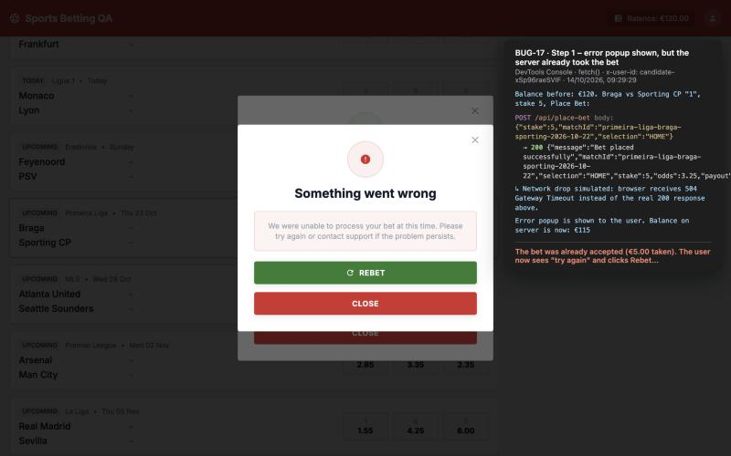  11_bug17_error_popup_but_bet_taken.jpg

BUG-06: Past matches are shown as upcoming and accept bets
Bug ID | BUG-06
Module | Match List, Place Bet API
Severity | High
Priority | P1
Status | Open
Pre-condition | Today is 12 Oct 2026
Steps to Reproduce | 1. Open the app. Check the list under "Upcoming Football Matches"  2. Select Juventus vs AC Milan (Sun 01 Mar, tag "PAST") "2", stake 3, Place Bet  3. API: curl -X POST $BASE/api/place-bet -H "x-user-id: $USER" -H "Content-Type: application/json" -d '{"matchId":"premier-league-manutd-chelsea","selection":"HOME","stake":1}'
Expected Result | Only upcoming matches are listed. Bets on past matches are rejected.
Actual Result | 83 of 103 matches are in the past and their odds can be clicked. UI bet placed (receipt #B-17930). API returns 200.
Impact | Users can bet on matches that have already been played and whose result is known.
Attachments | evidence/04_receipt_past_match_payout.jpg
Screenshots | 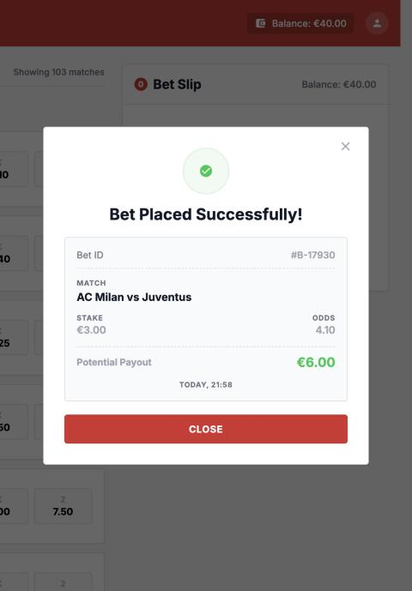  04_receipt_past_match_payout.jpg

BUG-04: Receipt shows wrong potential payout
Bug ID | BUG-04
Module | Success Receipt
Severity | High
Priority | P2
Status | Open
Steps to Reproduce | 1. Select Monaco vs Lyon "1" (odds 2.15)  2. Enter stake 10. Bet slip shows Potential Payout €21.50  3. Click Place Bet  4. Check payout on the receipt
Expected Result | Receipt payout €21.50 (10 × 2.15), same as the bet slip and the API.
Actual Result | Receipt shows €20.00. The receipt always shows stake × 2:  – €10 at 3.35 → €20.00 (should be €33.50)  – €3 at 4.10 → €6.00 (should be €12.30)
Impact | The user's bet record is wrong. This will cause complaints when bets are settled.
Attachments | evidence/01_bet_slip_before_placement.jpg (slip €21.50)  evidence/03_receipt_wrong_payout_and_teams.jpg (receipt €20.00)
Screenshots | 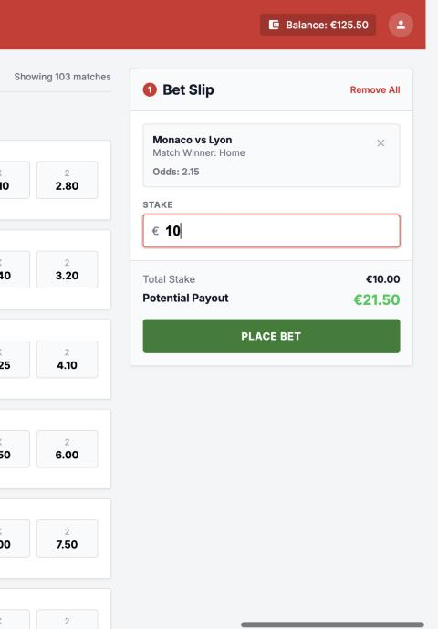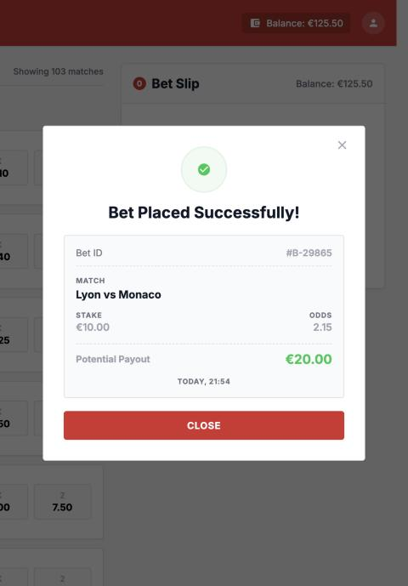  01_bet_slip_before_placement.jpg | 03_receipt_wrong_payout_and_teams.jpg

BUG-05: Receipt shows team names in reverse order
Bug ID | BUG-05
Module | Success Receipt
Severity | High
Priority | P2
Status | Open
Steps to Reproduce | 1. Select Monaco vs Lyon (Monaco is home)  2. Enter stake and place the bet  3. Check match name on receipt
Expected Result | "Monaco vs Lyon" (home team first, same as the list and bet slip)
Actual Result | "Lyon vs Monaco". Same for Juventus vs AC Milan ("AC Milan vs Juventus") and Feyenoord vs PSV ("PSV vs Feyenoord").
Impact | With "Match Winner: Home", the user cannot tell which team they bet on.
Attachments | evidence/03_receipt_wrong_payout_and_teams.jpg
Screenshots | 03_receipt_wrong_payout_and_teams.jpg

BUG-07: Reset balance response does not match saved balance
Bug ID | BUG-07
Module | Reset Balance API
Severity | High
Priority | P2
Status | Open
Steps to Reproduce | 1. curl -X POST $BASE/api/reset-balance -H "x-user-id: $USER"  2. curl $BASE/api/balance -H "x-user-id: $USER"
Expected Result | Both show the same balance (€125.50).
Actual Result | Reset response: "balance": 125.5. Balance API: "balance": 120. Happened 5 out of 5 times.
Impact | Any screen or tool that trusts the reset response shows the wrong balance. Test setup cannot rely on a known starting balance.
Attachments | API responses above

BUG-08: Header balance not updated after placing a bet
Bug ID | BUG-08
Module | Header, Bet Slip
Severity | Medium
Priority | P2
Status | Open
Steps to Reproduce | 1. Note header balance (€125.50)  2. Place a €10 bet and close the receipt  3. Check header and bet slip balance
Expected Result | Both show €115.50.
Actual Result | Both still show €125.50. GET /api/balance returns 115.50. Correct value appears only after page reload.
Impact | User thinks they have more money than they do. It also causes BUG-01 in the UI.
Attachments | evidence/03_receipt_wrong_payout_and_teams.jpg (header shows €125.50 behind the receipt)
Screenshots | 03_receipt_wrong_payout_and_teams.jpg

BUG-16: Server payout is rounded down, does not match bet slip
Bug ID | BUG-16
Module | Place Bet API
Severity | Medium
Priority | P2
Status | Open
Steps to Reproduce | 1. In UI select Monaco vs Lyon "1" (odds 2.15), enter stake 1.05. Slip shows €2.26  2. curl -X POST $BASE/api/place-bet -H "x-user-id: $USER" -H "Content-Type: application/json" -d '{"matchId":"ligue-1-monaco-lyon-2026-10-14","selection":"HOME","stake":1.05}'  3. Compare payout
Test Data | 1.05 × 2.15 = 2.2575
Expected Result | Server payout €2.26, same as slip
Actual Result | Server payout €2.25. More examples (server vs slip):  1.05 × 3.35 → 3.51 vs 3.52  33.33 × 2.15 → 71.65 vs 71.66  7.77 × 2.15 → 16.70 vs 16.71
Impact | User is shown one payout but the server saves a lower one. Small per bet, but happens on many bets.
Attachments | API responses above

BUG-09: Place bet response shows currency USD instead of EUR
Bug ID | BUG-09
Module | Place Bet API
Severity | Medium
Priority | P3
Status | Open
Steps to Reproduce | 1. Place any valid bet via API or UI  2. Check the response in Network tab
Expected Result | "currency": "EUR" (balance API returns EUR)
Actual Result | "currency": "USD" on every successful bet
Impact | Any screen or report using this field will show the wrong currency.
Attachments | {"message":"Bet placed successfully",...,"balance":115.5,"currency":"USD"}

BUG-10: Odds filter allows Min greater than Max
Bug ID | BUG-10
Module | Odds Filter
Severity | Medium
Priority | P3
Status | Open
Steps to Reproduce | 1. Click "Odds: All"  2. Enter Min 5 and Max 2  3. Click Apply
Expected Result | Validation message is shown and Apply is blocked.
Actual Result | No message. Filter is applied ("Odds: 5.00 - 2.00"). Match list is empty with no "no results" message.
Impact | User sees an empty page and may think there are no matches.
Attachments | evidence/06_odds_filter_min_gt_max.jpg, evidence/07_odds_filter_blank_list.jpg
Screenshots | 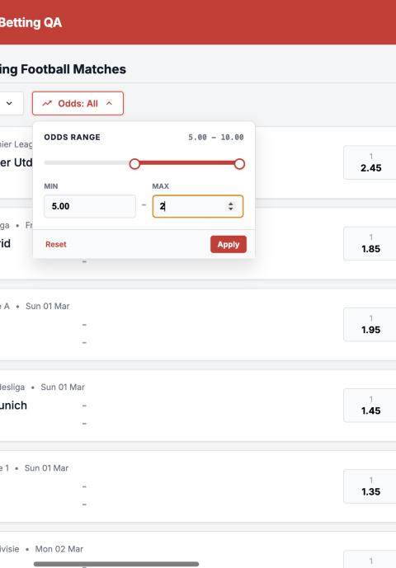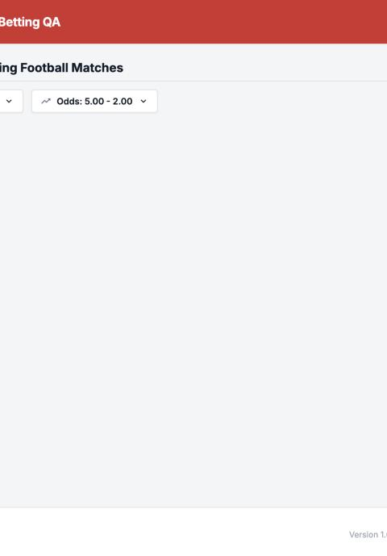  06_odds_filter_min_gt_max.jpg | 07_odds_filter_blank_list.jpg

BUG-11: Odds filter does not include the Min value
Bug ID | BUG-11
Module | Odds Filter
Severity | Medium
Priority | P3
Status | Open
Steps to Reproduce | 1. Set odds filter Min 4.50, Max 4.50, Apply  2. Set odds filter Min 4.40, Max 4.60, Apply  3. Compare with GET /api/matches
Expected Result | Step 1: Bayern Munich vs Dortmund shown (draw odds 4.50).  Step 2: all 7 matches with any odds between 4.40 and 4.60 shown.
Actual Result | Step 1: 0 matches.  Step 2: only 3 matches. The 4 missing matches all have odds exactly 4.40. The Max value is included, but the Min value is not.
Impact | Users miss matches at the edge of their search.
Attachments | evidence/14_bug11_bug13_odds_filter_4_50.jpg (filter 4.50 – 4.50 shows no matches)
Screenshots | 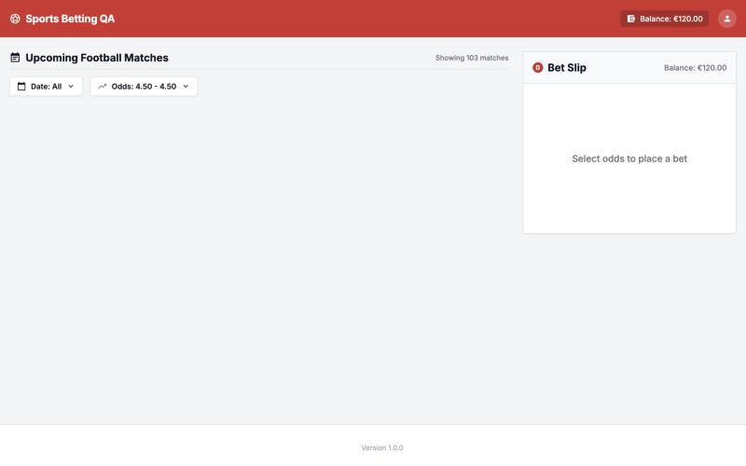  14_bug11_bug13_odds_filter_4_50.jpg

BUG-12: Broken JSON body returns 500 instead of 400
Bug ID | BUG-12
Module | Place Bet API
Severity | Medium
Priority | P3
Status | Open
Steps to Reproduce | curl -X POST $BASE/api/place-bet -H "x-user-id: $USER" -H "Content-Type: application/json" -d '{"matchId":'
Expected Result | 400 {"error":"invalid_json","message":"Malformed JSON body."} (as in API docs)
Actual Result | 500 {"error":"internal_server_error"}
Impact | A user mistake is reported as a server failure. This creates false alerts for the team.
Attachments | –

BUG-13: Match count does not change after filtering
Bug ID | BUG-13
Module | Match List
Severity | Low
Priority | P4
Status | Open
Steps to Reproduce | 1. Set Date filter to 14/10/2026, Apply  2. Check the count text next to the title
Expected Result | "Showing 1 match"
Actual Result | "Showing 103 matches" (1 card visible). Same for every filter.
Impact | Misleading text.
Attachments | evidence/14_bug11_bug13_odds_filter_4_50.jpg (0 cards on screen, text still says "Showing 103 matches")
Screenshots | 14_bug11_bug13_odds_filter_4_50.jpg

BUG-14: GET /api/place-bet returns 200 instead of 405
Bug ID | BUG-14
Module | Place Bet API
Severity | Low
Priority | P4
Status | Open
Steps to Reproduce | curl $BASE/api/place-bet -H "x-user-id: $USER"
Expected Result | 405 {"error":"method_not_allowed"} (PUT, PATCH, DELETE already return 405)
Actual Result | 200 {}
Impact | API does not follow its own contract.
Attachments | –

BUG-15: Receipt does not show selection; bet slip hides balance
Bug ID | BUG-15
Module | Success Receipt, Bet Slip
Severity | Low
Priority | P4
Status | Open
Steps to Reproduce | 1. Check bet slip with no selection: shows "Balance: €x"  2. Click any odds: balance disappears from the slip  3. Place the bet and check the receipt
Expected Result | Bet slip shows available balance. Receipt shows the selection (Home / Draw / Away), as per spec.
Actual Result | Balance hidden once a selection is added. Receipt has no selection field.
Impact | Less information for the user when deciding and on their bet record.
Attachments | evidence/01_bet_slip_before_placement.jpg, evidence/03_receipt_wrong_payout_and_teams.jpg
Screenshots | 01_bet_slip_before_placement.jpg | 03_receipt_wrong_payout_and_teams.jpg

BUG-18: Stake field accepts very long numbers
Bug ID | BUG-18
Module | Bet Slip
Severity | Low
Priority | P4
Status | Open
Steps to Reproduce | 1. Select any odds  2. Type 99999999999999999999 in Stake
Expected Result | Field length is limited. Totals are shown correctly.
Actual Result | "Maximum stake" error shown and button disabled (correct). But Total Stake shows €100000000000000000000.00 and Potential Payout €254999999999999967232.00 (wrong digits).
Impact | Looks broken. Shows that the UI uses imprecise number maths for money.
Attachments | evidence/12_bug18_very_long_stake.jpg
Screenshots | 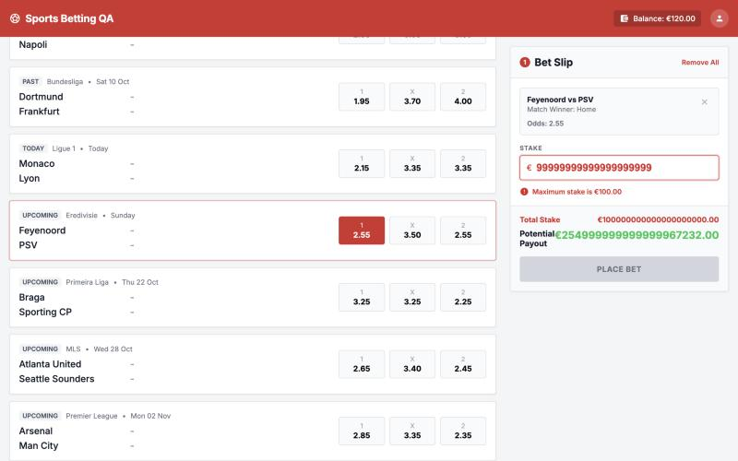  12_bug18_very_long_stake.jpg

BUG-19: Negative balance shown as "€-42.00"
Bug ID | BUG-19
Module | Header
Severity | Low
Priority | P4
Status | Open
Steps to Reproduce | 1. Make balance negative (see BUG-01)  2. Reload the page
Expected Result | Balance can never be negative. If shown, the format should be "−€42.00".
Actual Result | "Balance: €-42.00" (12 Oct) and "Balance: €-10.00" (re-test 14 Oct) in the header and bet slip
Impact | Confusing display. Will go away when BUG-01 is fixed.
Attachments | evidence/13_bug19_negative_balance_header.jpg
Screenshots | 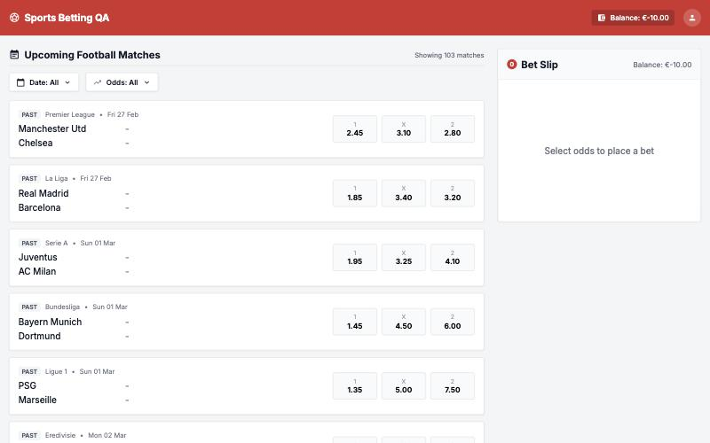  13_bug19_negative_balance_header.jpg

Other Observations (not logged as bugs)
- The match list is not sorted by date, and the 20 upcoming matches appear after 83 past matches. The spec does not say how the list should be sorted, so this is a question for the product team.
- The API accepts Content-Type: text/plain and JSON with repeated keys. Not wrong, but could be stricter.
- Clicking a different odds button replaces the selection and clears the stake. Clicking the same button again does nothing. This looks fine for single bets.

