Version 1.0

Updated May 25th, 2015

Addendum for Running AgMIP Climate Scenario Generation Tools with R

in Windows

*This Addendum explains how to produce climate metrics from the climate series and climate change scenarios created by the R scripts outlined in version 2.1 of the Guide for Running AgMIP Climate Scenario Generation Tools with R. This Addendum follows the AgMIP Climate team’s methodology as outlined in the AgMIP Guide for Regional Integrated Assessment: Handbook of Methods and Procedures (both documents available for download at* ***www.agmip.org****)*

Details how to:

* Calculate seasonal and/or yearly climate metrics from .AgMIP file(s)
* Create scatter plots of temperature and precipitation changes from GCM outputs
* Help determine which GCM is representative of desired climate scenarios

The Addendum also outlines a workflow that can be modified for application to your own climate data.

This Addendum presents a preliminary workflow for calculating metrics and will be incorporated in subsequent versions of the Guide. The methods and scenarios here are intended for AgMIP research and may not be suitable for other applications. Please contact Alex Ruane ([**alexander.c.ruane@nasa.gov**](mailto:alexander.c.ruane@nasa.gov)) if you have any questions or comments.

By John Simmons (**jms2402@columbia.edu**), Columbia University

and Alex Ruane ([**alexander.c.ruane@nasa.gov**](mailto:alexander.c.ruane@nasa.gov)), NASA Goddard Institute for Space Studies

**Contents**

1. **Background**
2. **Getting Started**
3. **Place files into correct location within folder hierarchy**
4. **Producing climate metrics with “run_acr_agmip2metrics.R”**
5. **Explanation of input variables to be changed in the run scripts**
6. **Suggested workflow for run_acr_agmip2metrics.R**
7. **Next Steps…**

# Background

Version 1.0 of this Addendum for Running AgMIP Climate Scenario Generation Tools with R provides a detailed explanation for running “run_agmip_CMIP5_TandP.R”. This Addendum requires the use of the most recent versions of both “run_agmip_CMIP5_TandP.R” and “agmip_CMIP5_TandP.R” If you did not receive these two scripts with this Addendum, please contact Alexander Ruane ([**alexander.c.ruane@nasa.gov**](mailto:alexander.c.ruane@nasa.gov)**)** for the most up-to-date versions of the scripts.

This Addendum assumes you have:

* Properly installed R
* Created the folder hierarchy housing the necessary scripts and data in the proper locations
* Produced climate series and/or climate change scenarios in the .AgMIP format

For further information on how to do any of the above steps, please see version 2.1 of the Guide for Running AgMIP Climate Scenario Generation Tools with R in Windows.

# Getting Started

This section explains where to save the new scripts “run_agmip_CMIP5_TandP.R” and “agmip_CMIP5_TandP.R” to properly produce visualizations from CMIP5 GCM outputs.

## Place files into correct location within folder hierarchy

With this Addendum, you should have received the most up-to-date versions of “run_agmip_CMIP5_TandP.R” and “agmip_CMIP5_TandP.R” Place these files into the “r” folder with the path “~/R/r/”. If you have set your folder hierarchy up correctly, you should see a number of other R scripts in this folder as well.

Before we begin, you should also confirm that your .AgMIP files, for which you would like to produce plots, are located in “~/R/data/Climate/Historical/”.

# Producing climate metrics with “run_acr_agmip2metrics.R”

After placing the new versions of “run_agmip_CMIP5_TandP.R” and “agmip_CMIP5_TandP.R” into “~/R/r/” and confirming the presence of your .AgMIP files in “~/R/data/Climate/Historical/”, you are ready to **create the visualization**.

The following section will:

1. Explain the input variables that will be modified for each of the run scripts
2. Outline a potential workflow for sourcing “run_agmip_CMIP5_TandP.R”

## Explanation of input variables to be changed in the run scripts

The input variables are used to set the parameters of the analysis as well as define the metrics you wish to produce. The next few pages describe the input variables that you will be required to adjust prior to sourcing the run scripts.

**rootDir** – This variable sets the location, or root directory, of your “~/R/” folder. If you created the recommended folder structure, defining this variable is straightforward. There is a line in every run script that reads:

rootDir <- '*** your directory here ***\\R\\'

Simply replace the text “*** your directory here***” with the location of your newly created R directory in the script using double forward slashes (\\) to separate folders. For example, if the location of the R folder is

C:\Users\Your Name Here\Desktop\R\

then the **rootDir** should look as follows

rootDir <- 'C:\\Users\\Your Name Here\\Desktop\\R\\'

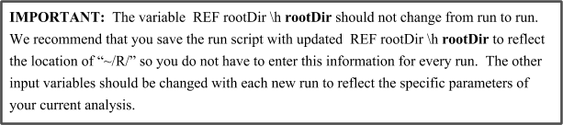

**figDir** – This variable sets the location, of the ultimate plots produced by the script.

**shortname –** 4 digit identifier used for the particular region of interest. Specifically, the first 2 digits are an abbreviation for the country, which can be found at the website <[**http://www.web-l.com/country-codes/**](http://www.web-l.com/country-codes/)>, while the second 2 digits refer to the specific site location and are up to you to assign. Example:

shortname = ‘USAM’

**stnname –** full name of your particular region of interest. Example

stnname = ‘Ames, Iowa’

**stnlat --** Latitude location of region of interest. Possible values range from 90°N (South Pole) to 90°N (North Pole). Example:

stnlat = 42.107

**stnlon –** Same as **stnlat** but with longitude. This variable should be defined in terms of degrees East such that 90°W should be entered either as -90°E or as 270°E. Example:

stnlon = -93.750

**mmstart –** Identifies the beginning of season of interest.Possible values range from 1 (January) to 12 (December).

**mmend –** Identifies the ending of season of interest.Possible values range from 1 (January) to 12 (December). The example below includes the entire year in the analysis:

mmstart = 1

mmend = 12

**thisrcp –** Identifies the Representative Concentration Pathway, or emissions pathway scenario of interest for the analysis. Possible values include ‘rcp4.5’ and ‘rcp85’, where each number represents the additional radiative forcing (in $W/M^{2})$ after 2100. The identifier ‘rcp85’ represents the greatest amount of global change.

**thisfut –** Identifies the 30 year future time period considered in the GCM analysis. Possible values include ‘near’, ‘mid’, and ‘end’, signifying different periods in the 21st century. The following example selects the midcentury (2040-2070) climate conditions assuming the RCP8.5 (most severe) emissions pathway:

thisrcp = ‘rcp85’

thisfut = ‘mid’

**Basefile –** Indicate the presence or absence of a baseline .AgMIP file created utilizing the enabled macro and located in“~/R/data/Climate/Historical” in the directory hierarchy (as described in the Guide for Running AgMIP Climate Scenario Generation with R v2.1). A ‘1’ indicates the presence of a basefile, while ‘0’ indicates that it does not yet exist. An analysis with a baseline will deliver more precise precipitation changes.

Basefile = 1

**Tmin –** Indicates the minimum temperature change to be shown on the scatter plot. If set to ‘NaN,’ outputs will be plotted using defaults**.**

**Tmax –** Indicates the maximum temperature change to be shown on the scatter plot. If set to ‘NaN,’ outputs will be plotted using defaults.

**Pmin –** Indicates the minimum precipitation change to be shown on the scatter plot. If set to ‘NaN,’ outputs will be plotted using defaults.

**Pmax –** Indicates the maximum precipitation change to be shown on the scatter plot. If set to ‘NaN,’ outputs will be plotted using defaults.

Tmin = NaN

Tmax = NaN

Pmin = NaN

Pmax = NaN

## Suggested workflow for run_agmip_CMIP5_TandP.R

The run script “run_agmip_CMIP5_TandP.R” produces a plot of temperature and precipitation changes for each of the CMIP5 Global Climate models for a specified future time period, season and emissions scenario. The results will be colored by categories with the following specifications.

Cool and Wet: **Green**

Cool and Dry: **Blue**

Hot and Wet: **Yellow**

Hot and Dry: **Red**

Middle: **Black**

The medians of each category will be represented by a filled circle of the same color.

Each climate model is represented as a letter in the following way:

|  |  |
| --- | --- |
| A = ACCESS1-0 | |
| B = bcc-csm1-1 | |
| C = BNU-ESM | |
| D = CanESM2 | |
| E = CCSM4 |  |
| F = CESM1-BGC | |
| G = CSIRO-Mk3-6-0 | |
| H = GFDL-ESM2G | |
| I = GFDL-ESM2M | |
| J = HadGEM2-CC | |
| K = HadGEM2-ES | |
| L = inmcm4 |  |
| M = IPSL-CM5A-LR | |
| N = IPSL-CM5A-MR | |
| O = MIROC5 | |
| P = MIROC-ESM | |
| Q = MPI-ESM-LR | |
| R = MPI-ESM-MR | |
| S = MRI-CGCM3 | |
| T = NorESM1-M | |

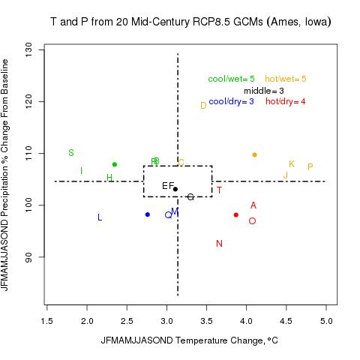

The workflow is fairly simple if you have placed all of the files in the correct location as described in **Creating folders for R scripts and input data** (from the Guide for Running AgMIP Climate Scenario Generation with R v2.1). To run the script, all you will have to do is define a few input variables prior to each run and the plot should be saved to your Figure Directory shortly.

To run this script,

1. Open R and then open the run script “run_agmip_CMIP5_TandP.R” to edit the input variables. You could also edit the run script in a text editor if you prefer.
2. Change the **rootDir** to reflect the location of the “R” folder. Specify a **figDir** to save the plots.
3. Save the updated run script as your template “run_agmip_CMIP5_TandP.R” script.
4. Adjust the input variables **shortname, stnname, stnlat, stnlon, mmstart, mmend, thisrcp,** and **thisfut** to reflect the specifications you would like the script to visualize. It is especially important to consider the growing season importance.
5. Confirm the presence of your baseline file, “****0XXX.AgMIP” in “~/R/data/Climate/Historical/”, and adjust the variable **Basefile** accordingly
6. Save the amended script with a unique name (for example, “run_agmip_CMIP5_TandP.R *USAM*_mid85.R” or “run_agmip_CMIP5_TandP.R_USAM_Jul_Sep.R”) to “~/R/r/”.
7. Source (run) the script from the R Console.
8. As the output of each Climate Model is analyzed, the number (1-20) of each model will be displayed in the R Console.
9. After the script has completed, the plot similar to above will appear, allowing the user to select individual climate models most representative of Cool/Wet, Cool/Dry, Hot/Wet, and Hot/Dry scenarios respectively.
10. The plot will automatically appear in the specified **figDir** with a specifying the **shortname**, **thisrcp**, **thisfut** and **Baseline** variables.

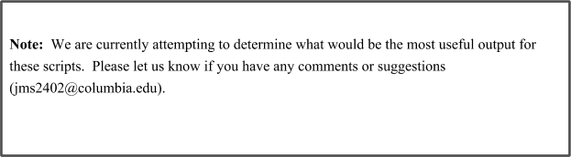

# Next Steps…

This concludes Version 1.0 of the Addendum for Running AgMIP Climate Scenario Generation Tools with R in Windows. We will be expanding this Addendum in the future to include other climate series and climate change scenario evaluation tools. Your feedback is helpful and we appreciate any suggestions or recommendations you may have to improve these tools.

If you have further questions, contact please feel free to contact John Simmons at [**jms2402@columbia.edu**](mailto:jms2402@columbia.edu)**.**

Thanks again for your collaboration and good luck with R!