Cluster formation

|  |
| --- |
| **/*20 Cluster run of FASTCLUS*/**  **libname census "/folders/myfolders/census";**  **proc fastclus data=census.psam_h17_subset1**  **radius=0 replace=full**  **converge=0 maxiter=200**  **maxclusters=20**  **OUTSTAT=census.psam_h17_subset1_20clusters_stat**  **OUT=census.psam_h17_subset1_20clusters**  **distance;**  **id SERIALNO;**  **var VALP HINCP;**  **run;**  **proc sgplot;**  **scatter y=HINCP x=VALP / group=cluster;**  **title ’ACS PUMS 2013 1 YR 20-Cluster Analysis’;**  **title2 ’of Data Containing Property Value and Household Income’;**  **run;** |

Created tables for each cluster

|  |  |
| --- | --- |
| **%macro sqlloop;**  **proc sql;**  **/*Loop through 20 times to create a table for each cluster*/**  **%DO k=1 %TO 20;**  **create table census.psam_h17_subset1_cluster_agg&k. as**  **select \***  **from census.psam_h17_subset1_20clusters_agg**  **where CLUSTER=&k.;**  **%END;**  **QUIT;**  **%mend;**  **%sqlloop;**  **For all vaiabls**   |  | | --- | | **/*Join additional variables from psam_h17 table for profiling*/**  **proc sql;**  **title '20 Cluster aggregated information for profiling';**  **create table census.psam_h17_subset1_20clusters_agg as**  **select a.SERIALNO, a.CLUSTER, a.DISTANCE, a.HINCP, a.VALP, a.TAXP,**  **b.MV, b.SMX, b.WORKSTAT, b.WIF**  **from census.psam_h17_subset1_20clusters as a left join census.psam_h17 as b**  **on a.SERIALNO=b.SERIALNO;**  **run;** |   Cluster 20 -  TAX distribution |

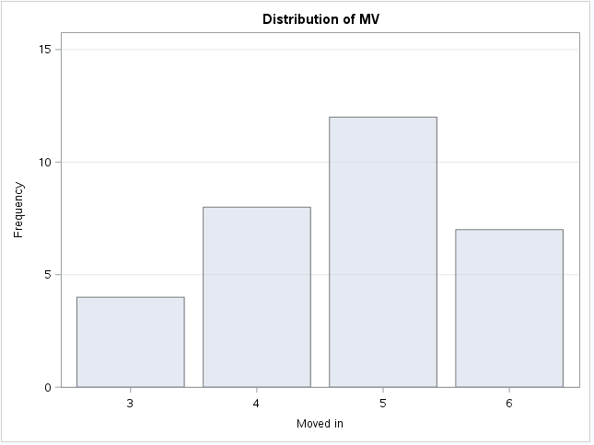

5 - 10 to 19 years

aaround 39% of total

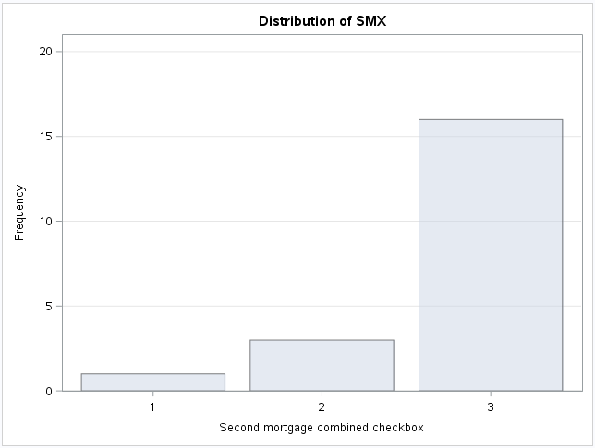

3 - No second mortgage

80% of total

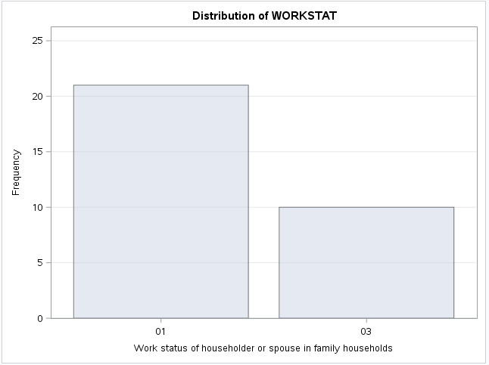

1- both employed

68%

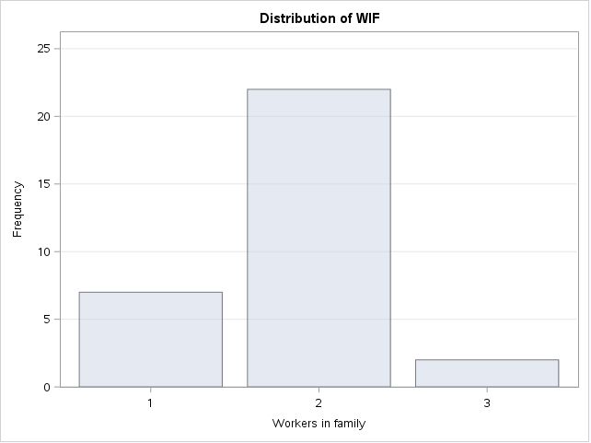

2- workers in family

71%

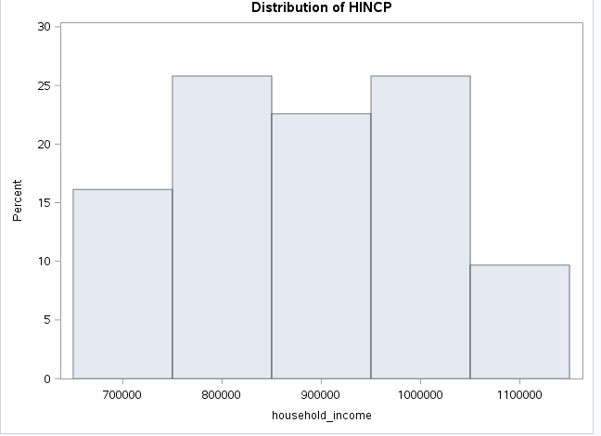

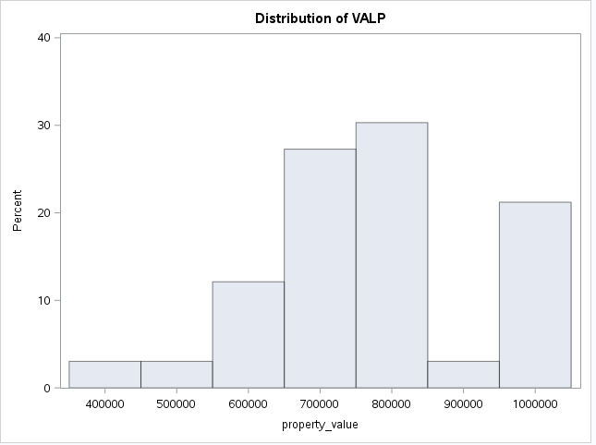

Cluster 1

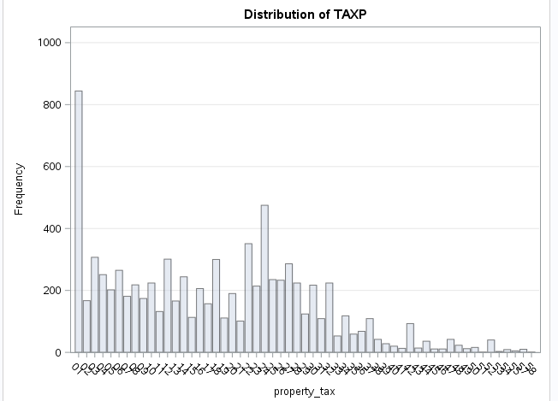

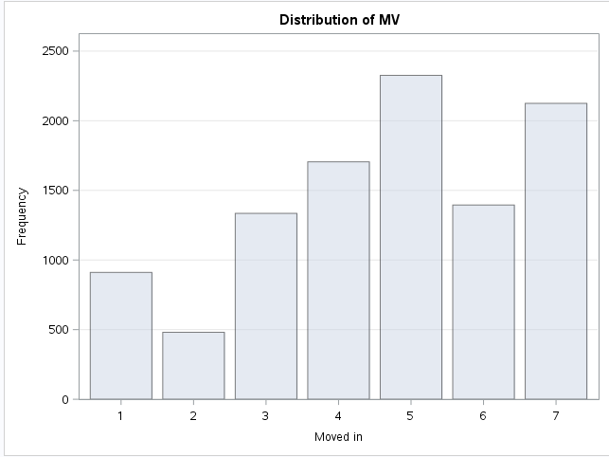

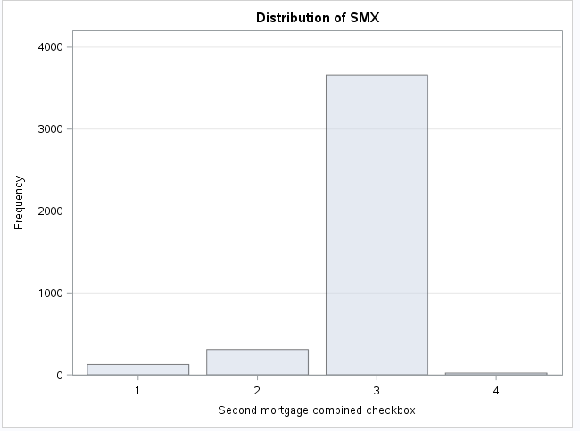

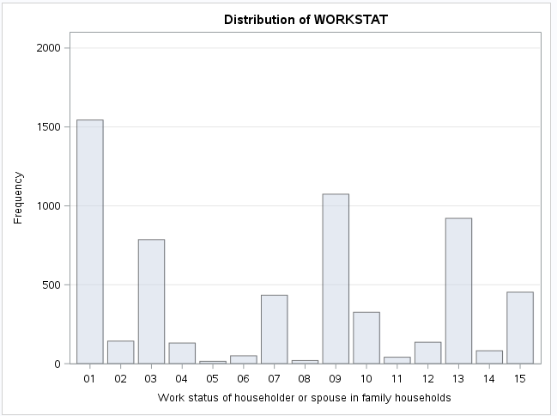

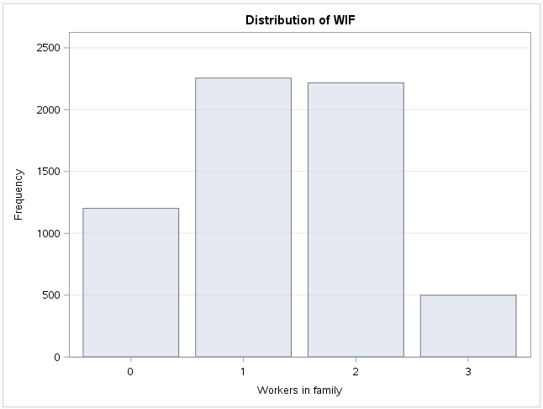

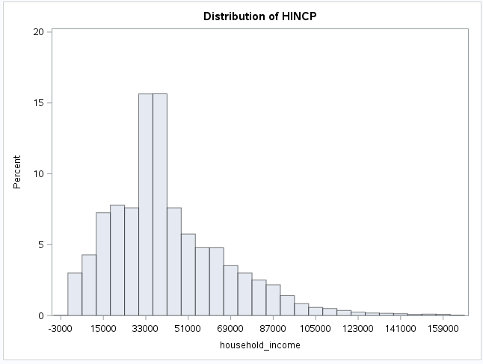

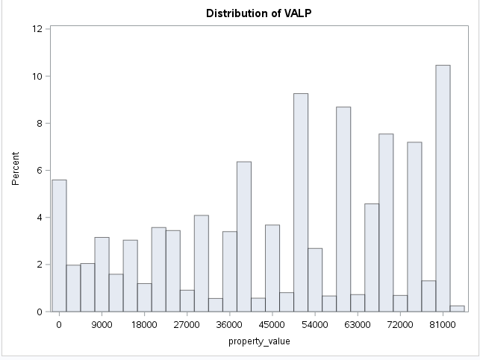

Cluster 2

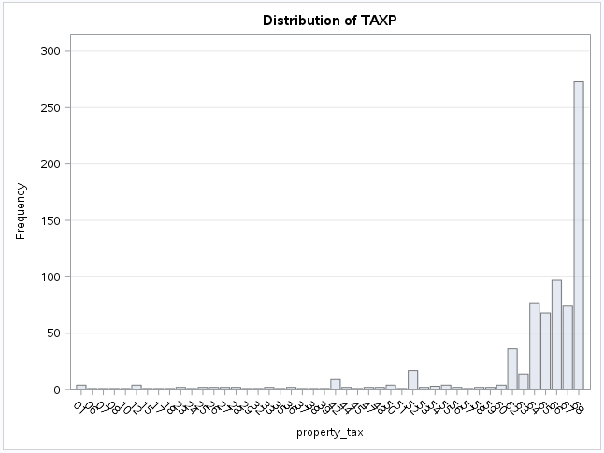

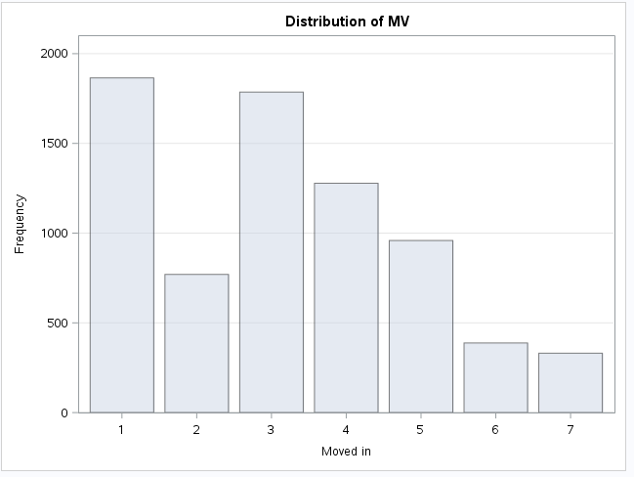

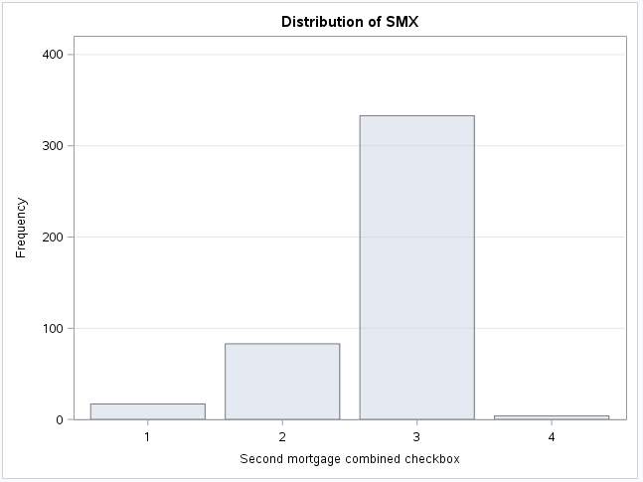

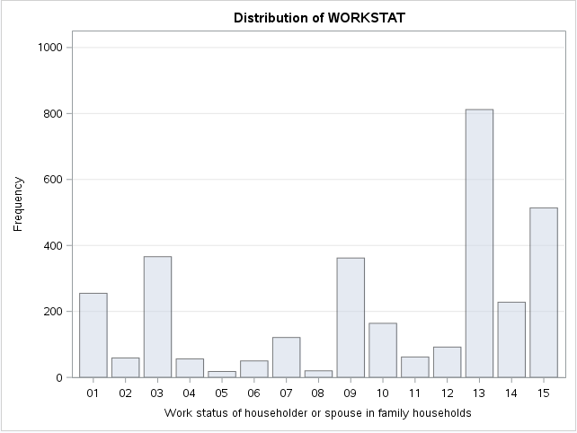

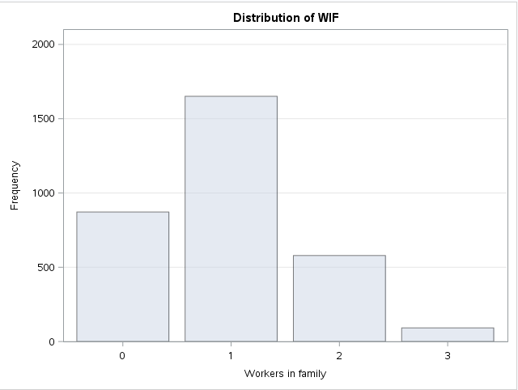

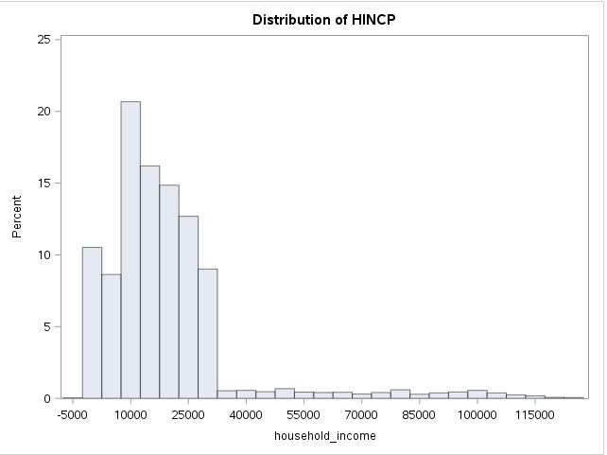

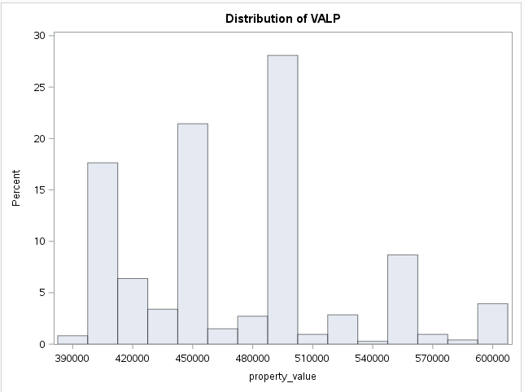

Cluster 3

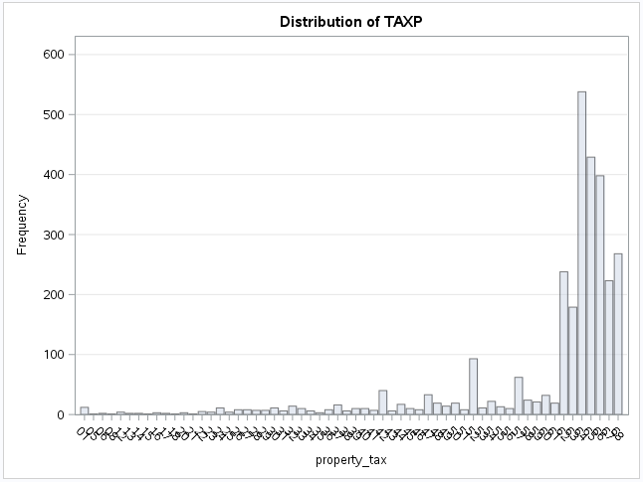

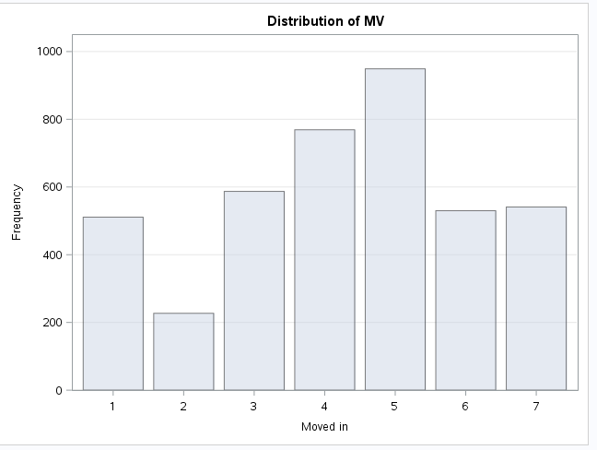

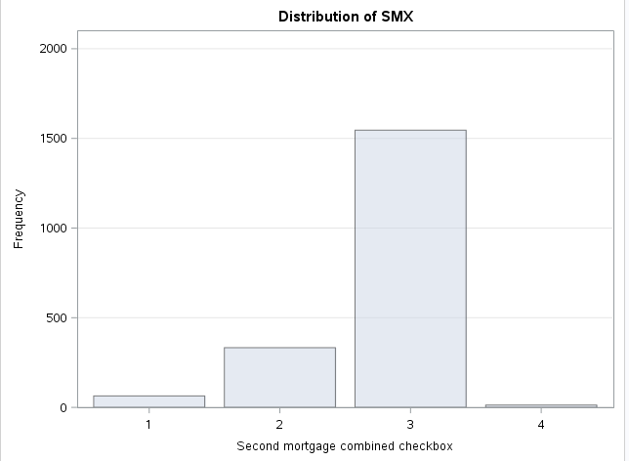

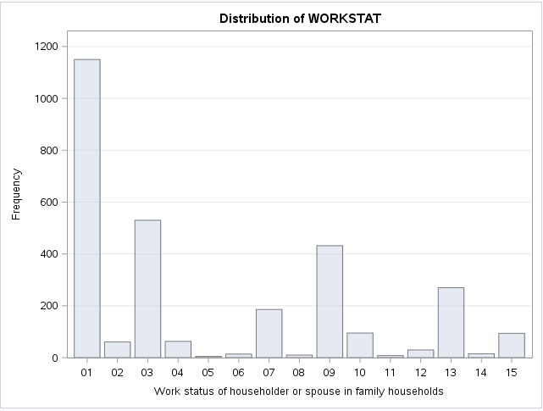

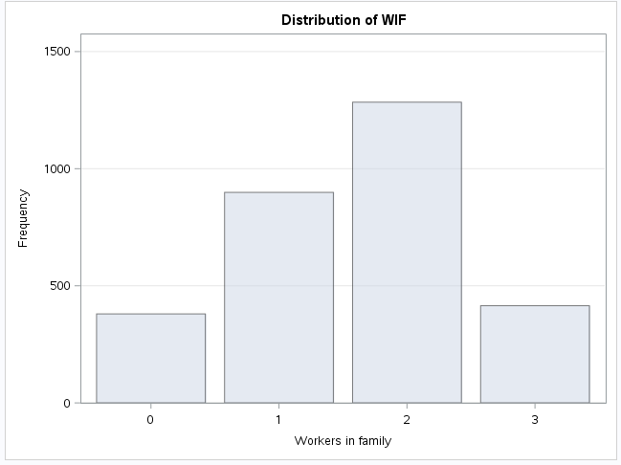

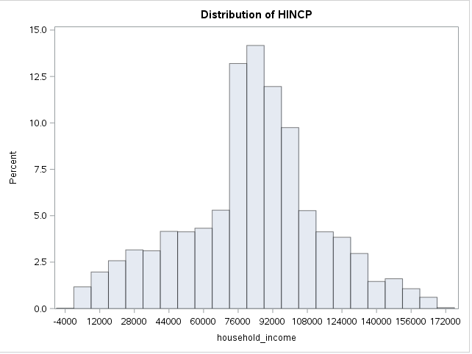

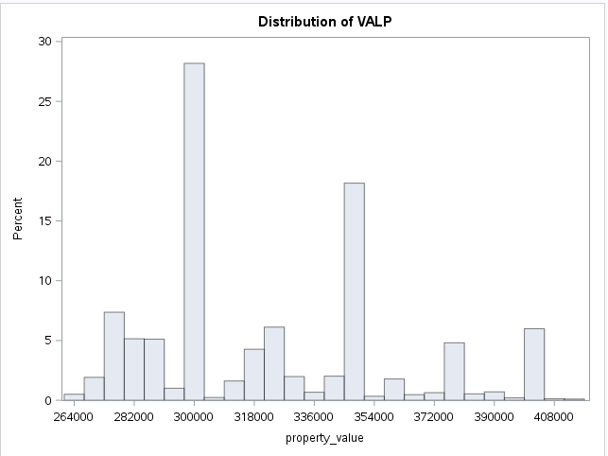

Cluster 4

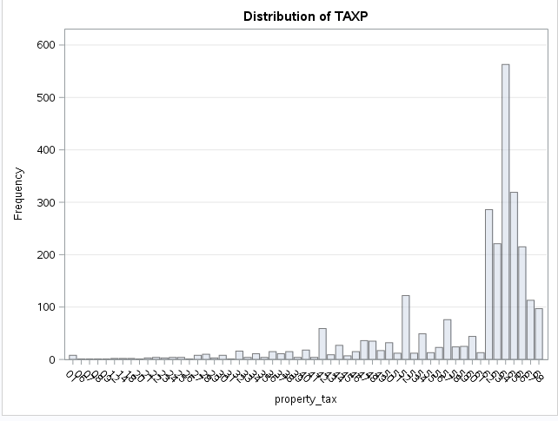

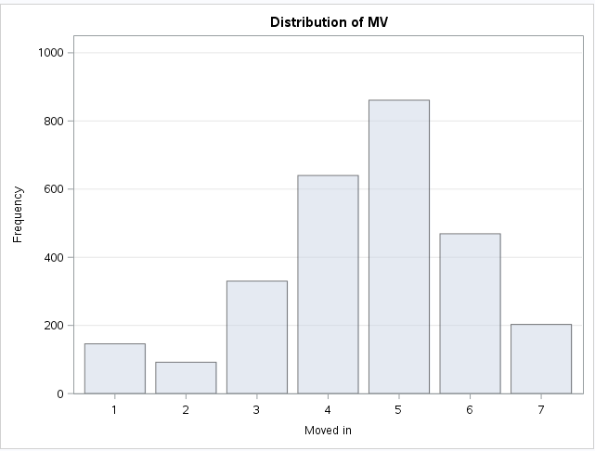

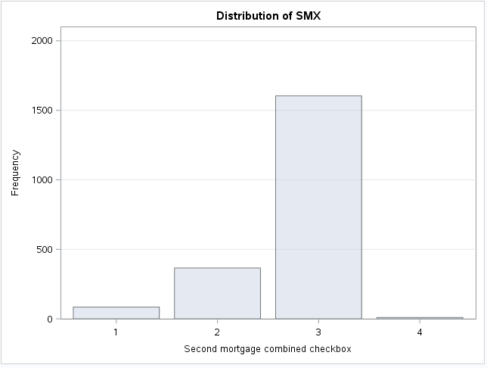

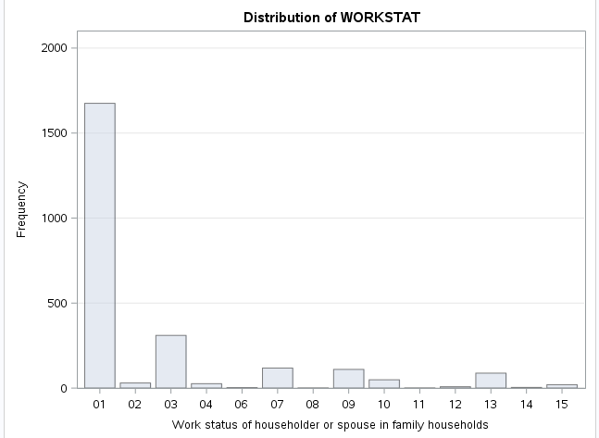

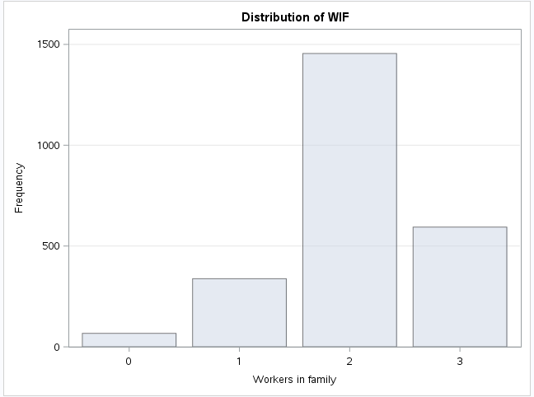

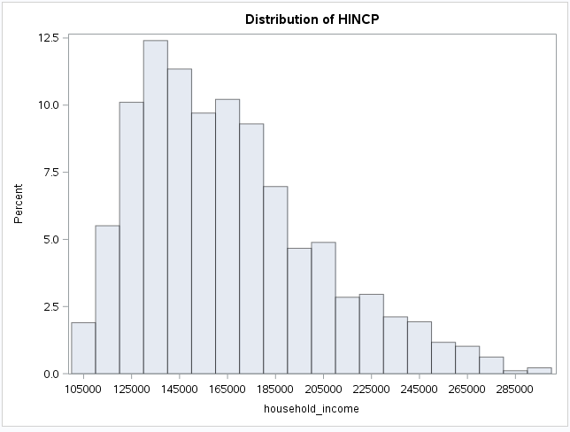

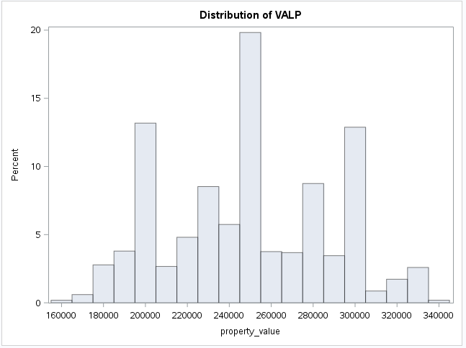

Cluster 5

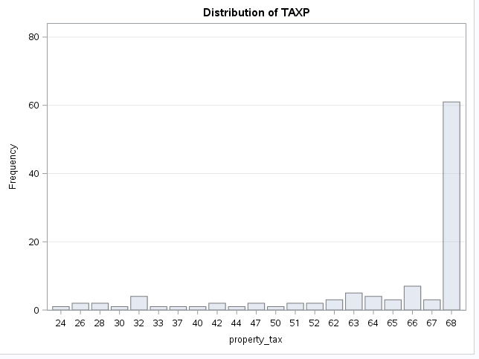

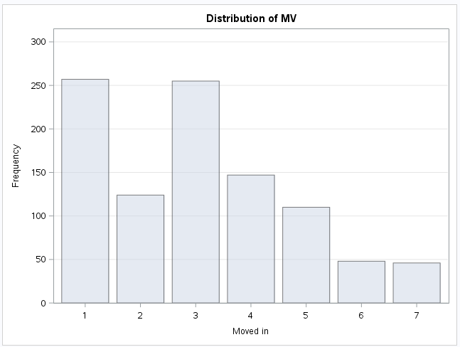

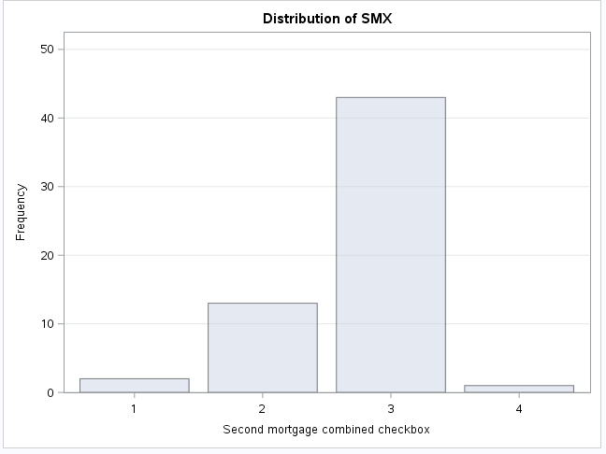

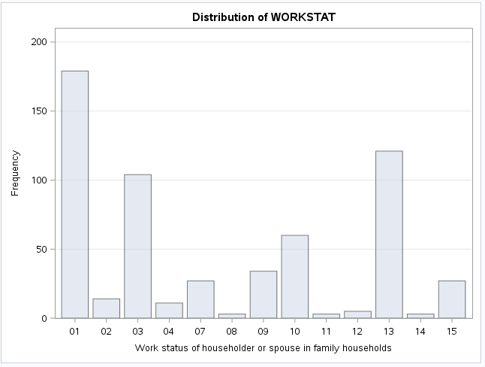

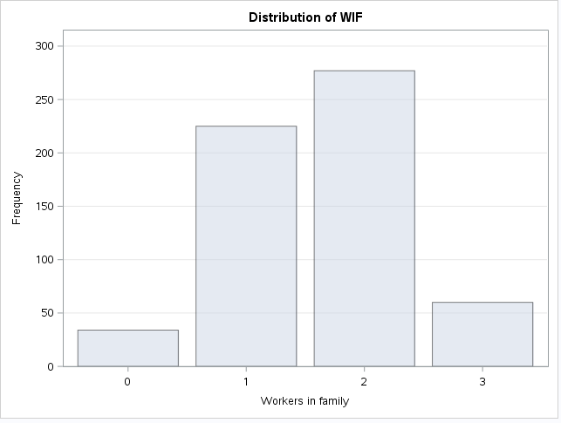

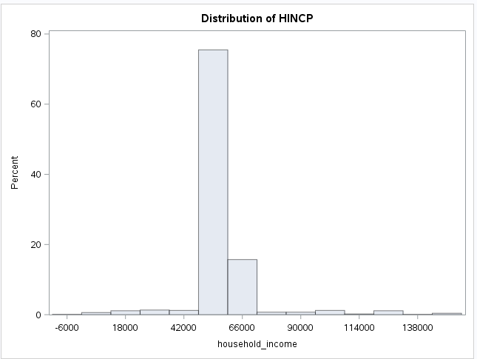

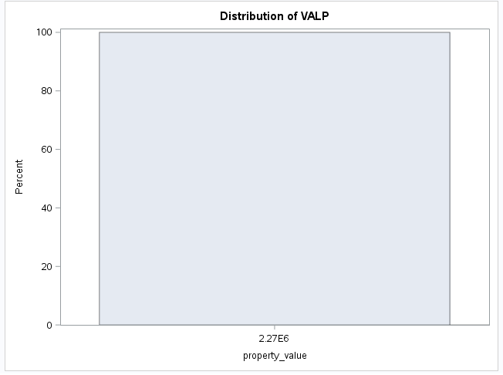

Cluster 6

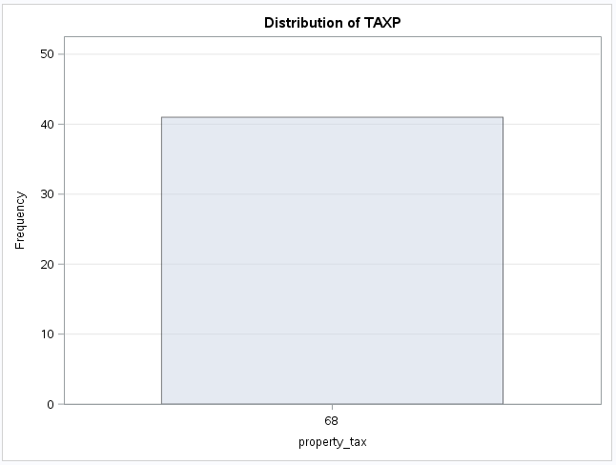

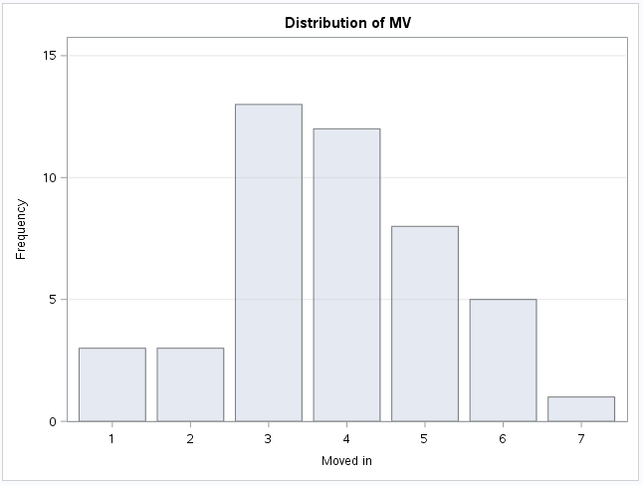

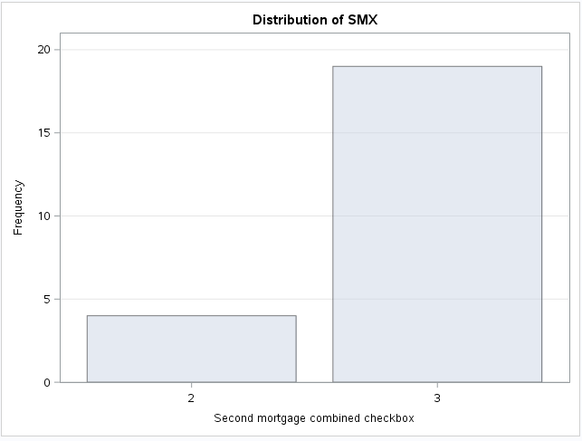

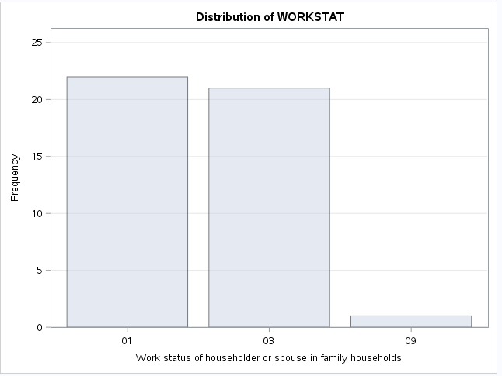

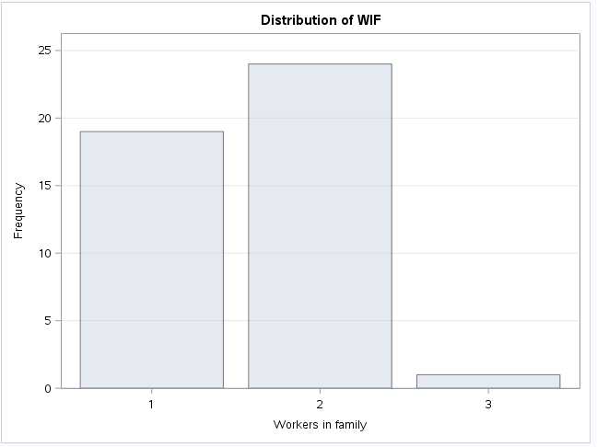

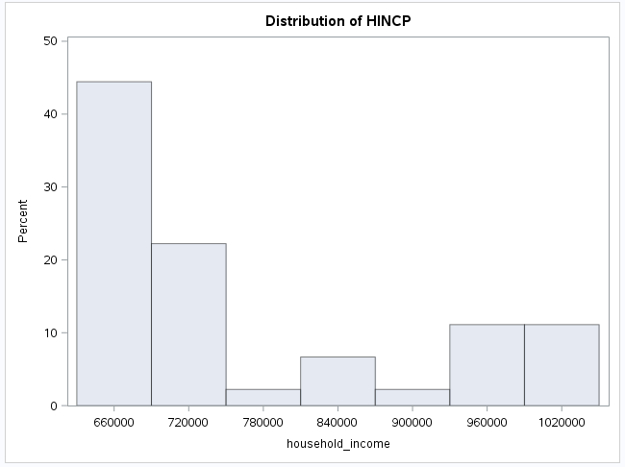

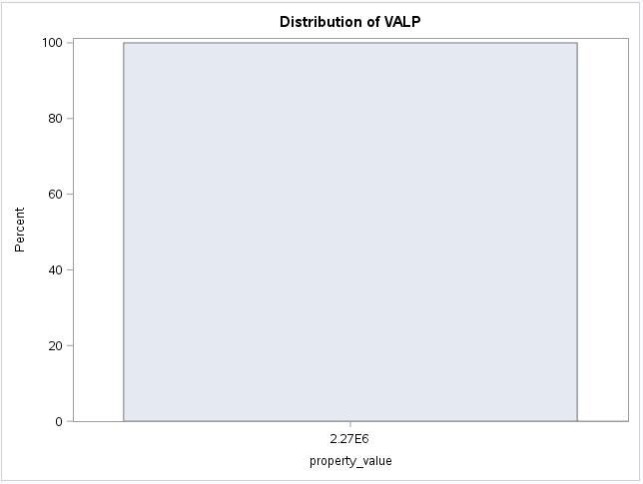

Cluster 7

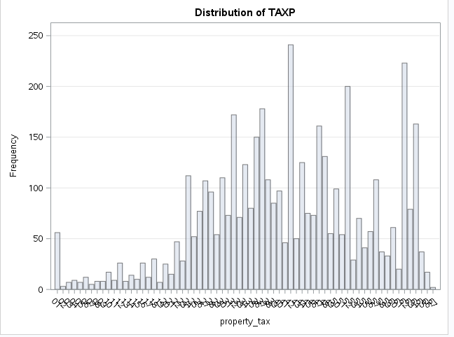

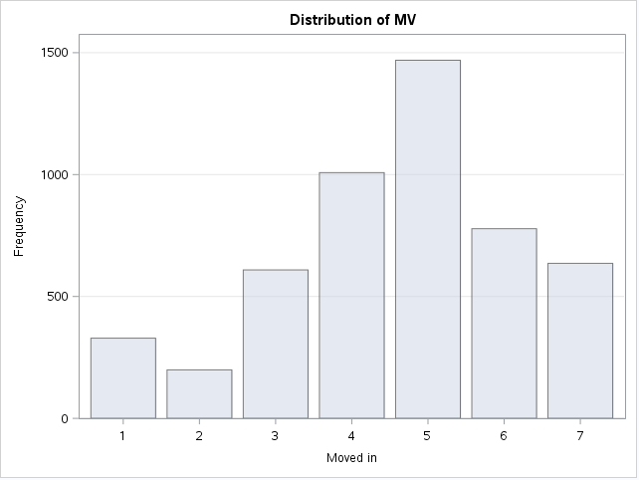

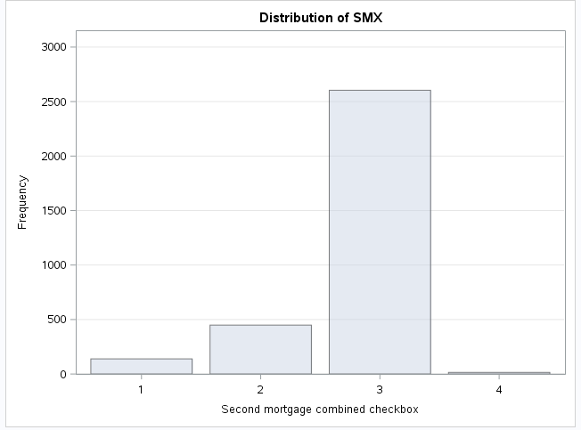

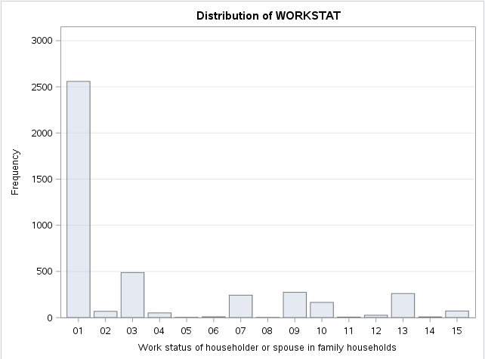

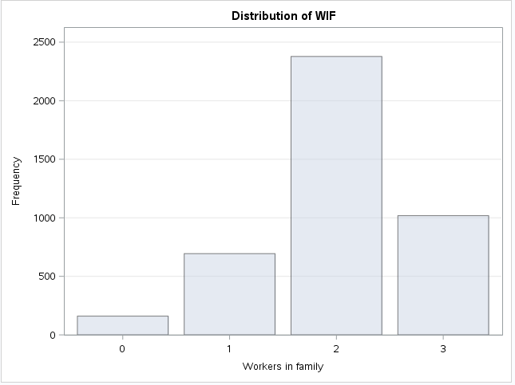

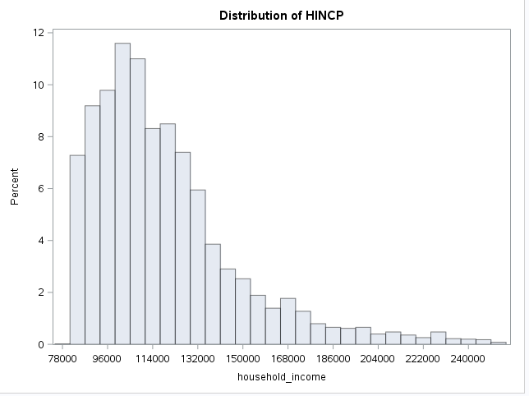

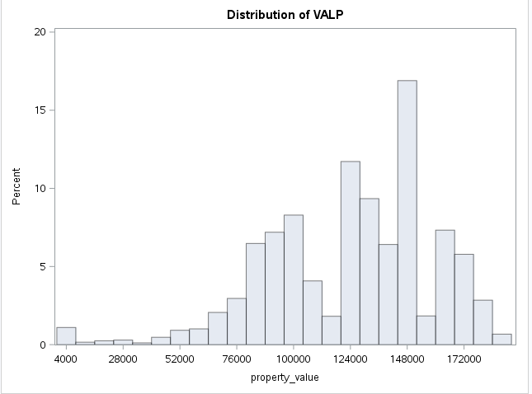

Cluster 8

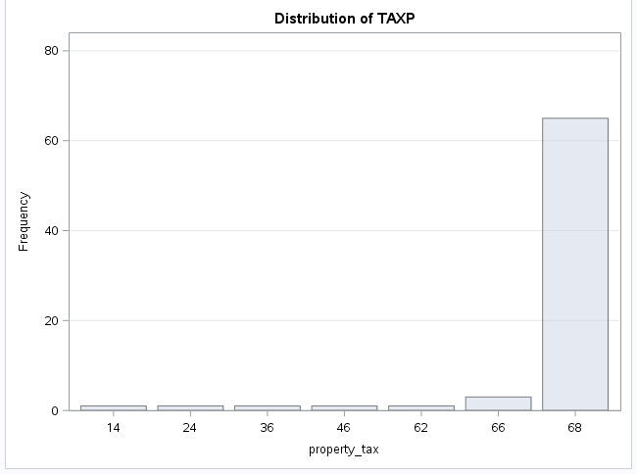

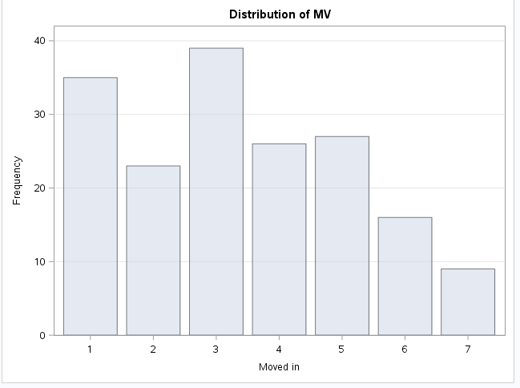

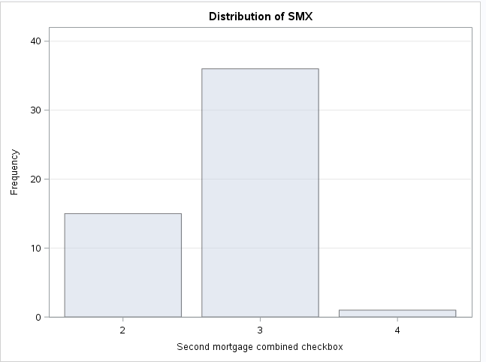

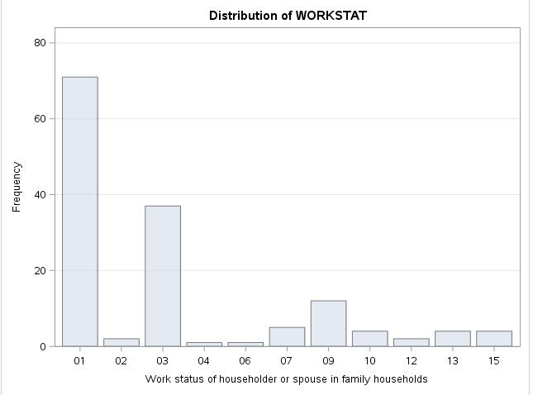

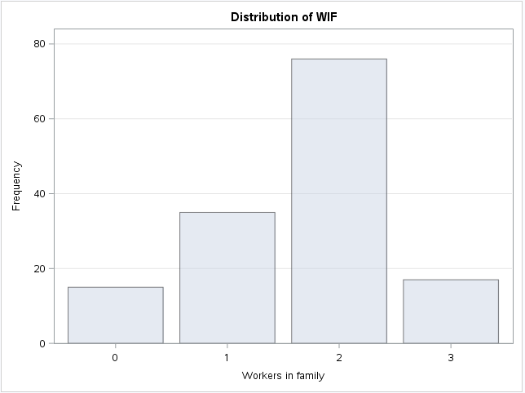

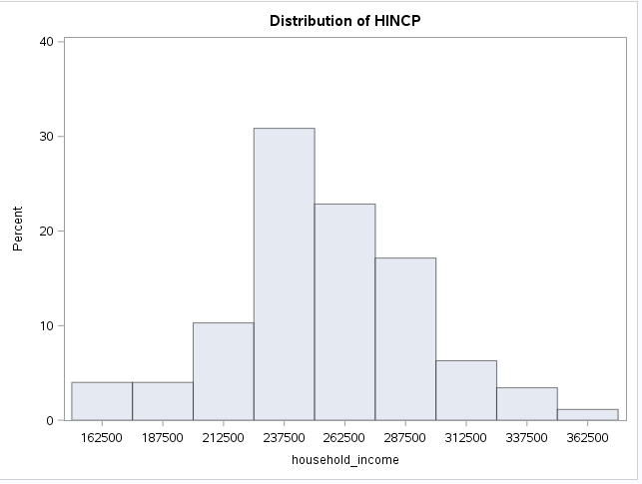

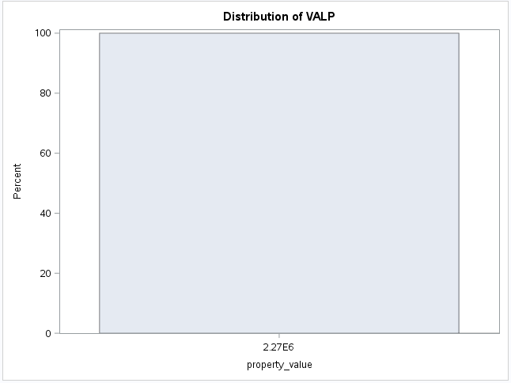

Cluster 9

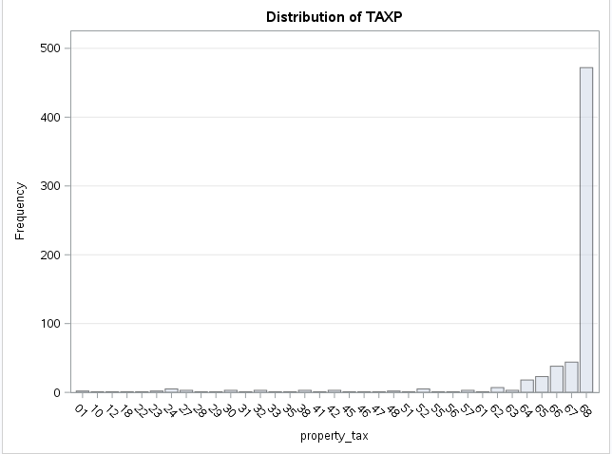

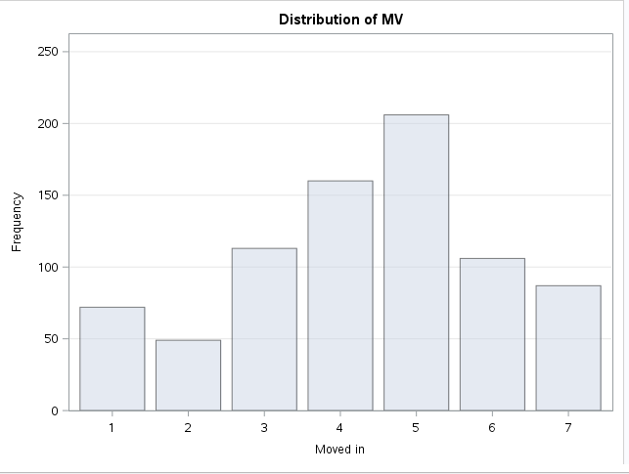

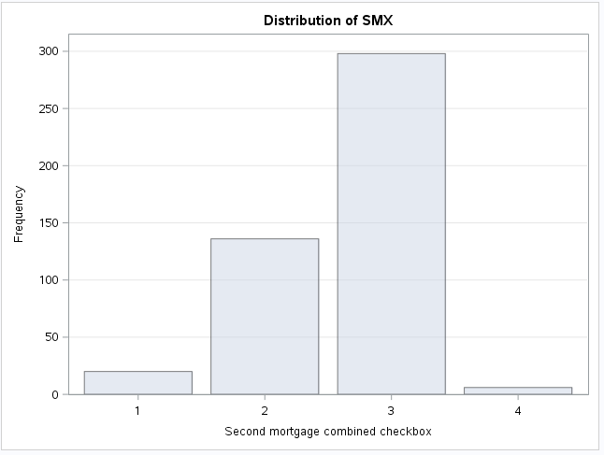

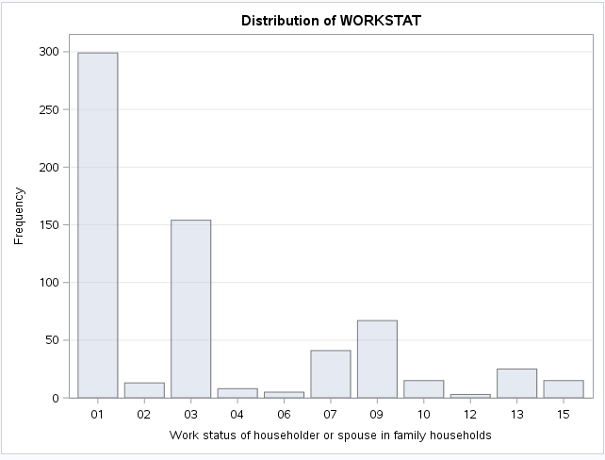

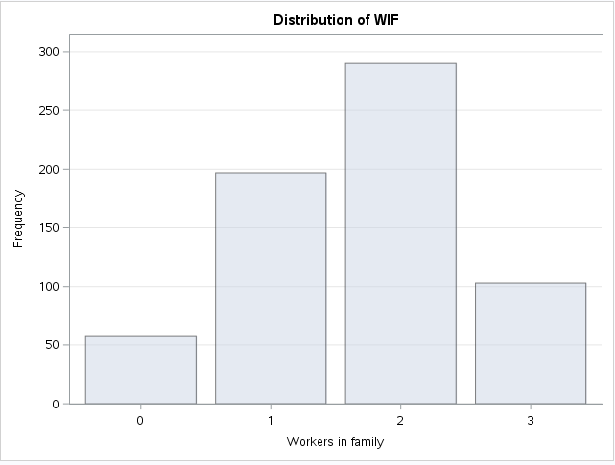

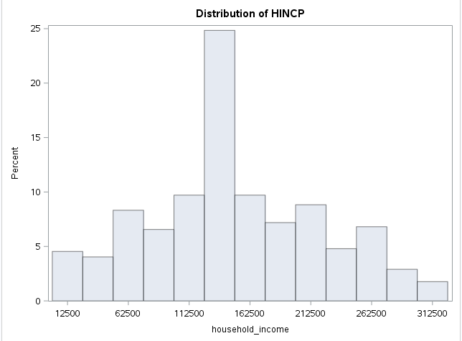

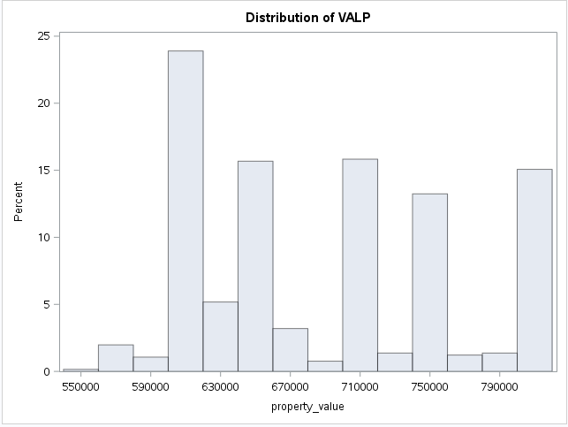

Cluster 10

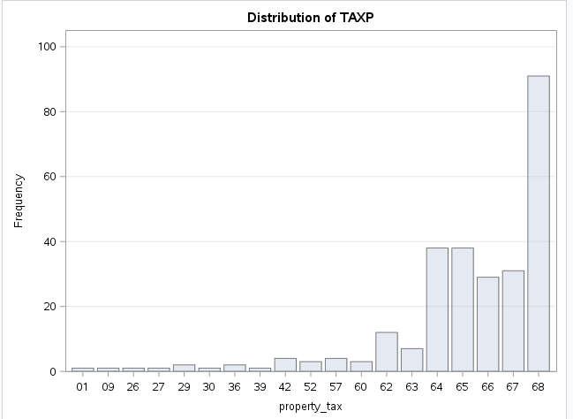

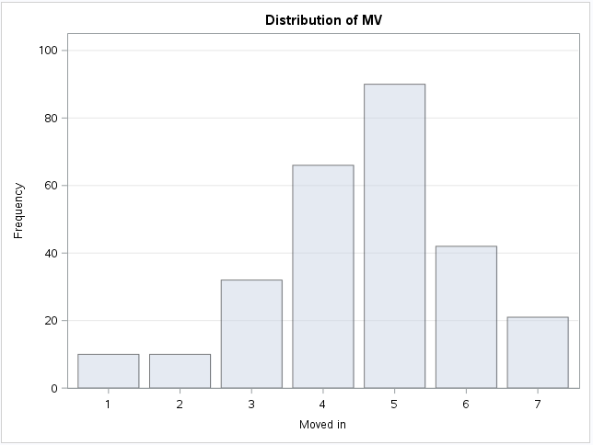

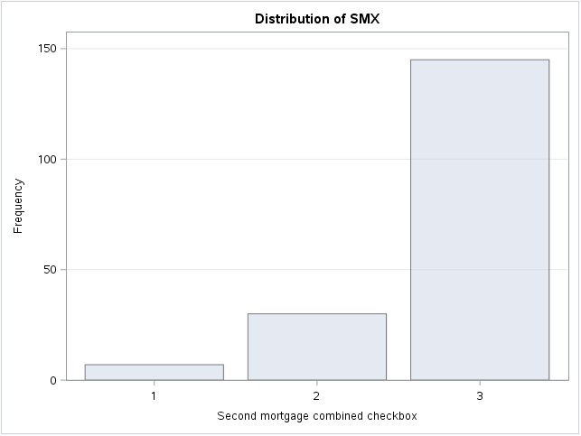

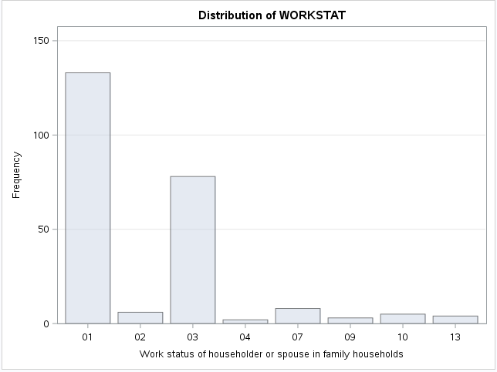

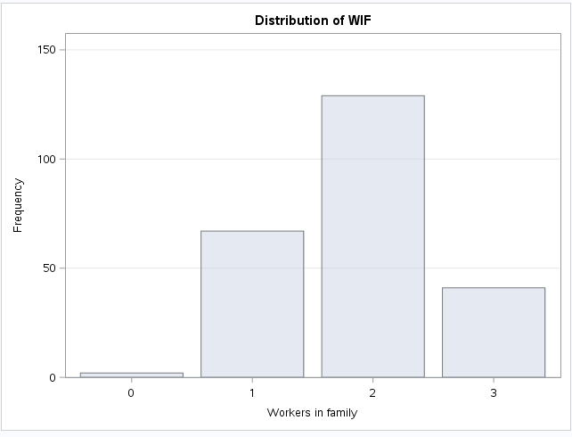

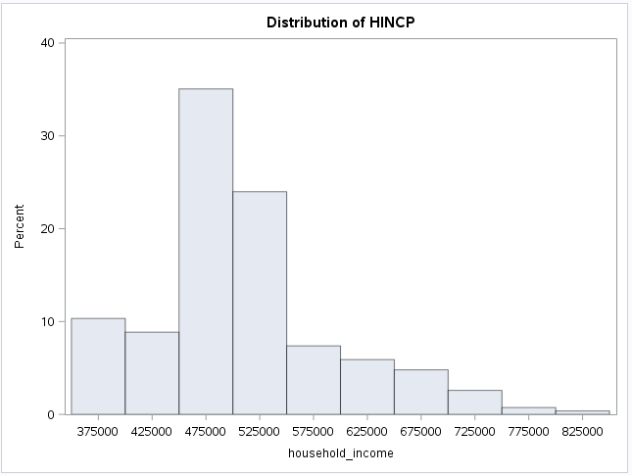

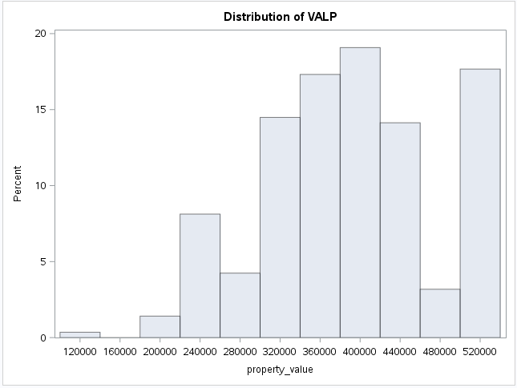

Cluster 11

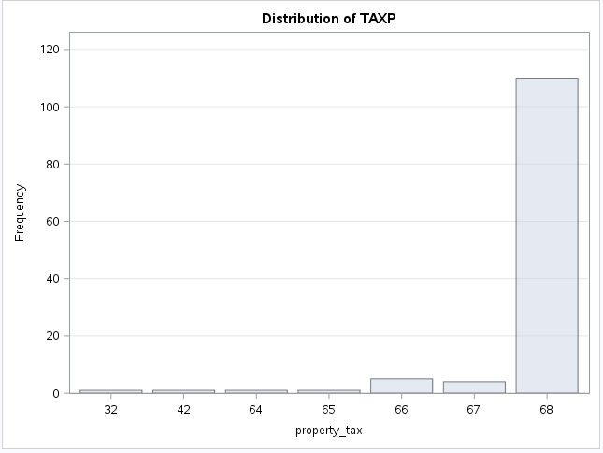

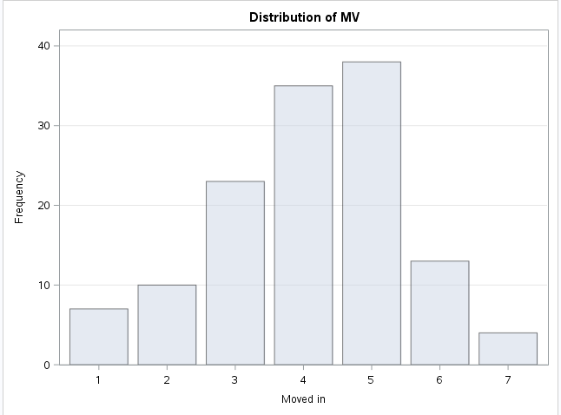

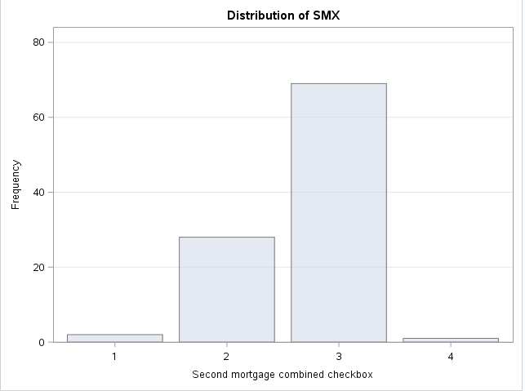

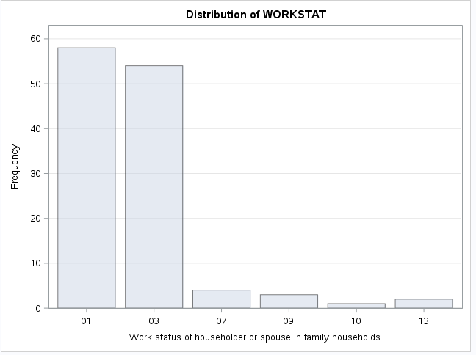

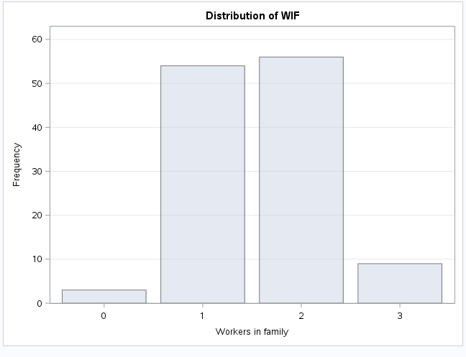

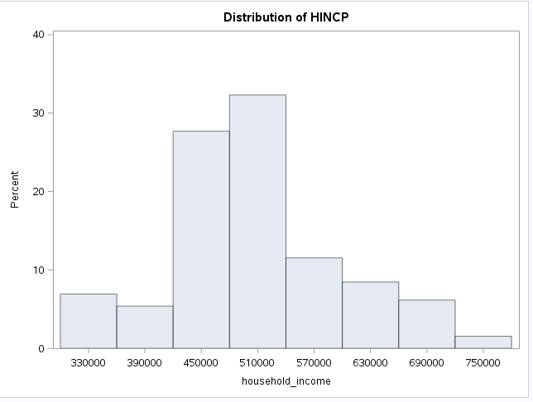

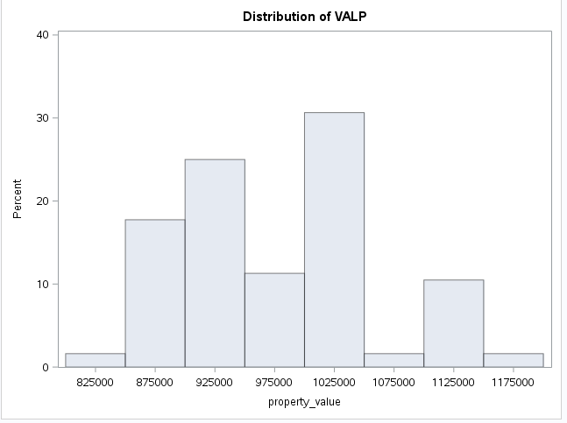

Cluster 12

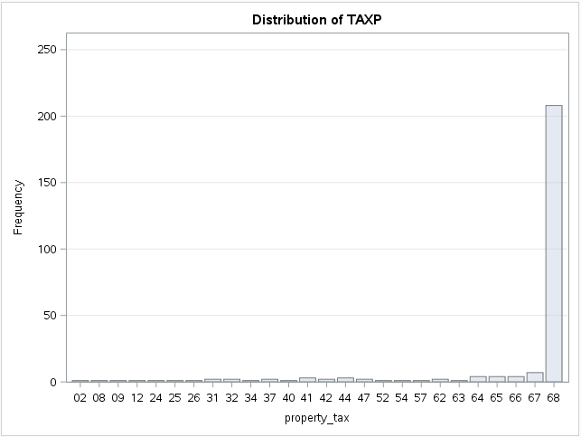

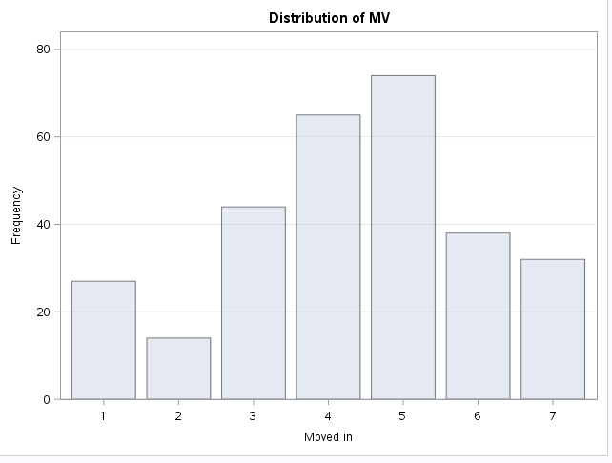

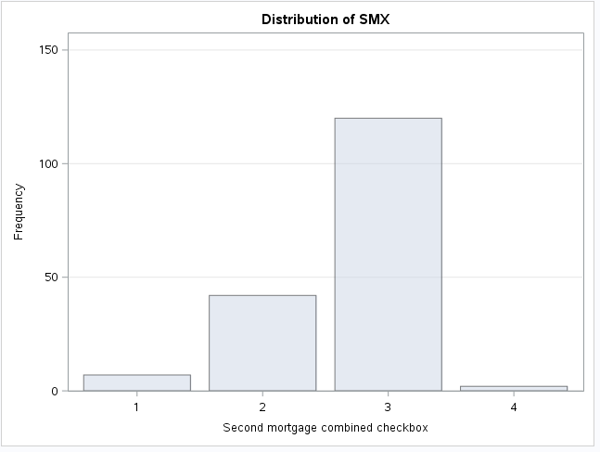

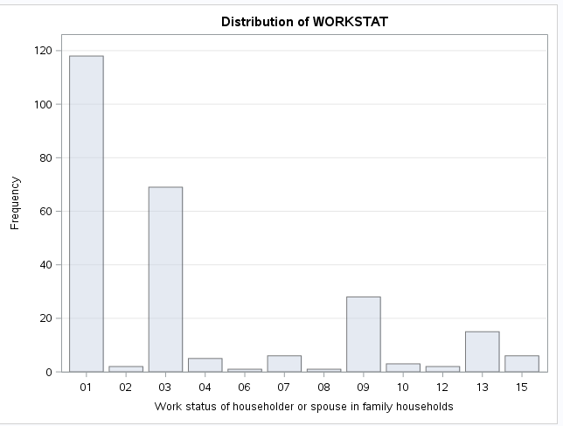

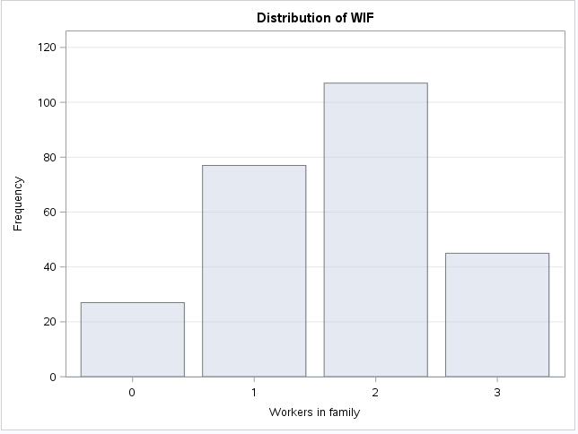

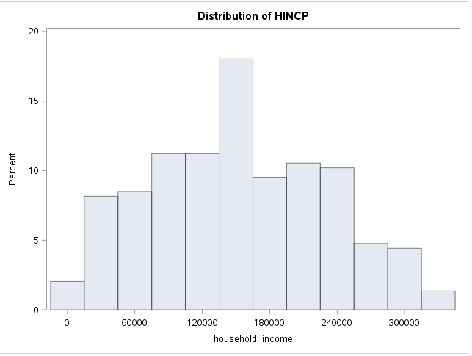

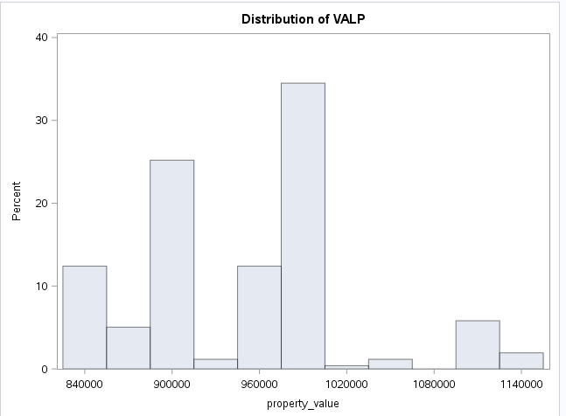

Cluster 13

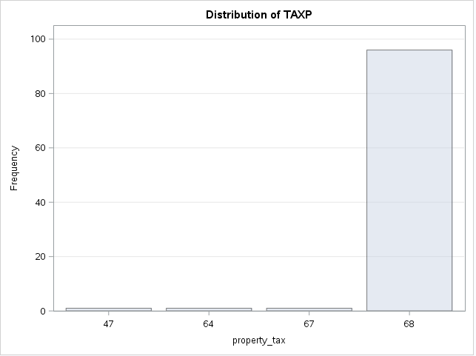

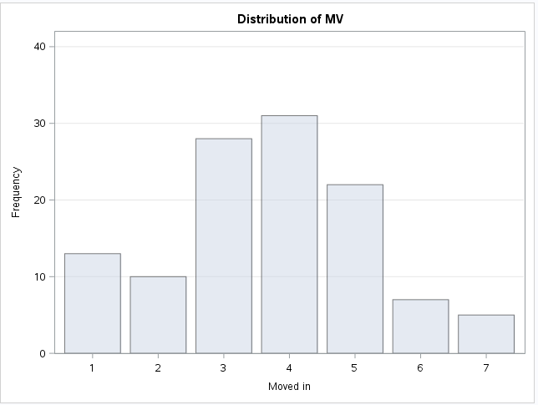

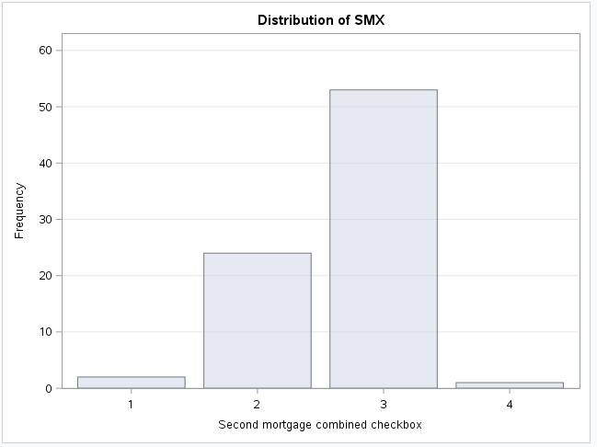

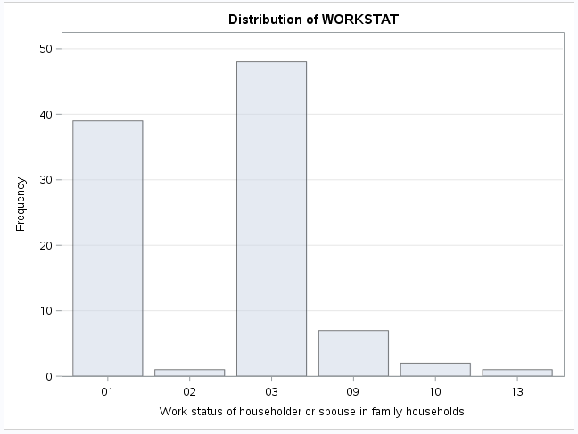

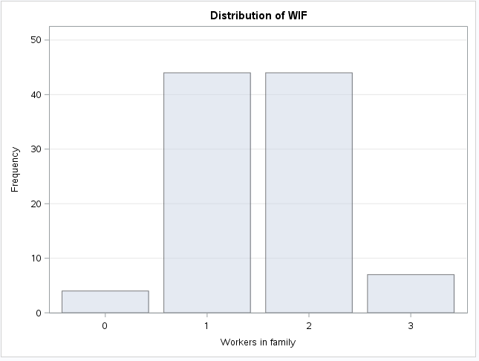

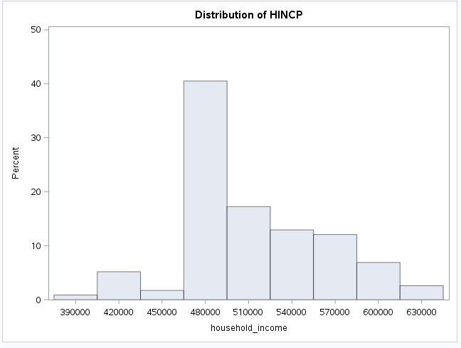

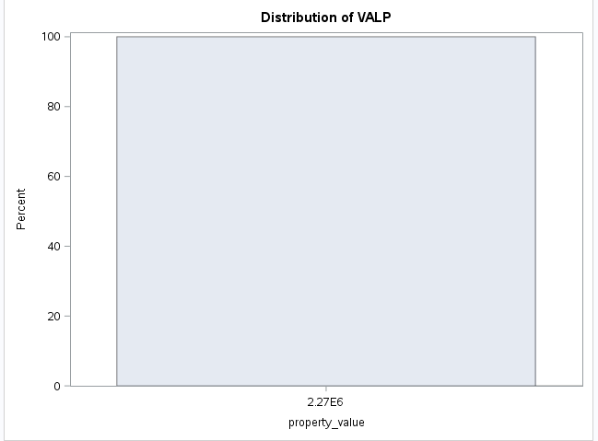

Cluster 14

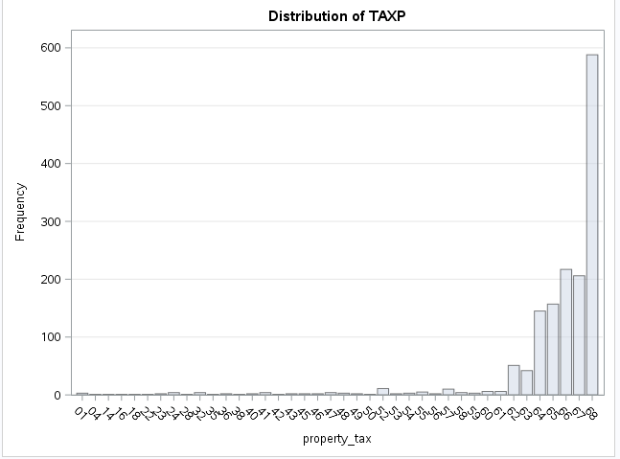

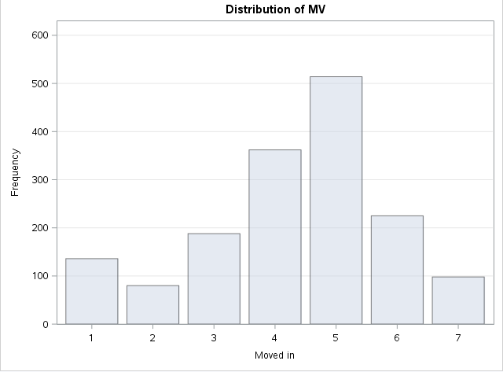

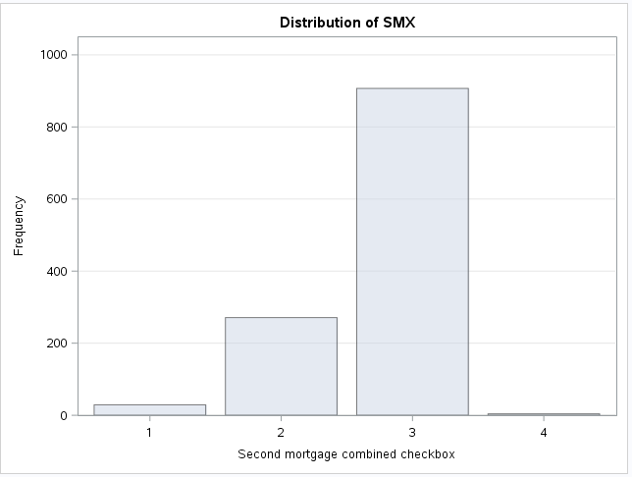

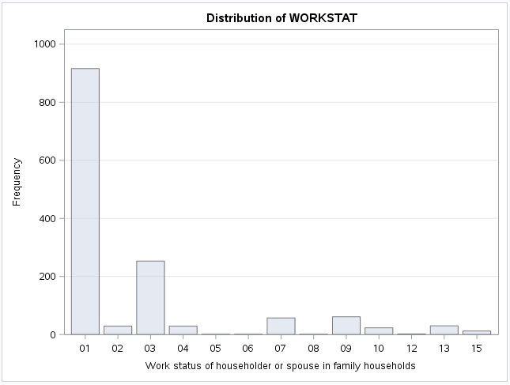

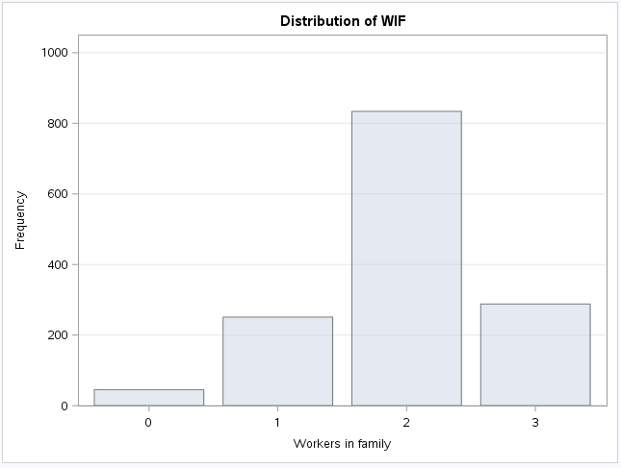

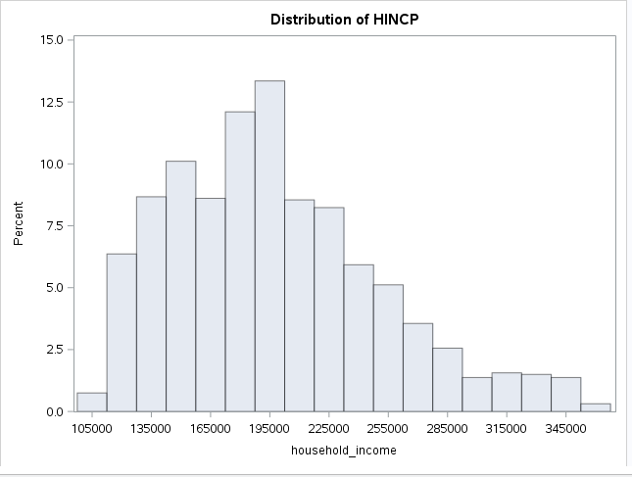

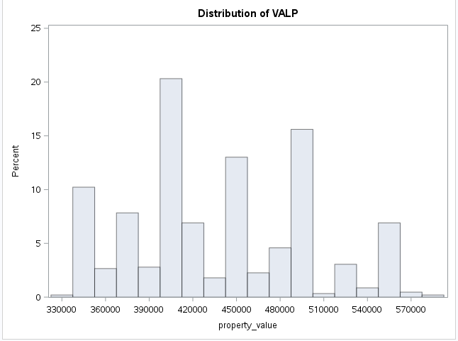

Cluster 15

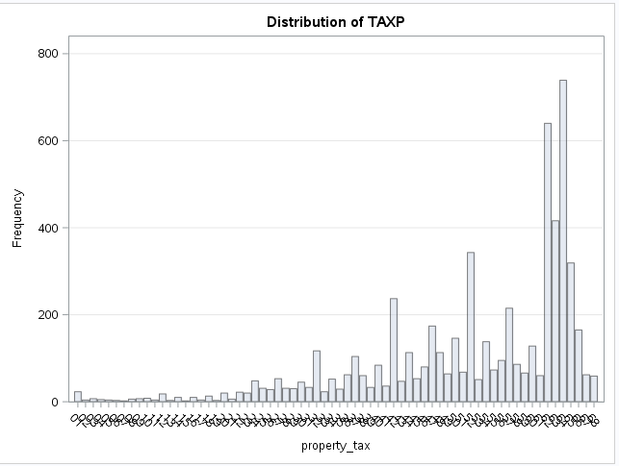

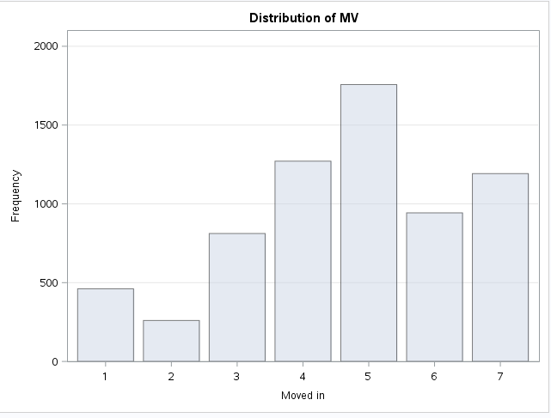

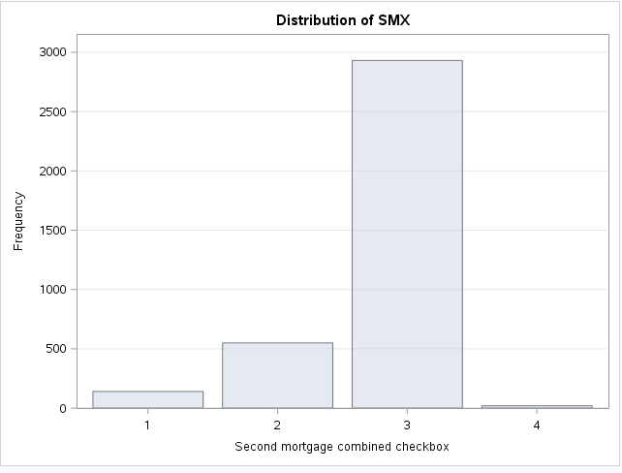

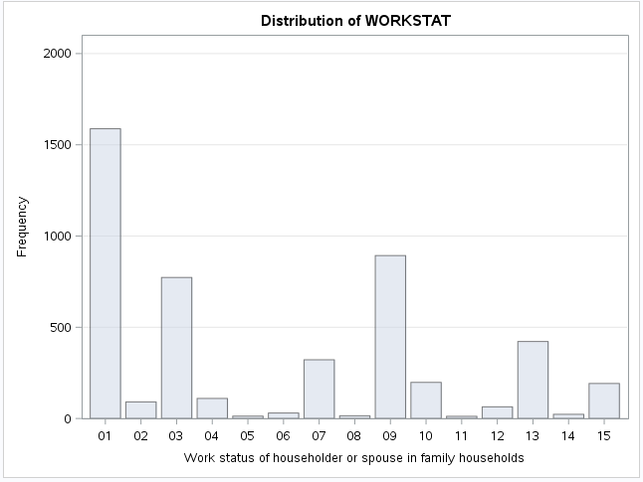

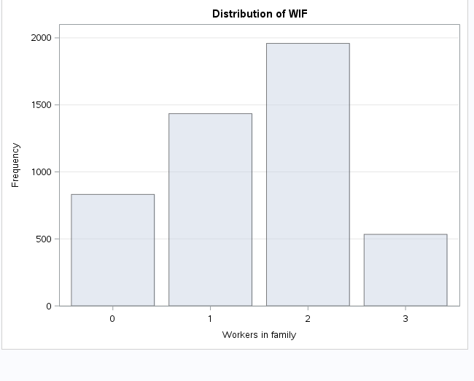

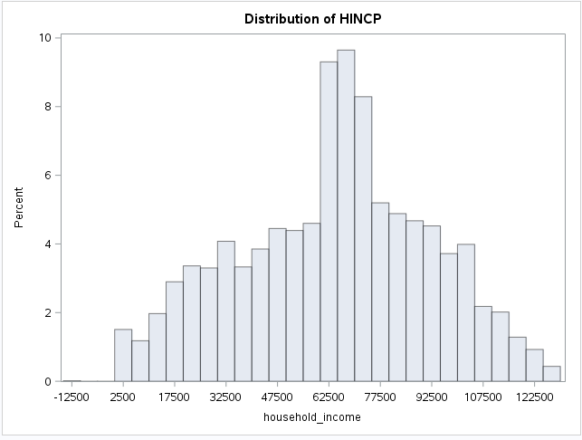

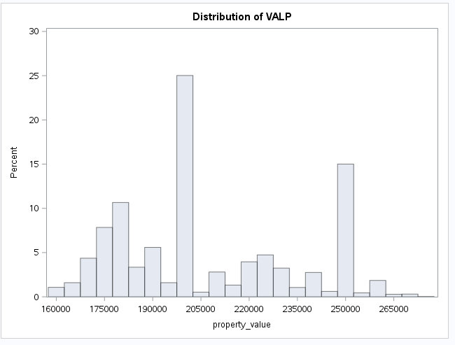

Cluster 16

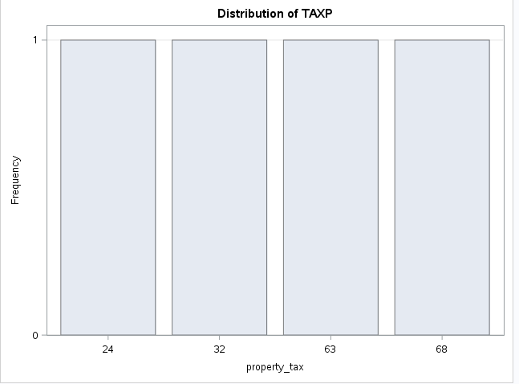

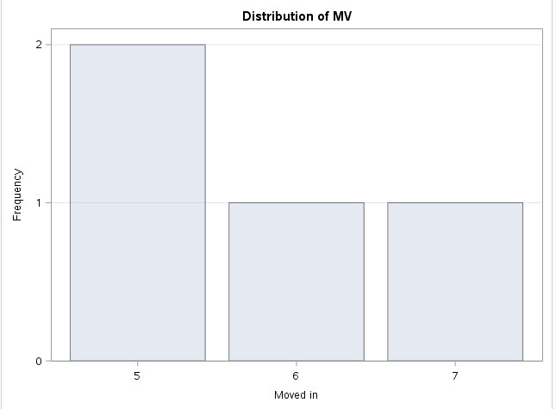

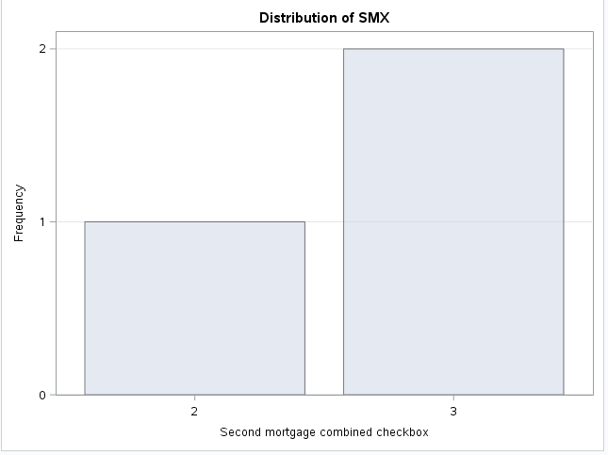

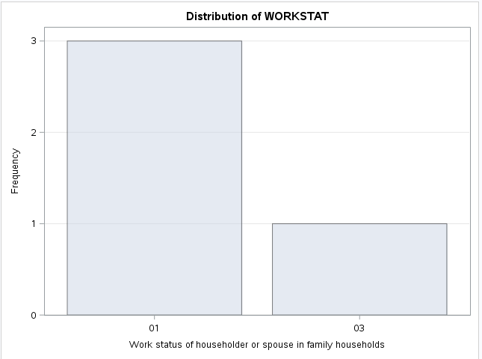

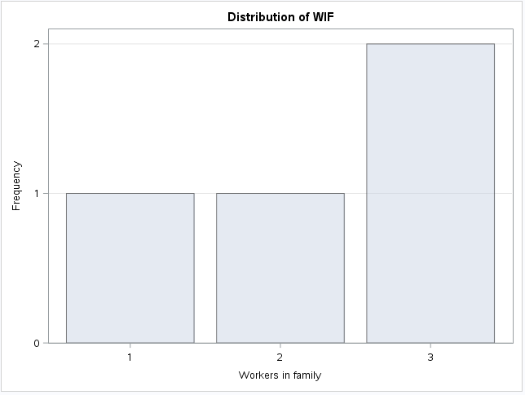

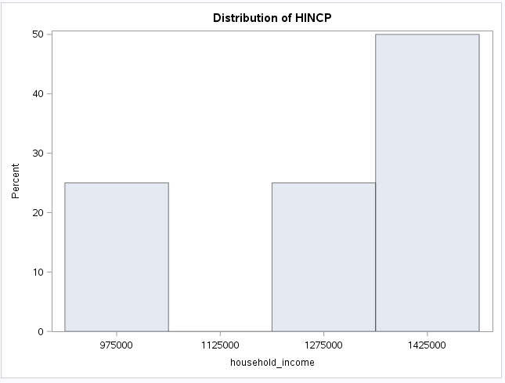

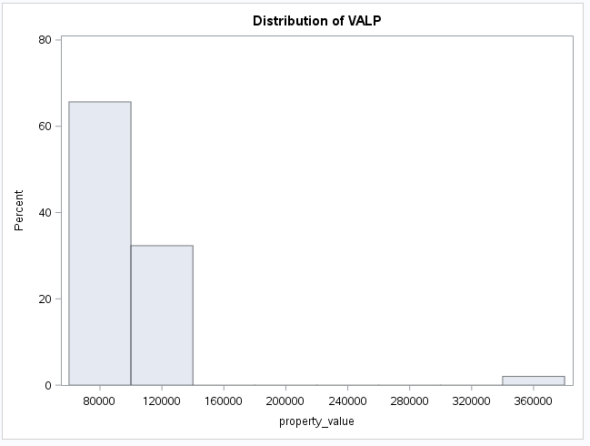

Cluster 17

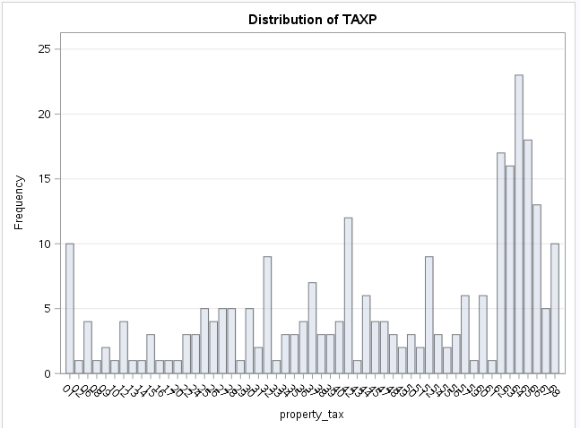

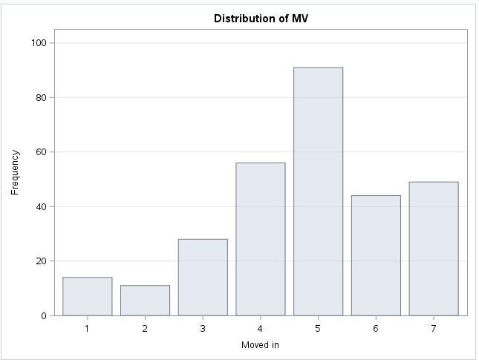

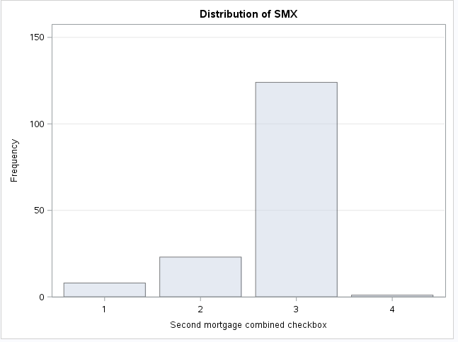

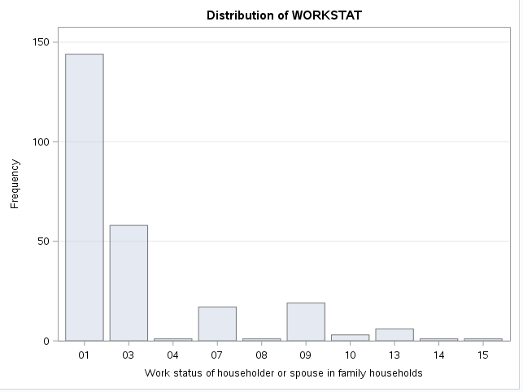

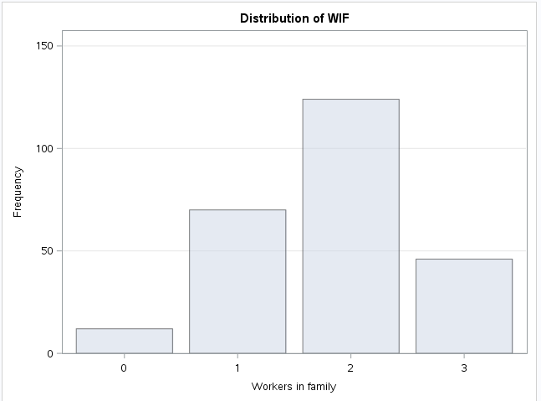

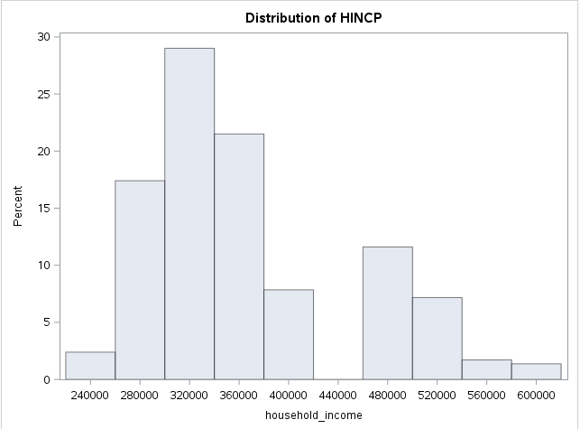

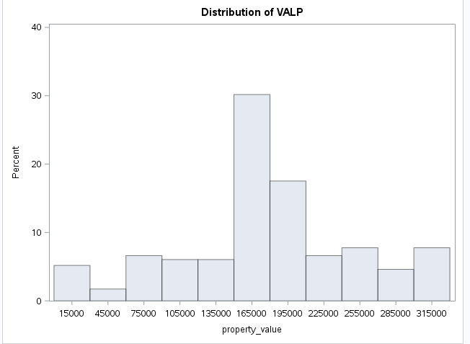

Cluster 18

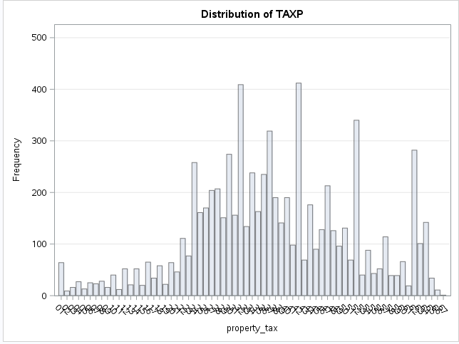

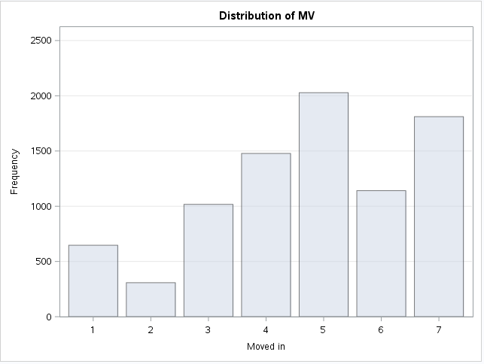

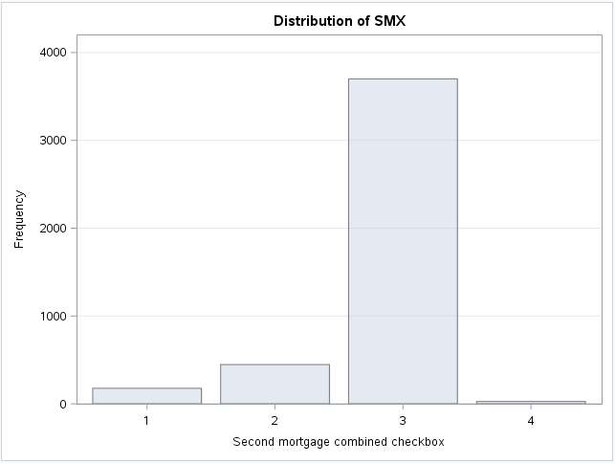

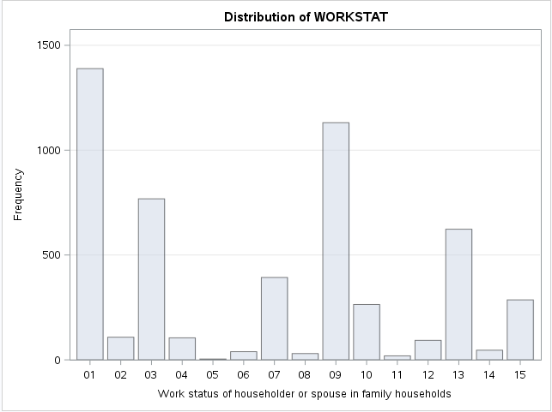

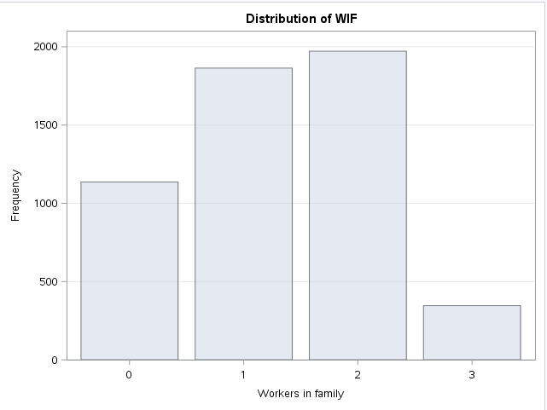

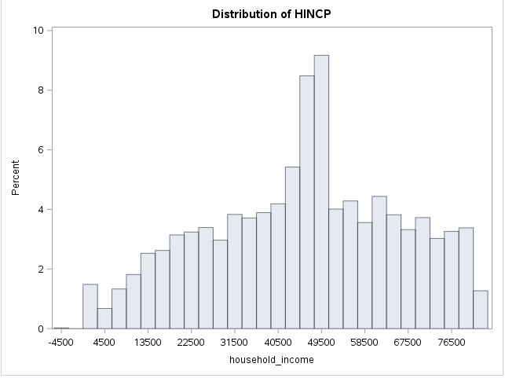

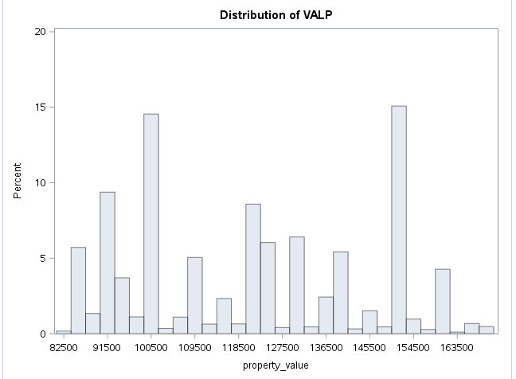

Cluster 19

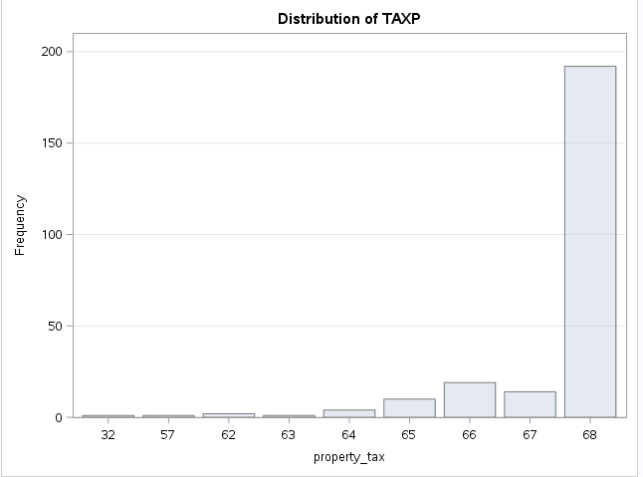

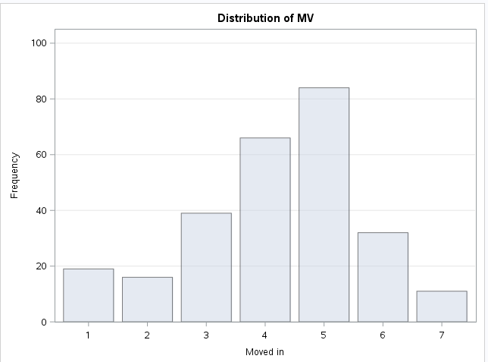

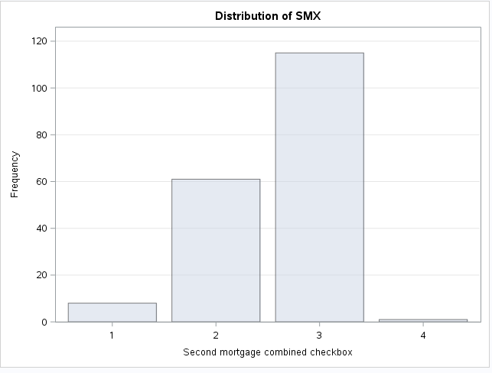

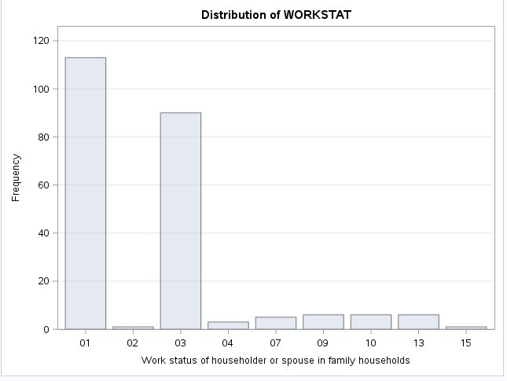

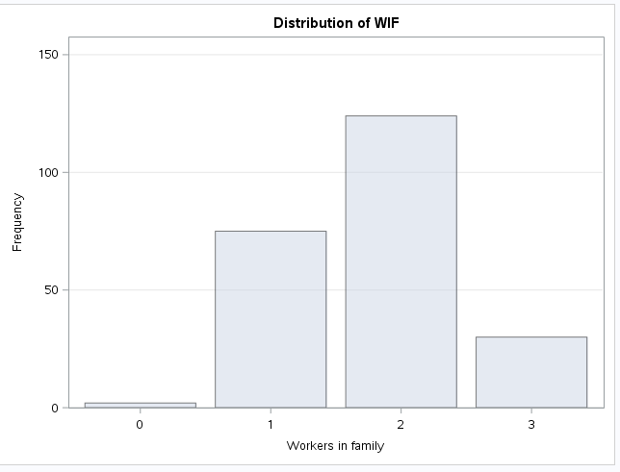

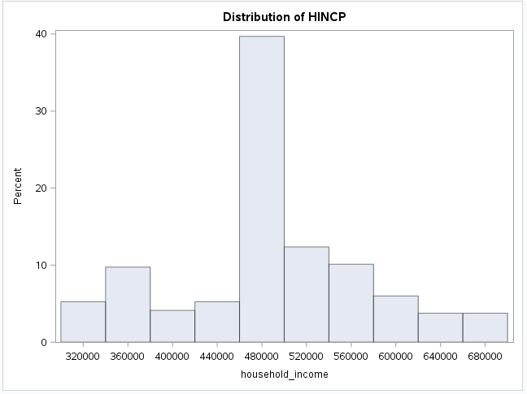

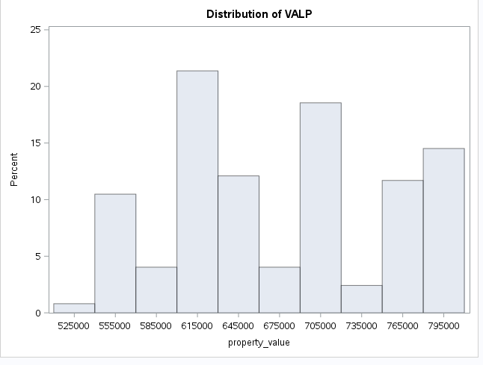

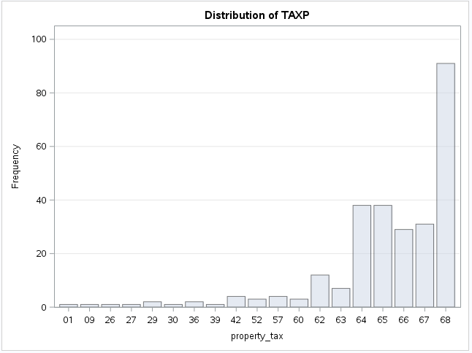

proc fastclus data=census.psam_h17_subset1

radius=0 replace=full

converge=0 maxiter=200

maxclusters=20

OUTSTAT=census.psam_h17_subset1_20clusters_stat

OUT=census.psam_h17_subset1_20clusters

distance;

id SERIALNO;

var VALP HINCP;

run;

proc sgplot;

scatter y=HINCP x=VALP / group=cluster;

title ’ACS PUMS 2013 1 YR 20-Cluster Analysis’;

title2 ’of Data Containing Property Value and Household Income’;

run;

proc standard data=census.psam_h17_subset1 out=Stand mean=0 std=1;

var VALP HINCP;

run;

proc fastclus data=Stand

radius=0 replace=full

converge=0 maxiter=200

maxclusters=20

OUTSTAT=subset1_20clus_stat_stan OUT=subset1_20clus_stan

distance;

id SERIALNO;

var VALP HINCP;

run;

proc sgplot;

scatter y=HINCP x=VALP / group=cluster;

title ’ACS PUMS 2013 1 YR 20-Cluster Analysis (w standardized data)’;

title2 ’of Data Containing Property Value and Household Income’;

run;

**stand**

proc standard data=census.psam_h17_subset1 out=Stand mean=0 std=1;

var VALP HINCP;

run;

proc fastclus data=Stand

radius=0 replace=full

converge=0 maxiter=200

maxclusters=20

OUTSTAT=subset1_20clus_stat_stan OUT=census.subset1_20clus_stan

distance;

id SERIALNO;

var VALP HINCP;

run;

proc sgplot;

scatter y=HINCP x=VALP / group=cluster;

title ’ACS PUMS 2013 1 YR 20-Cluster Analysis (w standardized data)’;

title2 ’of Data Containing Property Value and Household Income’;

run;

**agg stand**

proc standard data=census.psam_h17_subset1 out=Stand mean=0 std=1;

var VALP HINCP;

run;

proc fastclus data=Stand

radius=0 replace=full

converge=0 maxiter=200

maxclusters=20

OUTSTAT=subset1_20clus_stat_stan OUT=census.subset1_20clus_stan

distance;

id SERIALNO;

var VALP HINCP;

run;

proc sgplot;

scatter y=HINCP x=VALP / group=cluster;

title ’ACS PUMS 2013 1 YR 20-Cluster Analysis (w standardized data)’;

title2 ’of Data Containing Property Value and Household Income’;

run;

**Cluster 1**

proc sql;

title 'Cluster #20 aggregated information for profiling';

create table census.psam_h17_subset1_clus_1_agg_stan as

select *

from census.psam_h17_subset1_20clus_agg_stan

where CLUSTER=1;

run;

**grp a**

proc sql;

select group,cluster,scheme,count(*) as frequency,sum(TAXP_INCREASE) as total from census.psam_h17_subset1_cluster_tax

group by group,cluster,scheme;

run;

proc sql;

select group,sum(TAXP_INCREASE) as total from census.psam_h17_subset1_cluster_tax

group by group;

run;

proc sql;

select sum(TAXP_INCREASE) as total from census.psam_h17_subset1_cluster_tax;

run;

proc sql;

create table census.psam_h17_subset1_cluster_tax as

select 'A' as GROUP,a.*, b.AVG,case when (b.No_=68 and a.VALP>2000000 and a.HINCP>150000 and VALP is not null) then '30% Tax Increase'

when (b.No_>=62 and a.VALP>=700000 and a.HINCP>150000 and VALP is not null) then '25% Tax Increase'

when (b.No_>=62 and a.VALP<=700000 and a.HINCP>150000 and VALP is not null and VALP > 0) then '20% Tax Increase'

when (b.No_>=37 and b.No_<62 and a.HINCP>90000 and a.WIF<>'1' and a.WORKSTAT not in ('15','9','12')

and VALP is not null and VALP > 0) then '15% Tax Increase'

when (b.No_>=22 and b.No_<37 and a.HINCP>70000 and a.WIF<>'1' and a.WORKSTAT not in ('15','9','12')

and VALP is not null and VALP > 0) then '10% Tax Increase'

else 'No Tax Increase' end as SCHEME,

case when (b.No_=68 and a.VALP>2000000 and a.HINCP>150000 and VALP is not null) then (b.AVG*0.3)

when (b.No_>=62 and a.VALP>=700000 and a.HINCP>150000 and VALP is not null) then (b.AVG*0.25)

when (b.No_>=62 and a.VALP<=700000 and a.HINCP>150000 and VALP is not null and VALP > 0) then (b.AVG*0.20)

when (b.No_>=37 and b.No_<62 and a.HINCP>90000 and a.WIF<>'1' and a.WORKSTAT not in ('15','9','12')

and VALP is not null and VALP > 0) then (b.AVG*0.15)

when (b.No_>=22 and b.No_<37 and a.HINCP>70000 and a.WIF<>'1' and a.WORKSTAT not in ('15','9','12')

and VALP is not null and VALP > 0) then (b.AVG*0.10)

else 0 end as TAXP_INCREASE

from census.psam_h17_subset1_cluster_agg20 as a left join

census.tax_lkp as b

on input(a.taxp,18.) =b.No_

union all

select 'A' as GROUP,a.*, b.AVG, case when (b.No_=68 and a.VALP>2000000 and a.HINCP>150000 and VALP is not null) then '30% Tax Increase'

when (b.No_>=62 and a.VALP>=700000 and a.HINCP>150000 and VALP is not null) then '25% Tax Increase'

when (b.No_>=62 and a.VALP<=700000 and a.HINCP>150000 and VALP is not null and VALP > 0) then '20% Tax Increase'

when (b.No_>=37 and b.No_<62 and a.HINCP>90000 and a.WIF<>'1' and a.WORKSTAT not in ('15','9','12')

and VALP is not null and VALP > 0) then '15% Tax Increase'

when (b.No_>=22 and b.No_<37 and a.HINCP>70000 and a.WIF<>'1' and a.WORKSTAT not in ('15','9','12')

and VALP is not null and VALP > 0) then '10% Tax Increase'

else 'No Tax Increase' end as SCHEME,

case when (b.No_=68 and a.VALP>2000000 and a.HINCP>150000 and VALP is not null) then (b.AVG*0.3)

when (b.No_>=62 and a.VALP>=700000 and a.HINCP>150000 and VALP is not null) then (b.AVG*0.25)

when (b.No_>=62 and a.VALP<=700000 and a.HINCP>150000 and VALP is not null and VALP > 0) then (b.AVG*0.20)

when (b.No_>=37 and b.No_<62 and a.HINCP>90000 and a.WIF<>'1' and a.WORKSTAT not in ('15','9','12')

and VALP is not null and VALP > 0) then (b.AVG*0.15)

when (b.No_>=22 and b.No_<37 and a.HINCP>70000 and a.WIF<>'1' and a.WORKSTAT not in ('15','9','12')

and VALP is not null and VALP > 0) then (b.AVG*0.10)

else 0 end as TAXP_INCREASE

from census.psam_h17_subset1_cluster_agg8 as a left join

census.tax_lkp as b

on input(a.taxp,18.) =b.No_

union all

select 'A' as GROUP,a.*, b.AVG, case when (b.No_=68 and a.VALP>2000000 and a.HINCP>150000 and VALP is not null) then '30% Tax Increase'

when (b.No_>=62 and a.VALP>=700000 and a.HINCP>150000 and VALP is not null) then '25% Tax Increase'

when (b.No_>=62 and a.VALP<=700000 and a.HINCP>150000 and VALP is not null and VALP > 0) then '20% Tax Increase'

when (b.No_>=37 and b.No_<62 and a.HINCP>90000 and a.WIF<>'1' and a.WORKSTAT not in ('15','9','12')

and VALP is not null and VALP > 0) then '15% Tax Increase'

when (b.No_>=22 and b.No_<37 and a.HINCP>70000 and a.WIF<>'1' and a.WORKSTAT not in ('15','9','12')

and VALP is not null and VALP > 0) then '10% Tax Increase'

else 'No Tax Increase' end as SCHEME,

case when (b.No_=68 and a.VALP>2000000 and a.HINCP>150000 and VALP is not null) then (b.AVG*0.3)

when (b.No_>=62 and a.VALP>=700000 and a.HINCP>150000 and VALP is not null) then (b.AVG*0.25)

when (b.No_>=62 and a.VALP<=700000 and a.HINCP>150000 and VALP is not null and VALP > 0) then (b.AVG*0.20)

when (b.No_>=37 and b.No_<62 and a.HINCP>90000 and a.WIF<>'1' and a.WORKSTAT not in ('15','9','12')

and VALP is not null and VALP > 0) then (b.AVG*0.15)

when (b.No_>=22 and b.No_<37 and a.HINCP>70000 and a.WIF<>'1' and a.WORKSTAT not in ('15','9','12')

and VALP is not null and VALP > 0) then (b.AVG*0.10)

else 0 end as TAXP_INCREASE

from census.psam_h17_subset1_cluster_agg6 as a left join

census.tax_lkp as b

on input(a.taxp,18.) =b.No_

union all

select 'A' as GROUP,a.*, b.AVG,case when (b.No_=68 and a.VALP>2000000 and a.HINCP>150000 and VALP is not null) then '30% Tax Increase'

when (b.No_>=62 and a.VALP>=700000 and a.HINCP>150000 and VALP is not null) then '25% Tax Increase'

when (b.No_>=62 and a.VALP<=700000 and a.HINCP>150000 and VALP is not null and VALP > 0) then '20% Tax Increase'

when (b.No_>=37 and b.No_<62 and a.HINCP>90000 and a.WIF<>'1' and a.WORKSTAT not in ('15','9','12')

and VALP is not null and VALP > 0) then '15% Tax Increase'

when (b.No_>=22 and b.No_<37 and a.HINCP>70000 and a.WIF<>'1' and a.WORKSTAT not in ('15','9','12')

and VALP is not null and VALP > 0) then '10% Tax Increase'

else 'No Tax Increase' end as SCHEME,

case when (b.No_=68 and a.VALP>2000000 and a.HINCP>150000 and VALP is not null) then (b.AVG*0.3)

when (b.No_>=62 and a.VALP>=700000 and a.HINCP>150000 and VALP is not null) then (b.AVG*0.25)

when (b.No_>=62 and a.VALP<=700000 and a.HINCP>150000 and VALP is not null and VALP > 0) then (b.AVG*0.20)

when (b.No_>=37 and b.No_<62 and a.HINCP>90000 and a.WIF<>'1' and a.WORKSTAT not in ('15','9','12')

and VALP is not null and VALP > 0) then (b.AVG*0.15)

when (b.No_>=22 and b.No_<37 and a.HINCP>70000 and a.WIF<>'1' and a.WORKSTAT not in ('15','9','12')

and VALP is not null and VALP > 0) then (b.AVG*0.10)

else 0 end as TAXP_INCREASE

from census.psam_h17_subset1_cluster_agg11 as a left join

census.tax_lkp as b

on input(a.taxp,18.) =b.No_

union all

select 'A' as GROUP,a.*, b.AVG,case when (b.No_=68 and a.VALP>2000000 and a.HINCP>150000 and VALP is not null) then '30% Tax Increase'

when (b.No_>=62 and a.VALP>=700000 and a.HINCP>150000 and VALP is not null) then '25% Tax Increase'

when (b.No_>=62 and a.VALP<=700000 and a.HINCP>150000 and VALP is not null and VALP > 0) then '20% Tax Increase'

when (b.No_>=37 and b.No_<62 and a.HINCP>90000 and a.WIF<>'1' and a.WORKSTAT not in ('15','9','12')

and VALP is not null and VALP > 0) then '15% Tax Increase'

when (b.No_>=22 and b.No_<37 and a.HINCP>70000 and a.WIF<>'1' and a.WORKSTAT not in ('15','9','12')

and VALP is not null and VALP > 0) then '10% Tax Increase'

else 'No Tax Increase' end as SCHEME,

case when (b.No_=68 and a.VALP>2000000 and a.HINCP>150000 and VALP is not null) then (b.AVG*0.3)

when (b.No_>=62 and a.VALP>=700000 and a.HINCP>150000 and VALP is not null) then (b.AVG*0.25)

when (b.No_>=62 and a.VALP<=700000 and a.HINCP>150000 and VALP is not null and VALP > 0) then (b.AVG*0.20)

when (b.No_>=37 and b.No_<62 and a.HINCP>90000 and a.WIF<>'1' and a.WORKSTAT not in ('15','9','12')

and VALP is not null and VALP > 0) then (b.AVG*0.15)

when (b.No_>=22 and b.No_<37 and a.HINCP>70000 and a.WIF<>'1' and a.WORKSTAT not in ('15','9','12')

and VALP is not null and VALP > 0) then (b.AVG*0.10)

else 0 end as TAXP_INCREASE

from census.psam_h17_subset1_cluster_agg12 as a left join

census.tax_lkp as b

on input(a.taxp,18.) =b.No_

union all

select 'A' as GROUP,a.*, b.AVG,case when (b.No_=68 and a.VALP>2000000 and a.HINCP>150000 and VALP is not null) then '30% Tax Increase'

when (b.No_>=62 and a.VALP>=700000 and a.HINCP>150000 and VALP is not null) then '25% Tax Increase'

when (b.No_>=62 and a.VALP<=700000 and a.HINCP>150000 and VALP is not null and VALP > 0) then '20% Tax Increase'

when (b.No_>=37 and b.No_<62 and a.HINCP>90000 and a.WIF<>'1' and a.WORKSTAT not in ('15','9','12')

and VALP is not null and VALP > 0) then '15% Tax Increase'

when (b.No_>=22 and b.No_<37 and a.HINCP>70000 and a.WIF<>'1' and a.WORKSTAT not in ('15','9','12')

and VALP is not null and VALP > 0) then '10% Tax Increase'

else 'No Tax Increase' end as SCHEME,

case when (b.No_=68 and a.VALP>2000000 and a.HINCP>150000 and VALP is not null) then (b.AVG*0.3)

when (b.No_>=62 and a.VALP>=700000 and a.HINCP>150000 and VALP is not null) then (b.AVG*0.25)

when (b.No_>=62 and a.VALP<=700000 and a.HINCP>150000 and VALP is not null and VALP > 0) then (b.AVG*0.20)

when (b.No_>=37 and b.No_<62 and a.HINCP>90000 and a.WIF<>'1' and a.WORKSTAT not in ('15','9','12')

and VALP is not null and VALP > 0) then (b.AVG*0.15)

when (b.No_>=22 and b.No_<37 and a.HINCP>70000 and a.WIF<>'1' and a.WORKSTAT not in ('15','9','12')

and VALP is not null and VALP > 0) then (b.AVG*0.10)

else 0 end as TAXP_INCREASE

from census.psam_h17_subset1_cluster_agg13 as a left join

census.tax_lkp as b

on input(a.taxp,18.) =b.No_

union all

select 'B' as GROUP,a.*, b.AVG,case when (b.No_=68 and a.VALP>2000000 and a.HINCP>150000 and VALP is not null) then '30% Tax Increase'

when (b.No_>=62 and a.VALP>=700000 and a.HINCP>150000 and VALP is not null) then '25% Tax Increase'

when (b.No_>=62 and a.VALP<=700000 and a.HINCP>150000 and VALP is not null and VALP > 0) then '20% Tax Increase'

when (b.No_>=37 and b.No_<62 and a.HINCP>90000 and a.WIF<>'1' and a.WORKSTAT not in ('15','9','12')

and VALP is not null and VALP > 0) then '15% Tax Increase'

when (b.No_>=22 and b.No_<37 and a.HINCP>70000 and a.WIF<>'1' and a.WORKSTAT not in ('15','9','12')

and VALP is not null and VALP > 0) then '10% Tax Increase'

else 'No Tax Increase' end as SCHEME,

case when (b.No_=68 and a.VALP>2000000 and a.HINCP>150000 and VALP is not null) then (b.AVG*0.3)

when (b.No_>=62 and a.VALP>=700000 and a.HINCP>150000 and VALP is not null) then (b.AVG*0.25)

when (b.No_>=62 and a.VALP<=700000 and a.HINCP>150000 and VALP is not null and VALP > 0) then (b.AVG*0.20)

when (b.No_>=37 and b.No_<62 and a.HINCP>90000 and a.WIF<>'1' and a.WORKSTAT not in ('15','9','12')

and VALP is not null and VALP > 0) then (b.AVG*0.15)

when (b.No_>=22 and b.No_<37 and a.HINCP>70000 and a.WIF<>'1' and a.WORKSTAT not in ('15','9','12')

and VALP is not null and VALP > 0) then (b.AVG*0.10)

else 0 end as TAXP_INCREASE

from census.psam_h17_subset1_cluster_agg4 as a left join

census.tax_lkp as b

on input(a.taxp,18.) =b.No_

union all

select 'B' as GROUP,a.*, b.AVG,case when (b.No_=68 and a.VALP>2000000 and a.HINCP>150000 and VALP is not null) then '30% Tax Increase'

when (b.No_>=62 and a.VALP>=700000 and a.HINCP>150000 and VALP is not null) then '25% Tax Increase'

when (b.No_>=62 and a.VALP<=700000 and a.HINCP>150000 and VALP is not null and VALP > 0) then '20% Tax Increase'

when (b.No_>=37 and b.No_<62 and a.HINCP>90000 and a.WIF<>'1' and a.WORKSTAT not in ('15','9','12')

and VALP is not null and VALP > 0) then '15% Tax Increase'

when (b.No_>=22 and b.No_<37 and a.HINCP>70000 and a.WIF<>'1' and a.WORKSTAT not in ('15','9','12')

and VALP is not null and VALP > 0) then '10% Tax Increase'

else 'No Tax Increase' end as SCHEME,

case when (b.No_=68 and a.VALP>2000000 and a.HINCP>150000 and VALP is not null) then (b.AVG*0.3)

when (b.No_>=62 and a.VALP>=700000 and a.HINCP>150000 and VALP is not null) then (b.AVG*0.25)

when (b.No_>=62 and a.VALP<=700000 and a.HINCP>150000 and VALP is not null and VALP > 0) then (b.AVG*0.20)

when (b.No_>=37 and b.No_<62 and a.HINCP>90000 and a.WIF<>'1' and a.WORKSTAT not in ('15','9','12')

and VALP is not null and VALP > 0) then (b.AVG*0.15)

when (b.No_>=22 and b.No_<37 and a.HINCP>70000 and a.WIF<>'1' and a.WORKSTAT not in ('15','9','12')

and VALP is not null and VALP > 0) then (b.AVG*0.10)

else 0 end as TAXP_INCREASE

from census.psam_h17_subset1_cluster_agg7 as a left join

census.tax_lkp as b

on input(a.taxp,18.) =b.No_

union all

select 'B' as GROUP,a.*, b.AVG,case when (b.No_=68 and a.VALP>2000000 and a.HINCP>150000 and VALP is not null) then '30% Tax Increase'

when (b.No_>=62 and a.VALP>=700000 and a.HINCP>150000 and VALP is not null) then '25% Tax Increase'

when (b.No_>=62 and a.VALP<=700000 and a.HINCP>150000 and VALP is not null and VALP > 0) then '20% Tax Increase'

when (b.No_>=37 and b.No_<62 and a.HINCP>90000 and a.WIF<>'1' and a.WORKSTAT not in ('15','9','12')

and VALP is not null and VALP > 0) then '15% Tax Increase'

when (b.No_>=22 and b.No_<37 and a.HINCP>70000 and a.WIF<>'1' and a.WORKSTAT not in ('15','9','12')

and VALP is not null and VALP > 0) then '10% Tax Increase'

else 'No Tax Increase' end as SCHEME,

case when (b.No_=68 and a.VALP>2000000 and a.HINCP>150000 and VALP is not null) then (b.AVG*0.3)

when (b.No_>=62 and a.VALP>=700000 and a.HINCP>150000 and VALP is not null) then (b.AVG*0.25)

when (b.No_>=62 and a.VALP<=700000 and a.HINCP>150000 and VALP is not null and VALP > 0) then (b.AVG*0.20)

when (b.No_>=37 and b.No_<62 and a.HINCP>90000 and a.WIF<>'1' and a.WORKSTAT not in ('15','9','12')

and VALP is not null and VALP > 0) then (b.AVG*0.15)

when (b.No_>=22 and b.No_<37 and a.HINCP>70000 and a.WIF<>'1' and a.WORKSTAT not in ('15','9','12')

and VALP is not null and VALP > 0) then (b.AVG*0.10)

else 0 end as TAXP_INCREASE

from census.psam_h17_subset1_cluster_agg9 as a left join

census.tax_lkp as b

on input(a.taxp,18.) =b.No_

union all

select 'B' as GROUP,a.*, b.AVG, case when (b.No_=68 and a.VALP>2000000 and a.HINCP>150000 and VALP is not null) then '30% Tax Increase'

when (b.No_>=62 and a.VALP>=700000 and a.HINCP>150000 and VALP is not null) then '25% Tax Increase'

when (b.No_>=62 and a.VALP<=700000 and a.HINCP>150000 and VALP is not null and VALP > 0) then '20% Tax Increase'

when (b.No_>=37 and b.No_<62 and a.HINCP>90000 and a.WIF<>'1' and a.WORKSTAT not in ('15','9','12')

and VALP is not null and VALP > 0) then '15% Tax Increase'

when (b.No_>=22 and b.No_<37 and a.HINCP>70000 and a.WIF<>'1' and a.WORKSTAT not in ('15','9','12')

and VALP is not null and VALP > 0) then '10% Tax Increase'

else 'No Tax Increase' end as SCHEME,

case when (b.No_=68 and a.VALP>2000000 and a.HINCP>150000 and VALP is not null) then (b.AVG*0.3)

when (b.No_>=62 and a.VALP>=700000 and a.HINCP>150000 and VALP is not null) then (b.AVG*0.25)

when (b.No_>=62 and a.VALP<=700000 and a.HINCP>150000 and VALP is not null and VALP > 0) then (b.AVG*0.20)

when (b.No_>=37 and b.No_<62 and a.HINCP>90000 and a.WIF<>'1' and a.WORKSTAT not in ('15','9','12')

and VALP is not null and VALP > 0) then (b.AVG*0.15)

when (b.No_>=22 and b.No_<37 and a.HINCP>70000 and a.WIF<>'1' and a.WORKSTAT not in ('15','9','12')

and VALP is not null and VALP > 0) then (b.AVG*0.10)

else 0 end as TAXP_INCREASE

from census.psam_h17_subset1_cluster_agg10 as a left join

census.tax_lkp as b

on input(a.taxp,18.) =b.No_

union all

select 'B' as GROUP,a.*, b.AVG, case when (b.No_=68 and a.VALP>2000000 and a.HINCP>150000 and VALP is not null) then '30% Tax Increase'

when (b.No_>=62 and a.VALP>=700000 and a.HINCP>150000 and VALP is not null) then '25% Tax Increase'

when (b.No_>=62 and a.VALP<=700000 and a.HINCP>150000 and VALP is not null and VALP > 0) then '20% Tax Increase'

when (b.No_>=37 and b.No_<62 and a.HINCP>90000 and a.WIF<>'1' and a.WORKSTAT not in ('15','9','12')

and VALP is not null and VALP > 0) then '15% Tax Increase'

when (b.No_>=22 and b.No_<37 and a.HINCP>70000 and a.WIF<>'1' and a.WORKSTAT not in ('15','9','12')

and VALP is not null and VALP > 0) then '10% Tax Increase'

else 'No Tax Increase' end as SCHEME,

case when (b.No_=68 and a.VALP>2000000 and a.HINCP>150000 and VALP is not null) then (b.AVG*0.3)

when (b.No_>=62 and a.VALP>=700000 and a.HINCP>150000 and VALP is not null) then (b.AVG*0.25)

when (b.No_>=62 and a.VALP<=700000 and a.HINCP>150000 and VALP is not null and VALP > 0) then (b.AVG*0.20)

when (b.No_>=37 and b.No_<62 and a.HINCP>90000 and a.WIF<>'1' and a.WORKSTAT not in ('15','9','12')

and VALP is not null and VALP > 0) then (b.AVG*0.15)

when (b.No_>=22 and b.No_<37 and a.HINCP>70000 and a.WIF<>'1' and a.WORKSTAT not in ('15','9','12')

and VALP is not null and VALP > 0) then (b.AVG*0.10)

else 0 end as TAXP_INCREASE

from census.psam_h17_subset1_cluster_agg14 as a left join

census.tax_lkp as b

on input(a.taxp,18.) =b.No_

union all

select 'B' as GROUP,a.*, b.AVG, case when (b.No_=68 and a.VALP>2000000 and a.HINCP>150000 and VALP is not null) then '30% Tax Increase'

when (b.No_>=62 and a.VALP>=700000 and a.HINCP>150000 and VALP is not null) then '25% Tax Increase'

when (b.No_>=62 and a.VALP<=700000 and a.HINCP>150000 and VALP is not null and VALP > 0) then '20% Tax Increase'

when (b.No_>=37 and b.No_<62 and a.HINCP>90000 and a.WIF<>'1' and a.WORKSTAT not in ('15','9','12')

and VALP is not null and VALP > 0) then '15% Tax Increase'

when (b.No_>=22 and b.No_<37 and a.HINCP>70000 and a.WIF<>'1' and a.WORKSTAT not in ('15','9','12')

and VALP is not null and VALP > 0) then '10% Tax Increase'

else 'No Tax Increase' end as SCHEME,

case when (b.No_=68 and a.VALP>2000000 and a.HINCP>150000 and VALP is not null) then (b.AVG*0.3)

when (b.No_>=62 and a.VALP>=700000 and a.HINCP>150000 and VALP is not null) then (b.AVG*0.25)

when (b.No_>=62 and a.VALP<=700000 and a.HINCP>150000 and VALP is not null and VALP > 0) then (b.AVG*0.20)

when (b.No_>=37 and b.No_<62 and a.HINCP>90000 and a.WIF<>'1' and a.WORKSTAT not in ('15','9','12')

and VALP is not null and VALP > 0) then (b.AVG*0.15)

when (b.No_>=22 and b.No_<37 and a.HINCP>70000 and a.WIF<>'1' and a.WORKSTAT not in ('15','9','12')

and VALP is not null and VALP > 0) then (b.AVG*0.10)

else 0 end as TAXP_INCREASE

from census.psam_h17_subset1_cluster_agg17 as a left join

census.tax_lkp as b

on input(a.taxp,18.) =b.No_

union all

select 'B' as GROUP,a.*, b.AVG, case when (b.No_=68 and a.VALP>2000000 and a.HINCP>150000 and VALP is not null) then '30% Tax Increase'

when (b.No_>=62 and a.VALP>=700000 and a.HINCP>150000 and VALP is not null) then '25% Tax Increase'

when (b.No_>=62 and a.VALP<=700000 and a.HINCP>150000 and VALP is not null and VALP > 0) then '20% Tax Increase'

when (b.No_>=37 and b.No_<62 and a.HINCP>90000 and a.WIF<>'1' and a.WORKSTAT not in ('15','9','12')

and VALP is not null and VALP > 0) then '15% Tax Increase'

when (b.No_>=22 and b.No_<37 and a.HINCP>70000 and a.WIF<>'1' and a.WORKSTAT not in ('15','9','12')

and VALP is not null and VALP > 0) then '10% Tax Increase'

else 'No Tax Increase' end as SCHEME,

case when (b.No_=68 and a.VALP>2000000 and a.HINCP>150000 and VALP is not null) then (b.AVG*0.3)

when (b.No_>=62 and a.VALP>=700000 and a.HINCP>150000 and VALP is not null) then (b.AVG*0.25)

when (b.No_>=62 and a.VALP<=700000 and a.HINCP>150000 and VALP is not null and VALP > 0) then (b.AVG*0.20)

when (b.No_>=37 and b.No_<62 and a.HINCP>90000 and a.WIF<>'1' and a.WORKSTAT not in ('15','9','12')

and VALP is not null and VALP > 0) then (b.AVG*0.15)

when (b.No_>=22 and b.No_<37 and a.HINCP>70000 and a.WIF<>'1' and a.WORKSTAT not in ('15','9','12')

and VALP is not null and VALP > 0) then (b.AVG*0.10)

else 0 end as TAXP_INCREASE

from census.psam_h17_subset1_cluster_agg19 as a left join

census.tax_lkp as b

on input(a.taxp,18.) =b.No_

union all

select 'C' as GROUP,a.*, b.AVG, case when (b.No_=68 and a.VALP>2000000 and a.HINCP>150000 and VALP is not null) then '30% Tax Increase'

when (b.No_>=62 and a.VALP>=700000 and a.HINCP>150000 and VALP is not null) then '25% Tax Increase'

when (b.No_>=62 and a.VALP<=700000 and a.HINCP>150000 and VALP is not null and VALP > 0) then '20% Tax Increase'

when (b.No_>=37 and b.No_<62 and a.HINCP>90000 and a.WIF<>'1' and a.WORKSTAT not in ('15','9','12')

and VALP is not null and VALP > 0) then '15% Tax Increase'

when (b.No_>=22 and b.No_<37 and a.HINCP>70000 and a.WIF<>'1' and a.WORKSTAT not in ('15','9','12')

and VALP is not null and VALP > 0) then '10% Tax Increase'

else 'No Tax Increase' end as SCHEME,

case when (b.No_=68 and a.VALP>2000000 and a.HINCP>150000 and VALP is not null) then (b.AVG*0.3)

when (b.No_>=62 and a.VALP>=700000 and a.HINCP>150000 and VALP is not null) then (b.AVG*0.25)

when (b.No_>=62 and a.VALP<=700000 and a.HINCP>150000 and VALP is not null and VALP > 0) then (b.AVG*0.20)

when (b.No_>=37 and b.No_<62 and a.HINCP>90000 and a.WIF<>'1' and a.WORKSTAT not in ('15','9','12')

and VALP is not null and VALP > 0) then (b.AVG*0.15)

when (b.No_>=22 and b.No_<37 and a.HINCP>70000 and a.WIF<>'1' and a.WORKSTAT not in ('15','9','12')

and VALP is not null and VALP > 0) then (b.AVG*0.10)

else 0 end as TAXP_INCREASE

from census.psam_h17_subset1_cluster_agg3 as a left join

census.tax_lkp as b

on input(a.taxp,18.) =b.No_

union all

select 'C' as GROUP,a.*, b.AVG,case when (b.No_=68 and a.VALP>2000000 and a.HINCP>150000 and VALP is not null) then '30% Tax Increase'

when (b.No_>=62 and a.VALP>=700000 and a.HINCP>150000 and VALP is not null) then '25% Tax Increase'

when (b.No_>=62 and a.VALP<=700000 and a.HINCP>150000 and VALP is not null and VALP > 0) then '20% Tax Increase'

when (b.No_>=37 and b.No_<62 and a.HINCP>90000 and a.WIF<>'1' and a.WORKSTAT not in ('15','9','12')

and VALP is not null and VALP > 0) then '15% Tax Increase'

when (b.No_>=22 and b.No_<37 and a.HINCP>70000 and a.WIF<>'1' and a.WORKSTAT not in ('15','9','12')

and VALP is not null and VALP > 0) then '10% Tax Increase'

else 'No Tax Increase' end as SCHEME,

case when (b.No_=68 and a.VALP>2000000 and a.HINCP>150000 and VALP is not null) then (b.AVG*0.3)

when (b.No_>=62 and a.VALP>=700000 and a.HINCP>150000 and VALP is not null) then (b.AVG*0.25)

when (b.No_>=62 and a.VALP<=700000 and a.HINCP>150000 and VALP is not null and VALP > 0) then (b.AVG*0.20)

when (b.No_>=37 and b.No_<62 and a.HINCP>90000 and a.WIF<>'1' and a.WORKSTAT not in ('15','9','12')

and VALP is not null and VALP > 0) then (b.AVG*0.15)

when (b.No_>=22 and b.No_<37 and a.HINCP>70000 and a.WIF<>'1' and a.WORKSTAT not in ('15','9','12')

and VALP is not null and VALP > 0) then (b.AVG*0.10)

else 0 end as TAXP_INCREASE

from census.psam_h17_subset1_cluster_agg15 as a left join

census.tax_lkp as b

on input(a.taxp,18.) =b.No_

union all

select 'C' as GROUP,a.*, b.AVG, case when (b.No_=68 and a.VALP>2000000 and a.HINCP>150000 and VALP is not null) then '30% Tax Increase'

when (b.No_>=62 and a.VALP>=700000 and a.HINCP>150000 and VALP is not null) then '25% Tax Increase'

when (b.No_>=62 and a.VALP<=700000 and a.HINCP>150000 and VALP is not null and VALP > 0) then '20% Tax Increase'

when (b.No_>=37 and b.No_<62 and a.HINCP>90000 and a.WIF<>'1' and a.WORKSTAT not in ('15','9','12')

and VALP is not null and VALP > 0) then '15% Tax Increase'

when (b.No_>=22 and b.No_<37 and a.HINCP>70000 and a.WIF<>'1' and a.WORKSTAT not in ('15','9','12')

and VALP is not null and VALP > 0) then '10% Tax Increase'

else 'No Tax Increase' end as SCHEME,

case when (b.No_=68 and a.VALP>2000000 and a.HINCP>150000 and VALP is not null) then (b.AVG*0.3)

when (b.No_>=62 and a.VALP>=700000 and a.HINCP>150000 and VALP is not null) then (b.AVG*0.25)

when (b.No_>=62 and a.VALP<=700000 and a.HINCP>150000 and VALP is not null and VALP > 0) then (b.AVG*0.20)

when (b.No_>=37 and b.No_<62 and a.HINCP>90000 and a.WIF<>'1' and a.WORKSTAT not in ('15','9','12')

and VALP is not null and VALP > 0) then (b.AVG*0.15)

when (b.No_>=22 and b.No_<37 and a.HINCP>70000 and a.WIF<>'1' and a.WORKSTAT not in ('15','9','12')

and VALP is not null and VALP > 0) then (b.AVG*0.10)

else 0 end as TAXP_INCREASE

from census.psam_h17_subset1_cluster_agg18 as a left join

census.tax_lkp as b

on input(a.taxp,18.) =b.No_

union all

select 'D' as GROUP,a.*, b.AVG,case when (b.No_=68 and a.VALP>2000000 and a.HINCP>150000 and VALP is not null) then '30% Tax Increase'

when (b.No_>=62 and a.VALP>=700000 and a.HINCP>150000 and VALP is not null) then '25% Tax Increase'

when (b.No_>=62 and a.VALP<=700000 and a.HINCP>150000 and VALP is not null and VALP > 0) then '20% Tax Increase'

when (b.No_>=37 and b.No_<62 and a.HINCP>90000 and a.WIF<>'1' and a.WORKSTAT not in ('15','9','12')

and VALP is not null and VALP > 0) then '15% Tax Increase'

when (b.No_>=22 and b.No_<37 and a.HINCP>70000 and a.WIF<>'1' and a.WORKSTAT not in ('15','9','12')

and VALP is not null and VALP > 0) then '10% Tax Increase'

else 'No Tax Increase' end as SCHEME,

case when (b.No_=68 and a.VALP>2000000 and a.HINCP>150000 and VALP is not null) then (b.AVG*0.3)

when (b.No_>=62 and a.VALP>=700000 and a.HINCP>150000 and VALP is not null) then (b.AVG*0.25)

when (b.No_>=62 and a.VALP<=700000 and a.HINCP>150000 and VALP is not null and VALP > 0) then (b.AVG*0.20)

when (b.No_>=37 and b.No_<62 and a.HINCP>90000 and a.WIF<>'1' and a.WORKSTAT not in ('15','9','12')

and VALP is not null and VALP > 0) then (b.AVG*0.15)

when (b.No_>=22 and b.No_<37 and a.HINCP>70000 and a.WIF<>'1' and a.WORKSTAT not in ('15','9','12')

and VALP is not null and VALP > 0) then (b.AVG*0.10)

else 0 end as TAXP_INCREASE

from census.psam_h17_subset1_cluster_agg1 as a left join

census.tax_lkp as b

on input(a.taxp,18.) =b.No_

union all

select 'D' as GROUP,a.*, b.AVG,case when (b.No_=68 and a.VALP>2000000 and a.HINCP>150000 and VALP is not null) then '30% Tax Increase'

when (b.No_>=62 and a.VALP>=700000 and a.HINCP>150000 and VALP is not null) then '25% Tax Increase'

when (b.No_>=62 and a.VALP<=700000 and a.HINCP>150000 and VALP is not null and VALP > 0) then '20% Tax Increase'

when (b.No_>=37 and b.No_<62 and a.HINCP>90000 and a.WIF<>'1' and a.WORKSTAT not in ('15','9','12')

and VALP is not null and VALP > 0) then '15% Tax Increase'

when (b.No_>=22 and b.No_<37 and a.HINCP>70000 and a.WIF<>'1' and a.WORKSTAT not in ('15','9','12')

and VALP is not null and VALP > 0) then '10% Tax Increase'

else 'No Tax Increase' end as SCHEME,

case when (b.No_=68 and a.VALP>2000000 and a.HINCP>150000 and VALP is not null) then (b.AVG*0.3)

when (b.No_>=62 and a.VALP>=700000 and a.HINCP>150000 and VALP is not null) then (b.AVG*0.25)

when (b.No_>=62 and a.VALP<=700000 and a.HINCP>150000 and VALP is not null and VALP > 0) then (b.AVG*0.20)

when (b.No_>=37 and b.No_<62 and a.HINCP>90000 and a.WIF<>'1' and a.WORKSTAT not in ('15','9','12')

and VALP is not null and VALP > 0) then (b.AVG*0.15)

when (b.No_>=22 and b.No_<37 and a.HINCP>70000 and a.WIF<>'1' and a.WORKSTAT not in ('15','9','12')

and VALP is not null and VALP > 0) then (b.AVG*0.10)

else 0 end as TAXP_INCREASE

from census.psam_h17_subset1_cluster_agg2 as a left join

census.tax_lkp as b

on input(a.taxp,18.) =b.No_;

run;