**NATIONAL INSTITUTE OF TECHNOLOGY, DURGAPUR**

MAHATMA GANDHI AVENUE, DURGAPUR- 713209

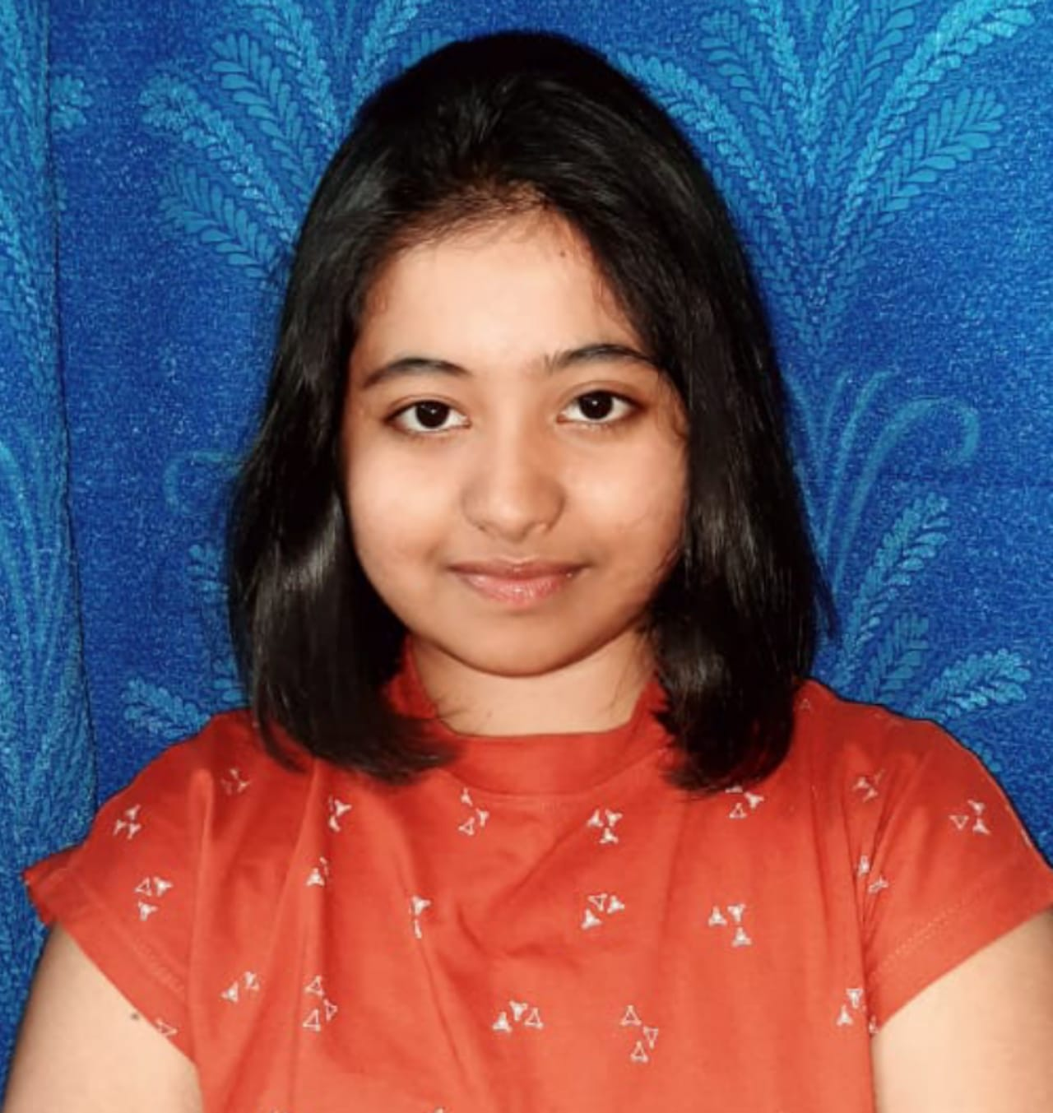



CURRICULUM VITAE

1. **PERSONAL DETAILS :**
   1. **Name**: Sonali Nandi
   2. **Date of Birth**: 1 3 1 2 2 0 0 2 DD/MM/YYYY
   3. **Guardian’s Name:** Ratan Nandi
   4. **B.Tech :** 2021-2025
   5. **Branch / Specialization:** Computer Science & Engineering
   6. **Registration No :** 21U10470
   7. **OP / SC/ ST/ OBC / PWD :** OP
   8. **Male/Female:** Female
   9. **Present Address:** Vill +P.O – Matikumra , P.S – Ranaghat , Dist – Nadia , Pin – 741201, West Bengal
   10. **Address for Correspondence:** Vill +P.O – Matikumra , P.S – Ranaghat , Dist – Nadia , Pin – 741201, West Bengal

* 1. **E-Mail Id**: [nandi.sonali023@gmail.com](mailto:nandi.sonali023@gmail.com) **Cell No:** +919800944588
  2. **GitHub :** [Sonali](https://github.com/sonalinandi023)

1. **EDUCATIONAL QUALIFICATIONS :**

* 1. **Secondary & Higher Secondary :**

|  |  |  |  |  |  |
| --- | --- | --- | --- | --- | --- |
| **Examination** | **Board / Institution** | **Year of Passing** | **Marks** | | |
| **Obtained** | **Out of (Total)** | **%** |
| 10th Std | WEST BENGAL BOARD OF SECONDARY EDUCATION | 2018 | 639 | 700 | 91.28 |
| 12th Std | WEST BENGAL COUNCIL OF HIGHER SECONDARY EDUCATION | 2020 | 469 | 500 | 93.8 |

|  |  |  |  |  |  |  |  |  |
| --- | --- | --- | --- | --- | --- | --- | --- | --- |
| **SEM** | **1** | **2** | **3** | **4** | **5** | **6** | **7** | **8** |
| **SGPA** | 8.84 | 7.78 | 8.39 |  |  |  |  |  |
| **CGPA** | 8.84 | 8.36 | 8.37 |  |  |  |  |  |

* 1. **Graduation :**

1. **Scholastic achievements :**

* One of the top 3 students in school level upto 12th grade.
* Secured 2nd position in an inter-school quiz competition .

1. **Academic projects :**

* **Portfolio Website**

Designed a personal portfolio website to showcase my work and skills .

**Technologies used : HTML, CSS & Javascript .**

**GitHub Repo :** [Portfolio-Website](https://sonalinandi023.github.io/PortfolioWeb/)

* Movie Website – (API based Application)

Developed a movie website that allows user to browse movies,view movie details and search for movies based on different categories .

Technologies used : HTML, CSS, Javascript, ReactJS .

**GitHub Repo :** [Movie-Website](https://sonalinandi023.github.io/myMovie)

* Book Reading Website – (API based Application)

A book reading website that enables user to search for books ,view book details and read books online.

Technologies used : HTML, CSS, Javascript, ReactJS .

**GitHub Repo :** [Book-Website](https://sonalinandi023.github.io/myBook/)

1. **Skills :**

* **Technical Skills :**
* Programming Languages – C/C++, Javascript, Python
* Technologies – HTML, CSS, Windows, Linux
* **Soft Skills :**
* Communication ,Time Management , Leadership , Teamwork, Hardworking

1. **Position of responsibility:**

* **School Prefecture** position in school (2015-2019).

1. **Extracurricular activities :**

* Passionate about reading detective novels
* Dancing
* Drawing

I hereby declare that the information given above is true and correct.

**DATE: 22/03/2023** **SIGNATURE:** 