WEEK 3
DATA VISUALIZATION AND REPORTING
Agricultural Production and Yield Analysis Across Indian States and Districts
Internship: Junior Data Analyst – Agribusiness
Dataset period: 2017–18 to 2022–23
Tools: Python, Pandas, Matplotlib, Google Colab
Prepared as a visualization design and analytical reporting document

Executive Summary
This report presents a visualization plan and analytical interpretation for a cleaned Indian agricultural dataset containing state- and district-level area, production and yield measures across six agricultural years (2017–18 to 2022–23). The purpose is to convert tabular records into clear visual evidence that can support agribusiness monitoring, comparison and further investigation.
The analysis produced year-wise summaries, state and district production rankings, a yield distribution review, and an IQR-based screening of unusually high yield values. The reported total area increased from 186.03 million hectares in 2017–18 to 200.64 million hectares in 2022–23. The calculated weighted yield varied across the period, reaching 107.55 in 2022–23 after a low of 67.24 in 2020–21. The latest-year state ranking placed Tamil Nadu, Karnataka and Kerala highest by the recorded production totals.
A key limitation emerged: the source-labelled yield values are mathematically consistent with production divided by area, but the scale of some district values is unusually high. In addition, 153 of 738 valid 2022–23 yield records exceeded the pooled IQR upper threshold of 16.59. These values were not removed or altered. They are treated as statistical flags requiring source metadata and domain validation.
The document combines completed analytical charts with proposed visualization blueprints, explains why each chart type is suitable, discusses tools, and recommends improvements for a production-ready agribusiness dashboard.

1. Project Background and Objectives
Agribusiness decisions depend on understanding how cultivated area, production and yield change over time and differ across locations. Raw spreadsheets can contain hundreds of district records and multiple annual measures, making it difficult to identify patterns quickly. Data visualization helps analysts communicate changes, compare regions, identify unusual observations and direct attention to questions that need further investigation.

1.1 Objectives
- Summarise agricultural area, production and calculated weighted yield over six years.
- Compare recorded production across states and districts for 2022–23.
- Examine the distribution of reported yield values and flag unusually high observations using the IQR method.
- Design additional visualizations that could support agribusiness monitoring, including scatter plots, heatmaps and KPI cards.
- Explain the purpose, audience, design choices and limitations of each visualization.
- Recommend practical improvements for a clear, accurate and reusable analytical report.

2. Dataset and Analytical Preparation
The cleaned dataset used for this exercise contains 742 rows and 21 columns. It includes a serial number, State, District, and annual Area, Production and Yield measures for six agricultural years from 2017–18 through 2022–23. The data covers 35 state/territory labels and 736 distinct district names in the source records.
The cleaning work completed earlier in the project found 645 missing cells across 61 rows, including one missing District value. No duplicate rows were identified. Text whitespace in State and District fields was trimmed. Missing agricultural values were retained rather than automatically replaced with zero, because a missing value does not mean that production or area was zero.

2.1 Aggregation approach
For each year, the year-wise summary used records with both area and production present. Total area and total production were summed over those paired valid records. Weighted yield was calculated as total production divided by total area. This is preferable to taking a simple average of district yields when the objective is an area-weighted overall ratio.
For state and district comparisons, the latest year (2022–23) was selected. State totals were calculated by summing available district records. The top 10 rankings are rankings of recorded values in the supplied file and should not be interpreted as verified national rankings until the source definitions, unit scale and aggregation level have been checked.

2.2 Data-quality and interpretation cautions
- The source labels production in tonnes and yield in tonnes per hectare. However, some reported yields reach several thousand units per hectare, which is unusual and requires verification against the original source documentation.
- Reported yield is mathematically consistent with Production / Area in the examined records. This confirms internal arithmetic consistency, not necessarily that the unit labels or source values are correct.
- The IQR threshold is calculated across all valid districts together. Different crop mixes, agro-climatic conditions, district sizes or reporting conventions can make pooled outlier flags appear concentrated in particular states.
- Outliers are not automatically errors. No flagged records were deleted, winsorised or changed.
- Some year-wise totals use different numbers of valid records (683 in 2017–18 and 738 in 2022–23). Changes may partly reflect changing data coverage as well as real agricultural change.

3. Key Metrics for Agribusiness Visualization
Metric | Definition / calculation | Why it matters
Total cultivated area | Sum of valid area records for a year or region | Shows the scale of land represented in the dataset.
Total production | Sum of valid production records | Measures recorded output and supports regional comparison.
Weighted yield | Total production ÷ total area | Summarises output per unit area while accounting for area size.
District record count | Number of valid district observations included | Provides context about coverage and comparability.
Yield distribution | Distribution of district yield values | Shows spread, skewness and unusual observations.
IQR flag | Yield > Q3 + 1.5 × IQR | Screens for unusually high values for further investigation.
Outlier percentage | Flagged records ÷ valid records × 100 | Compares flagged share while accounting for different state sample sizes.

4. Completed Visualizations and Findings

4.1 Year-wise agricultural area trend — line graph
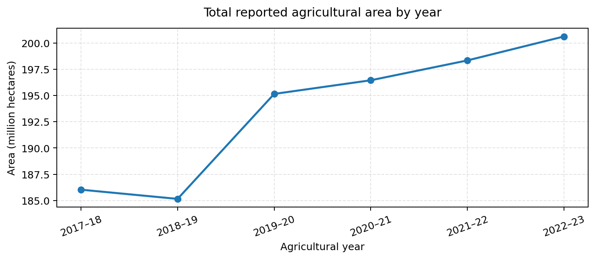
Figure 1. Year-wise total area, displayed in millions of hectares.
Rationale: A line graph is suitable for ordered time periods because it makes direction and turning points easy to see. The chart shows a small decline from 186.03 million hectares in 2017–18 to 185.15 million in 2018–19, followed by increases in each subsequent year, reaching 200.64 million hectares in 2022–23. The chart supports monitoring of the area represented in the dataset. It does not, by itself, explain why area changed.

4.2 Year-wise production trend — line graph
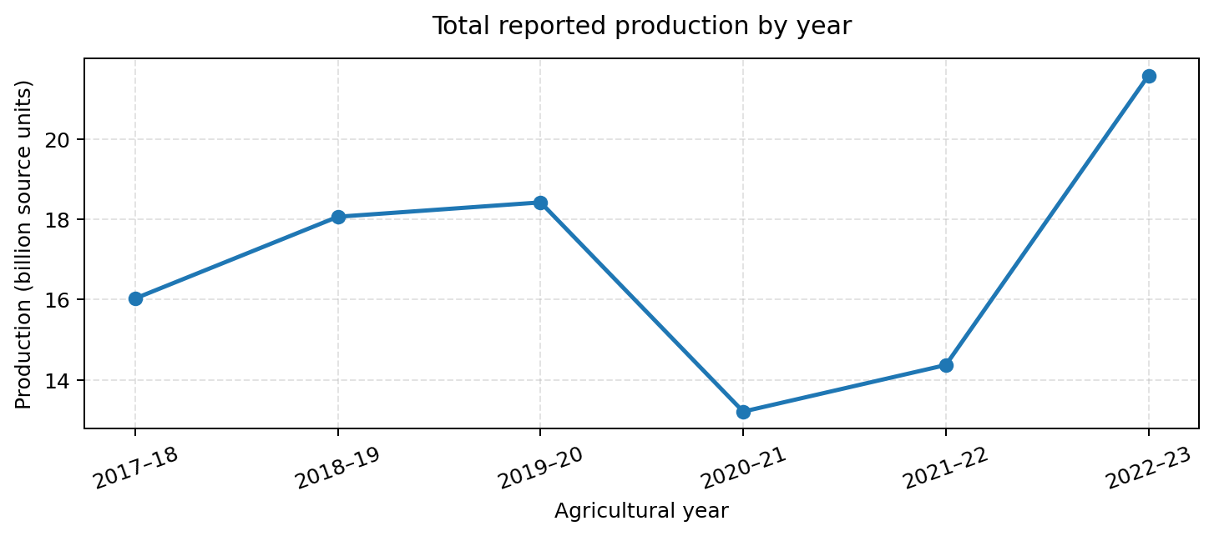
Figure 2. Total recorded production by year, displayed in billions of source-labelled units.
Rationale: The line graph communicates year-to-year movement in production. Recorded production increased from approximately 16.03 billion in 2017–18 to 18.42 billion in 2019–20, fell to 13.21 billion in 2020–21, and then rose to 21.58 billion in 2022–23. Before interpreting the change as a real production increase or decrease, the analyst should verify consistent units, crop coverage, reporting methods and completeness across years.

4.3 Weighted yield trend — line graph
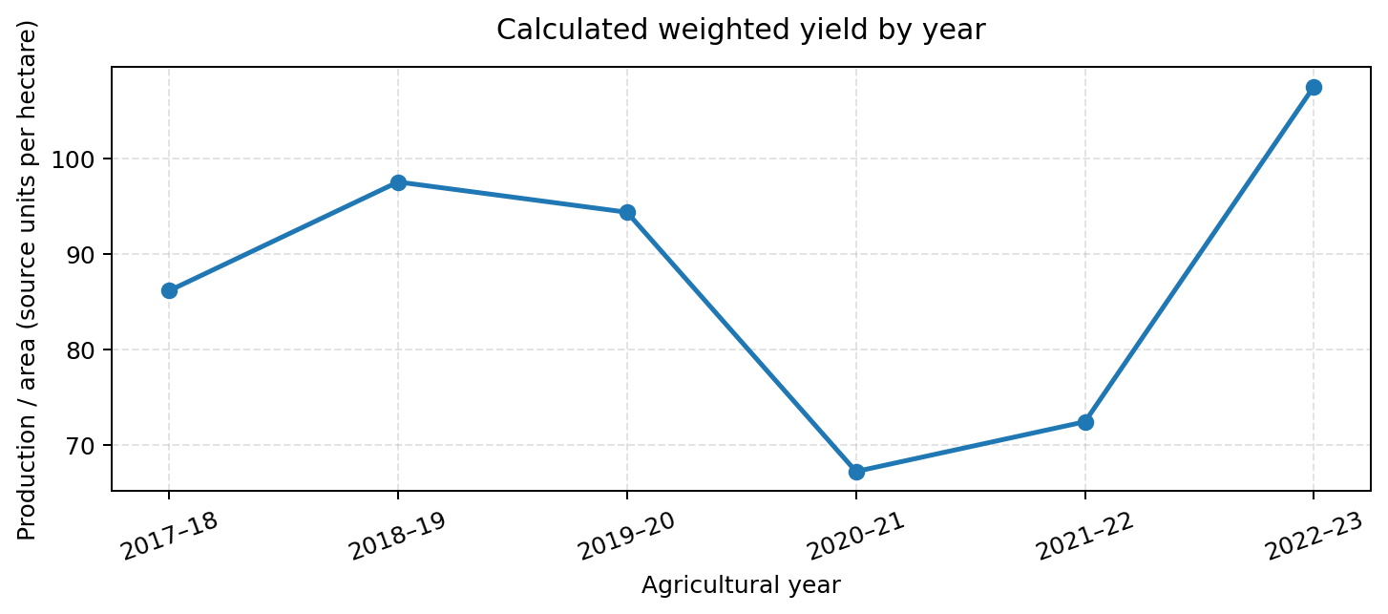
Figure 3. Calculated weighted yield (total production divided by total area).
Rationale: A line graph is appropriate for comparing an annual efficiency-style indicator over time. The calculated weighted yield was 86.16 in 2017–18, rose to 97.55 in 2018–19, fell to 67.24 in 2020–21 and reached 107.55 in 2022–23. Values are reported in the source-derived ratio units; the unit scale must be validated before communicating them as tonnes per hectare.

4.4 State production ranking — horizontal bar chart
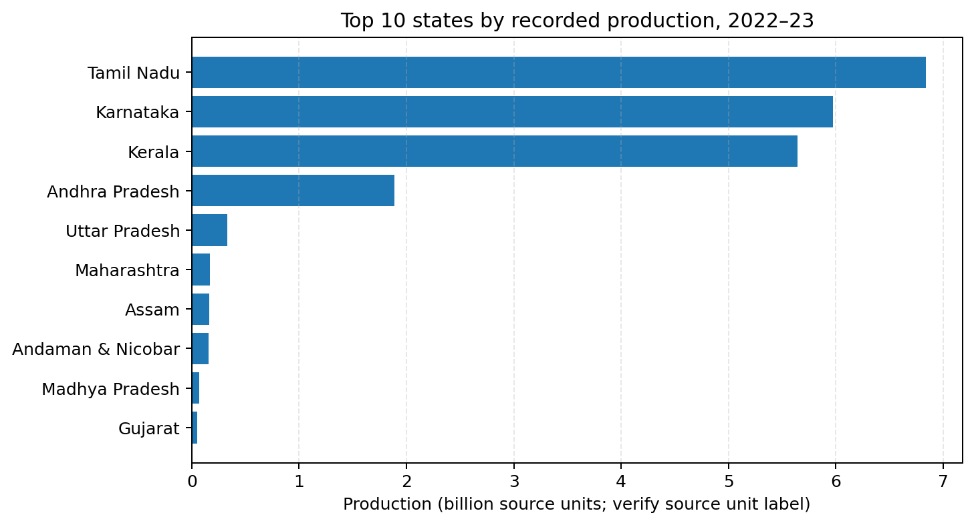
Figure 4. Ten states with the highest recorded production in 2022–23.
Rationale: A horizontal bar chart is effective for ranking categories with long names. Tamil Nadu had the largest recorded total (about 6.84 billion source units), followed by Karnataka (5.97 billion) and Kerala (5.64 billion). Andhra Pradesh followed at about 1.89 billion. The chart makes the difference between the first three and the remaining states immediately visible. Rankings should be treated as dataset-specific until unit and aggregation definitions are confirmed.

4.5 District production ranking — horizontal bar chart
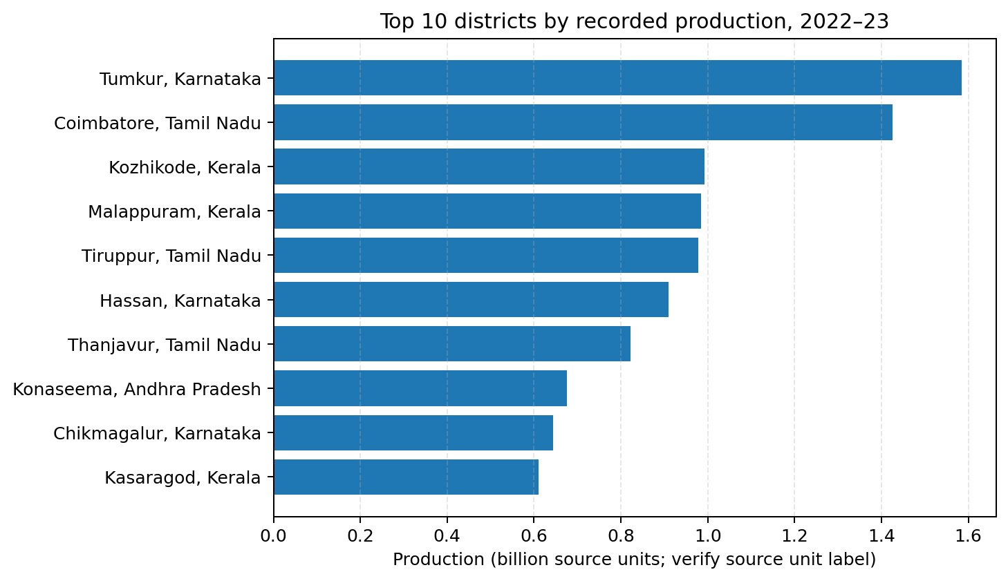
Figure 5. Ten districts with the highest recorded production in 2022–23.
Rationale: District-level ranking helps identify locations that contribute the largest recorded totals and may merit deeper crop- or supply-chain analysis. Tumkur (Karnataka) recorded approximately 1.585 billion source units, followed by Coimbatore (Tamil Nadu) at 1.426 billion and Kozhikode (Kerala) at 0.992 billion. A horizontal bar chart supports clear label reading and ranking.

4.6 Yield distribution — histogram
Rationale: A histogram groups numerical yield observations into bins and shows the shape of the distribution. A logarithmic horizontal axis is useful here because the distribution is strongly right-skewed: most values are much smaller than the largest values. The chart generated in the analysis helps show the concentration of observations at the lower end and the long upper tail. The exact distribution should be interpreted alongside source definitions and regional context.

4.7 State-wise high-yield outlier percentage — horizontal bar chart
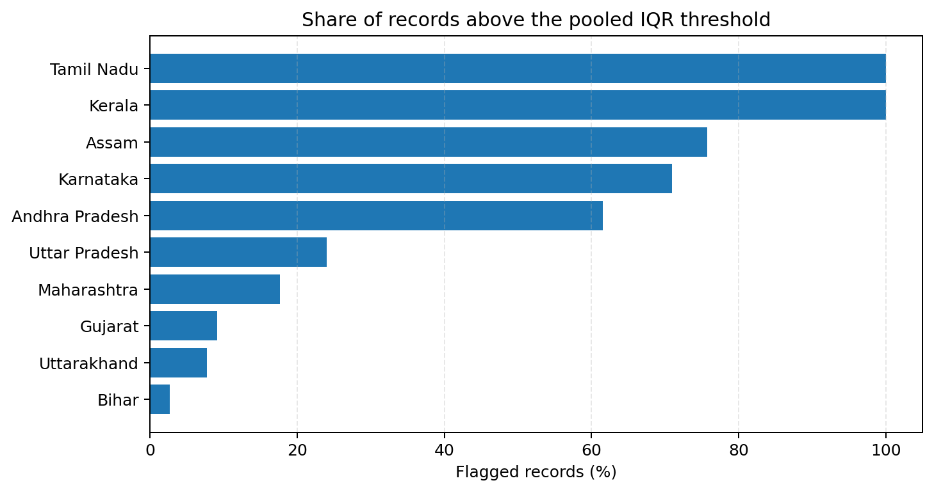
Figure 6. State-wise share of valid 2022–23 records above the pooled IQR threshold; states with at least 10 valid records.
Rationale: Percentages are more comparable than raw counts when states have different numbers of valid district records. Among states with at least 10 records, Tamil Nadu and Kerala had 100% of records above the pooled threshold, Assam 75.76%, Karnataka 70.97%, Andhra Pradesh 61.54%, and Odisha 0% (30 valid records). These results are descriptive flags, not a judgement of data quality or agricultural performance. The pooled threshold may not be suitable for comparing unlike regional populations.

5. Outlier Detection Method and Results
The Interquartile Range (IQR) method was used on the 2022–23 reported yield column. Q1 (25th percentile) was 2.26 and Q3 (75th percentile) was 8.00. The IQR was approximately 5.73. The upper screening threshold was calculated as Q3 + 1.5 × IQR, giving approximately 16.59. A total of 153 out of 738 valid records exceeded this threshold, representing approximately 20.7% of the valid observations.
The highest reported yield in the records examined was 9,708.30. The median was 3.27. This gap indicates a strongly right-skewed distribution. Tamil Nadu contributed 38 flagged records, Assam 25 and Karnataka 22. However, the state-wise rates reveal that the flags are not evenly distributed.
The pooled IQR method is a first-pass screening technique. A stronger follow-up would calculate outliers within comparable groups (for example, crop, year, state or agro-climatic zone), inspect source metadata, and check whether the observations represent different units or aggregation practices. Records should only be corrected after evidence from the source or domain expert supports a correction.

6. Additional Visualization Blueprints and Mockup Designs
The following designs extend the completed analysis into a practical agribusiness reporting dashboard. They are proposed layouts; they should be populated only when the required fields are available and validated.

6.1 KPI summary cards
Card | Display | Design note
Area | Total area for selected year | Large number, unit, year and comparison with previous year.
Production | Total production for selected year | Show source unit explicitly and include data coverage.
Weighted yield | Production ÷ area | Show formula and unit; suppress interpretation until unit validation.
Coverage | Valid records / expected records | Make missingness and coverage visible, not hidden.

6.2 Scatter plot: area versus production
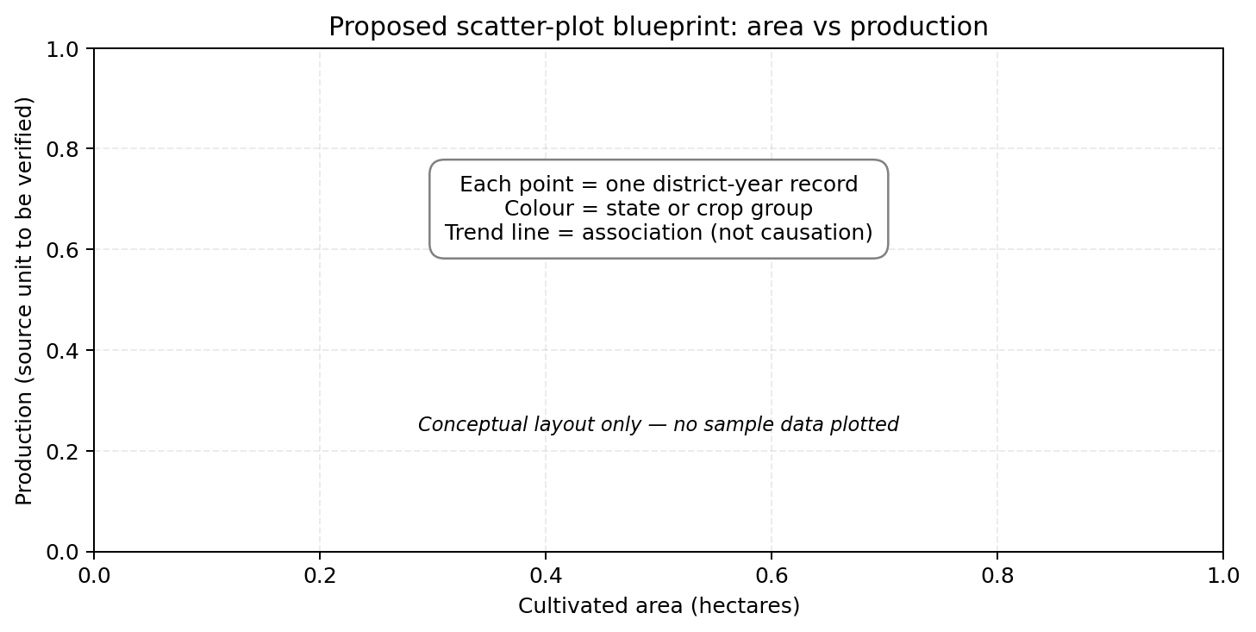
Figure 7. Conceptual scatter-plot layout only; no fabricated observations are plotted.
Purpose: Each point would represent a district-year (or district-crop-year) observation. Area would be placed on the horizontal axis and production on the vertical axis. Colour could represent state or crop, while point size could represent cultivated area. A scatter plot can reveal association, clusters and unusual observations. It cannot establish causation. Before use, the dataset should include clearly defined comparable units and ideally crop-level detail.

6.3 State-by-year heatmap
Proposed design: rows represent states and columns represent agricultural years. Cell colour represents weighted yield or percentage change in production. A heatmap is useful for spotting regional patterns and years that differ from a state's usual range. Use a colour scale with a labelled legend, display missing cells distinctly, and avoid comparing raw values if the units or crop composition differ.

6.4 Production composition chart
Proposed design: a 100% stacked bar chart can show each state's share of the selected-year total, provided the production values are comparable and the denominator is clearly defined. This is useful for communicating contribution rather than absolute size. If there are many states, show the leading contributors and group the remainder as 'Other' only when that aggregation is explained.

6.5 Small-multiple trend charts
Proposed design: create a small line chart for each selected state, using the same year range and consistent scales where appropriate. Small multiples make regional trajectories easier to compare without forcing all state labels into one crowded chart. They are especially useful for identifying states whose trends differ from the national pattern.

7. Visualization Rationale and Best Practices
Analytical question | Recommended visual | Reason for selection
How has a metric changed over time? | Line graph | Time order and turning points are immediately visible.
Which states or districts rank highest? | Sorted horizontal bar chart | Supports accurate category comparison and readable labels.
How are yield values distributed? | Histogram; box plot | Shows skew, spread and unusual values.
Is area associated with production? | Scatter plot | Shows relationship, clusters and potential anomalies.
How do states differ across years? | Heatmap or small multiples | Reveals patterns across two dimensions.
What is the current overall position? | KPI cards | Provides a quick summary with units and coverage.

- Use descriptive titles that state the metric, geography and period.
- Label both axes and include units. Never rely on the reader to infer units.
- Sort bar charts by value and use a zero baseline for ordinary bar comparisons.
- Use line charts for ordered time periods, not unordered categories.
- Keep colours consistent across charts and use colour palettes that remain legible for colour-vision deficiencies.
- Avoid 3D effects, excessive decoration and unnecessary gridlines.
- Show missing-data coverage and sample size wherever comparisons may be affected by incomplete records.
- Use annotations to explain important changes, but do not imply causes that the data cannot establish.
- Use logarithmic scales only when clearly labelled and explained.

8. Tools and Technology Discussion
Tool | Role in this project | Reason / trade-off
Python | Analysis workflow and reproducibility | Flexible, scriptable and suitable for repeatable data preparation and chart generation.
Pandas | Loading, cleaning, grouping and summarising tabular data | Efficient for district-year data and missing-value checks.
Matplotlib | Line graphs, bar charts and histograms | Provides detailed control over chart layout, labels and export quality.
Google Colab | Cloud notebook environment | Runs Python in a browser and supports sharing and step-by-step documentation.
Microsoft Excel | Quick inspection and simple reporting | Accessible for reviewers and useful for pivot tables and quick checks.
Power BI / Tableau | Potential interactive dashboard tools | Useful for filters, drill-downs and stakeholder-facing reports; requires validated data model and measures.

Python, Pandas and Matplotlib were selected for the current analysis because they support transparent calculations and repeatable charts. Google Colab reduces setup requirements and keeps code, outputs and explanations together. Power BI or Tableau would be suitable next steps if stakeholders need interactive filtering by year, state, district or crop. Excel remains useful for quick validation and sharing summary tables.

9. Recommendations for Improvement
- Verify the original data dictionary and source metadata for the exact units of area, production and yield, including whether production is reported in tonnes, kilograms or another unit.
- Confirm whether records represent individual crops, crop aggregates, district totals or another reporting grain before summing across rows.
- Add crop name, season, irrigation status, price, input cost and market-arrival fields if available. These would support richer agribusiness analysis beyond production volume.
- Show valid-record counts and missing-value percentages alongside every annual or state-level metric.
- Compare like with like: calculate yield distributions within crop and year, or within appropriate regional groups, rather than relying only on one pooled national threshold.
- Add year-over-year percentage change, but calculate it only after checking consistent coverage and units.
- Use a dashboard filter for year, state and crop, with drill-down from state to district.
- Add data validation checks for impossible or unusual values and maintain an audit log of any correction supported by source evidence.
- Include a short methodology note and a source citation on every report page or dashboard tab.

10. Conclusion
The Week 3 work demonstrates how cleaned agricultural data can be transformed into a set of visual summaries for time trends, regional rankings and distribution analysis. Line graphs communicate the six-year movement in area, production and weighted yield. Horizontal bar charts support state and district comparisons. The histogram and IQR screening identify a highly right-skewed yield distribution and records that require further checking.
The strongest analytical lesson is that visualization must be paired with data validation. A visually clear ranking can still be misleading if units, aggregation level or data coverage are not understood. The next stage should verify the source definitions, examine outliers within comparable groups and expand the data model with crop and market variables. With these controls, the proposed visualizations can form a useful foundation for an agribusiness monitoring dashboard.

Appendix A. Year-wise Summary
Year | Total area (ha) | Total production (source units) | Weighted yield (source units/ha) | Valid records
2017–18 | 186,025,929 | 16,027,640,000 | 86.16 | 683
2018–19 | 185,148,808 | 18,061,150,000 | 97.55 | 687
2019–20 | 195,158,706 | 18,418,650,000 | 94.38 | 705
2020–21 | 196,459,301 | 13,210,140,000 | 67.24 | 709
2021–22 | 198,351,067 | 14,369,720,000 | 72.45 | 715
2022–23 | 200,636,276 | 21,577,880,000 | 107.55 | 738

Note: Production and yield figures are transcribed from the analysis output. The source's unit labels require verification before external or policy use.

Appendix B. Top 10 State Production Results, 2022–23
State | Area (ha) | Production (source units) | District records
Tamil Nadu | 5,535,342 | 6,837,861,000 | 38
Karnataka | 13,422,383 | 5,971,213,000 | 31
Kerala | 1,304,105 | 5,644,652,000 | 14
Andhra Pradesh | 5,670,254 | 1,885,394,000 | 26
Uttar Pradesh | 27,019,353 | 329,820,500 | 75
Maharashtra | 22,427,355 | 168,256,700 | 34
Assam | 3,304,015 | 165,212,600 | 33
Andaman and Nicobar Islands | 30,007 | 153,429,900 | 3
Madhya Pradesh | 30,049,183 | 72,230,260 | 52
Gujarat | 11,004,161 | 51,262,210 | 33

Appendix C. Outlier Screening Summary
Item | Result
Valid 2022–23 yield records | 738
Q1 | 2.26
Q3 | 8.00
IQR | 5.73
Upper IQR threshold | 16.59
Records above threshold | 153
Share of valid records | 20.7%
Median reported yield | 3.27
Maximum reported yield | 9,708.30

The outlier percentage by state was calculated from each state's valid record count. States with small samples (for example, two or three records) should not be compared without considering sample size. The main comparison chart therefore focuses on states with at least ten valid records.

Appendix D. Reproducibility and Submission Checklist
- Save the Colab notebook as Week_3_Data_Visualization.ipynb.
- Keep the seven PNG charts in a clearly named Week_3_Charts folder or ZIP.
- Keep the cleaned dataset separate from temporary analysis files.
- Ensure the report, notebook and charts use matching year labels and metric definitions.
- Upload the DOC/DOCX report to the internship portal and include the GitHub repository link if required.
- Do not claim that outliers were corrected or that source units were validated until evidence is obtained.

