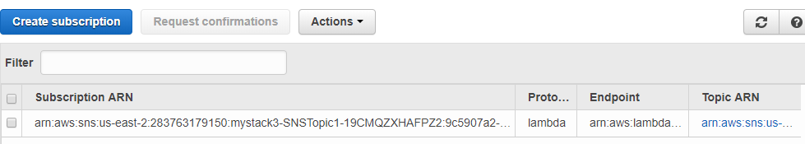

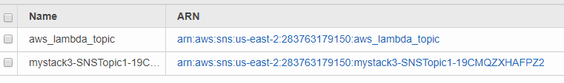



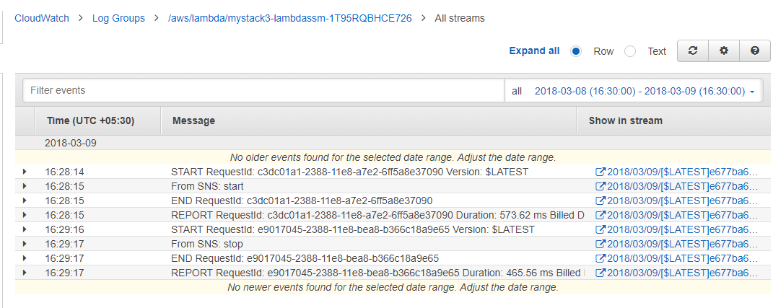

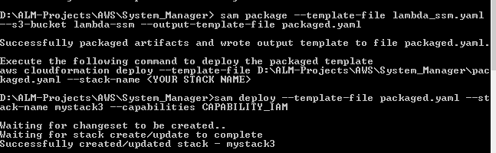

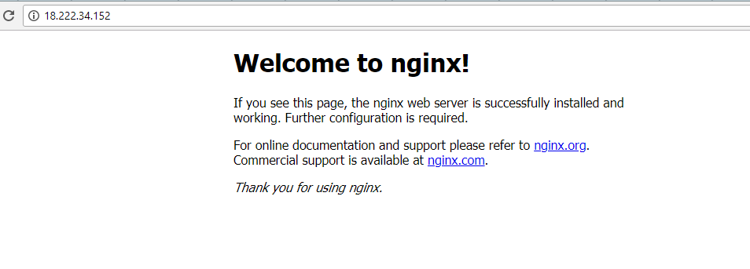

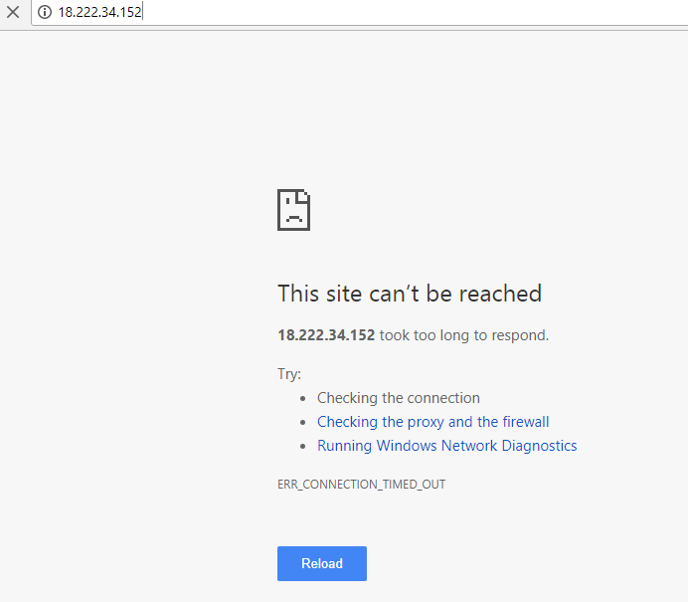

Refer the following :

<https://github.com/awslabs/aws-sam-local#main-features>

# Package SAM template

sam package --template-file lambda_ssm.yaml --s3-bucket lambda-ssm --output-template-file packaged.yaml

# Deploy packaged SAM template

sam deploy --template-file packaged.yaml --stack-name mystack2 --capabilities CAPABILITY_IAM

* Install npm on your windows machine
* Check whether npm is installed correctly or not by typing **node –v**
* npm install -g aws-sam-local
* Verify the installation worked:
* sam --version
* **Upgrading via npm**
* To update **sam** once installed via npm:
* npm update -g aws-sam-local