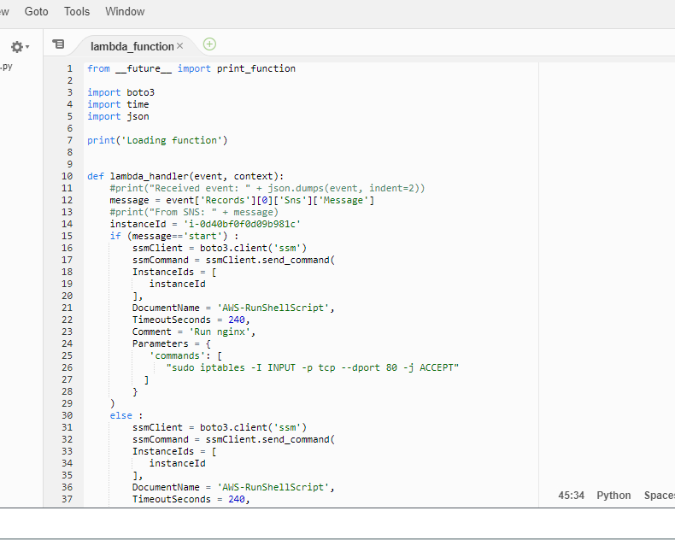

Automatic creation of Run command through Lambda function

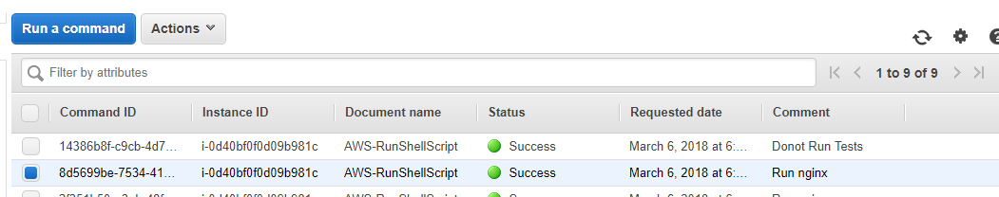

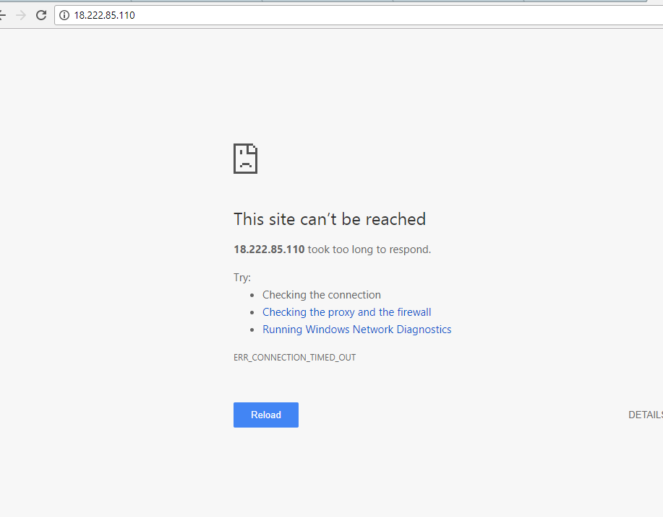

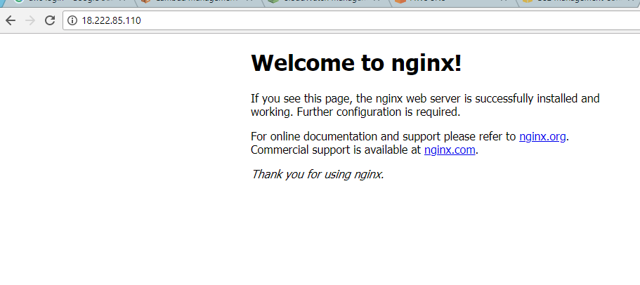

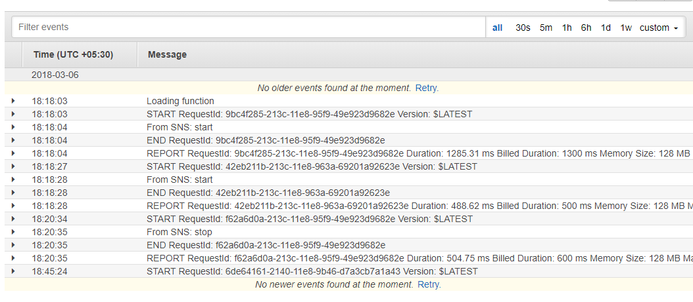

**#function_name.lambda_handler name ------- CodeUri: s3://lambda-ssm/lambda_ssm.zip**