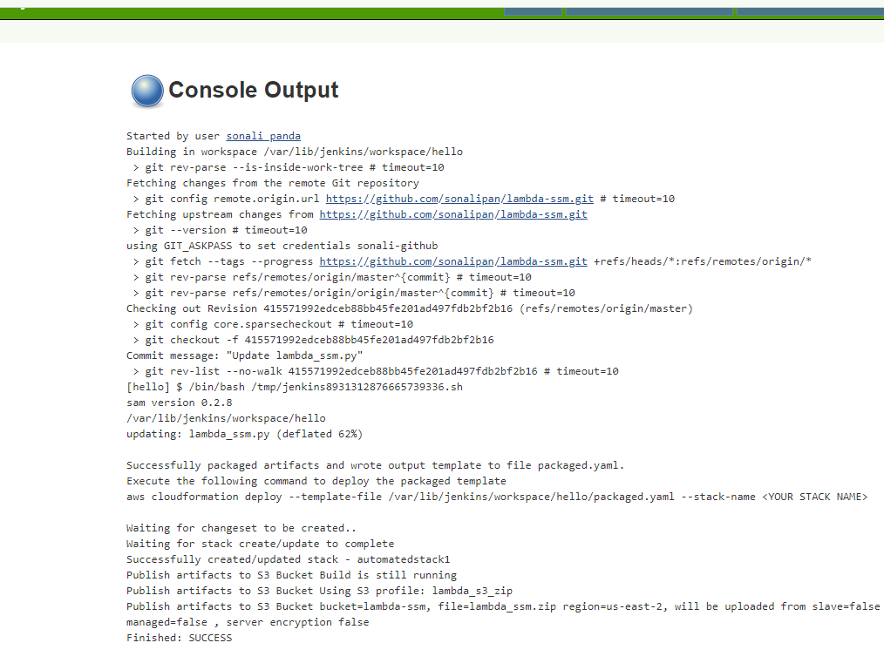

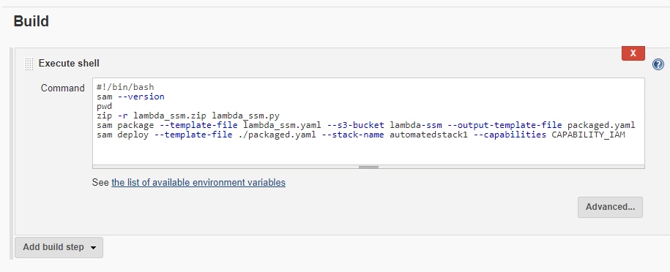

Go to Manage Jenkins->Configure System->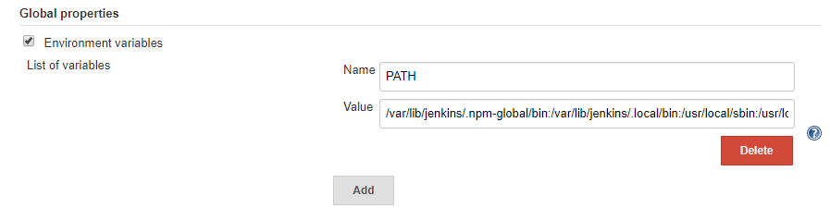

The value of PATH variable:

/var/lib/jenkins/.npm-global/bin:/var/lib/jenkins/.local/bin:/usr/local/sbin:/usr/local/bin:/usr/sbin:/usr/bin:/sbin:/bin:/usr/games:/usr/local/games



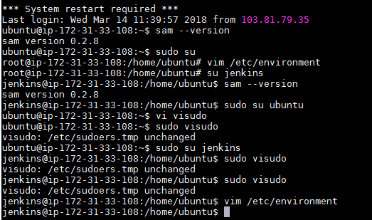

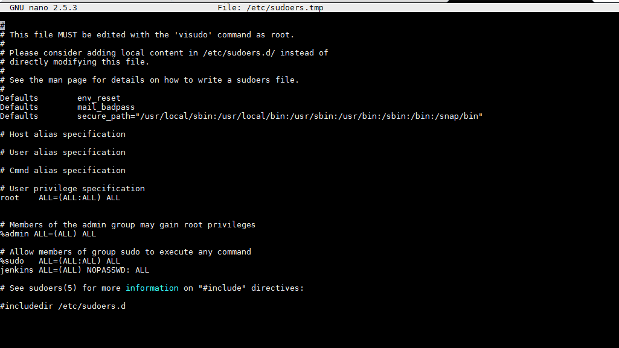

**Inside vim/environment**

PATH="/var/lib/jenkins/.npm-global/bin:/var/lib/jenkins/.local/bin:/usr/local/sbin:/usr/local/bin:/usr/sbin:/usr/bin:/sbin:/bin:/usr/games:/usr/local/games"

JAVA_HOME="/usr/lib/jvm/java-8-openjdk-amd64/"