--1. Total Revenue:

SELECT CAST(

SUM(quantity*unit_price) AS DECIMAL(10,3)) AS total_revenue

FROM pizza;

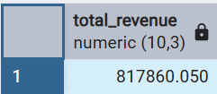

--2. Average Order Value

SELECT SUM(total_price)/COUNT(*) AS avg_order_value

FROM pizza;

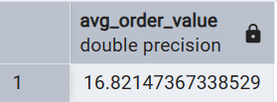

--3. Total Pizzas Sold

SELECT SUM(quantity) AS total_pizza_sold

FROM pizza;

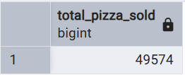

--4. Total Orders

SELECT COUNT(DISTINCT order_id) AS total_orders

FROM pizza;

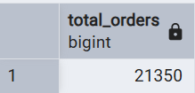

--5. Average Pizzas Per Order

SELECT SUM(quantity)/COUNT(DISTINCT order_id) AS avg_pizza_per_order

FROM pizza;

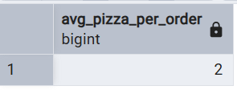

--B. Daily Trend for Total Orders

SELECT

TO_CHAR(order_date, 'DAY') AS order_day,

COUNT(*)

FROM pizza

GROUP BY 1

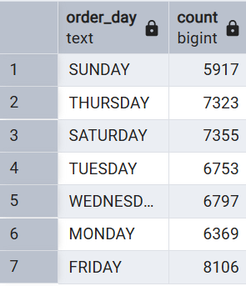

--C. Monthly Trend for Orders

SELECT

TO_CHAR(order_date, 'MONTH') AS order_month,

COUNT(*)

FROM pizza

GROUP BY 1;

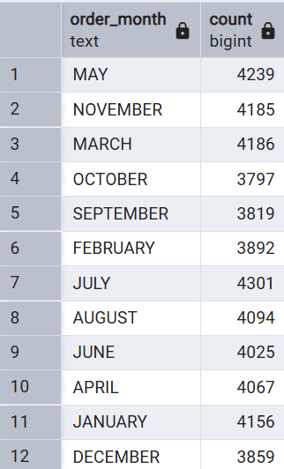

--D. % of Sales by Pizza Category

SELECT pizza_category,

SUM(total_price) AS total_revenue,

CAST(SUM(total_price)*100.0/(SELECT SUM(total_price) FROM pizza) AS DECIMAL(5,2)) AS percentage_sale_by_category

FROM pizza

GROUP BY 1;

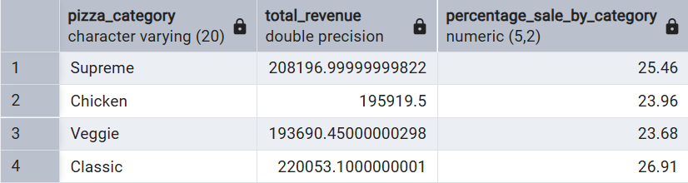

--E. % of Sales by Pizza Size

SELECT pizza_size,

SUM(total_price) AS total_revenue,

CAST(SUM(total_price)*100.0/(SELECT SUM(total_price) FROM pizza) AS DECIMAL(5,2)) AS percentage_sale_by_size

FROM pizza

GROUP BY 1;

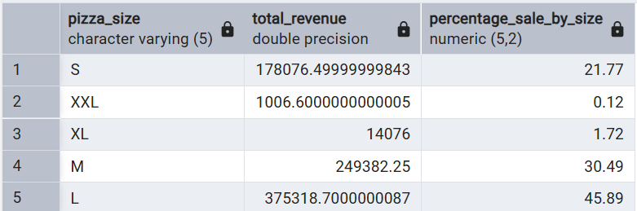

--F. Top 5 Pizzas by Quantity

SELECT pizza_name,

SUM(quantity) AS total_sold_qty

FROM pizza

GROUP BY 1

ORDER BY 2 DESC

LIMIT 5;

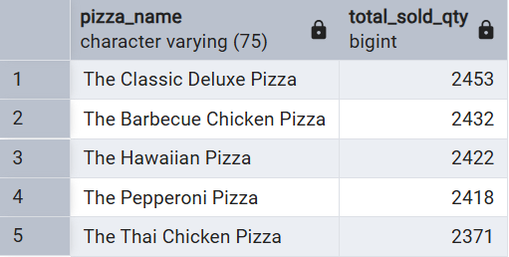

--G. Bottom 5 Pizzas by Quantity

SELECT pizza_name,

SUM(quantity) AS total_sold_qty

FROM pizza

GROUP BY 1

ORDER BY 2

LIMIT 5;

