------JUNIT------
1.what is test and why junit
2.what is Maven
3.assertions and anonations
4.test lifecycle
5.j unit file architecture
6.UNIT TEST = it is small piece of code that calls ur code and checks the whether it produces the expected result.
Eg..Before selling a cake, you test a small slice to check its taste and quality. Similarly, in software development, we test a small piece of code to check whether it works correctly.
With test u press one button nowhether everything works.
Junit file is library that

Every test follows 3 steps:
Arragnge act assert
1 Arrange: Prepare the data.
2 Act: Run the code.
3 Assert: Check whether the output is correct
What is maven?
Maven is a project management and build automation tool used in Java to manage dependencies, compile code, and run tests.
-It downloads the libraries like junit.
-It compiles code for you.
-Runs ur test with one command.
Analogy of Maven:
Imagine you are a chef, and you write a recipe (Java code).
Maven is your kitchen manager. You give it a shopping list (pom.xml), and it downloads the required ingredients (libraries), prepares everything, runs the tests, and helps build the final product.
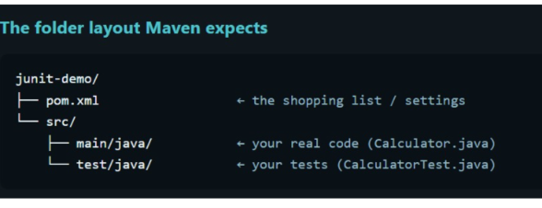
Syntax:
1. mvn -v — Checks the Maven version and verifies that Maven is available in the terminal.
2. mvn test — Compiles the required code and runs the test cases.
3. mvn clean test — Deletes previous build files, compiles the code, and runs the test cases.
Steps for junit testing:
Design – understand the problems statement and write the pseudo code
Write code
Write test
Run the test(junit)

Junit platform :-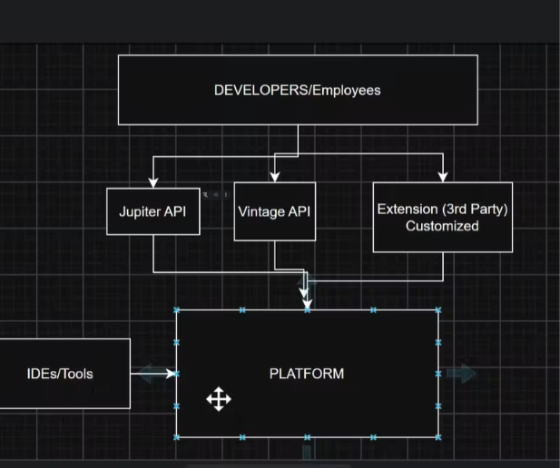

2.Junit Jupiter
The new programming model: @Test, @BeforeEach, assertions. Also contains the engine that runs Jupiter tests.
It is used by develpoers while writing a test.
3.Junit vintage
A compatibility engine that runs old junit three and four test on the new platform. It is used by old project that haven’t yet migrated.
Analogy: JUnit Platform is a movie theatre. 🎬
- JUnit Platform: The theatre building and overall system where different types of movies can be shown.
- Jupiter: Modern movies. It is used to write and run new JUnit 5 tests.
- Vintage: Old movies. It supports older JUnit tests written using JUnit 3 and JUnit 4.
- Test Engine: Like the ticket counter, it identifies which type of movie is being shown and helps the theatre run it.
- Test cases: The movies being shown.
Example: Imagine the theatre can show both modern and old movies. The theatre doesn't care whether the movie is new or old; it provides a place to show both.
Similarly, the JUnit Platform supports both Jupiter and Vintage test engines, allowing modern and older tests to run on the same platform.
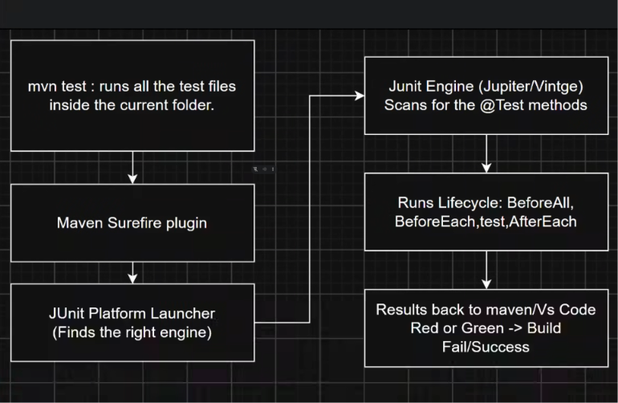
(it’s the diagram of the how the code run).
Types of testing :
1.unit testing : testing ofan individual unit or method.
2.integration testing : testig of multiple modules together, to test if system behave properly when wired together. Does intended behavior .
Use case 1: service -> repo. -> db
Wired multiple modules of one component .
1.u invoke method in service layer.
2. verify that dependencies injection works correctly.
3.the flow should react data base layer.
4. your test can assert that data was persisted in db

Service A ->

3.Functional testing:

