Software Requirements Specification (SRS)
Pennywise – Expense Tracker with Monthly Wrapped
1. Project Selection & Team Formation
1.1 Project Selection
The selected project is Pennywise, an expense tracking system designed for UPI users to monitor, analyze, and understand their personal spending behavior. The system integrates conventional expense tracking with a Monthly Wrapped feature, which presents spending insights in a visual, story-based format inspired by music analytics platforms.
The project was selected because:
- UPI-based transactions dominate digital payments in India
- Users lack awareness of cumulative spending due to frictionless payments
- The project is feasible within a single academic semester
- It enables practical application of software engineering principles
1.2 Team Composition and Roles
Team Member | Role | Responsibilities
Senna Krishna | Project Manager | Planning, scheduling, coordination, instructor liaison
Abhishek Girish | Lead Developer | Architecture design, implementation, database management
S Sonali | QA Lead | Test case design, validation, defect tracking
Neha Nakte | Documentation Lead | SRS preparation, formatting, documentation control

2. Team Agreement (Working Norms)
Pennywise Team Working Agreement
Meeting Schedule:
- Weekly Meetings: Every Saturday, 5:00 PM - 6:00 PM (College Library,/Group Study Room/Virtual Meeting)
- Emergency Meetings: As needed, minimum 1 day notice via WhatsApp group
- Duration: Maximum 1 hour per meeting (we all have other subjects too)

Communication:
- Primary: WhatsApp group "SEAD Project"
- Document Sharing: Google Drive shared folder
- Code Sharing: GitHub repository
- Response Time: Within 24 hours for non-urgent, within 3 hours for urgent
Work Distribution Principles:
- Everyone contributes equally
- Tasks assigned based on expertise
- Honest communication if workload gets too much
Decision Making:
- Minor decisions: Discuss in WhatsApp, majority votes wins
- Major decisions: Discuss in meetings, must reach consensus
- Tie-breaker: Project Manager has final call after hearing everyone
Quality Standards:
- Review each other's work before finalizing
- If something's not good enough, we redo it together
Conflict Resolution:
- Talk it out directly first
- If unresolved, involve the whole team
- If still stuck, approach lab instructor
- NO ghosting team members or passive aggression
What We Promise Each Other:
- Show up to meetings or inform in advance
- Complete assigned tasks on time or ask for help early
- Respect each other's ideas even if we disagree
- Have fun while learning - we're in this together!
Signatures: [All 4 members sign/date]

3. Problem Statement Development
3.1 Problem Definition
UPI-based digital payments enable rapid transactions with minimal effort, resulting in reduced spending awareness among users. Individuals often fail to track small but frequent expenses, leading to budget overruns and poor financial discipline. Existing expense tracking solutions are either overly complex, subscription-based, or lack engagement.
3.2 Affected Users
- UPI users across age groups
- Working professionals
- College students
- Homemakers
- Freelancers and gig workers
- Individuals managing fixed monthly budgets
3.3 Proposed Solution
Pennywise is an expense tracking system that allows users to manually record expenses, categorize spending, set budgets, and receive periodic insights. A Monthly Wrapped module summarizes user spending behaviour using visual storytelling techniques to improve engagement and retention.
4. Stakeholder Analysis
4.1 Primary Stakeholders
- UPI Users
  - Direct users of the system
  - Responsible for entering expenses and viewing insights
4.2 Secondary Stakeholders
- Family members (parents/spouses)
- Financial advisors (via shared reports)
- College or organizational administrators (aggregated usage insights)
4.3 Tertiary Stakeholders
- Development team
- Project guide and lab instructors
- Future developers and maintainers
5. Stakeholder Interests and Influence
Stakeholder | Primary Interest | Influence
UPI Users | Expense awareness, insights | High
Family Members | Financial transparency | Medium
System Administrator | Stability and maintenance | Medium
Project Guide | Learning outcomes | High

6. Stakeholder Register
ID | Stakeholder | Category | Interest | Influence
STK-01 | UPI Users | Primary | High | High
STK-02 | Family Members | Secondary | Medium | Medium
STK-03 | System Administrator | Support | Medium | Medium
STK-04 | Project Guide | Evaluator | High | High

7. Scope Definition – In Scope
The following features are included within the scope of the system:
- User authentication
- Manual expense entry
- Expense categorization
- Monthly and category-wise budgeting
- Dashboard with visual analytics
- Monthly Wrapped (visual summary of spending patterns)
- Report generation (monthly summaries)
8. Scope Definition – Out of Scope
The following features are excluded from the current scope:
- Automatic expense import from UPI apps or banks
- SMS or email parsing
- Investment or loan tracking
- Group expense splitting
- Advertisements or data monetization
- Advanced AI-based predictions
9. Scope Boundaries Document
The system boundaries are defined as follows:
- Single-user expense tracking
- Manual data entry only
- No direct integration with UPI platforms
- Desktop or standalone execution environment
10. SRS Introduction
10.1 Purpose
This document specifies the functional and non-functional requirements for the Pennywise expense tracking system.
10.2 Scope
The scope includes expense tracking, budgeting, analytics, and Monthly Wrapped reporting for UPI users.
10.3 Definitions and Acronyms
- UPI: Unified Payments Interface
- SRS: Software Requirements Specification
- QA: Quality Assurance

11. Overall Description
11.1 Product Perspective
Pennywise is a standalone expense tracking application.
11.2 Product Functions
- Record expenses
- Categorize transactions
- Display dashboards
- Generate Monthly Wrapped summaries
11.3 User Characteristics
Users are expected to have basic digital literacy and familiarity with UPI payments.
11.4 Constraints
- Academic semester timeline
- Limited development resources
- No paid third-party APIs
12. Functional Requirements
FR-01: User Authentication
The system shall allow users to authenticate using credentials.
Acceptance Criteria: Valid users gain system access.
FR-02: Add Expense
The system shall allow users to record expenses with amount, category, and date.
Acceptance Criteria: Expense is saved and reflected in summaries.
FR-03: Monthly Wrapped Generation
The system shall generate a monthly visual summary of user spending.
Acceptance Criteria: Wrapped displays correct aggregated insights for the selected month.
13. Non-Functional Requirements
NFR-01: Usability
The system shall be easy to use for non-technical users.
NFR-02: Performance
Expense entry shall complete within 2 seconds.
NFR-03: Reliability
The system shall preserve user data during normal operation.
NFR-04: Maintainability
The system shall be modular and documented for future maintenance.
14. Use Case Diagrams
Use case diagrams shall include:
- Add Expense
- View Dashboard
- View Monthly Wrapped
(Provided in Appendix) 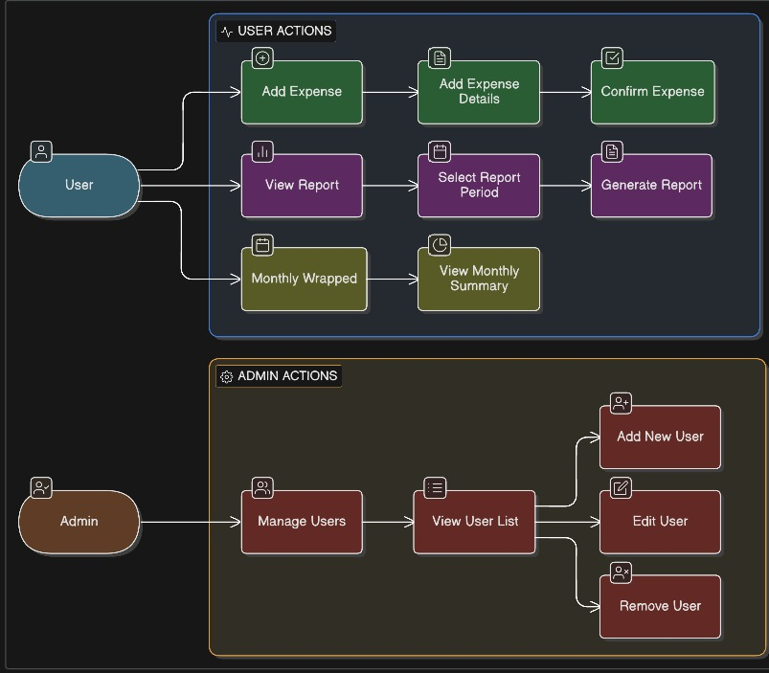

15. Glossary
Term | Definition
Monthly Wrapped | Visual monthly spending summary
Expense | Monetary transaction recorded by user
Category | Classification of expenses

16. Project Charter
The project charter defines objectives, stakeholders, roles, scope, and constraints for Pennywise.
17. Stakeholder Register
A formal stakeholder register is maintained as a separate artifact.
18. Complete SRS Document
This document constitutes the complete Software Requirements Specification for Pennywise.
19. Requirements Sign-Off
Name | Role | Signature | Date
Project Guide | Approver | ______ | ______

