Capstone Project - The Battle of Neighborhoods (Week 2)

**Topic: Indian Restaurants in New York City**

Indians constitute one of the largest and fastest growing ethnicities in the New York city of the United States. The Indian population also represents the second-largest metropolitan within the New York City. New York City is a home to nearly 8.6 million people. Over the last decade the city has been growing faster than the region. The New York region continues to be by far the leading metropolitan gateway for legal immigrants admitted into the United States. People from all over India live in New York city, with diverse culture, there are many Indian restaurants in New York City, each belonging to different categories like North Indian food or south Indian and many more.

1. **Introduction:**

The idea of this project is to help people to search Indian restaurant in New York city, choose the right location by providing data, rating and different cuisines.

To provide people the necessary information I'll be combining New York city data that contains list of Boroughs, Neighborhoods along with their latitude and longitude and Foursquare API to collect competitors on the same neighborhoods

1. **Data Set:**

As part of this project, we will list and visualize all major parts of New York City that has great Indian restaurants.

1. New York City data that contains list Boroughs, Neighborhoods along with their latitude and longitude**.**

Data: <https://cocl.us/new_york_dataset>

1. Indian restaurants in each neighborhood of New York city.

Data: Foursquare API

1. GeoSpace data

Data: <https://data.cityofnewyork.us/City-Government/Borough-Boundaries/tqmj-j8zm>

## **Methodology:**

## Methodology section which represents the main component of the report where you discuss and describe any exploratory data analysis that you did. For this report I used a few different maps that could help a new investor to decide the best restaurant in New York City based on its cuisine, rating type of the food, population.

## Using Foursquare API, we will find all venues for each neighborhood.

## Filter out all venues that are Indian Restaurants.

## Find rating, tips and like count for each Indian Restaurants using Foursquare API.

## Using rating for each restaurant, we will sort that data

1. **Analysis:**

We see that queens have highest number of neighborhoods

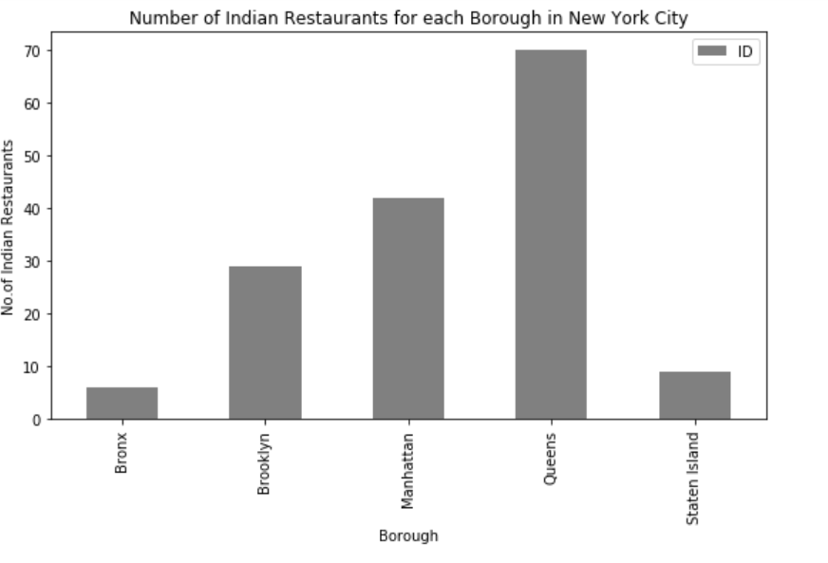

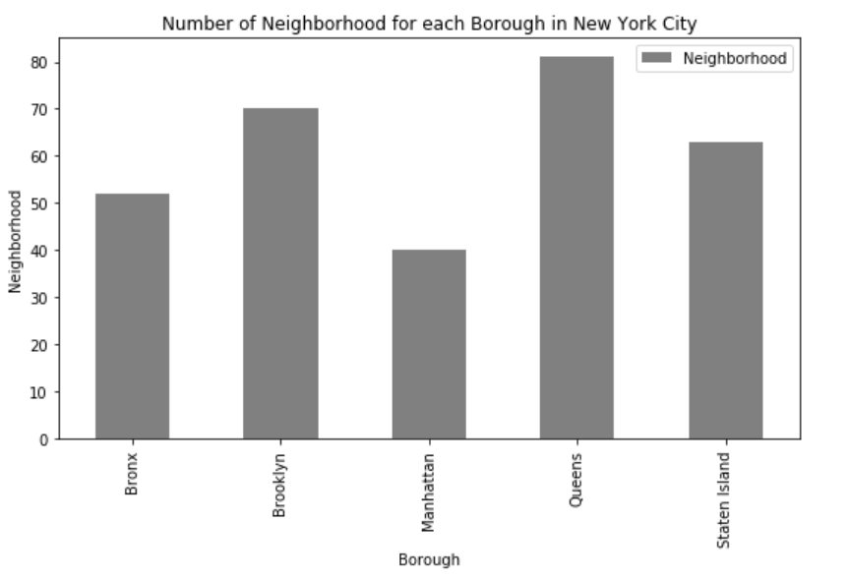

## We see that Queens have more Indian Restaurants

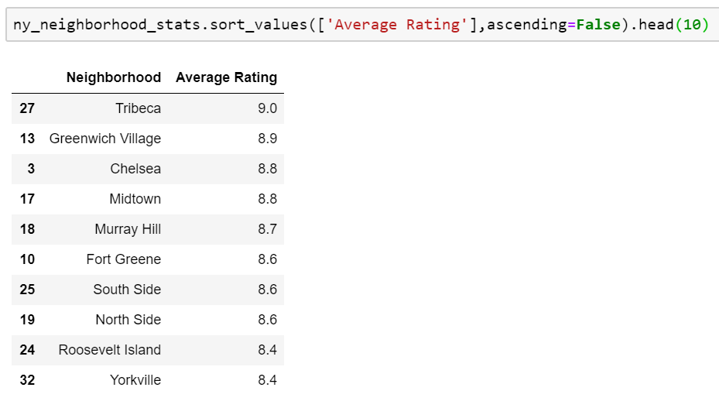

Decision is made on the average rating of the restaurants.

## **Results:**

## Results section where you discuss the results. We see that which neighborhood has the highest number average rating of restaurants.

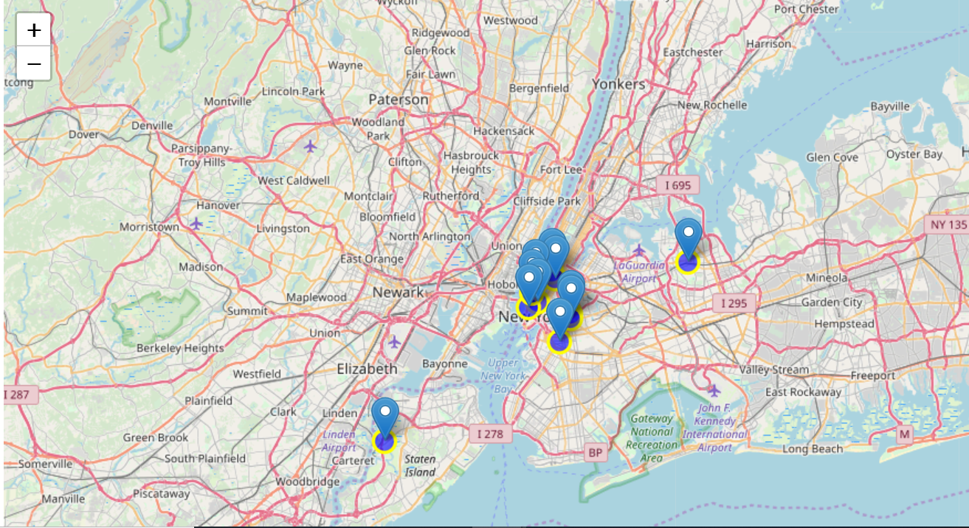

## **Conclusion**:

## Conclusion section where you conclude the report. This report may be helpful for people for find the best location in New York City for Indian Cuisine. areas that lack Indian Restaurants, best place to stay if I prefer Indian Cuisine, the accuracy of data depends on the data provided by Foursquare