STEPS TO FOLLOW:
1. Create Folder naming hello
2. three files add in folder hello
3.python install 3.13
4.cross check with open cmd and write in cmd<< python
5.google cloud sdk recent
6.google cloud sdk opening and adding gmail account
7.gcloud init (command)
8. path where hello folder exist
9. cross check all files are present
10.set FLASK_APP=hello.py (command)
11.set FLASK_ENV=development (command)
12.python.exe -m pip install --upgrade pip (command)
13.pip install -r requirements.txt (command)
14.python -m flask run

APP.PY:
runtime: python313
entrypoint: gunicorn -b :$PORT hello:app

instance_class: F1

automatic_scaling:
min_instances: 0
max_instances: 1

HELLO.PY
from flask import Flask

app = Flask(__name__)

@app.route("/")
def hello():
return "Hello World from Google App Engine (Python 3.13)!"

if __name__ == "__main__":
app.run(host="127.0.0.1", port=8080, debug=True)

requirements.txt:
Flask==3.0.0
gunicorn==21.2.0

OUTPUT:
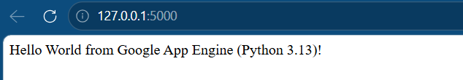

TERMINAL OUTPUT:
THIS IS LAST STEP:

C:\Users\91937\OneDrive\Desktop\Hello_1>python -m flask run
* Serving Flask app 'main.py'
* Debug mode: off
WARNING: This is a development server. Do not use it in a production deployment. Use a production WSGI server instead.
* Running on http://127.0.0.1:5000
Press CTRL+C to quit
127.0.0.1 - - [19/Apr/2026 11:58:29] "GET / HTTP/1.1" 200 -
127.0.0.1 - - [19/Apr/2026 11:58:34] "GET / HTTP/1.1" 200 -
127.0.0.1 - - [19/Apr/2026 11:59:07] "POST / HTTP/1.1" 200 -

