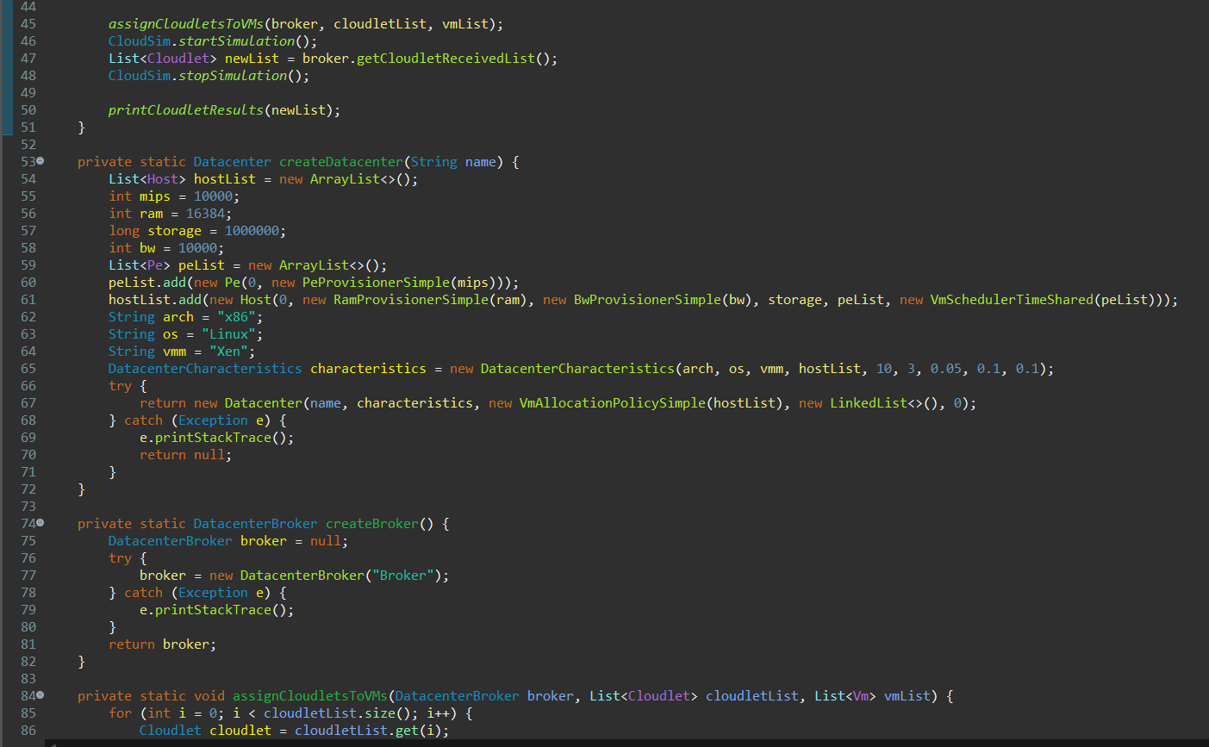
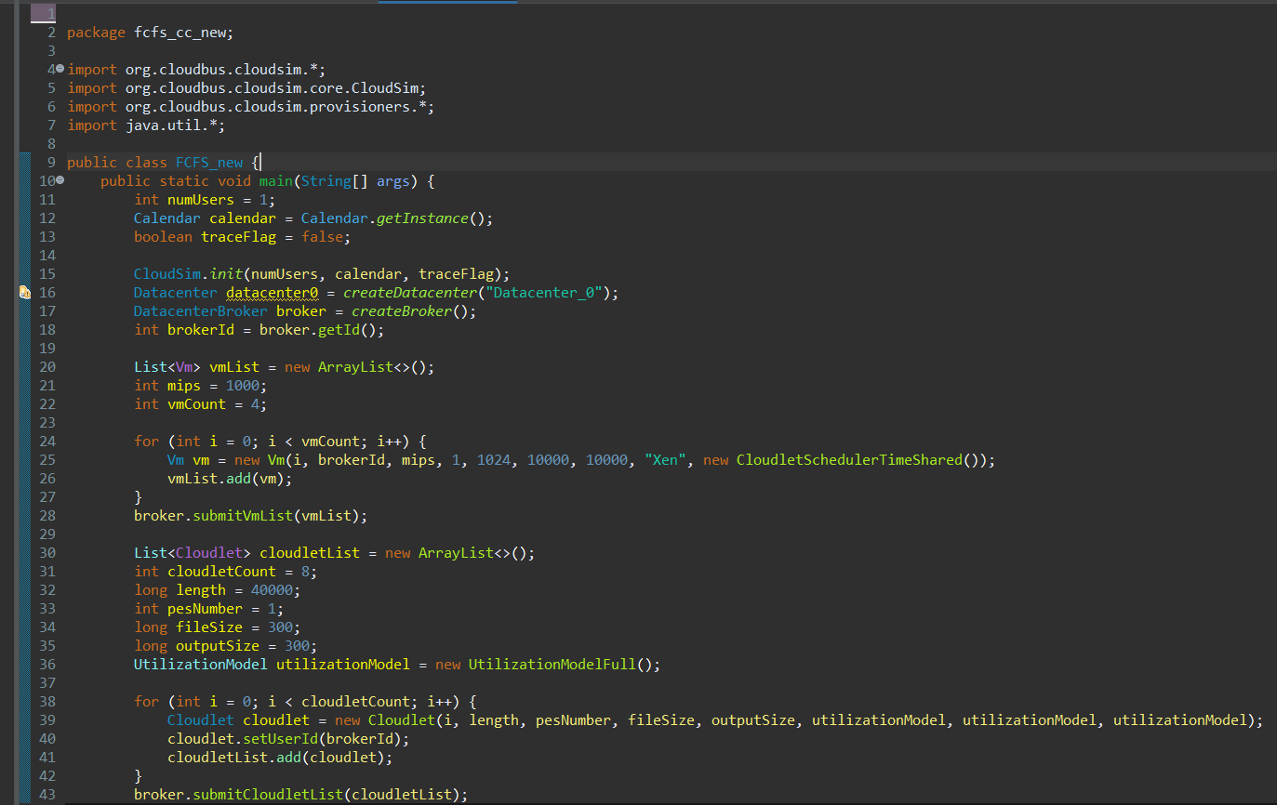
CODE FCFS:
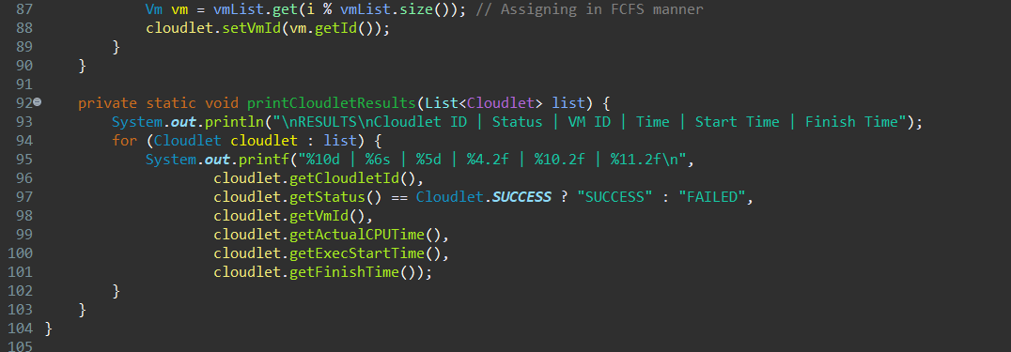
File Structure
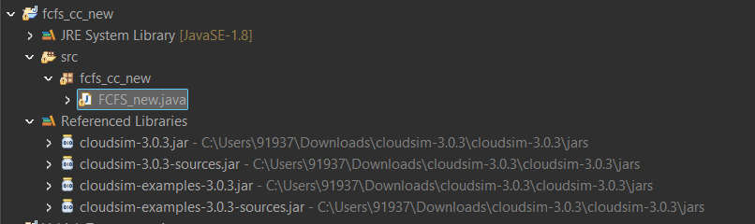
REQUIREMENT
- Clousim version 3.0.3 OR 4 aswell
- Java version which is compatible 8 or below

Steps
- Create java Project
- Select the javaSE 1.8 which is java 8 on pc
- Add the referenced libraries which is inside the souce in buide path by selecting the library section then add the external jar files .
- Cloudsim 3.0.3 or cloudsim4 aswell
- In source select new project as class
- Then paste your fcfs code their
- It will show the output change the package name and classname

OUTPUT
