Assignment 6

Sonali Singh

# **Logistic Regression Models for Voting Preferences**

### **EPPS6323 Knowledge Mining**

Instructor: Dr. Karl Ho

The logistic regression models analyzed the factors influencing voting for Tsai Ing-wen using the TEDS_2016 dataset. The models progress from simpler ones with fewer predictors to more complex ones including additional demographic and opinion variables.

# Knowledge Mining: Linear regression  
# File: Lab_linearregression01.R  
# Theme: Linear regression  
# Data: MASS, ISLR  
# Adapted from ISLR Chapter 3 Lab  
# Set CRAN mirror  
options(repos = c(CRAN = "https://cran.rstudio.com"))  
  
# Install necessary packages  
install.packages("haven")

## Installing package into '/Users/sonalisingh/Library/R/arm64/4.3/library'  
## (as 'lib' is unspecified)

##   
## The downloaded binary packages are in  
## /var/folders/xn/9hrlj2853_l2y50d525yjqyw0000gn/T//RtmprQtkR0/downloaded_packages

install.packages("MASS")

## Installing package into '/Users/sonalisingh/Library/R/arm64/4.3/library'  
## (as 'lib' is unspecified)

## Warning: package 'MASS' is not available for this version of R  
##   
## A version of this package for your version of R might be available elsewhere,  
## see the ideas at  
## https://cran.r-project.org/doc/manuals/r-patched/R-admin.html#Installing-packages

install.packages("ISLR")

## Installing package into '/Users/sonalisingh/Library/R/arm64/4.3/library'  
## (as 'lib' is unspecified)

##   
## The downloaded binary packages are in  
## /var/folders/xn/9hrlj2853_l2y50d525yjqyw0000gn/T//RtmprQtkR0/downloaded_packages

install.packages("arm")

## Installing package into '/Users/sonalisingh/Library/R/arm64/4.3/library'  
## (as 'lib' is unspecified)

##   
## The downloaded binary packages are in  
## /var/folders/xn/9hrlj2853_l2y50d525yjqyw0000gn/T//RtmprQtkR0/downloaded_packages

# Load the 'haven' package to use in your script  
library(haven)  
  
install.packages(c("easypackages","MASS","ISLR","arm"))

## Installing packages into '/Users/sonalisingh/Library/R/arm64/4.3/library'  
## (as 'lib' is unspecified)

## Warning: package 'MASS' is not available for this version of R  
##   
## A version of this package for your version of R might be available elsewhere,  
## see the ideas at  
## https://cran.r-project.org/doc/manuals/r-patched/R-admin.html#Installing-packages

##   
## The downloaded binary packages are in  
## /var/folders/xn/9hrlj2853_l2y50d525yjqyw0000gn/T//RtmprQtkR0/downloaded_packages

library(easypackages)  
libraries("arm","MASS","ISLR")

## Loading required package: arm

## Loading required package: Matrix

## Loading required package: lme4

##   
## arm (Version 1.14-4, built: 2024-4-1)

## Working directory is /Users/sonalisingh/Downloads/Lab

## All packages loaded successfully

## Load datasets from MASS and ISLR packages  
attach(Boston)  
  
library(haven)  
TEDS_2016 <- read_stata("https://github.com/datageneration/home/blob/master/DataProgramming/data/TEDS_2016.dta?raw=true")  
glm.vt <- glm(votetsai ~ female, data = TEDS_2016, family = binomial)  
  
summary(glm.vt)

##   
## Call:  
## glm(formula = votetsai ~ female, family = binomial, data = TEDS_2016)  
##   
## Coefficients:  
## Estimate Std. Error z value Pr(>|z|)   
## (Intercept) 0.54971 0.08245 6.667 2.61e-11 ***  
## female -0.06517 0.11644 -0.560 0.576   
## ---  
## Signif. codes: 0 '***' 0.001 '**' 0.01 '*' 0.05 '.' 0.1 ' ' 1  
##   
## (Dispersion parameter for binomial family taken to be 1)  
##   
## Null deviance: 1666.5 on 1260 degrees of freedom  
## Residual deviance: 1666.2 on 1259 degrees of freedom  
## (429 observations deleted due to missingness)  
## AIC: 1670.2  
##   
## Number of Fisher Scoring iterations: 4

plot(glm.vt)

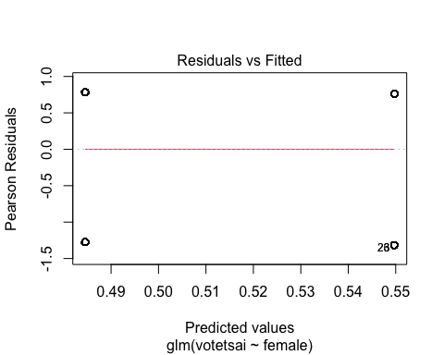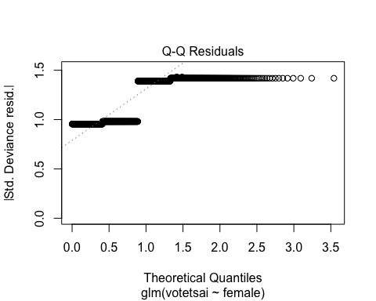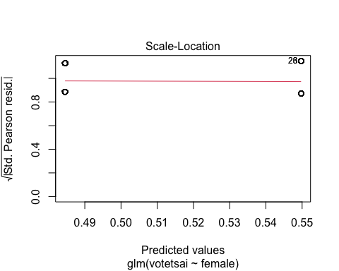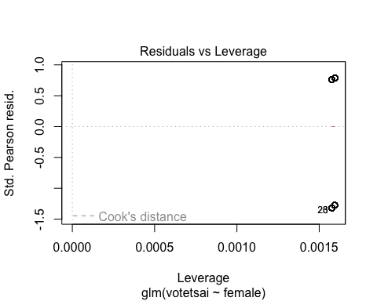

glm.vt <- glm(votetsai ~ female + KMT + DPP + age + edu + income, data = TEDS_2016, family = binomial)  
summary(glm.vt)

##   
## Call:  
## glm(formula = votetsai ~ female + KMT + DPP + age + edu + income,   
## family = binomial, data = TEDS_2016)  
##   
## Coefficients:  
## Estimate Std. Error z value Pr(>|z|)   
## (Intercept) 1.618640 0.592084 2.734 0.00626 **   
## female 0.047406 0.177403 0.267 0.78930   
## KMT -3.156273 0.250360 -12.607 < 2e-16 ***  
## DPP 2.888943 0.267968 10.781 < 2e-16 ***  
## age -0.011808 0.007164 -1.648 0.09931 .   
## edu -0.184604 0.083102 -2.221 0.02632 *   
## income 0.013727 0.034382 0.399 0.68971   
## ---  
## Signif. codes: 0 '***' 0.001 '**' 0.01 '*' 0.05 '.' 0.1 ' ' 1  
##   
## (Dispersion parameter for binomial family taken to be 1)  
##   
## Null deviance: 1661.76 on 1256 degrees of freedom  
## Residual deviance: 836.15 on 1250 degrees of freedom  
## (433 observations deleted due to missingness)  
## AIC: 850.15  
##   
## Number of Fisher Scoring iterations: 6

glm.vt <- glm(votetsai ~ female + KMT + DPP + age + edu + income + Independence + Econ_worse + Govt_dont_care + Minnan_father + Mainland_father + Taiwanese, data = TEDS_2016, family = binomial)  
summary(glm.vt)

##   
## Call:  
## glm(formula = votetsai ~ female + KMT + DPP + age + edu + income +   
## Independence + Econ_worse + Govt_dont_care + Minnan_father +   
## Mainland_father + Taiwanese, family = binomial, data = TEDS_2016)  
##   
## Coefficients:  
## Estimate Std. Error z value Pr(>|z|)   
## (Intercept) -0.015976 0.679780 -0.024 0.98125   
## female -0.097996 0.189840 -0.516 0.60571   
## KMT -2.922246 0.259333 -11.268 < 2e-16 ***  
## DPP 2.468855 0.275350 8.966 < 2e-16 ***  
## age 0.003287 0.007884 0.417 0.67672   
## edu -0.092110 0.090119 -1.022 0.30674   
## income 0.021771 0.036406 0.598 0.54984   
## Independence 1.020953 0.251776 4.055 5.01e-05 ***  
## Econ_worse 0.310462 0.189100 1.642 0.10063   
## Govt_dont_care -0.014295 0.188765 -0.076 0.93964   
## Minnan_father -0.247650 0.253921 -0.975 0.32941   
## Mainland_father -1.089332 0.396822 -2.745 0.00605 **   
## Taiwanese 0.909019 0.198930 4.570 4.89e-06 ***  
## ---  
## Signif. codes: 0 '***' 0.001 '**' 0.01 '*' 0.05 '.' 0.1 ' ' 1  
##   
## (Dispersion parameter for binomial family taken to be 1)  
##   
## Null deviance: 1661.76 on 1256 degrees of freedom  
## Residual deviance: 767.13 on 1244 degrees of freedom  
## (433 observations deleted due to missingness)  
## AIC: 793.13  
##   
## Number of Fisher Scoring iterations: 6

### Simple linear regression  
names(Boston)

## [1] "crim" "zn" "indus" "chas" "nox" "rm" "age"   
## [8] "dis" "rad" "tax" "ptratio" "black" "lstat" "medv"

# What is the Boston dataset?  
?Boston  
plot(medv~lstat,Boston, pch=20, cex=.8, col="steelblue")  
fit1=lm(medv~lstat,data=Boston)  
fit1

##   
## Call:  
## lm(formula = medv ~ lstat, data = Boston)  
##   
## Coefficients:  
## (Intercept) lstat   
## 34.55 -0.95

summary(fit1)

##   
## Call:  
## lm(formula = medv ~ lstat, data = Boston)  
##   
## Residuals:  
## Min 1Q Median 3Q Max   
## -15.168 -3.990 -1.318 2.034 24.500   
##   
## Coefficients:  
## Estimate Std. Error t value Pr(>|t|)   
## (Intercept) 34.55384 0.56263 61.41 <2e-16 ***  
## lstat -0.95005 0.03873 -24.53 <2e-16 ***  
## ---  
## Signif. codes: 0 '***' 0.001 '**' 0.01 '*' 0.05 '.' 0.1 ' ' 1  
##   
## Residual standard error: 6.216 on 504 degrees of freedom  
## Multiple R-squared: 0.5441, Adjusted R-squared: 0.5432   
## F-statistic: 601.6 on 1 and 504 DF, p-value: < 2.2e-16

abline(fit1,col="firebrick")

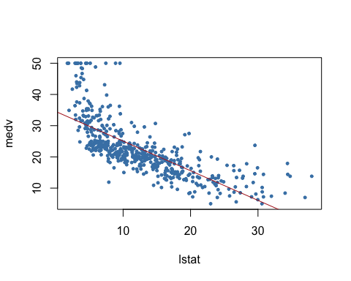

names(fit1)

## [1] "coefficients" "residuals" "effects" "rank"   
## [5] "fitted.values" "assign" "qr" "df.residual"   
## [9] "xlevels" "call" "terms" "model"

confint(fit1) # confidence intervals

## 2.5 % 97.5 %  
## (Intercept) 33.448457 35.6592247  
## lstat -1.026148 -0.8739505

# Predictions using values in lstat  
predict(fit1,data.frame(lstat=c(0,5,10,15)),interval="confidence") # confidence intervals

## fit lwr upr  
## 1 34.55384 33.44846 35.65922  
## 2 29.80359 29.00741 30.59978  
## 3 25.05335 24.47413 25.63256  
## 4 20.30310 19.73159 20.87461

predict(fit1,data.frame(lstat=c(0,5,10,15)),interval="prediction") # prediction intervals

## fit lwr upr  
## 1 34.55384 22.291923 46.81576  
## 2 29.80359 17.565675 42.04151  
## 3 25.05335 12.827626 37.27907  
## 4 20.30310 8.077742 32.52846

# Prediction interval uses sample mean and takes into account the variability of the estimators for μ and σ.  
# Therefore, the interval will be wider.  
  
### Multiple linear regression  
fit2=lm(medv~lstat+age,data=Boston)  
summary(fit2)

##   
## Call:  
## lm(formula = medv ~ lstat + age, data = Boston)  
##   
## Residuals:  
## Min 1Q Median 3Q Max   
## -15.981 -3.978 -1.283 1.968 23.158   
##   
## Coefficients:  
## Estimate Std. Error t value Pr(>|t|)   
## (Intercept) 33.22276 0.73085 45.458 < 2e-16 ***  
## lstat -1.03207 0.04819 -21.416 < 2e-16 ***  
## age 0.03454 0.01223 2.826 0.00491 **   
## ---  
## Signif. codes: 0 '***' 0.001 '**' 0.01 '*' 0.05 '.' 0.1 ' ' 1  
##   
## Residual standard error: 6.173 on 503 degrees of freedom  
## Multiple R-squared: 0.5513, Adjusted R-squared: 0.5495   
## F-statistic: 309 on 2 and 503 DF, p-value: < 2.2e-16

fit3=lm(medv~.,Boston)  
summary(fit3)

##   
## Call:  
## lm(formula = medv ~ ., data = Boston)  
##   
## Residuals:  
## Min 1Q Median 3Q Max   
## -15.595 -2.730 -0.518 1.777 26.199   
##   
## Coefficients:  
## Estimate Std. Error t value Pr(>|t|)   
## (Intercept) 3.646e+01 5.103e+00 7.144 3.28e-12 ***  
## crim -1.080e-01 3.286e-02 -3.287 0.001087 **   
## zn 4.642e-02 1.373e-02 3.382 0.000778 ***  
## indus 2.056e-02 6.150e-02 0.334 0.738288   
## chas 2.687e+00 8.616e-01 3.118 0.001925 **   
## nox -1.777e+01 3.820e+00 -4.651 4.25e-06 ***  
## rm 3.810e+00 4.179e-01 9.116 < 2e-16 ***  
## age 6.922e-04 1.321e-02 0.052 0.958229   
## dis -1.476e+00 1.995e-01 -7.398 6.01e-13 ***  
## rad 3.060e-01 6.635e-02 4.613 5.07e-06 ***  
## tax -1.233e-02 3.760e-03 -3.280 0.001112 **   
## ptratio -9.527e-01 1.308e-01 -7.283 1.31e-12 ***  
## black 9.312e-03 2.686e-03 3.467 0.000573 ***  
## lstat -5.248e-01 5.072e-02 -10.347 < 2e-16 ***  
## ---  
## Signif. codes: 0 '***' 0.001 '**' 0.01 '*' 0.05 '.' 0.1 ' ' 1  
##   
## Residual standard error: 4.745 on 492 degrees of freedom  
## Multiple R-squared: 0.7406, Adjusted R-squared: 0.7338   
## F-statistic: 108.1 on 13 and 492 DF, p-value: < 2.2e-16

par(mfrow=c(2,2))  
plot(fit3,pch=20, cex=.8, col="steelblue")  
mtext("fit3", side = 3, line = - 2, cex = 2, outer = TRUE)

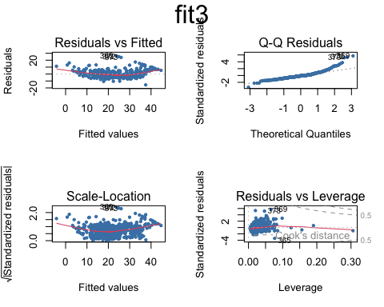

# Update function to re-specify the model, i.e. include all but age and indus variables  
fit4=update(fit3,~.-age-indus)  
summary(fit4)

##   
## Call:  
## lm(formula = medv ~ crim + zn + chas + nox + rm + dis + rad +   
## tax + ptratio + black + lstat, data = Boston)  
##   
## Residuals:  
## Min 1Q Median 3Q Max   
## -15.5984 -2.7386 -0.5046 1.7273 26.2373   
##   
## Coefficients:  
## Estimate Std. Error t value Pr(>|t|)   
## (Intercept) 36.341145 5.067492 7.171 2.73e-12 ***  
## crim -0.108413 0.032779 -3.307 0.001010 **   
## zn 0.045845 0.013523 3.390 0.000754 ***  
## chas 2.718716 0.854240 3.183 0.001551 **   
## nox -17.376023 3.535243 -4.915 1.21e-06 ***  
## rm 3.801579 0.406316 9.356 < 2e-16 ***  
## dis -1.492711 0.185731 -8.037 6.84e-15 ***  
## rad 0.299608 0.063402 4.726 3.00e-06 ***  
## tax -0.011778 0.003372 -3.493 0.000521 ***  
## ptratio -0.946525 0.129066 -7.334 9.24e-13 ***  
## black 0.009291 0.002674 3.475 0.000557 ***  
## lstat -0.522553 0.047424 -11.019 < 2e-16 ***  
## ---  
## Signif. codes: 0 '***' 0.001 '**' 0.01 '*' 0.05 '.' 0.1 ' ' 1  
##   
## Residual standard error: 4.736 on 494 degrees of freedom  
## Multiple R-squared: 0.7406, Adjusted R-squared: 0.7348   
## F-statistic: 128.2 on 11 and 494 DF, p-value: < 2.2e-16

# Set the next plot configuration  
par(mfrow=c(2,2), main="fit4")

## Warning in par(mfrow = c(2, 2), main = "fit4"): "main" is not a graphical  
## parameter

plot(fit4,pch=20, cex=.8, col="steelblue")  
mtext("fit4", side = 3, line = - 2, cex = 2, outer = TRUE)

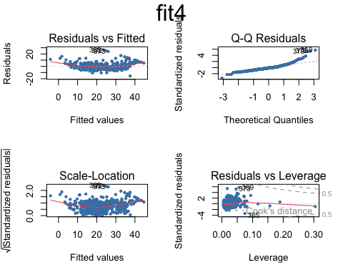

# Uses coefplot to plot coefficients. Note the line at 0.  
par(mfrow=c(1,1))  
arm::coefplot(fit4)

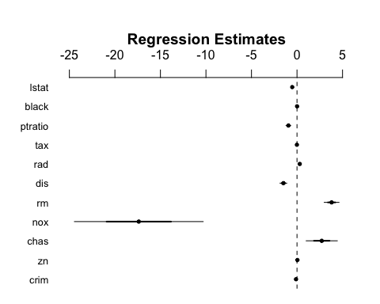

### Nonlinear terms and Interactions  
fit5=lm(medv~lstat*age,Boston) # include both variables and the interaction term x1:x2  
summary(fit5)

##   
## Call:  
## lm(formula = medv ~ lstat * age, data = Boston)  
##   
## Residuals:  
## Min 1Q Median 3Q Max   
## -15.806 -4.045 -1.333 2.085 27.552   
##   
## Coefficients:  
## Estimate Std. Error t value Pr(>|t|)   
## (Intercept) 36.0885359 1.4698355 24.553 < 2e-16 ***  
## lstat -1.3921168 0.1674555 -8.313 8.78e-16 ***  
## age -0.0007209 0.0198792 -0.036 0.9711   
## lstat:age 0.0041560 0.0018518 2.244 0.0252 *   
## ---  
## Signif. codes: 0 '***' 0.001 '**' 0.01 '*' 0.05 '.' 0.1 ' ' 1  
##   
## Residual standard error: 6.149 on 502 degrees of freedom  
## Multiple R-squared: 0.5557, Adjusted R-squared: 0.5531   
## F-statistic: 209.3 on 3 and 502 DF, p-value: < 2.2e-16

## I() identity function for squared term to interpret as-is  
## Combine two command lines with semicolon  
fit6=lm(medv~lstat +I(lstat^2),Boston); summary(fit6)

##   
## Call:  
## lm(formula = medv ~ lstat + I(lstat^2), data = Boston)  
##   
## Residuals:  
## Min 1Q Median 3Q Max   
## -15.2834 -3.8313 -0.5295 2.3095 25.4148   
##   
## Coefficients:  
## Estimate Std. Error t value Pr(>|t|)   
## (Intercept) 42.862007 0.872084 49.15 <2e-16 ***  
## lstat -2.332821 0.123803 -18.84 <2e-16 ***  
## I(lstat^2) 0.043547 0.003745 11.63 <2e-16 ***  
## ---  
## Signif. codes: 0 '***' 0.001 '**' 0.01 '*' 0.05 '.' 0.1 ' ' 1  
##   
## Residual standard error: 5.524 on 503 degrees of freedom  
## Multiple R-squared: 0.6407, Adjusted R-squared: 0.6393   
## F-statistic: 448.5 on 2 and 503 DF, p-value: < 2.2e-16

par(mfrow=c(1,1))  
plot(medv~lstat, pch=20, col="forestgreen")  
  
points(lstat,fitted(fit6),col="firebrick",pch=20)  
fit7=lm(medv~poly(lstat,4))  
points(lstat,fitted(fit7),col="steelblue",pch=20)

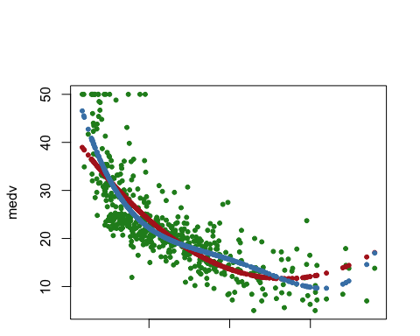

###Qualitative predictors  
names(Carseats)

## [1] "Sales" "CompPrice" "Income" "Advertising" "Population"   
## [6] "Price" "ShelveLoc" "Age" "Education" "Urban"   
## [11] "US"

summary(Carseats)

## Sales CompPrice Income Advertising   
## Min. : 0.000 Min. : 77 Min. : 21.00 Min. : 0.000   
## 1st Qu.: 5.390 1st Qu.:115 1st Qu.: 42.75 1st Qu.: 0.000   
## Median : 7.490 Median :125 Median : 69.00 Median : 5.000   
## Mean : 7.496 Mean :125 Mean : 68.66 Mean : 6.635   
## 3rd Qu.: 9.320 3rd Qu.:135 3rd Qu.: 91.00 3rd Qu.:12.000   
## Max. :16.270 Max. :175 Max. :120.00 Max. :29.000   
## Population Price ShelveLoc Age Education   
## Min. : 10.0 Min. : 24.0 Bad : 96 Min. :25.00 Min. :10.0   
## 1st Qu.:139.0 1st Qu.:100.0 Good : 85 1st Qu.:39.75 1st Qu.:12.0   
## Median :272.0 Median :117.0 Medium:219 Median :54.50 Median :14.0   
## Mean :264.8 Mean :115.8 Mean :53.32 Mean :13.9   
## 3rd Qu.:398.5 3rd Qu.:131.0 3rd Qu.:66.00 3rd Qu.:16.0   
## Max. :509.0 Max. :191.0 Max. :80.00 Max. :18.0   
## Urban US   
## No :118 No :142   
## Yes:282 Yes:258   
##   
##   
##   
##

fit1=lm(Sales~.+Income:Advertising+Age:Price,Carseats) # add two interaction terms  
summary(fit1)

##   
## Call:  
## lm(formula = Sales ~ . + Income:Advertising + Age:Price, data = Carseats)  
##   
## Residuals:  
## Min 1Q Median 3Q Max   
## -2.9208 -0.7503 0.0177 0.6754 3.3413   
##   
## Coefficients:  
## Estimate Std. Error t value Pr(>|t|)   
## (Intercept) 6.5755654 1.0087470 6.519 2.22e-10 ***  
## CompPrice 0.0929371 0.0041183 22.567 < 2e-16 ***  
## Income 0.0108940 0.0026044 4.183 3.57e-05 ***  
## Advertising 0.0702462 0.0226091 3.107 0.002030 **   
## Population 0.0001592 0.0003679 0.433 0.665330   
## Price -0.1008064 0.0074399 -13.549 < 2e-16 ***  
## ShelveLocGood 4.8486762 0.1528378 31.724 < 2e-16 ***  
## ShelveLocMedium 1.9532620 0.1257682 15.531 < 2e-16 ***  
## Age -0.0579466 0.0159506 -3.633 0.000318 ***  
## Education -0.0208525 0.0196131 -1.063 0.288361   
## UrbanYes 0.1401597 0.1124019 1.247 0.213171   
## USYes -0.1575571 0.1489234 -1.058 0.290729   
## Income:Advertising 0.0007510 0.0002784 2.698 0.007290 **   
## Price:Age 0.0001068 0.0001333 0.801 0.423812   
## ---  
## Signif. codes: 0 '***' 0.001 '**' 0.01 '*' 0.05 '.' 0.1 ' ' 1  
##   
## Residual standard error: 1.011 on 386 degrees of freedom  
## Multiple R-squared: 0.8761, Adjusted R-squared: 0.8719   
## F-statistic: 210 on 13 and 386 DF, p-value: < 2.2e-16

attach(Carseats)  
contrasts(Carseats$ShelveLoc) # what is contrasts function?

## Good Medium  
## Bad 0 0  
## Good 1 0  
## Medium 0 1

?contrasts  
  
### Writing an R function to combine the lm, plot and abline functions to   
### create a one step regression fit plot function  
regplot=function(x,y){  
 fit=lm(y~x)  
 plot(x,y, pch=20)  
 abline(fit,col="firebrick")  
}  
attach(Carseats)

## The following objects are masked from Carseats (pos = 3):  
##   
## Advertising, Age, CompPrice, Education, Income, Population, Price,  
## Sales, ShelveLoc, Urban, US

regplot(Price,Sales)

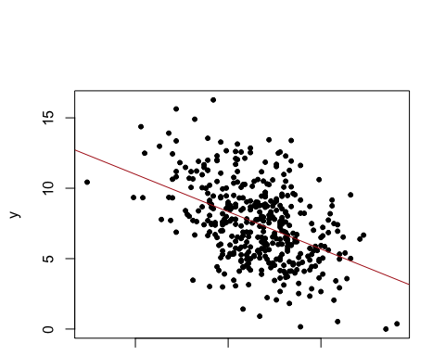

## Allow extra room for additional arguments/specifications  
regplot=function(x,y,...){  
 fit=lm(y~x)  
 plot(x,y,...)  
 abline(fit,col="firebrick")  
}  
regplot(Price,Sales,xlab="Price",ylab="Sales",col="steelblue",pch=20)

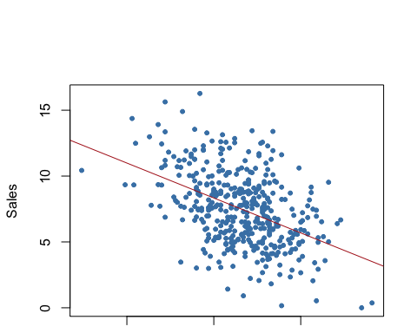

#### **Model 1: Basic Logistic Regression**

The first model included only the gender of the voters (**female**) as a predictor. The coefficient for **female** was not statistically significant (z = -0.560, p = 0.576), suggesting that gender alone does not significantly predict voting for Tsai Ing-wen. The model had a relatively high residual deviance, indicating poor fit.

#### **Model 2: Adding Demographic Variables**

The second model incorporated party identification (**KMT**, **DPP**), along with **age**, **edu** (education level), and **income**. This model showed significant improvements:

* **KMT** (z = -12.607, p < 0.001) and **DPP** (z = 10.781, p < 0.001) were highly significant, indicating strong party loyalty effects.
* **edu** was significant (z = -2.221, p = 0.026), suggesting that education level inversely affects the likelihood of voting for Tsai.
* The inclusion of these variables greatly reduced the residual deviance, improving the model’s explanatory power.

#### **Model 3: Incorporating Political and Social Attitudes**

Further expansion included variables related to political and social attitudes (**Independence**, **Econ_worse**, **Govt_dont_care**, **Minnan_father**, **Mainland_father**, **Taiwanese**). Key findings:

* **Independence** (support for Taiwan’s independence) was strongly positive (z = 4.055, p < 0.001), indicating that voters who favor independence are more likely to vote for Tsai.
* **Taiwanese** self-identification was also a strong positive predictor (z = 4.570, p < 0.001).
* **Mainland_father** had a negative coefficient (z = -2.745, p = 0.006), suggesting that descendants of mainland China are less likely to support Tsai.

The additional variables further refined the model, reducing the AIC and residual deviance, which suggests a better model fit.

#### **Residual Analysis**

Residual plots (not detailed here) would typically provide insight into any remaining patterns that the model fails to explain. Patterns in residuals can indicate model misspecifications or the need for transformation or additional variables.

#### **Conclusion**

The analysis demonstrates that voting for Tsai Ing-wen is influenced by a combination of party loyalty, political views, and demographics. Incorporating a broad range of predictors offers a nuanced understanding of voter behavior, which is crucial for accurately modeling election outcomes.

## Stata Output Comparison

### **Comparison of Stata and R Outputs for Logistic Regression**

Upon reviewing the logistic regression results from both Stata and R for the same model specifications, several points can be made about their comparison:

#### **Model Fit and Statistical Outputs**

* **Log-Likelihood:** The final log-likelihood values are identical in both Stata and R, suggesting that both software packages converge to the same solution for the logistic regression model.
* **Coefficient Estimates:** The estimates of the coefficients are identical across both outputs for each predictor, confirming consistent results across different software for the specified model.
* **Standard Errors, z-values, and p-values:** These values are also the same between Stata and R, indicating that the underlying statistical computations and the inference drawn about the significance of the predictors would be the same regardless of the software used.

#### **Interpretation of Results**

* **Independence, DPP, and Taiwanese variables** show a significant positive effect on the likelihood of voting for Tsai Ing-wen.
* **KMT and Mainland_father variables** have a significant negative impact on voting for Tsai, indicating strong partisan divides and cultural influences.
* **Econ_worse and Govt_dont_care variables**, though included in the model, do not show statistically significant effects.

### Can you use mrobust to find the best predictor combination (by best consistency) as a prediction set?

* **mrobust** is not a standard function in R or Stata and might refer to a specific package or a function in a specialized statistical software that isn’t universally recognized. Typically, variable selection in logistic regression can be performed using methods like stepwise regression, Lasso, or other regularization techniques that penalize the inclusion of less significant variables.