**Bug1: Date picker is accepting backdate in both ‘Check In’ date-field and ‘Check Out’ date-filed.**

Expected Scenario: User should get error message while selecting backdate in ‘Check In’ date field and ‘Check Out’ date field.

Actual Scenario: User is not getting any error, and navigating to ‘Our Rooms’ section.

Steps to reproduce:

|  |  |
| --- | --- |
| Hit URL: https://automationintesting.online/ | User should be landed on "Welcome to Shady Meadows B&B" page |
| Scroll to Check Availability section, enter backdate in 'CheckIn' and 'CheckOut' date | CheckIn' and 'CheckOut' date should be entered properly |
| Click on 'Check Availability' button | The following error message should be displayed:  "Check In date and Check Out date cannot be backdated." |

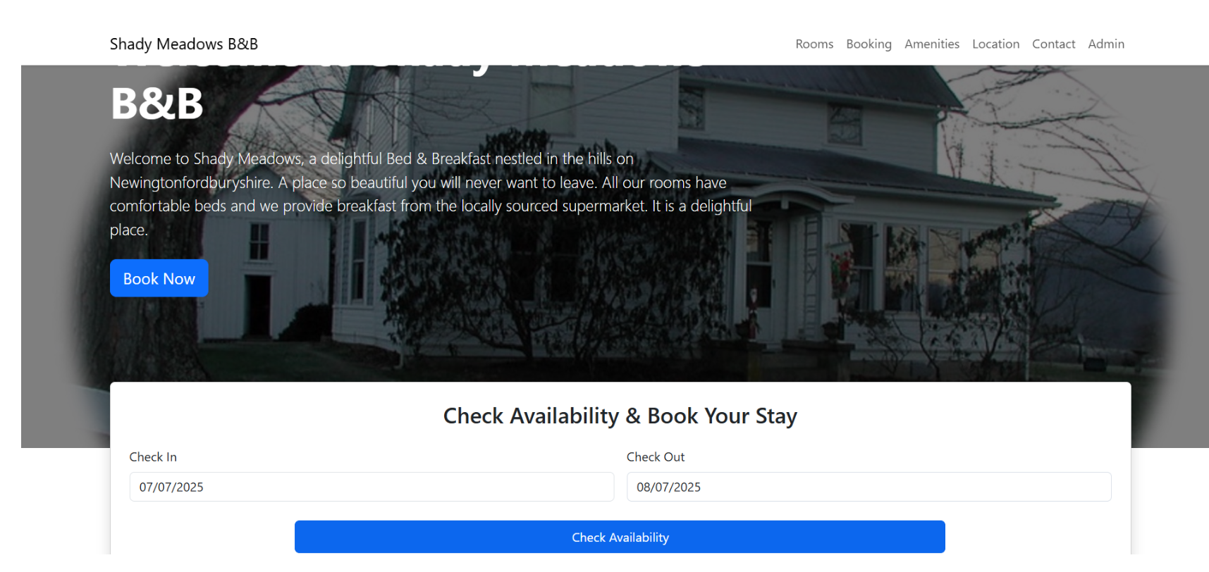

**Bug2: Date picker is accepting lesser date in ‘Check Out’ field than ‘Check In’ field.**

Expected Scenario: User should get error message while providing lesser date in ‘Check Out’ field than ‘Check In’ field. For eg, if ‘Check In’ date Is 01/12/2024 and ‘Check Out’ date is 01/11/2024, then user should get error message.

Actual Scenario: User is not getting any error, and navigating to ‘Our Rooms’ section.

Steps to reproduce:

|  |  |
| --- | --- |
| Hit URL: https://automationintesting.online/ | User should be landed on "Welcome to Shady Meadows B&B" page |
| Scroll to Check Availability section,enter future 'CheckIn', enter 'CheckOut' date lesser than Checkin date | CheckIn' and 'CheckOut' date should be entered properly |
| Click on 'Check Availability' button | The following error message should be displayed:  "Check In date and Check Out date cannot be backdated." |



**Bug1: ‘Name’ field under ‘Send Us a Message’ form is accepting special character**

Expected Scenario: User should get error message while providing special character in ‘Name’ field under ‘Send Us a Message’ form.

Actual Scenario: User is not getting any error message and receiving confirmation message

Steps to reproduce:

|  |  |
| --- | --- |
| Hit URL: https://automationintesting.online/ | User should be landed on "Welcome to Shady Meadows B&B" page |
| Click on 'Contact' link at the top right navigation bar. | 'User should be navigated to the "Send Us a Message" section. |
| Provide valid details in the following fields inside the "Send Us a Message" section:  Email  Phone  Subject  Message  Provide special character in 'Name' field  Then click on 'Submit' button | The following error message should be displayed:  "Name cannot have special character". |

