BCI Triggered Hand Exoskeleton for Neurohabilitation
Neurorehabilitation is a spiral management process in which a treatment program is initiated and then constantly revised and updated, based on therapy-mediated improvements.
Objective: upper limb recovery can be gained if stroke sufferers with limb impairments, perform intensive active physical practice (PP) in conjunction with motor imagery (MI) practice (or mental practice) of activities of daily living. Although a PP can be performed with the help of a therapist, dependence on the therapist may lead to a passive practice.
- A lightweight three-finger exoskeleton with embedded sensors, capable of replicating human motion for physical practice. It will be controlled by users’ EMG and EEG signals in assist-as-needed mode.
- EMG and EEG for controlling the exoskeleton and provides visual neurofeedback to ensure focused physical and MI practices

Robotic assisted rehabilitation: In one approach robot assist the patient only when s/he cannot complete the therapy unassisted. These systems modify the amount of assistance according to the online measurement of patient’s performance.
Impedance control where parameters like (inertia, damping and stiffness) can determine the level of assistance offered by the robot. Adjusting the impedance parameters of a human-exoskeleton interaction.
User apply force on fingertips to interact with exoskeleton. Exoskeleton generate movements in proportion to applied force. In case, applied force is not sufficient then exoskeleton passively assists him/her in completing the action.
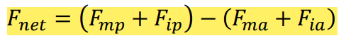
if the net force Fnet > 0, then it is considered to be acting in the extension direction and if Fnet < 0 then the net force is considered to be acting in the grasping direction.
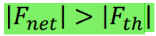
To set the threshold force we asked the participants to keep their hand passive and moved the exoskeleton for a finger open and close motion. Then we took the average of all the forces which was passively reflected on the force sensor to calculate the threshold force level. Thus the value of Fth turned out to be 0.02 N.
Non-assist active mode, in which an impedance model (Section III-B) is used to compute the exoskeleton motion from the fingertip force.
During the passive assistance the exoskeleton was driven in velocity control mode, where it maintained a fixed velocity of 9.27 deg/s until it receives further input from the user
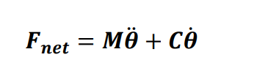

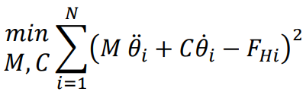
Where M and C are the mass and the damping parameters respectively and 𝜽 is the crank angular position of the coupled index-middle finger linkage.
The estimates of the patient’s M, C parameters were calculated with reference to a healthy individual’s M, C . The fingertip force and the corresponding change in the actuator angle were recorded. The variation of the fingertip force (FH) with the actuator angle, averaged over all participants. From the actuator angular position, the velocity and the acceleration were computed numerically (Fig. 6b). The actuator velocity, acceleration and fingertip force data were then used to estimate the M, C parameters of the impedance model Eq. (3), by solving a nonlinear curve fitting problem using a non-linear least square solver. T The impedance parameters for a session (𝑀𝑠 , 𝐶𝑠) are calculated from the previous session score 𝑆𝑆𝑝𝑟𝑒𝑣 by calculating first the modified force profile 𝐹𝑠𝑖 and then solving the optimization problem to fit the healthy finger motion trajectory from the 𝐹𝑠𝑖 using (𝑀𝑠 , 𝐶𝑠 ) as the parameters. At the end of the session the new 𝑆𝑆 is generated to be used in the next session.

Action-Research-Arm-Test (ARAT)

Finger motion capture setup
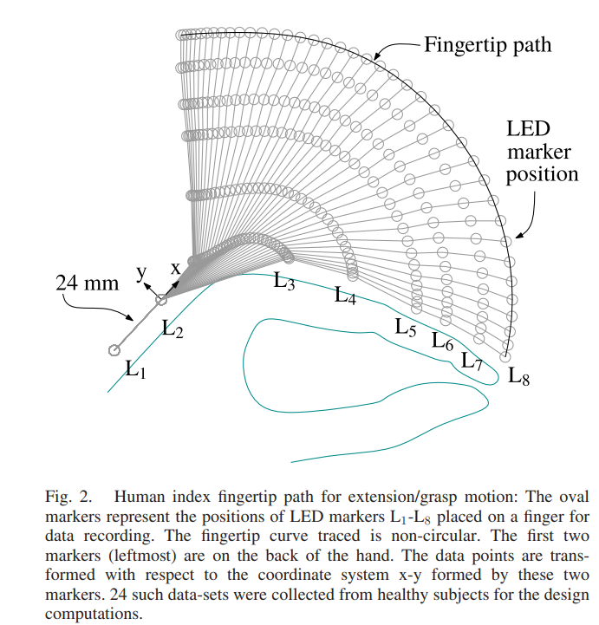

ARAT test
- Combination of physical practice (PP) and mental practice (MP)
- Optimally challenge the patients during the therapeutic task to keep them motivated and assist them as required.
- Feature extraction technique by fusing the subjects’ EEG and EMG signals, to predict user’s movement intension in a BCI system to trigger a hand exoskeleton device.
- corticomuscular-coherence Corticomuscular interactions measuring the coherence between brain and muscle signals.
- Bandpower Corelation
Rehabilitation policies for motor functional recovery
Challenge based, Assistive/resistive, Haptic feedback, and coaching.
- adjusting the system parameters based on performance, to update the desired challenge level
- Active non assist mode
- Passive assistance mode
e impedance based exoskeleton assisted rehabilitation
User is being challenged on the basis of his/her performance i.e. average force generation capacity
This challenge is increased after each session.

