# awt_01

# 💻 Web Technology Lab – Experiments Summary

This repository contains all experiments and classwork done as part of the *Advanced Web Technology (AWT)* lab.  
Each experiment focuses on different web technologies including HTML, CSS, JavaScript, jQuery, AngularJS, and Node.js.

## 📑 Table of Contents

1. Experiment 1
2. Experiment 2
3. Experiment 3
4. Experiment 4
5. Experiment 5
6. Experiment 5_6
7. Experiment 7
8. Conclusion

## 🧪 Experiment 1

*Topic:* Basic HTML, CSS, and JavaScript Integration  
*Files:* index.html, d1.js, s.css

*What I learned:* - Creating basic web pages using HTML. - Linking CSS and JS files to an HTML document. - Handling basic DOM manipulation using JavaScript.

**Code**

#### 🗂 index.html

<!DOCTYPE html>  
<html lang="en">  
<head>  
 <meta charset="UTF-8">  
 <meta name="viewport" content="width=device-width, initial-scale=1.0">  
 <title>LAB EXP 1</title>  
 <script src="https://ajax.googleapis.com/ajax/libs/jquery/3.7.1/jquery.min.js"></script>  
 <link rel="stylesheet" href="s.css">  
</head>  
<body>  
  
 <div class="container">  
 <h1>1. Right-Click Disabled</h1>  
 <p>Try right-clicking anywhere on this page. The context menu will not appear.</p>  
 </div>  
  
 <hr>  
  
 <div class="container">  
 <h1>2. Show/Hide Message</h1>  
 <button id="showBtn">Show Message</button>  
 <button id="hideBtn">Hide Message</button>  
 <div id="messageDiv">  
 <p>Hello! This message can be hidden and shown using the buttons above.</p>  
 </div>  
 </div>  
  
 <hr>  
  
 <div class="container">  
 <h1>3. Paragraph Color Change on Hover</h1>  
 <p class="hover-para">This paragraph changes color.</p>  
 </div>  
  
 <hr>  
  
 <div class="container" style="height: 1200px;">  
 <h1>4. Scroll to Top</h1>  
 <p>Scroll down this page to see the image in the bottom-right corner. Clicking it will bring you back to the top of the page.</p>  
 </div>  
  
   
 <img src="C:\Users\hp\Pictures\Screenshots\Screenshot 2025-08-25 231221.png" alt="Scroll to Top" id="scrollToTopBtn">  
  
 <script src="d1.js"></script>  
  
</body>  
</html>

#### 🗂 s.css

body {  
 font-family: Arial, sans-serif;  
 margin: 20px;  
 padding-bottom: 1500px;   
 }  
 .container {  
 margin-bottom: 40px;  
 }  
 h1 {  
 color: orchid;  
 }  
 p {  
 font-size: 1.1em;  
 cursor: pointer;  
 transition: color 0.3s ease;  
 }  
 #messageDiv {  
 padding: 20px;  
 border: 1px solid yellowgreen;  
 background-color:white;  
 margin-top: 10px;  
 border-radius: 8px;  
 display: none;   
 }  
 button {  
 padding: 10px 15px;  
 margin-right: 10px;  
 cursor: pointer;  
 border: none;  
 border-radius: 5px;  
 background-color: pink ;  
 color: white;  
 }  
 button:hover {  
 background-color: red;  
 }  
 #scrollToTopBtn {  
 position: fixed;  
 bottom: 20px;  
 right: 20px;  
 width: 50px;  
 height: 50px;  
 cursor: pointer;  
 border: 2px solid beige;  
 border-radius: 50%;  
 background-color: powderblue;  
 box-shadow: 0 4px 6px black;  
 }

#### 🗂 d1.js

$(document).on("selectstart", function(e){   
 e.preventDefault();  
});  
  
$(document).on("keydown", function(e) {  
 if (e.ctrlKey && e.keyCode === 67) e.preventDefault();  
});  
  
 $(document).ready(function() {  
 // 1. Disable the right-click menu  
 $(document).on("contextmenu", function(e) {  
 e.preventDefault();  
 });  
  
 // 2. Display and hide a message  
 $("#showBtn").click(function() {  
 $("#messageDiv").show('slow');  
 });  
 $("#hideBtn").click(function() {  
 $("#messageDiv").hide('slow');  
 });  
  
 // 3. Change paragraph color on mouseover  
 $(".hover-para").mouseover(function() {  
 $(this).css("color", "red");  
 });  
 $(".hover-para").mouseout(function() {  
 $(this).css("color", "#333");  
 });  
  
 // 4. Click an image to scroll to the top  
 $("#scrollToTopBtn").click(function() {  
 $("html, body").animate({ scrollTop: 0 }, 'slow');  
 })  
  
 });

### output

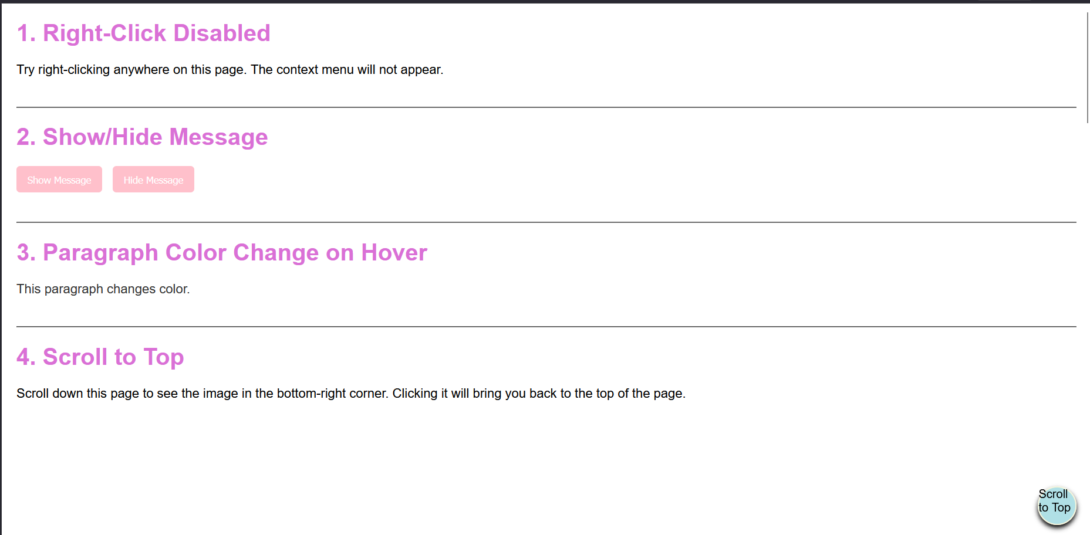

Output Screenshot

*Challenges faced:* - Understanding how external JS and CSS files are connected. - Debugging syntax errors in JavaScript.

## 🧪 Experiment 2

*Topic:* Advanced JavaScript – Events and DOM  
*Files:* index.html, d2.js, s.css

*What I learned:* - Implementing DOM manipulation using JavaScript. - Handling user events like click, hover, etc. - Understanding internal vs external JS files.

**Code**

#### 🗂 index.html

<!DOCTYPE html>  
<html lang="en">  
<head>  
 <meta charset="UTF-8">  
 <meta name="viewport" content="width=device-width, initial-scale=1.0">  
 <title>Lab exp 2</title>  
 <link rel="stylesheet" href="s.css">  
 <script src="https://code.jquery.com/jquery-3.6.0.min.js"></script>  
</head>  
<body>  
 <div class="container">  
 <h1>Add a class to an element</h1>  
 <button id="addbtn">Add border</button>  
 <p id="adclass">Click the button to add a border to me</p>  
 </div>  
  
 <hr>  
  
 <div class="container">  
 <h1>Access element's position</h1>  
 <button id="getposition">Get position</button>  
 <div id="result"></div>  
 <div id="pele">This is the positioned element</div>  
 </div>  
  
 <hr>  
  
 <div class="container">  
 <h1>Animate multiple CSS properties</h1>  
 <button id="animatebtn">Animate box</button>  
 <div id="animatedBox"></div>  
 </div>  
  
 <script src="d2.js"></script>  
</body>  
</html>

#### 🗂 s.css

body {  
 font-family: Arial, sans-serif;  
 margin: 20px;  
 padding-bottom: 1500px;  
}  
.container {  
 margin-bottom: 40px;  
}  
h1 {  
 color: #333;  
}  
.highlighted {  
 border: 5px solid #ff0000;  
 box-shadow: 0 0 10px rgba(255, 0, 0, 0.5);  
}  
#animatedBox {  
 width: 100px;  
 height: 100px;  
 background-color: #ff9800;  
 position: relative;  
}  
button {  
 padding: 10px 15px;  
 margin-right: 10px;  
 cursor: pointer;  
 border: none;  
 border-radius: 5px;  
 background-color: blue;  
 color: white;  
}

#### 🗂 d2.js

$(document).ready(function(){  
 $("#addbtn").click(function(){  
 $("#adclass").addClass("highlighted");  
 });  
  
 $("#getposition").click(function(){  
 var position = $("#pele").position();  
 var res = "Top: " + position.top + "px, Left: " + position.left + "px";  
 $("#result").text(res);  
 });  
  
 $("#animatebtn").click(function(){  
 $("#animatedBox").animate({  
 width: '200px',  
 height: '200px',  
 opacity: 0.5,  
 marginLeft: '50px'  
 }, 1000, function() {  
 $(this).animate({  
 width: '100px',  
 height: '100px',  
 opacity: 1,  
 marginLeft: '0px'  
 }, 1000);  
 });  
 });  
 });

### output

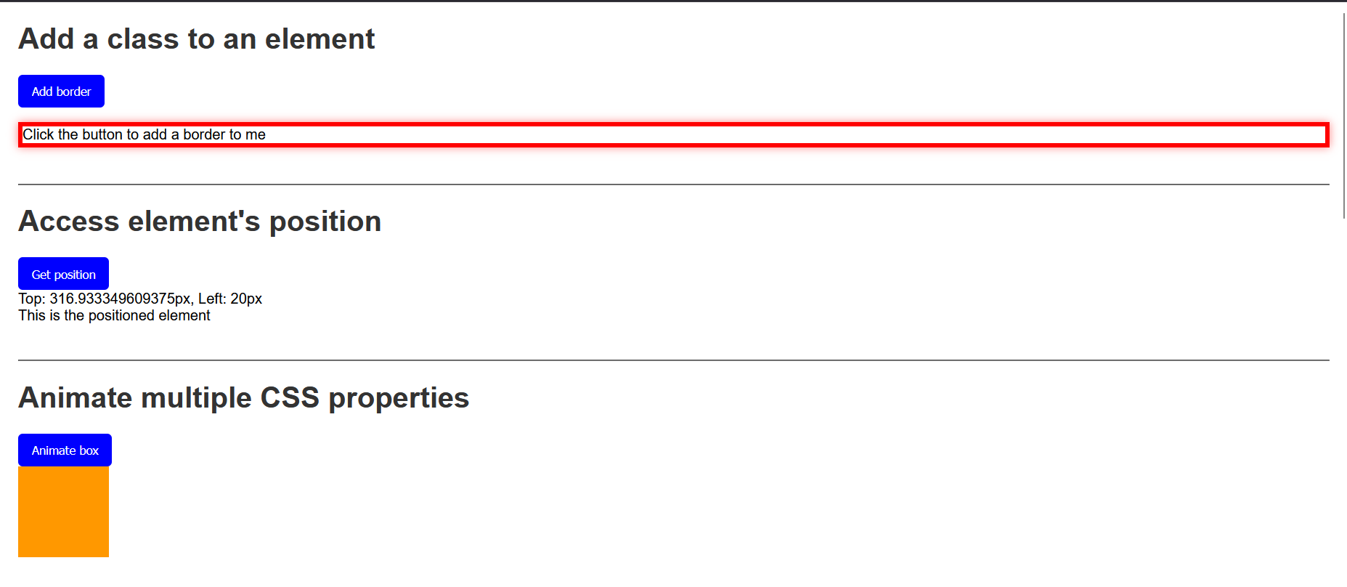

Output Screenshot

*Challenges faced:* - Managing multiple event listeners. - Debugging issues caused by incorrect DOM element references.

## 🧪 Experiment 3

*Topic:* Introduction to Node.js  
*Files:* index.html, app.js

*What I learned:* - Setting up a Node.js environment. - Creating a simple web server using Node.js. - Sending responses to client requests.

**Code**

#### 🗂 index.html

<!doctype html>  
<html ng-app="tableApp">  
<head>  
 <meta charset="utf-8">  
 <title>Experiment 3 - AngularJS Tables</title>  
 <script src="https://ajax.googleapis.com/ajax/libs/angularjs/1.8.3/angular.min.js"></script>  
 <script src="app.js"></script>  
 <style>  
 table { border-collapse: collapse; width: 100%; }  
 th, td { border: 1px solid #ccc; padding: 8px; }  
 tr.even { background: #f8f8f8; }  
 tr.odd { background: #ffffff; }  
 th { background: #eee; }  
 </style>  
</head>  
<body ng-controller="TableController as ctrl">  
 <div class="container">  
 <h1>AngularJS Table Examples</h1>  
  
 <section>  
 <h2>1. Display a Table</h2>  
 <table>  
 <thead>  
 <tr>  
 <th>#</th>  
 <th>Name</th>  
 <th>Age</th>  
 <th>Department</th>  
 </tr>  
 </thead>  
 <tbody>  
 <tr ng-repeat="student in ctrl.students track by $index" ng-class-odd="'odd'" ng-class-even="'even'">  
 <td>{{$index + 1}}</td>  
 <td>{{student.name}}</td>  
 <td>{{student.age}}</td>  
 <td>{{student.dept}}</td>  
 </tr>  
 </tbody>  
 </table>  
 </section>  
  
 <section>  
 <h2>2. Display contents with orderBy filter</h2>  
 <label>Sort by:  
 <select ng-model="ctrl.sortKey">  
 <option value="name">Name</option>  
 <option value="age">Age</option>  
 <option value="dept">Department</option>  
 </select>  
 <label><input type="checkbox" ng-model="ctrl.reverse"> Reverse</label>  
 </label>  
  
 <table>  
 <thead>  
 <tr>  
 <th>#</th>  
 <th>Name</th>  
 <th>Age</th>  
 <th>Department</th>  
 </tr>  
 </thead>  
 <tbody>  
 <tr ng-repeat="student in ctrl.students | orderBy:ctrl.sortKey:ctrl.reverse track by $index" ng-class-even="'even'" ng-class-odd="'odd'">  
 <td>{{$index + 1}}</td>  
 <td>{{student.name}}</td>  
 <td>{{student.age}}</td>  
 <td>{{student.dept}}</td>  
 </tr>  
 </tbody>  
 </table>  
 </section>  
  
 <section>  
 <h2>3. Display Table with even and odd rows (styling already shown)</h2>  
 <p>Notice rows have alternating backgrounds using <code>ng-class-even</code> and <code>ng-class-odd</code>.</p>  
 </section>  
 </div>  
</body>  
</html>

#### 🗂 app.js

angular.module('tableApp', [])  
 .controller('TableController', function() {  
 const vm = this;  
  
 vm.students = [  
 { name: 'Asha', age: 22, dept: 'CSE' },  
 { name: 'Bikram', age: 24, dept: 'ECE' },  
 { name: 'Charu', age: 21, dept: 'ME' },  
 { name: 'Deep', age: 23, dept: 'CSE' },  
 { name: 'Esha', age: 20, dept: 'EE' }  
 ];  
  
 vm.sortKey = 'name';  
 vm.reverse = false;  
 });

### output

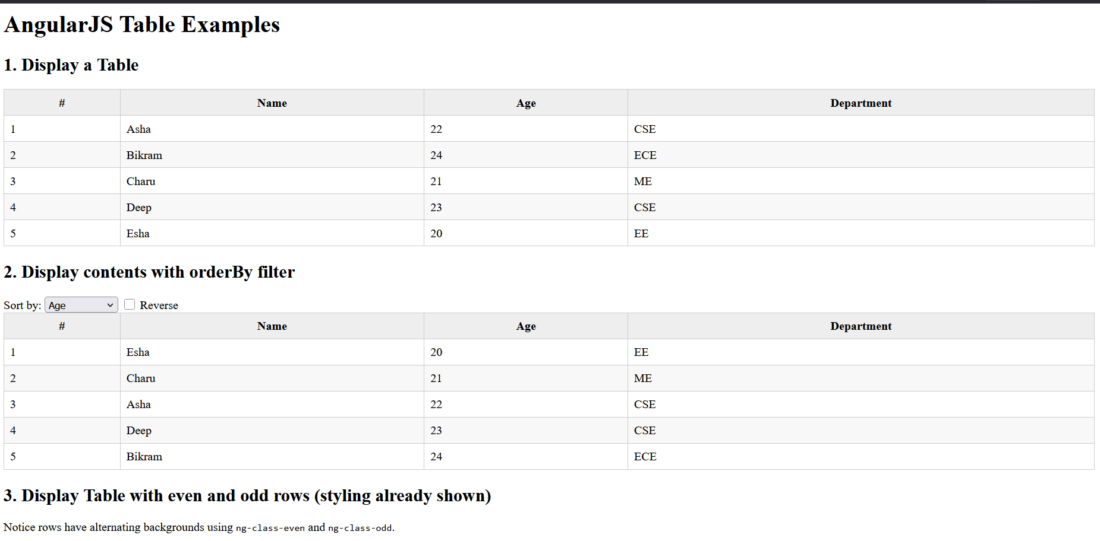

Output Screenshot

*Challenges faced:* - Installing Node.js packages using npm. - Understanding asynchronous execution in Node.js.

## 🧪 Experiment 4

*Topic:* HTML Forms and Data Handling  
*Files:* bill.html, form.html

*What I learned:* - Creating HTML forms and input fields. - Using form attributes like action, method, and name. - Validating form inputs.

**Code**

#### 🗂 bill.html

<!DOCTYPE html>  
<html lang="en" ng-app="billApp">  
<head>  
 <meta charset="UTF-8">  
 <title>Bill Payment Record</title>  
 <script src="https://ajax.googleapis.com/ajax/libs/angularjs/1.8.3/angular.min.js"></script>  
 <style>  
 body { font-family: Arial, sans-serif; margin: 20px; }  
 table { border-collapse: collapse; width: 100%; margin-top: 20px; }  
 th, td { border: 1px solid #ccc; padding: 8px; text-align: left; }  
 th { background: #eee; }  
 input, button { margin: 5px; padding: 6px; }  
 </style>  
</head>  
<body ng-controller="BillController">  
  
 <h2>Bill Payment Record</h2>  
  
 <!-- Form to add new records -->  
 <form name="billForm" ng-submit="addRecord(billForm)" novalidate>  
 <label>  
 Name:  
 <input type="text" name="name" ng-model="newRecord.name" required>  
 </label>  
 <label>  
 Amount:  
 <input type="number" name="amount" ng-model="newRecord.amount" required min="0">  
 </label>  
 <label>  
 Date:  
 <input type="date" name="date" ng-model="newRecord.date" required>  
 </label>  
 <button type="submit" ng-disabled="billForm.$invalid">Add</button>  
 </form>  
  
 <!-- Records table -->  
 <table ng-if="records.length > 0">  
 <thead>  
 <tr>  
 <th>#</th>  
 <th>Name</th>  
 <th>Amount</th>  
 <th>Date</th>  
 </tr>  
 </thead>  
 <tbody>  
 <tr ng-repeat="record in records track by record.id">  
 <td>{{$index + 1}}</td>  
 <td>{{record.name}}</td>  
 <td>{{record.amount | currency}}</td>  
 <td>{{record.date | date:'mediumDate'}}</td>  
 </tr>  
 </tbody>  
 </table>  
  
 <script>  
 angular.module('billApp', [])  
 .controller('BillController', function($scope) {  
 // Initial records  
 $scope.records = [  
 { id: 1, name: 'Electricity', amount: 1200, date: '2025-07-01' },  
 { id: 2, name: 'Internet', amount: 799, date: '2025-07-05' }  
 ];  
  
 $scope.newRecord = {};  
  
 // Add new record  
 $scope.addRecord = function(form) {  
 if (form.$valid) {  
 let newId = $scope.records.length + 1;  
 $scope.records.push({  
 id: newId,  
 name: $scope.newRecord.name,  
 amount: $scope.newRecord.amount,  
 date: $scope.newRecord.date  
 });  
 $scope.newRecord = {};  
 form.$setPristine();  
 form.$setUntouched();  
 }  
 };  
 });  
 </script>  
</body>  
</html>

#### 🗂 form.html

<!DOCTYPE html>  
<html lang="en" ng-app="formApp">  
<head>  
 <meta charset="UTF-8">  
 <title>AngularJS Registration Form</title>  
 <script src="https://ajax.googleapis.com/ajax/libs/angularjs/1.8.3/angular.min.js"></script>  
  
 <style>  
 .error { color: red; font-size: 14px; }  
 input.ng-invalid.ng-touched { border: 2px solid red; }  
 input.ng-valid.ng-touched { border: 2px solid green; }  
 .success { color: green; margin-top: 10px; }  
 </style>  
  
</head>  
  
<body ng-controller="FormController">  
  
 <h2>User Registration</h2>  
 <form name="regForm" novalidate ng-submit="register(regForm)">  
 <label>Name:  
 <input type="text" name="name" ng-model="user.name" required ng-minlength="3">  
 </label>  
 <div class="error"   
 ng-show="(regForm.name.$touched || submitted) && regForm.name.$invalid">  
 Name must be at least 3 characters.  
 </div>  
 <br><br>  
  
 <label>Email:  
 <input type="email" name="email" ng-model="user.email" required>  
 </label>  
 <div class="error"   
 ng-show="(regForm.email.$touched || submitted) && regForm.email.$invalid">  
 Enter a valid email.  
 </div>  
 <br><br>  
  
 <label>Password:  
 <input type="password" name="password" ng-model="user.password" required ng-minlength="6">  
 </label>  
 <div class="error"   
 ng-show="(regForm.password.$touched || submitted) && regForm.password.$invalid">  
 Password must be at least 6 characters.  
 </div>  
 <br><br>  
  
 <button type="submit">Register</button>  
 </form>  
  
 <p class="success" ng-if="success">{{success}}</p>  
  
 <script>  
 angular.module('formApp', [])  
 .controller('FormController', function($scope) {  
 $scope.user = {};  
 $scope.submitted = false;  
 $scope.success = '';  
  
 $scope.register = function(form) {  
 if (form.$valid) {  
 // In real app, send data to server  
 $scope.success = 'Registration successful for ' + $scope.user.name;  
 $scope.user = {};  
 form.$setPristine(); // Reset form state  
 form.$setUntouched(); // Reset touched state  
 $scope.submitted = false;  
 } else {  
 $scope.success = '';  
 $scope.submitted = true; // Show validation messages  
 }  
 };  
 });  
 </script>  
</body>  
</html>

### output-bill

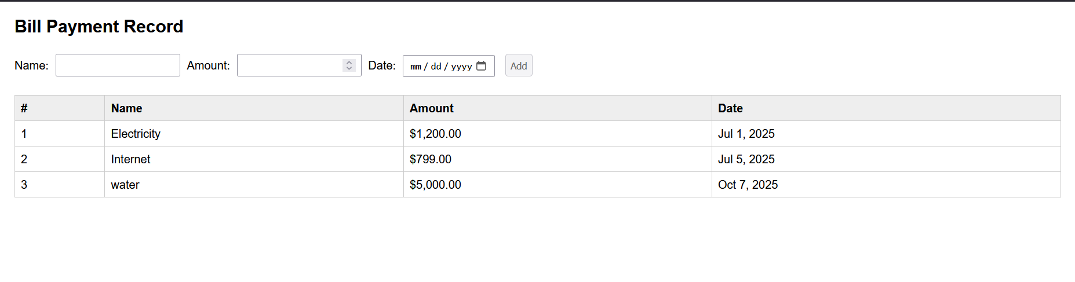 ### output-form 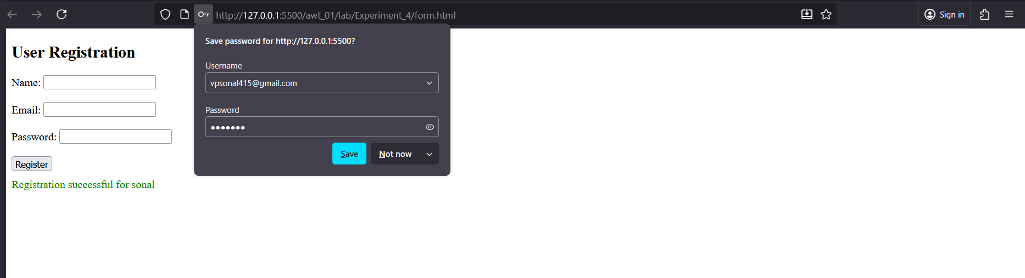

*Challenges faced:* - Handling form validation using JavaScript. - Designing a clean and structured form layout.

### 🧪 Experiment 5_6

*Topic:* Express.js and Modular Node.js Applications  
*Files:* server.js, package.json

*What I learned:* - Installing and using Express.js framework. - Creating routes and handling requests in Express. - Understanding package.json and dependencies.

**Code**

#### 🗂 server.js

const express = require('express');  
const app = express();  
const PORT = process.env.PORT || 3000;   
  
// Hello World endpoint  
app.get('/', (req, res) => {  
 res.send('Hello, World!');  
});  
  
// String replacement endpoint  
app.get('/replace', (req, res) => {  
 const { text } = req.query;  
 if (!text) {  
 return res.status(400).json({ error: 'Text parameter is required' });  
 }  
   
 const regex = /a{2,}/g;  
 const result = text.replace(regex, 'b');  
 res.json({ original: text, replaced: result });  
});  
  
// Calculator endpoint  
app.get('/calculate', (req, res) => {  
 const { operation, num1, num2 } = req.query;  
 const n1 = parseFloat(num1);  
 const n2 = parseFloat(num2);  
   
 if (isNaN(n1) || isNaN(n2)) {  
 return res.status(400).json({ error: 'Invalid numbers provided' });  
 }  
   
 let result;  
 switch(operation) {  
 case 'add':  
 result = n1 + n2;  
 break;  
 case 'subtract':  
 result = n1 - n2;  
 break;  
 case 'multiply':  
 result = n1 * n2;  
 break;  
 case 'divide':  
 result = n2 !== 0 ? n1 / n2 : 'Error: Division by zero';  
 break;  
 default:  
 return res.status(400).json({ error: 'Invalid operation. Use add, subtract, multiply, or divide' });  
 }  
   
 res.json({ operation, num1: n1, num2: n2, result });  
});  
  
// Array iteration endpoint  
app.get('/iterate', (req, res) => {  
 const array = [10, 20, 30, 40, 50];  
 const iterations = [];  
   
 // Using for loop  
 iterations.push("Using for loop:");  
 for (let i = 0; i < array.length; i++) {  
 iterations.push(`Index ${i}: ${array[i]}`);  
 }  
   
 // Using forEach  
 iterations.push("Using forEach:");  
 array.forEach((item, index) => {  
 iterations.push(`Index ${index}: ${item}`);  
 });  
   
 // Using for...of  
 iterations.push("Using for...of:");  
 for (const item of array) {  
 iterations.push(`Item: ${item}`);  
 }  
   
 res.json({ array, iterations });  
});  
  
app.listen(PORT, () => {  
 console.log(`Server running at http://localhost:${PORT}`);  
 console.log('Available endpoints:');  
 console.log(' GET / - Hello World');  
 console.log(' GET /replace?text=your_text - Replace multiple a\'s with b');  
 console.log(' GET /calculate?operation=add&num1=5&num2=3 - Calculator');  
 console.log(' GET /iterate - Array iteration examples');  
});

#### 🗂 package.json

{  
 "name": "nodeja-lab",  
 "version": "1.0.0",  
 "description": "\"NodeJS basic exercies lab\",",  
 "main": "index.js",  
 "dependencies": {  
 "accepts": "^2.0.0",  
 "body-parser": "^2.2.0",  
 "bytes": "^3.1.2",  
 "call-bind-apply-helpers": "^1.0.2",  
 "call-bound": "^1.0.4",  
 "content-disposition": "^1.0.0",  
 "content-type": "^1.0.5",  
 "cookie": "^0.7.2",  
 "cookie-signature": "^1.2.2",  
 "debug": "^4.4.3",  
 "depd": "^2.0.0",  
 "dunder-proto": "^1.0.1",  
 "ee-first": "^1.1.1",  
 "encodeurl": "^2.0.0",  
 "es-define-property": "^1.0.1",  
 "es-errors": "^1.3.0",  
 "es-object-atoms": "^1.1.1",  
 "escape-html": "^1.0.3",  
 "etag": "^1.8.1",  
 "express": "^5.1.0",  
 "finalhandler": "^2.1.0",  
 "forwarded": "^0.2.0",  
 "fresh": "^2.0.0",  
 "function-bind": "^1.1.2",  
 "get-intrinsic": "^1.3.0",  
 "get-proto": "^1.0.1",  
 "gopd": "^1.2.0",  
 "has-symbols": "^1.1.0",  
 "hasown": "^2.0.2",  
 "http-errors": "^2.0.0",  
 "iconv-lite": "^0.6.3",  
 "inherits": "^2.0.4",  
 "ipaddr.js": "^1.9.1",  
 "is-promise": "^4.0.0",  
 "math-intrinsics": "^1.1.0",  
 "media-typer": "^1.1.0",  
 "merge-descriptors": "^2.0.0",  
 "mime-db": "^1.54.0",  
 "mime-types": "^3.0.1",  
 "ms": "^2.1.3",  
 "negotiator": "^1.0.0",  
 "object-inspect": "^1.13.4",  
 "on-finished": "^2.4.1",  
 "once": "^1.4.0",  
 "parseurl": "^1.3.3",  
 "path-to-regexp": "^8.3.0",  
 "proxy-addr": "^2.0.7",  
 "qs": "^6.14.0",  
 "range-parser": "^1.2.1",  
 "raw-body": "^3.0.1",  
 "router": "^2.2.0",  
 "safe-buffer": "^5.2.1",  
 "safer-buffer": "^2.1.2",  
 "send": "^1.2.0",  
 "serve-static": "^2.2.0",  
 "setprototypeof": "^1.2.0",  
 "side-channel": "^1.1.0",  
 "side-channel-list": "^1.0.0",  
 "side-channel-map": "^1.0.1",  
 "side-channel-weakmap": "^1.0.2",  
 "statuses": "^2.0.2",  
 "toidentifier": "^1.0.1",  
 "type-is": "^2.0.1",  
 "unpipe": "^1.0.0",  
 "vary": "^1.1.2",  
 "wrappy": "^1.0.2"  
 },  
 "devDependencies": {},  
 "scripts": {  
 "test": "node server.js",  
 "start": "node lab/Experiment_5_6/server.js"  
 },  
 "repository": {  
 "type": "git",  
 "url": "awt_01"  
 },  
 "keywords": [  
 "[\"nodejs\"",  
 "\"express\"",  
 "\"lab\"]"  
 ],  
 "author": "sonal",  
 "license": "ISC"  
}

### output

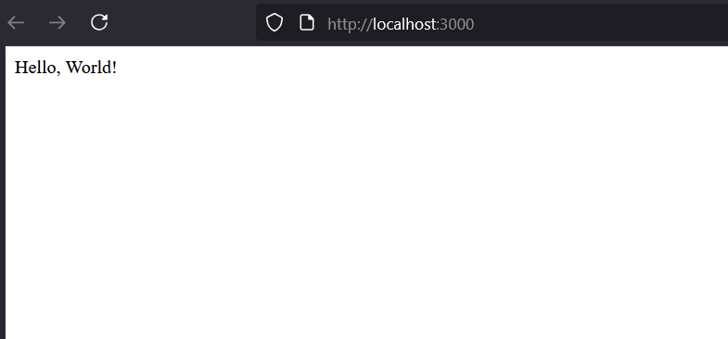 ### output 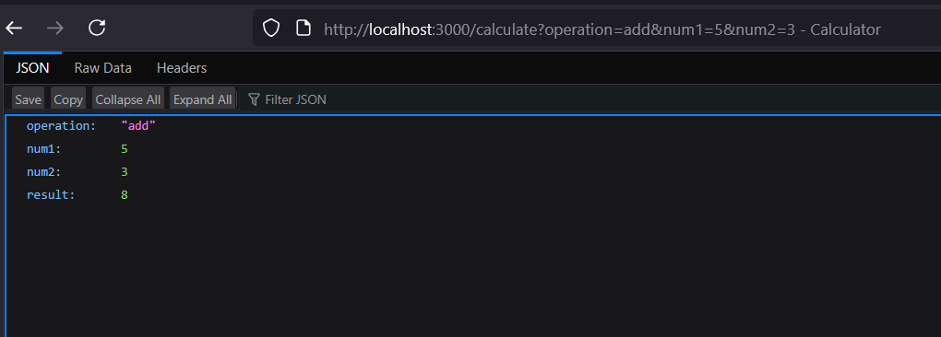 ### output 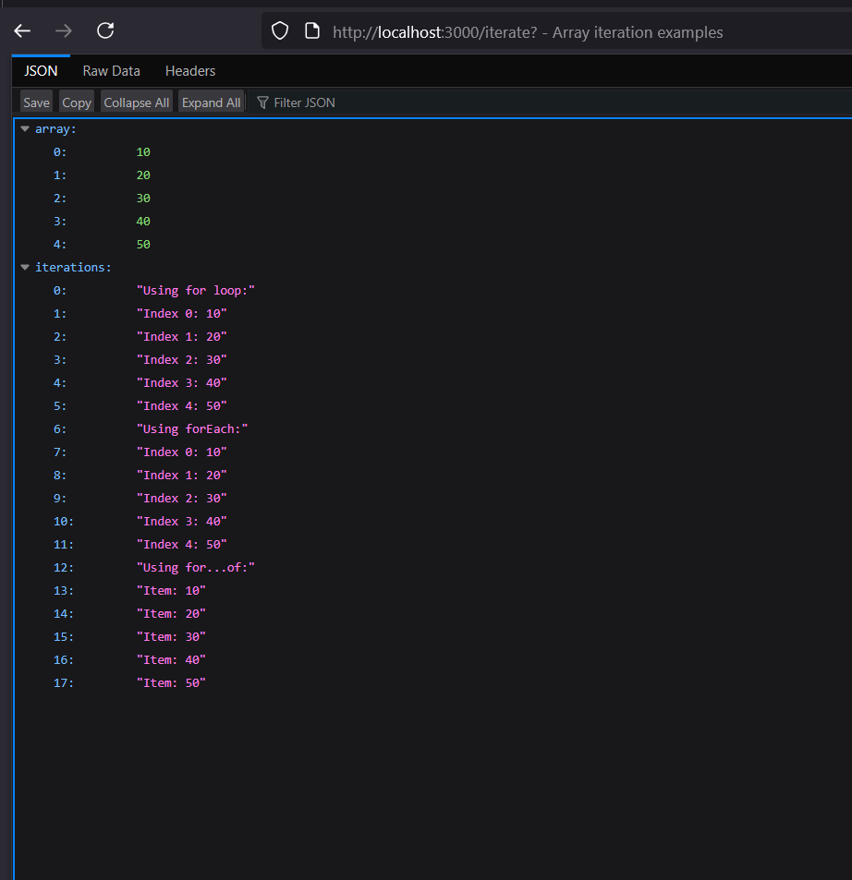 ### output 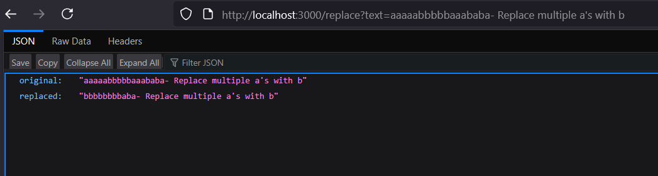

*Challenges faced:* - Configuring Express properly. - Managing multiple JavaScript files in one project.

## 🧪 Experiment 7

*Topic:* Node.js Sessions and Cookies  
*Files:* source/, server.js, package.json

*What I learned:* - Using cookies and sessions in Node.js. - Maintaining user sessions across multiple pages. - Understanding middleware and session storage.

**Code**

#### 🗂 cookie-example.js

const express = require('express');  
const cookieParser = require('cookie-parser');  
  
const app = express();  
app.use(cookieParser());  
  
app.get('/set-cookie', (req, res) => {  
 res.cookie('username', 'JohnDoe', { maxAge: 900000 });  
 res.send('Cookie has been set');  
});  
  
app.get('/get-cookie', (req, res) => {  
 const user = req.cookies['username'];  
 res.send(`Cookie Retrieved: ${user}`);  
});  
  
app.get('/delete-cookie', (req, res) => {  
 res.clearCookie('username');  
 res.send('Cookie deleted');  
});  
  
const PORT = process.env.PORT || 3000;  
  
app.listen(PORT, () => {  
 console.log(`Server started on http://localhost:${PORT}`);  
});

#### 🗂 session-example.js

const express = require('express');  
const session = require('express-session');  
  
const app = express();  
  
app.use(session({  
 secret: 'mysecretkey',  
 resave: false,  
 saveUninitialized: true  
}));  
  
app.get('/', (req, res) => {  
 if (req.session.views) {  
 req.session.views++;  
 res.send(`Welcome back! You visited ${req.session.views} times.`);  
 } else {  
 req.session.views = 1;  
 res.send('Welcome to the session demo. Refresh to count visits.');  
 }  
});  
  
app.get('/destroy', (req, res) => {  
 req.session.destroy(err => {  
 if (err) {  
 return res.send('Error destroying session');  
 }  
 res.send('Session destroyed');  
 });  
});  
  
const PORT = process.env.PORT || 3000;  
  
app.listen(PORT, () => {  
 console.log(`Server started on http://localhost:${PORT}`);  
});

### 🗂 package.json

{  
 "name": "experiment_7",  
 "version": "1.0.0",  
 "description": "",  
 "main": "index.js",  
 "scripts": {  
 "test": "echo \"Error: no test specified\" && exit 1"  
 },  
 "keywords": [],  
 "author": "",  
 "license": "ISC",  
 "dependencies": {  
 "cookie-parser": "^1.4.7",  
 "express": "^5.1.0",  
 "express-session": "^1.18.2"  
 }  
}

### output-cookie.js

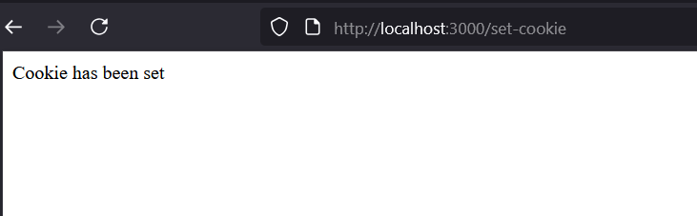 ### output-cookie.js 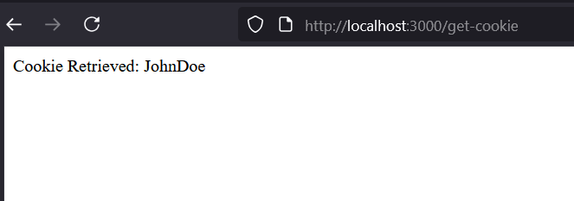  
### output-cookie.js 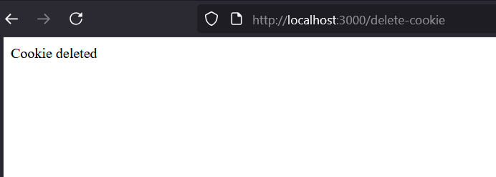  
### output-session.js 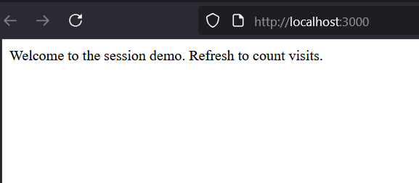  
### output-session.js 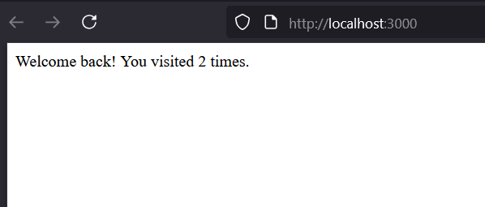

*Challenges faced:* - Configuring session middleware correctly. - Debugging cookie handling issues.

## 🏁 Conclusion

This lab helped me gain hands-on experience in *front-end and back-end web development*.  
I learned how to: - Design interactive front-end applications (HTML, CSS, JS, jQuery, Angular). - Build and deploy backend applications using *Node.js and Express*. - Handle user sessions, cookies, and server routing.

*Overall Challenge:*  
Initially, understanding how client and server communicate was difficult, but through these experiments, I developed a clear understanding of *full-stack web development*.

*Submitted by:* Sonal  
*Course:* Advanced Web Technology Lab  
*Tools Used:* VS Code, Node.js, GitHub