AWT PROGRESS # awt_01 # Web Technology Lab – Experiments Summary
This repository contains all experiments and classwork done as part of the Advanced Web Technology (AWT) lab.
Each experiment focuses on different web technologies including HTML, CSS, JavaScript, jQuery, AngularJS, and Node.js.

📑 Table of Contents
- Experiment 1
- Experiment 2
- Experiment 3
- Experiment 4
- Experiment 5
- Experiment 5_6
- Experiment 7
- Conclusion

Experiment 1
Topic: Basic HTML, CSS, and JavaScript Integration
Files: index.html, d1.js, s.css
What I learned: - Creating basic web pages using HTML. - Linking CSS and JS files to an HTML document. - Handling basic DOM manipulation using JavaScript.
Code

index.html
<!DOCTYPE html>
<html lang="en">
<head>
<meta charset="UTF-8">
<meta name="viewport" content="width=device-width, initial-scale=1.0">
<title>LAB EXP 1</title>
<script src="https://ajax.googleapis.com/ajax/libs/jquery/3.7.1/jquery.min.js"></script>
<link rel="stylesheet" href="s.css">
</head>
<body>
<div class="container">
<h1>1. Right-Click Disabled</h1>
<p>Try right-clicking anywhere on this page. The context menu will not appear.</p>
</div>
<hr>
<div class="container">
<h1>2. Show/Hide Message</h1>
<button id="showBtn">Show Message</button>
<button id="hideBtn">Hide Message</button>
<div id="messageDiv">
<p>Hello! This message can be hidden and shown using the buttons above.</p>
</div>
</div>
<hr>
<div class="container">
<h1>3. Paragraph Color Change on Hover</h1>
<p class="hover-para">This paragraph changes color.</p>
</div>
<hr>
<div class="container" style="height: 1200px;">
<h1>4. Scroll to Top</h1>
<p>Scroll down this page to see the image in the bottom-right corner. Clicking it will bring you back to the top of the page.</p>
</div>
<img src="C:\Users\hp\Pictures\Screenshots\Screenshot 2025-08-25 231221.png" alt="Scroll to Top" id="scrollToTopBtn">
<script src="d1.js"></script>
</body>
</html>

s.css
body {
font-family: Arial, sans-serif;
margin: 20px;
padding-bottom: 1500px;
}
.container {
margin-bottom: 40px;
}
h1 {
color: orchid;
}
p {
font-size: 1.1em;
cursor: pointer;
transition: color 0.3s ease;
}
#messageDiv {
padding: 20px;
border: 1px solid yellowgreen;
background-color:white;
margin-top: 10px;
border-radius: 8px;
display: none;
}
button {
padding: 10px 15px;
margin-right: 10px;
cursor: pointer;
border: none;
border-radius: 5px;
background-color: pink ;
color: white;
}
button:hover {
background-color: red;
}
#scrollToTopBtn {
position: fixed;
bottom: 20px;
right: 20px;
width: 50px;
height: 50px;
cursor: pointer;
border: 2px solid beige;
border-radius: 50%;
background-color: powderblue;
box-shadow: 0 4px 6px black;
}

d1.js
$(document).on("selectstart", function(e){
e.preventDefault();
});
$(document).on("keydown", function(e) {
if (e.ctrlKey && e.keyCode === 67) e.preventDefault();
});
$(document).ready(function() {
// 1. Disable the right-click menu
$(document).on("contextmenu", function(e) {
e.preventDefault();
});
// 2. Display and hide a message
$("#showBtn").click(function() {
$("#messageDiv").show('slow');
});
$("#hideBtn").click(function() {
$("#messageDiv").hide('slow');
});
// 3. Change paragraph color on mouseover
$(".hover-para").mouseover(function() {
$(this).css("color", "red");
});
$(".hover-para").mouseout(function() {
$(this).css("color", "#333");
});
// 4. Click an image to scroll to the top
$("#scrollToTopBtn").click(function() {
$("html, body").animate({ scrollTop: 0 }, 'slow');
})
});

output
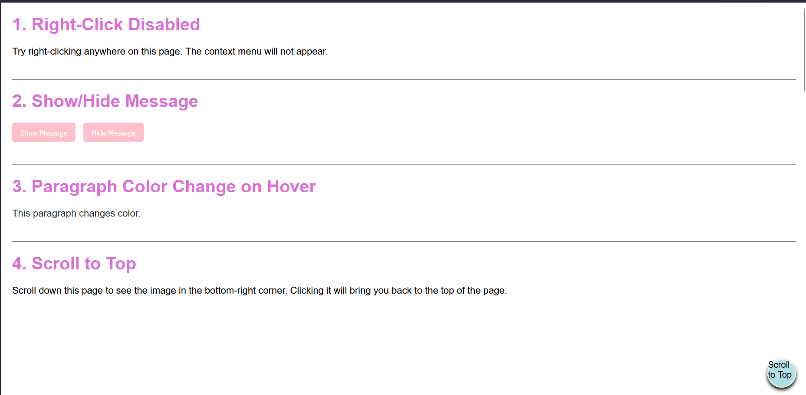
Output Screenshot
Challenges faced: - Understanding how external JS and CSS files are connected. - Debugging syntax errors in JavaScript.

Experiment 2
Topic: Advanced JavaScript – Events and DOM
Files: index.html, d2.js, s.css
What I learned: - Implementing DOM manipulation using JavaScript. - Handling user events like click, hover, etc. - Understanding internal vs external JS files.
Code

index.html
<!DOCTYPE html>
<html lang="en">
<head>
<meta charset="UTF-8">
<meta name="viewport" content="width=device-width, initial-scale=1.0">
<title>Lab exp 2</title>
<link rel="stylesheet" href="s.css">
<script src="https://code.jquery.com/jquery-3.6.0.min.js"></script>
</head>
<body>
<div class="container">
<h1>Add a class to an element</h1>
<button id="addbtn">Add border</button>
<p id="adclass">Click the button to add a border to me</p>
</div>
<hr>
<div class="container">
<h1>Access element's position</h1>
<button id="getposition">Get position</button>
<div id="result"></div>
<div id="pele">This is the positioned element</div>
</div>
<hr>
<div class="container">
<h1>Animate multiple CSS properties</h1>
<button id="animatebtn">Animate box</button>
<div id="animatedBox"></div>
</div>
<script src="d2.js"></script>
</body>
</html>

s.css
body {
font-family: Arial, sans-serif;
margin: 20px;
padding-bottom: 1500px;
}
.container {
margin-bottom: 40px;
}
h1 {
color: #333;
}
.highlighted {
border: 5px solid #ff0000;
box-shadow: 0 0 10px rgba(255, 0, 0, 0.5);
}
#animatedBox {
width: 100px;
height: 100px;
background-color: #ff9800;
position: relative;
}
button {
padding: 10px 15px;
margin-right: 10px;
cursor: pointer;
border: none;
border-radius: 5px;
background-color: blue;
color: white;
}

d2.js
$(document).ready(function(){
$("#addbtn").click(function(){
$("#adclass").addClass("highlighted");
});
$("#getposition").click(function(){
var position = $("#pele").position();
var res = "Top: " + position.top + "px, Left: " + position.left + "px";
$("#result").text(res);
});
$("#animatebtn").click(function(){
$("#animatedBox").animate({
width: '200px',
height: '200px',
opacity: 0.5,
marginLeft: '50px'
}, 1000, function() {
$(this).animate({
width: '100px',
height: '100px',
opacity: 1,
marginLeft: '0px'
}, 1000);
});
});
});

output
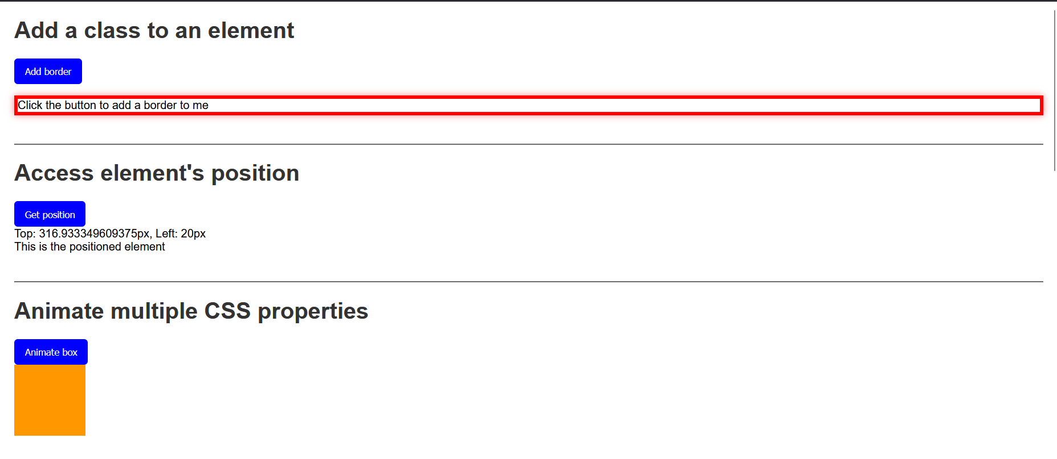
Output Screenshot
Challenges faced: - Managing multiple event listeners. - Debugging issues caused by incorrect DOM element references.

Experiment 3
Topic: Introduction to Node.js
Files: index.html, app.js
What I learned: - Setting up a Node.js environment. - Creating a simple web server using Node.js. - Sending responses to client requests.
Code

index.html
<!doctype html>
<html ng-app="tableApp">
<head>
<meta charset="utf-8">
<title>Experiment 3 - AngularJS Tables</title>
<script src="https://ajax.googleapis.com/ajax/libs/angularjs/1.8.3/angular.min.js"></script>
<script src="app.js"></script>
<style>
table { border-collapse: collapse; width: 100%; }
th, td { border: 1px solid #ccc; padding: 8px; }
tr.even { background: #f8f8f8; }
tr.odd { background: #ffffff; }
th { background: #eee; }
</style>
</head>
<body ng-controller="TableController as ctrl">
<div class="container">
<h1>AngularJS Table Examples</h1>
<section>
<h2>1. Display a Table</h2>
<table>
<thead>
<tr>
<th>#</th>
<th>Name</th>
<th>Age</th>
<th>Department</th>
</tr>
</thead>
<tbody>
<tr ng-repeat="student in ctrl.students track by $index" ng-class-odd="'odd'" ng-class-even="'even'">
<td>{{$index + 1}}</td>
<td>{{student.name}}</td>
<td>{{student.age}}</td>
<td>{{student.dept}}</td>
</tr>
</tbody>
</table>
</section>
<section>
<h2>2. Display contents with orderBy filter</h2>
<label>Sort by:
<select ng-model="ctrl.sortKey">
<option value="name">Name</option>
<option value="age">Age</option>
<option value="dept">Department</option>
</select>
<label><input type="checkbox" ng-model="ctrl.reverse"> Reverse</label>
</label>
<table>
<thead>
<tr>
<th>#</th>
<th>Name</th>
<th>Age</th>
<th>Department</th>
</tr>
</thead>
<tbody>
<tr ng-repeat="student in ctrl.students | orderBy:ctrl.sortKey:ctrl.reverse track by $index" ng-class-even="'even'" ng-class-odd="'odd'">
<td>{{$index + 1}}</td>
<td>{{student.name}}</td>
<td>{{student.age}}</td>
<td>{{student.dept}}</td>
</tr>
</tbody>
</table>
</section>
<section>
<h2>3. Display Table with even and odd rows (styling already shown)</h2>
<p>Notice rows have alternating backgrounds using <code>ng-class-even</code> and <code>ng-class-odd</code>.</p>
</section>
</div>
</body>
</html>

app.js
angular.module('tableApp', [])
.controller('TableController', function() {
const vm = this;
vm.students = [
{ name: 'Asha', age: 22, dept: 'CSE' },
{ name: 'Bikram', age: 24, dept: 'ECE' },
{ name: 'Charu', age: 21, dept: 'ME' },
{ name: 'Deep', age: 23, dept: 'CSE' },
{ name: 'Esha', age: 20, dept: 'EE' }
];
vm.sortKey = 'name';
vm.reverse = false;
});

output
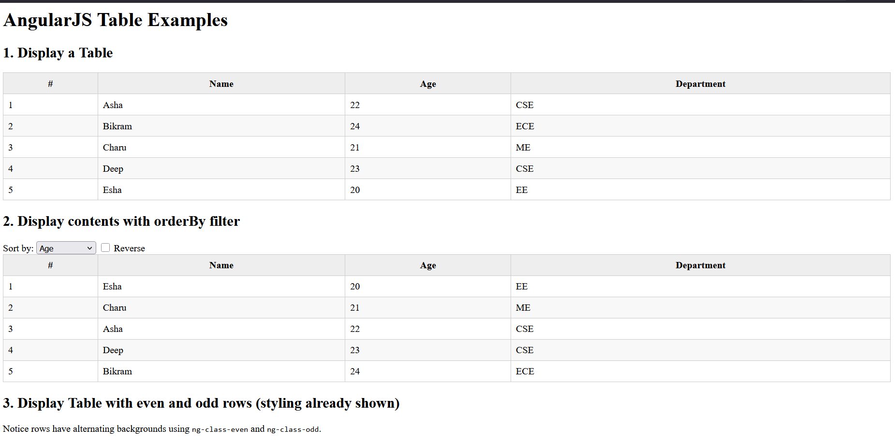
Output Screenshot
Challenges faced: - Installing Node.js packages using npm. - Understanding asynchronous execution in Node.js.

Experiment 4
Topic: HTML Forms and Data Handling
Files: bill.html, form.html
What I learned: - Creating HTML forms and input fields. - Using form attributes like action, method, and name. - Validating form inputs.
Code

bill.html
<!DOCTYPE html>
<html lang="en" ng-app="billApp">
<head>
<meta charset="UTF-8">
<title>Bill Payment Record</title>
<script src="https://ajax.googleapis.com/ajax/libs/angularjs/1.8.3/angular.min.js"></script>
<style>
body { font-family: Arial, sans-serif; margin: 20px; }
table { border-collapse: collapse; width: 100%; margin-top: 20px; }
th, td { border: 1px solid #ccc; padding: 8px; text-align: left; }
th { background: #eee; }
input, button { margin: 5px; padding: 6px; }
</style>
</head>
<body ng-controller="BillController">
<h2>Bill Payment Record</h2>
<!-- Form to add new records -->
<form name="billForm" ng-submit="addRecord(billForm)" novalidate>
<label>
Name:
<input type="text" name="name" ng-model="newRecord.name" required>
</label>
<label>
Amount:
<input type="number" name="amount" ng-model="newRecord.amount" required min="0">
</label>
<label>
Date:
<input type="date" name="date" ng-model="newRecord.date" required>
</label>
<button type="submit" ng-disabled="billForm.$invalid">Add</button>
</form>
<!-- Records table -->
<table ng-if="records.length > 0">
<thead>
<tr>
<th>#</th>
<th>Name</th>
<th>Amount</th>
<th>Date</th>
</tr>
</thead>
<tbody>
<tr ng-repeat="record in records track by record.id">
<td>{{$index + 1}}</td>
<td>{{record.name}}</td>
<td>{{record.amount | currency}}</td>
<td>{{record.date | date:'mediumDate'}}</td>
</tr>
</tbody>
</table>
<script>
angular.module('billApp', [])
.controller('BillController', function($scope) {
// Initial records
$scope.records = [
{ id: 1, name: 'Electricity', amount: 1200, date: '2025-07-01' },
{ id: 2, name: 'Internet', amount: 799, date: '2025-07-05' }
];
$scope.newRecord = {};
// Add new record
$scope.addRecord = function(form) {
if (form.$valid) {
let newId = $scope.records.length + 1;
$scope.records.push({
id: newId,
name: $scope.newRecord.name,
amount: $scope.newRecord.amount,
date: $scope.newRecord.date
});
$scope.newRecord = {};
form.$setPristine();
form.$setUntouched();
}
};
});
</script>
</body>
</html>

form.html
<!DOCTYPE html>
<html lang="en" ng-app="formApp">
<head>
<meta charset="UTF-8">
<title>AngularJS Registration Form</title>
<script src="https://ajax.googleapis.com/ajax/libs/angularjs/1.8.3/angular.min.js"></script>
<style>
.error { color: red; font-size: 14px; }
input.ng-invalid.ng-touched { border: 2px solid red; }
input.ng-valid.ng-touched { border: 2px solid green; }
.success { color: green; margin-top: 10px; }
</style>
</head>
<body ng-controller="FormController">
<h2>User Registration</h2>
<form name="regForm" novalidate ng-submit="register(regForm)">
<label>Name:
<input type="text" name="name" ng-model="user.name" required ng-minlength="3">
</label>
<div class="error"
ng-show="(regForm.name.$touched || submitted) && regForm.name.$invalid">
Name must be at least 3 characters.
</div>
<br><br>
<label>Email:
<input type="email" name="email" ng-model="user.email" required>
</label>
<div class="error"
ng-show="(regForm.email.$touched || submitted) && regForm.email.$invalid">
Enter a valid email.
</div>
<br><br>
<label>Password:
<input type="password" name="password" ng-model="user.password" required ng-minlength="6">
</label>
<div class="error"
ng-show="(regForm.password.$touched || submitted) && regForm.password.$invalid">
Password must be at least 6 characters.
</div>
<br><br>
<button type="submit">Register</button>
</form>
<p class="success" ng-if="success">{{success}}</p>
<script>
angular.module('formApp', [])
.controller('FormController', function($scope) {
$scope.user = {};
$scope.submitted = false;
$scope.success = '';
$scope.register = function(form) {
if (form.$valid) {
// In real app, send data to server
$scope.success = 'Registration successful for ' + $scope.user.name;
$scope.user = {};
form.$setPristine(); // Reset form state
form.$setUntouched(); // Reset touched state
$scope.submitted = false;
} else {
$scope.success = '';
$scope.submitted = true; // Show validation messages
}
};
});
</script>
</body>
</html>

output-bill
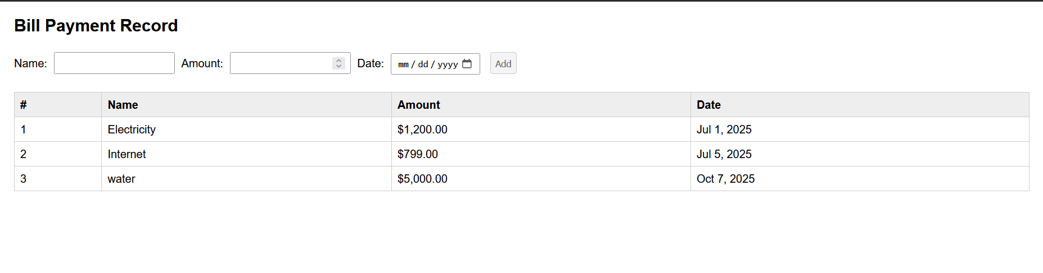 ### output-form 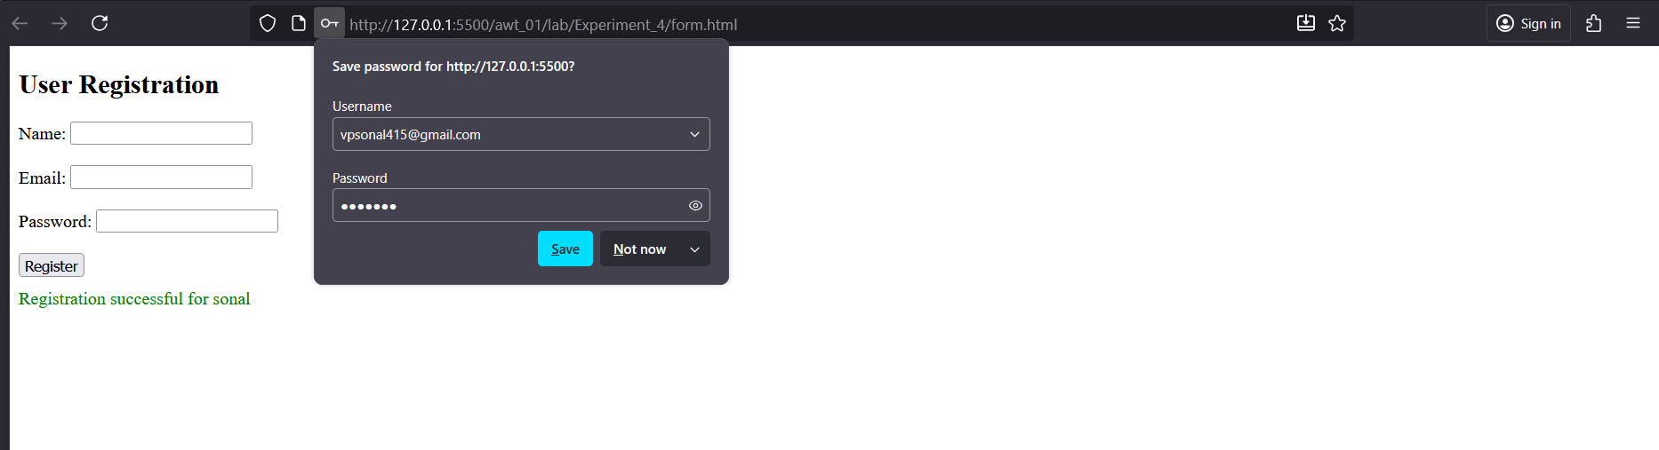
Challenges faced: - Handling form validation using JavaScript. - Designing a clean and structured form layout.

Experiment 5_6
Topic: Express.js and Modular Node.js Applications
Files: server.js, package.json
What I learned: - Installing and using Express.js framework. - Creating routes and handling requests in Express. - Understanding package.json and dependencies.
Code

server.js
const express = require('express');
const app = express();
const PORT = process.env.PORT || 3000;
// Hello World endpoint
app.get('/', (req, res) => {
res.send('Hello, World!');
});
// String replacement endpoint
app.get('/replace', (req, res) => {
const { text } = req.query;
if (!text) {
return res.status(400).json({ error: 'Text parameter is required' });
}
const regex = /a{2,}/g;
const result = text.replace(regex, 'b');
res.json({ original: text, replaced: result });
});
// Calculator endpoint
app.get('/calculate', (req, res) => {
const { operation, num1, num2 } = req.query;
const n1 = parseFloat(num1);
const n2 = parseFloat(num2);
if (isNaN(n1) || isNaN(n2)) {
return res.status(400).json({ error: 'Invalid numbers provided' });
}
let result;
switch(operation) {
case 'add':
result = n1 + n2;
break;
case 'subtract':
result = n1 - n2;
break;
case 'multiply':
result = n1 * n2;
break;
case 'divide':
result = n2 !== 0 ? n1 / n2 : 'Error: Division by zero';
break;
default:
return res.status(400).json({ error: 'Invalid operation. Use add, subtract, multiply, or divide' });
}
res.json({ operation, num1: n1, num2: n2, result });
});
// Array iteration endpoint
app.get('/iterate', (req, res) => {
const array = [10, 20, 30, 40, 50];
const iterations = [];
// Using for loop
iterations.push("Using for loop:");
for (let i = 0; i < array.length; i++) {
iterations.push(`Index ${i}: ${array[i]}`);
}
// Using forEach
iterations.push("Using forEach:");
array.forEach((item, index) => {
iterations.push(`Index ${index}: ${item}`);
});
// Using for...of
iterations.push("Using for...of:");
for (const item of array) {
iterations.push(`Item: ${item}`);
}
res.json({ array, iterations });
});
app.listen(PORT, () => {
console.log(`Server running at http://localhost:${PORT}`);
console.log('Available endpoints:');
console.log(' GET / - Hello World');
console.log(' GET /replace?text=your_text - Replace multiple a\'s with b');
console.log(' GET /calculate?operation=add&num1=5&num2=3 - Calculator');
console.log(' GET /iterate - Array iteration examples');
});

package.json
{
"name": "nodeja-lab",
"version": "1.0.0",
"description": "\"NodeJS basic exercies lab\",",
"main": "index.js",
"dependencies": {
"accepts": "^2.0.0",
"body-parser": "^2.2.0",
"bytes": "^3.1.2",
"call-bind-apply-helpers": "^1.0.2",
"call-bound": "^1.0.4",
"content-disposition": "^1.0.0",
"content-type": "^1.0.5",
"cookie": "^0.7.2",
"cookie-signature": "^1.2.2",
"debug": "^4.4.3",
"depd": "^2.0.0",
"dunder-proto": "^1.0.1",
"ee-first": "^1.1.1",
"encodeurl": "^2.0.0",
"es-define-property": "^1.0.1",
"es-errors": "^1.3.0",
"es-object-atoms": "^1.1.1",
"escape-html": "^1.0.3",
"etag": "^1.8.1",
"express": "^5.1.0",
"finalhandler": "^2.1.0",
"forwarded": "^0.2.0",
"fresh": "^2.0.0",
"function-bind": "^1.1.2",
"get-intrinsic": "^1.3.0",
"get-proto": "^1.0.1",
"gopd": "^1.2.0",
"has-symbols": "^1.1.0",
"hasown": "^2.0.2",
"http-errors": "^2.0.0",
"iconv-lite": "^0.6.3",
"inherits": "^2.0.4",
"ipaddr.js": "^1.9.1",
"is-promise": "^4.0.0",
"math-intrinsics": "^1.1.0",
"media-typer": "^1.1.0",
"merge-descriptors": "^2.0.0",
"mime-db": "^1.54.0",
"mime-types": "^3.0.1",
"ms": "^2.1.3",
"negotiator": "^1.0.0",
"object-inspect": "^1.13.4",
"on-finished": "^2.4.1",
"once": "^1.4.0",
"parseurl": "^1.3.3",
"path-to-regexp": "^8.3.0",
"proxy-addr": "^2.0.7",
"qs": "^6.14.0",
"range-parser": "^1.2.1",
"raw-body": "^3.0.1",
"router": "^2.2.0",
"safe-buffer": "^5.2.1",
"safer-buffer": "^2.1.2",
"send": "^1.2.0",
"serve-static": "^2.2.0",
"setprototypeof": "^1.2.0",
"side-channel": "^1.1.0",
"side-channel-list": "^1.0.0",
"side-channel-map": "^1.0.1",
"side-channel-weakmap": "^1.0.2",
"statuses": "^2.0.2",
"toidentifier": "^1.0.1",
"type-is": "^2.0.1",
"unpipe": "^1.0.0",
"vary": "^1.1.2",
"wrappy": "^1.0.2"
},
"devDependencies": {},
"scripts": {
"test": "node server.js",
"start": "node lab/Experiment_5_6/server.js"
},
"repository": {
"type": "git",
"url": "awt_01"
},
"keywords": [
"[\"nodejs\"",
"\"express\"",
"\"lab\"]"
],
"author": "sonal",
"license": "ISC"
}

output
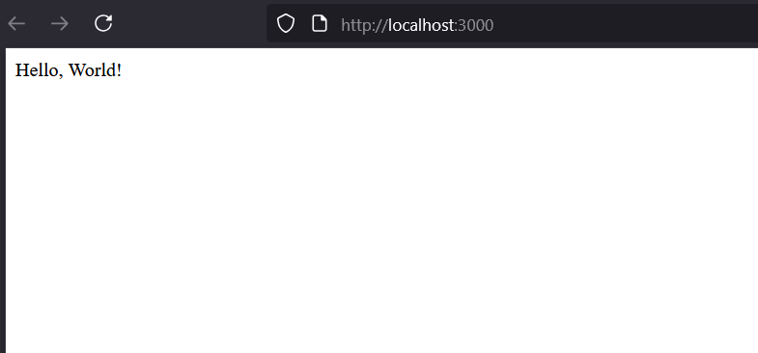 ### output 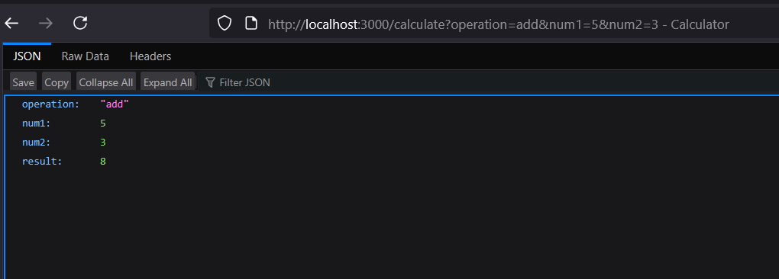 ### output 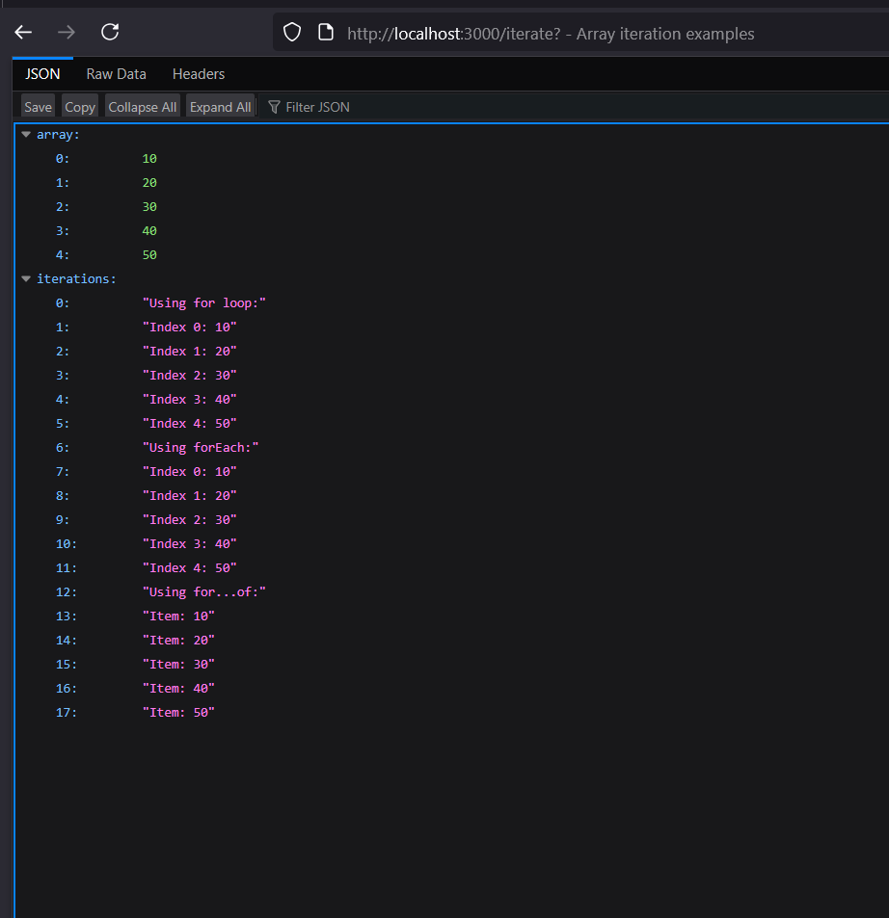 ### output 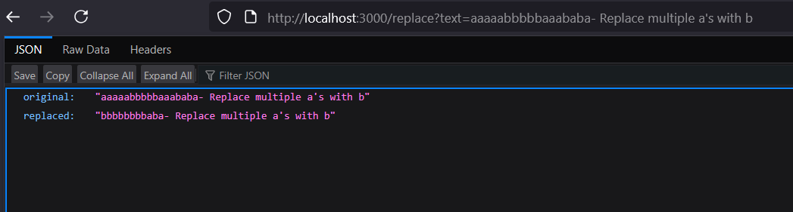
Challenges faced: - Configuring Express properly. - Managing multiple JavaScript files in one project.

Experiment 7
Topic: Node.js Sessions and Cookies
Files: source/, server.js, package.json
What I learned: - Using cookies and sessions in Node.js. - Maintaining user sessions across multiple pages. - Understanding middleware and session storage.
Code

cookie-example.js
const express = require('express');
const cookieParser = require('cookie-parser');
const app = express();
app.use(cookieParser());
app.get('/set-cookie', (req, res) => {
res.cookie('username', 'JohnDoe', { maxAge: 900000 });
res.send('Cookie has been set');
});
app.get('/get-cookie', (req, res) => {
const user = req.cookies['username'];
res.send(`Cookie Retrieved: ${user}`);
});
app.get('/delete-cookie', (req, res) => {
res.clearCookie('username');
res.send('Cookie deleted');
});
const PORT = process.env.PORT || 3000;
app.listen(PORT, () => {
console.log(`Server started on http://localhost:${PORT}`);
});

session-example.js
const express = require('express');
const session = require('express-session');
const app = express();
app.use(session({
secret: 'mysecretkey',
resave: false,
saveUninitialized: true
}));
app.get('/', (req, res) => {
if (req.session.views) {
req.session.views++;
res.send(`Welcome back! You visited ${req.session.views} times.`);
} else {
req.session.views = 1;
res.send('Welcome to the session demo. Refresh to count visits.');
}
});
app.get('/destroy', (req, res) => {
req.session.destroy(err => {
if (err) {
return res.send('Error destroying session');
}
res.send('Session destroyed');
});
});
const PORT = process.env.PORT || 3000;
app.listen(PORT, () => {
console.log(`Server started on http://localhost:${PORT}`);
});

package.json
{
"name": "experiment_7",
"version": "1.0.0",
"description": "",
"main": "index.js",
"scripts": {
"test": "echo \"Error: no test specified\" && exit 1"
},
"keywords": [],
"author": "",
"license": "ISC",
"dependencies": {
"cookie-parser": "^1.4.7",
"express": "^5.1.0",
"express-session": "^1.18.2"
}
}

output-cookie.js
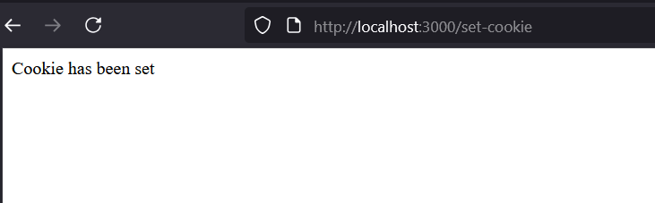 ### output-cookie.js 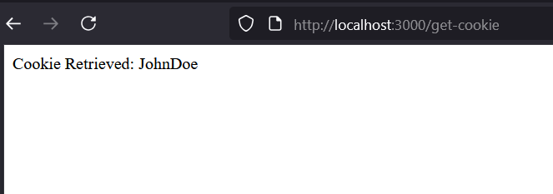
### output-cookie.js 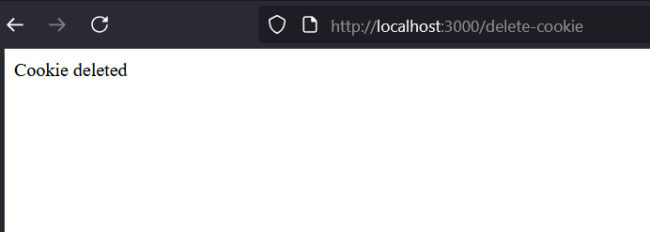
### output-session.js 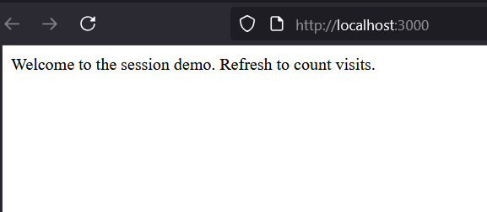
### output-session.js 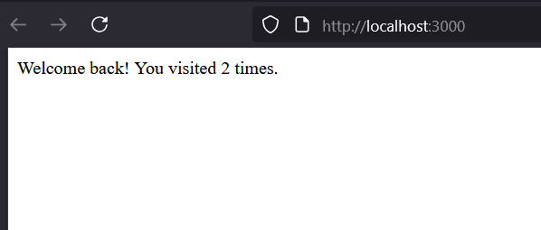
Challenges faced: - Configuring session middleware correctly. - Debugging cookie handling issues.

Experiment 8
Topic: NodeJS + MongoDB Integration, CRUD Operations. Files:* item.js, server.js, item.html,s.css ,student.html,student.js.
What I learned: - Creating a NodeJS application to connect to a MongoDB database - Creating an application to store student details in a database - Creating a search application to find students based on criteria - Creating a shopping center application with full CRUD features
Code
shopping-app

item.html
<!DOCTYPE html>
<html>
<head>
<title>Shopping Center</title>
<link rel="stylesheet" href="s.css">
</head>
<body>
<h1>Shopping Center Management</h1>
<h2>Add Item</h2>
<form id="addForm">
<input name="name" placeholder="Item Name" required><br>
<input name="price" placeholder="Price" type="number" required><br>
<input name="quantity" placeholder="Quantity" type="number" required><br>
<button type="submit">Add Item</button>
</form>
<h2>Stock Report</h2>
<table border="1">
<thead>
<tr>
<th>Name</th><th>Price</th><th>Qty</th><th>Actions</th>
</tr>
</thead>
<tbody id="itemTable"></tbody>
</table>
<script src="item.js"></script>
</body>
</html>

s.css
/* ---------- GLOBAL ---------- */
body {
font-family: Arial, Helvetica, sans-serif;
background: #f4f6f9;
margin: 0;
padding: 40px;
}
h1, h2 {
color: #222;
margin-bottom: 15px;
}
h1 {
font-size: 32px;
font-weight: 700;
}
h2 {
font-size: 22px;
font-weight: 600;
}
/* ---------- FORM AREA ---------- */
form input {
width: 280px;
padding: 12px;
margin: 8px 0;
border: 1px solid #ccc;
border-radius: 6px;
font-size: 16px;
}
button {
padding: 10px 18px;
background: #0051a8;
border: none;
color: white;
border-radius: 6px;
font-size: 15px;
cursor: pointer;
margin-right: 8px;
transition: 0.2s ease;
}
button:hover {
background: #003d82;
}
/* ---------- TABLE ---------- */
table {
width: 100%;
background: #fff;
margin-top: 20px;
border-collapse: collapse;
border-radius: 10px;
overflow: hidden;
box-shadow: 0 2px 10px rgba(0,0,0,0.1);
}
th {
background: #0051a8;
color: #fff;
padding: 14px;
font-size: 16px;
text-align: left;
}
td {
padding: 14px;
font-size: 16px;
border-bottom: 1px solid #eee;
}
/* row hover */
tr:hover {
background: #f2f7ff;
}
/* buttons inside table */
.action-btn {
padding: 6px 14px;
margin-right: 6px;
border-radius: 5px;
cursor: pointer;
border: none;
font-weight: 500;
}
.delete-btn {
background: #d9534f;
color: white;
}
.update-btn {
background: #0275d8;
color: white;
}
.sale-btn {
background: #5cb85c;
color: white;
}
.delete-btn:hover { background: #c9302c; }
.update-btn:hover { background: #025aa5; }
.sale-btn:hover { background: #449d44; }
/* ---------- TABLE EMPTY STATE ---------- */
.empty {
text-align: center;
padding: 20px;
color: gray;
font-style: italic;
font-size: 18px;
}

item.js
// Load stock
async function loadItems() {
let res = await fetch("/items");
let items = await res.json();
let table = document.getElementById("itemTable");
table.innerHTML = "";
items.forEach(i => {
table.innerHTML += `
<tr>
<td>${i.name}</td>
<td>${i.price}</td>
<td>${i.quantity}</td>
<td>
<button onclick="deleteItem('${i._id}')">Delete</button>
<button onclick="updateItem('${i._id}')">Update</button>
<button onclick="saleItem('${i._id}')">Sale</button>
</td>
</tr>`;
});
}
loadItems();
// Add item
document.getElementById("addForm").addEventListener("submit", async e => {
e.preventDefault();
let data = Object.fromEntries(new FormData(e.target).entries());
await fetch("/items/add", {
method: "POST",
headers: { "Content-Type": "application/json" },
body: JSON.stringify(data)
});
e.target.reset();
loadItems();
});
// Delete
async function deleteItem(id) {
await fetch(`/items/delete/${id}`, { method: "DELETE" });
loadItems();
}
// Update
async function updateItem(id) {
let price = prompt("Enter new price:");
let qty = prompt("Enter new quantity:");
await fetch(`/items/update/${id}`, {
method: "PUT",
headers: { "Content-Type": "application/json" },
body: JSON.stringify({ price, quantity: qty })
});
loadItems();
}
// Sale
async function saleItem(id) {
let qty = prompt("Enter quantity sold:");
await fetch(`/items/sale/${id}`, {
method: "PUT",
headers: { "Content-Type": "application/json" },
body: JSON.stringify({ quantity: qty })
});
loadItems();
}

server.js
const express = require("express");
const path = require("path");
const mongoose = require("mongoose");
const app = express();
app.use(express.json());
app.use(express.urlencoded({ extended: true }));
app.use(express.static(__dirname));
// MongoDB Connection
mongoose.connect("mongodb://127.0.0.1:27017/shopDB")
.then(() => console.log("MongoDB Connected"))
.catch(err => console.log(err));
// Schema
const itemSchema = new mongoose.Schema({
name: String,
price: Number,
quantity: Number
});
const Item = mongoose.model("Item", itemSchema);
// Serve UI
app.get("/", (req, res) => {
res.sendFile(path.join(__dirname, "item.html"));
});
// Add Item
app.post("/items/add", async (req, res) => {
let item = new Item(req.body);
await item.save();
res.json({ success: true });
});
// Get All Items (Stock Report)
app.get("/items", async (req, res) => {
let items = await Item.find();
res.json(items);
});
// Delete Item
app.delete("/items/delete/:id", async (req, res) => {
await Item.findByIdAndDelete(req.params.id);
res.json({ success: true });
});
// Update Item
app.put("/items/update/:id", async (req, res) => {
await Item.findByIdAndUpdate(req.params.id, req.body);
res.json({ success: true });
});
// Sale (reduce quantity)
app.put("/items/sale/:id", async (req, res) => {
let item = await Item.findById(req.params.id);
if (!item) return res.json({ success: false });
let qty = Number(req.body.quantity);
if (item.quantity < qty)
return res.json({ success: false, msg: "Not enough stock" });
item.quantity -= qty;
await item.save();
res.json({ success: true });
});
app.listen(3000, () => console.log("Server running on http://localhost:3000"));
code
student-app

item.html
<!DOCTYPE html>
<html>
<head>
<title>Student Management</title>
<style>
body {
font-family: Arial;
padding: 30px;
background: #f5f7fa;
}
h2 {
color: #003366;
border-left: 5px solid #003366;
padding-left: 10px;
}
input {
padding: 8px;
margin: 5px 0;
width: 250px;
border: 1px solid #ccc;
border-radius: 4px;
}
button {
padding: 8px 16px;
background: #003366;
color: white;
border: none;
border-radius: 4px;
cursor: pointer;
}
button:hover {
background: #0055a5;
}
table {
width: 80%;
margin-top: 15px;
border-collapse: collapse;
background: white;
box-shadow: 0 0 10px #ccc;
}
th, td {
padding: 12px;
border: 1px solid #ddd;
text-align: left;
}
th {
background: #003366;
color: white;
}
.highlight {
background: yellow !important;
font-weight: bold;
}
</style>
</head>
<body>
<h2>Add Student</h2>
<form id="addForm">
<input type="text" name="name" placeholder="Name" required><br>
<input type="number" name="roll" placeholder="Roll" required><br>
<input type="text" name="branch" placeholder="Branch" required><br>
<input type="number" name="year" placeholder="Year" required><br>
<button type="submit">Add Student</button>
</form>
<hr><br>
<h2>Search Student</h2>
<input type="text" id="searchBox" placeholder="Enter name or roll" onkeyup="highlightSearch()">
<button onclick="highlightSearch()">Search</button>
<hr><br>
<h2>All Students</h2>
<table>
<thead>
<tr>
<th>Name</th>
<th>Roll</th>
<th>Branch</th>
<th>Year</th>
</tr>
</thead>
<tbody id="studentTable"></tbody>
</table>
<!-- Single JS file only -->
<script src="student.js"></script>
</body>
</html>

student.js
// ADD student
document.getElementById("addForm").addEventListener("submit", async function (e) {
e.preventDefault();
let data = Object.fromEntries(new FormData(e.target).entries());
let res = await fetch("/students/add", {
method: "POST",
headers: { "Content-Type": "application/json" },
body: JSON.stringify(data)
});
let result = await res.json();
if (result.success) {
alert("Student Added!");
e.target.reset();
loadStudents();
}
});
// LOAD all students
async function loadStudents() {
let res = await fetch("/students");
let students = await res.json();
let table = document.getElementById("studentTable");
table.innerHTML = "";
students.forEach(s => {
table.innerHTML += `
<tr>
<td>${s.name}</td>
<td>${s.roll}</td>
<td>${s.branch}</td>
<td>${s.year}</td>
</tr>
`;
});
}
loadStudents();
// HIGHLIGHT SEARCH
async function highlightSearch() {
let keyword = document.getElementById("searchBox").value.toLowerCase();
let rows = document.querySelectorAll("#studentTable tr");
rows.forEach(row => row.classList.remove("highlight"));
if (keyword === "") return;
rows.forEach(row => {
let name = row.children[0].textContent.toLowerCase();
let roll = row.children[1].textContent.toLowerCase();
if (name.includes(keyword) || roll.includes(keyword)) {
row.classList.add("highlight");
}
});
}

server.js
const express = require("express");
const path = require("path");
const mongoose = require("mongoose");
const app = express();
app.use(express.urlencoded({ extended: true }));
app.use(express.json());
app.use(express.static(__dirname));
// MongoDB Connection
mongoose.connect("mongodb://127.0.0.1:27017/studentDB")
.then(() => console.log("MongoDB Connected"))
.catch(err => console.log(err));
// Schema
const studentSchema = new mongoose.Schema({
name: String,
roll: Number,
branch: String,
year: Number
});
const Student = mongoose.model("Student", studentSchema);
// Serve the HTML page
app.get("/", (req, res) => {
res.sendFile(path.join(__dirname, "student.html"));
});
// Add student
app.post("/students/add", async (req, res) => {
try {
await Student.create(req.body);
res.json({ success: true });
} catch (err) {
res.json({ success: false, error: err });
}
});
// Get all students
app.get("/students", async (req, res) => {
const students = await Student.find();
res.json(students);
});
// Search student (optional)
app.get("/students/search", async (req, res) => {
const q = req.query.q;
const result = await Student.find({
$or: [
{ name: { $regex: q, $options: "i" } },
{ roll: Number(q) }
]
});
res.json(result);
});
app.listen(3000, () => {
console.log("Server running on http://localhost:3000");
});

output
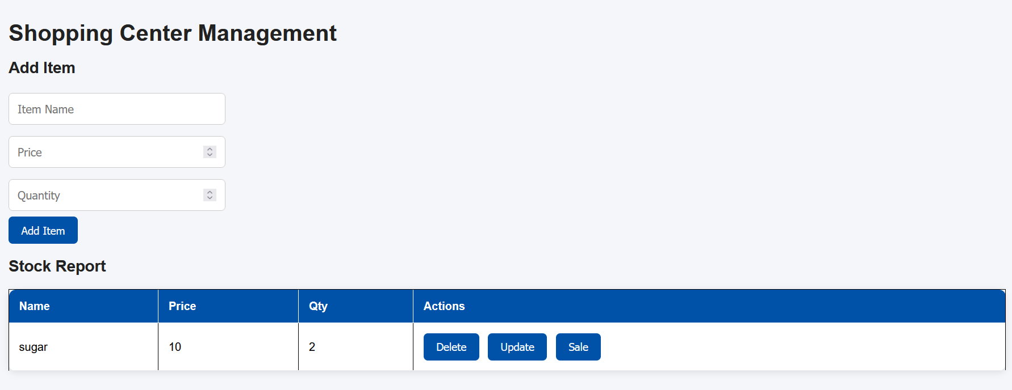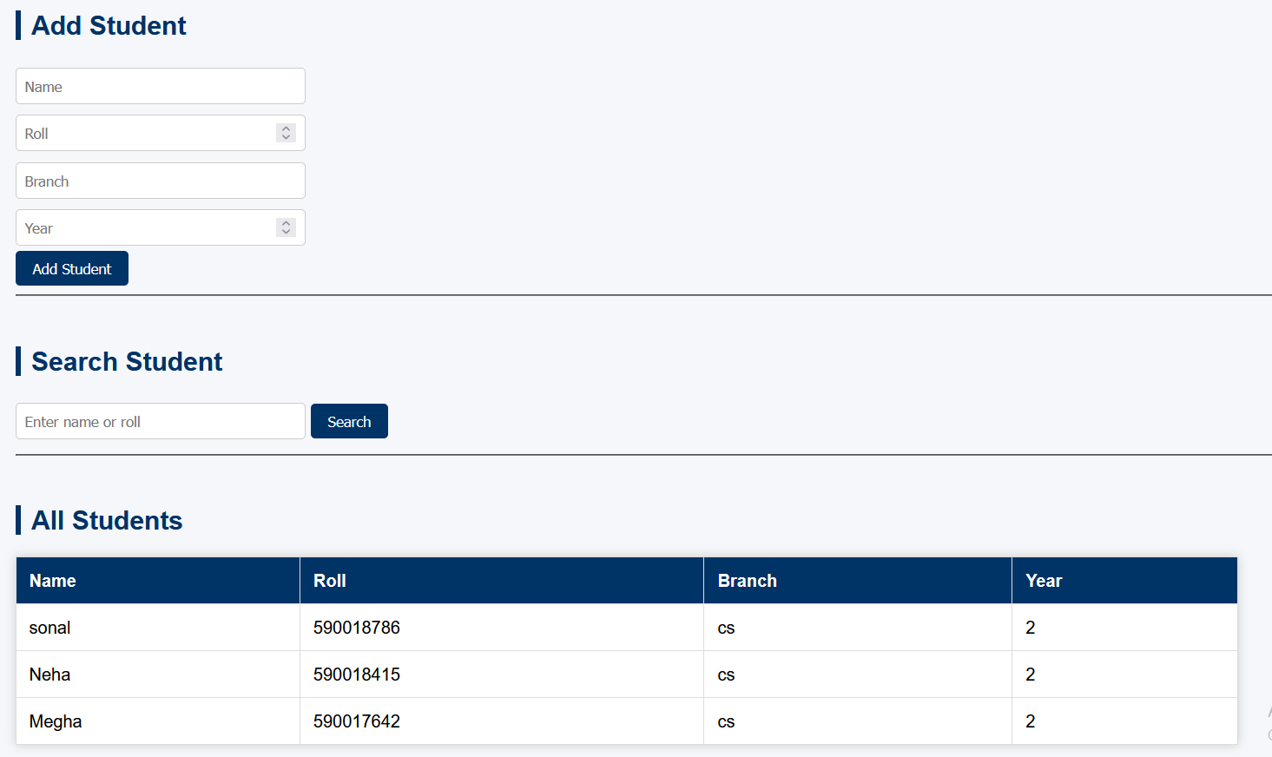
Challenges faced: - Understanding how async/await works with database operations. - Forgetting to use express.urlencoded() which caused form data to not reach the backend. - Schema mistakes like missing fields or wrong data types. - Difficulty connecting to MongoDB Cloud due to IP access settings.

Experiment 9&10
Topic: SVG Basics, D3.js Visualizations, Interactive Graphics, CSV Data Handling Files: csv.html,data.csv,exp.htm,index.html
What I learned: - Creating a bar chart using SVG and D3.js - Selecting and modifying particular elements using D3 - Creating circles and rectangles as interactive controls - Fetching data from CSV and creating a graph
Code

csv.html
<!DOCTYPE html>
<html>
<head>
<title>Experiment 10: CSV Graph</title>
<script src="https://d3js.org/d3.v7.min.js"></script>
</head>
<body>
<h1>Experiment 10: CSV → Graph using D3.js</h1>
<svg width="500" height="300"></svg>
<script>
const svg = d3.select("svg");
const width = 500;
const height = 300;
const barWidth = 50;
d3.csv("data.csv").then(data => {
data.forEach(d => d.value = +d.value);
svg.selectAll("rect")
.data(data)
.enter()
.append("rect")
.attr("x", (d, i) => i * (barWidth + 10))
.attr("y", d => height - d.value * 5)
.attr("width", barWidth)
.attr("height", d => d.value * 5)
.attr("fill", "teal");
svg.selectAll("text")
.data(data)
.enter()
.append("text")
.text(d => d.name)
.attr("x", (d, i) => i * (barWidth + 10) + 15)
.attr("y", height - 5)
.attr("fill", "black");
});
</script>
</body>
</html>

data.csv
name,value
A,10
B,20
C,15
D,25

exp.html
<!DOCTYPE html>
<html>
<head>
<title>Experiment 9: Combined Visualizations</title>
<script src="https://d3js.org/d3.v7.min.js"></script>
<style>
section {
margin-bottom: 50px;
padding: 20px;
border: 2px solid #ddd;
border-radius: 10px;
}
h2 { color: #003366; }
button { padding: 8px 15px; margin-right: 10px; }
</style>
</head>
<body>
<h1>Experiment 9: SVG + D3 (Combined)</h1>
<!-- ====================================================== -->
<!-- =============== 1. BAR CHART ========================= -->
<!-- ====================================================== -->
<section>
<h2>1. Bar Chart using SVG + D3.js</h2>
<svg id="barChart" width="500" height="250"></svg>
<script>
const data = [10, 30, 20, 40, 25];
const svg1 = d3.select("#barChart");
const height1 = 250;
const barWidth = 50;
svg1.selectAll("rect")
.data(data)
.enter()
.append("rect")
.attr("x", (d, i) => i * (barWidth + 10))
.attr("y", d => height1 - d * 5)
.attr("width", barWidth)
.attr("height", d => d * 5)
.attr("fill", "steelblue");
</script>
</section>
<!-- ====================================================== -->
<!-- =============== 2. INTERACTIVE SHAPES ================ -->
<!-- ====================================================== -->
<section>
<h2>2. Interactive Shapes (Circles & Rectangles)</h2>
<svg id="shapes" width="500" height="250"></svg>
<script>
const svg2 = d3.select("#shapes");
// Circle
svg2.append("circle")
.attr("cx", 100)
.attr("cy", 120)
.attr("r", 40)
.attr("fill", "orange")
.on("mouseover", () => d3.select("circle").attr("fill", "red"))
.on("mouseout", () => d3.select("circle").attr("fill", "orange"));
// Rectangle
svg2.append("rect")
.attr("x", 200)
.attr("y", 100)
.attr("width", 80)
.attr("height", 60)
.attr("fill", "green")
.on("click", function(){ d3.select(this).attr("fill", "purple"); });
</script>
</section>
<!-- ====================================================== -->
<!-- ============ 3. MODIFY ELEMENT USING D3 ============= -->
<!-- ====================================================== -->
<section>
<h2>3. Modify Selected Element</h2>
<svg id="mod" width="400" height="200">
<circle id="myCircle" cx="150" cy="100" r="50" fill="blue"></circle>
</svg>
<button onclick="changeColor()">Change Color</button>
<button onclick="increaseSize()">Increase Size</button>
<script>
function changeColor() {
d3.select("#myCircle").attr("fill", "red");
}
function increaseSize() {
d3.select("#myCircle").attr("r", 80);
}
</script>
</section>
</body>
</html>

index.html
<!DOCTYPE html>
<html>
<head>
<title>Data Visualization Experiments</title>
<style>
body {
font-family: Arial;
padding: 40px;
background: #f5f7fa;
}
.box {
border: 2px solid #003366;
padding: 20px;
border-radius: 8px;
width: 350px;
margin-bottom: 20px;
background: white;
}
a {
display: block;
text-decoration: none;
color: white;
background: #003366;
padding: 10px;
text-align: center;
border-radius: 6px;
}
a:hover { background: #0055a5; }
</style>
</head>
<body>
<h1>Data Visualization - Experiment 9 & 10</h1>
<div class="box">
<h3>Experiment 9 (Combined)</h3>
<p>Bar Chart + Interactive Shapes + Modify SVG Element</p>
<a href="exp.html">Open Experiment 9</a>
</div>
<div class="box">
<h3>Experiment 10</h3>
<p>CSV → Graph using D3</p>
<a href="csv.html">Open Experiment 10</a>
</div>
</body>
</html>

output
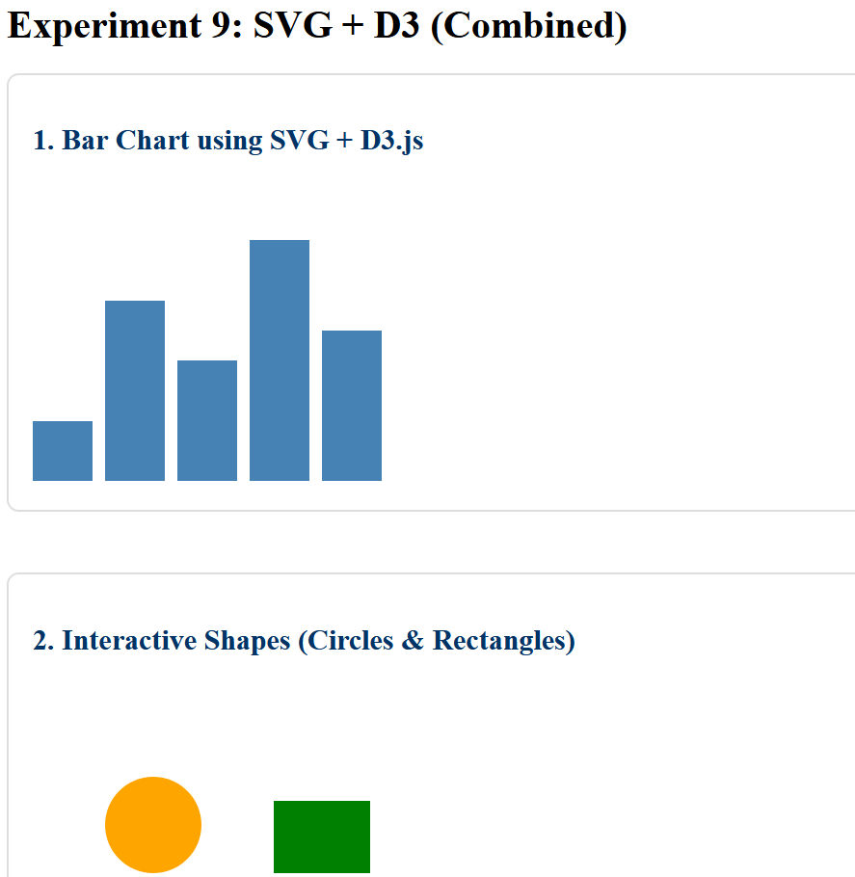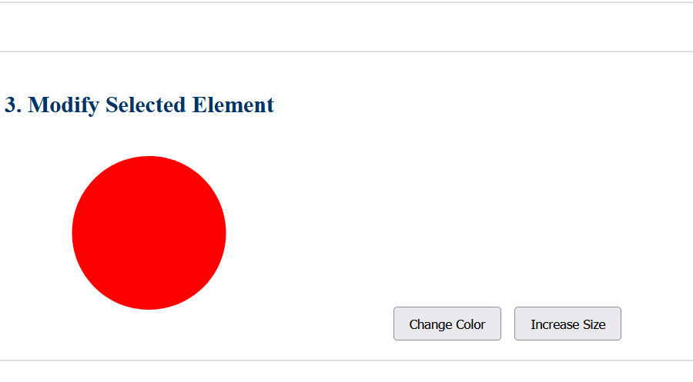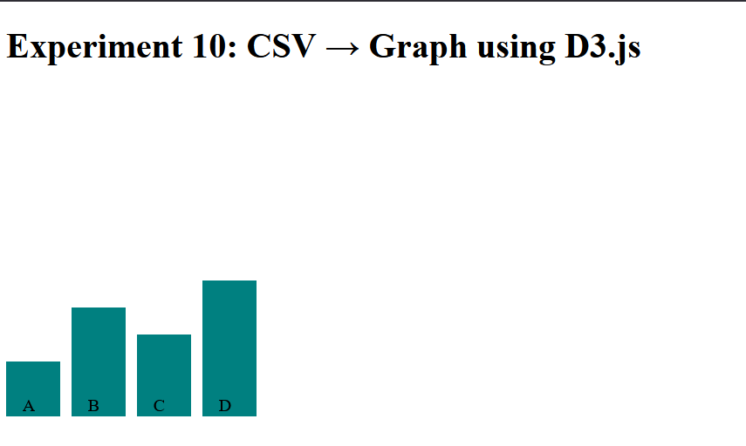
Challenges faced: - Understanding the enter-update-exit pattern of D3.js - Forgetting to include the D3 script link (leading to “d3 is not defined” errors). - Getting confused between pixel values and scale values. -Difficulty in making interactions (click/hover) work correctly.

Conclusion
This lab helped me gain hands-on experience in front-end and back-end web development.
I learned how to: - Design interactive front-end applications (HTML, CSS, JS, jQuery, Angular). - Build and deploy backend applications using Node.js and Express. - Handle user sessions, cookies, and server routing.
Overall Challenge:
Initially, understanding how client and server communicate was difficult, but through these experiments, I developed a clear understanding of full-stack web development.

Submitted by: Sonal
Course: Advanced Web Technology Lab
Tools Used: VS Code, Node.js, GitHub

