**7PAM2000-Applied Data Science 1**

**Assignment 1 – Visualization**

**STUDENT NAME : SONAL SHIVAJI SHERKAR**

**STUDENT ID : 22020085**

**References : www.metoffice.gov.uk**

__________________________________________________________________________

**Study of Southern Hemisphere Annual Data**

**INTRODUCTION :**

The southern hemisphere annual data gives us overview of climate change trends With reference to the climate and temperature changes happening from 1850 to 2025. We are going to analyse the pattern of southern region climate changes. Also, by using historical data we are going to predict the future climate changes. By using different visualisations like line plot, scatter plot and histograms.

__________________________________________________________________________

**GRAPH 1 : LINE PLOT**

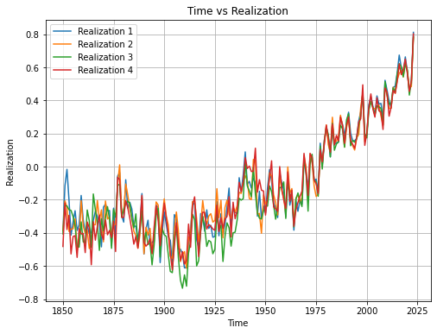

The above line plot is used to show the temperature realizations in the given years. In this plot we have used data of initial 4 temperature realizations. As we can analyse the temperature realizations are lower than zero in starting years i.e. 1850-1925 but as we go further the temperature realization started to increase from this and reaches to above 0.8 in recent years i.e. years 2020-2025.

__________________________________________________________________________

**GRAPH 2 : SCATTER PLOT**

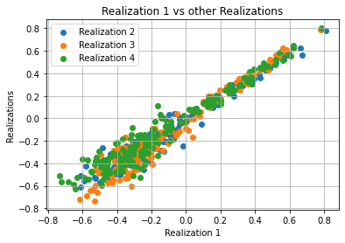

In above scatter plot, we have plotted the points between Realization 1 vs. rest of all other realizations i.e. Realization 2, 3 and 4. As we can notice here nearly all the Realizations are linearly related to each other and we have most of density in the temperature range of -0.5 to 0.0.

___________________________________________________________________________

**GRAPH 3 : HISTOGRAMS**

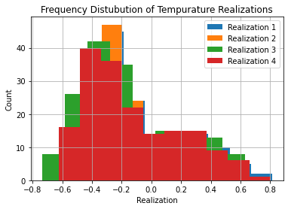

As we know, histogram statistical graph used to represent the distribution of continuous dataset. It is used to get the occurrences between categories of given column. Here, we get the total count of temperatures in the given Temperature Realization range. As we can see that we have highest count in the range of -0.4 to -0.2 for all the Realizations and uniquely highest count for Realization 2 in that range. The least count is for the range of 0.6 to 0.8 for all Realizations.

___________________________________________________________________________

**CONCLUSION :**

Finally, we have concluded that, as per the latest study on southern hemisphere annual data, we observed that there are different patterns of environmental changes. We have analysed some observations from this data with reference to the different visualisation graphs like line plot, scatter plot and histograms. Through the analysis of this data we reached towards future regional climate changes with respect to the historical data.