Clone my Repository code and then perform the below mentioned steps.

<https://github.com/sonam-niit/Devops-Capstone-March-2025.git>

Create Aws User using IAM

Attach below mention Permissions

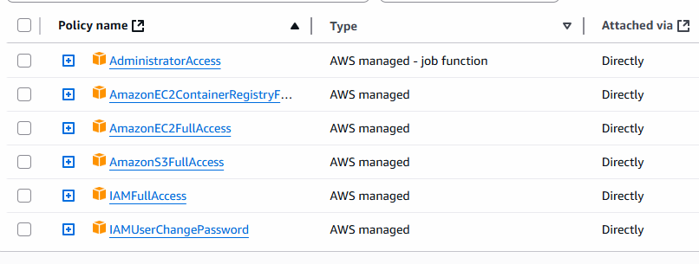

Also Create Access Keys and Secret keys

Configure AWS for executing Terraform

Set Repository Secrets

Repository 🡪 settings 🡪 Secrets 🡪 Actions 🡪 New repo Secret

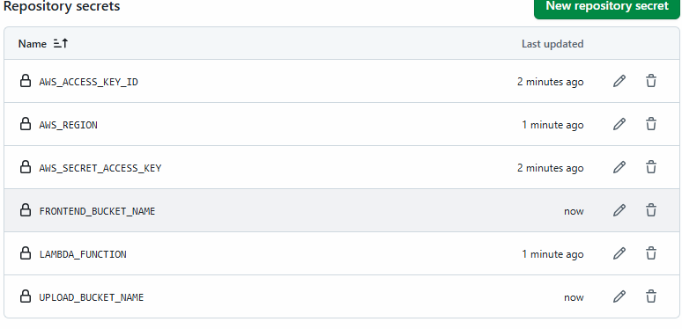

Let us Go to the code base and open wsl in your project.

Create Zip file for lambda functions

Cd backend/generate-presigned-url

zip –r lambda.zip

do it for both lambda function.

Let’s Create TfState(remote backend) Bucket

aws s3api create-bucket \

--bucket devops-accelerator-platform-tf-state1 \

--region us-east-1

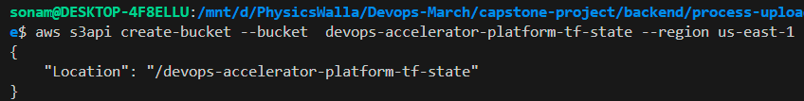

Create Dynamotable:

aws dynamodb create-table --table-name devops-accelerator-tf-locker --attribute-definitions AttributeName=LockID,AttributeType=S --key-schema AttributeName=LockID,KeyType=HASH --billing-mode PAY_PER_REQUEST --region us-east-1

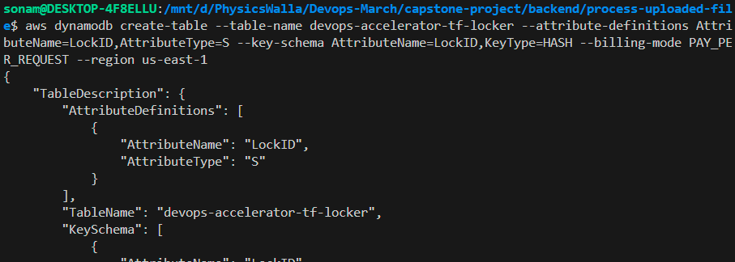

Let’s Push Thigs on Github

Then check terraform pipeline for resource creation

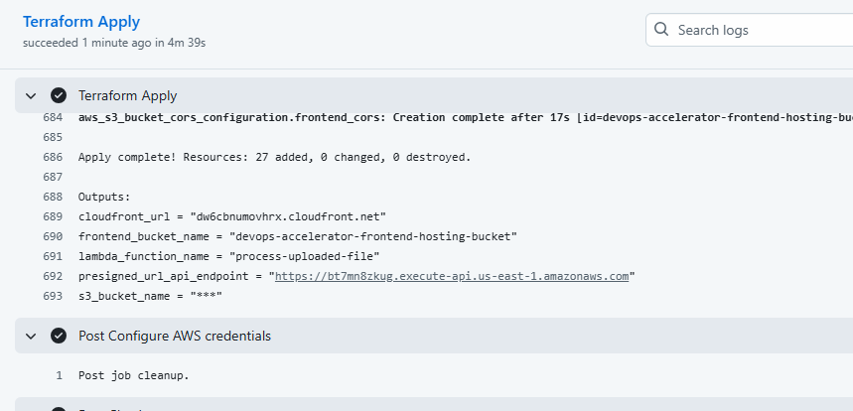

From here copy the presigned URL and paste it in your index.html file

Where use this path

apiUrl = <presigned_url_endpoint>/generate-presigned-url

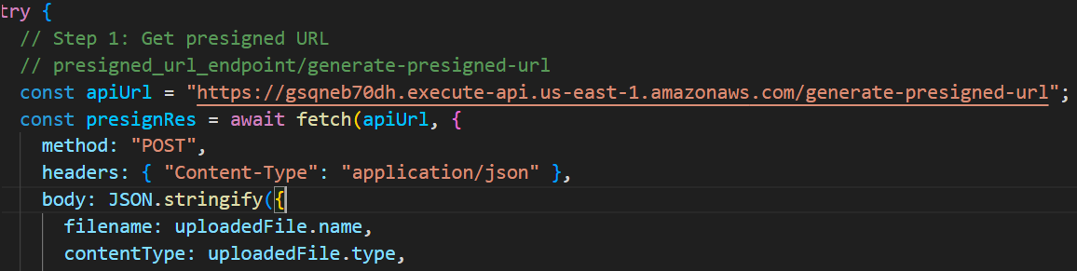

Save this file and upload it in s3 bucket.

For that open s3 bucket

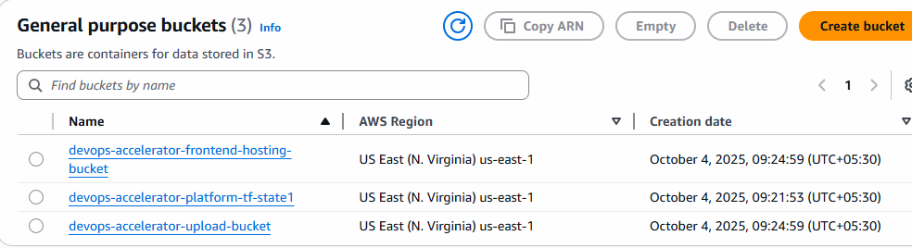

Devops-accelerator-frontend-hosting-bucket and upload index.html file there.

Now let’s check cloud front URL from the terraform pipeline Outputs

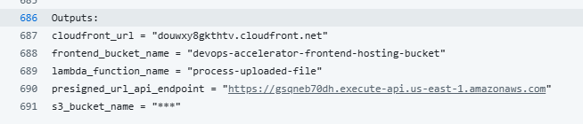

You will get below url which you can check: douwxy8gkthtv.cloudfront.net

Below will be output if you check in browser.

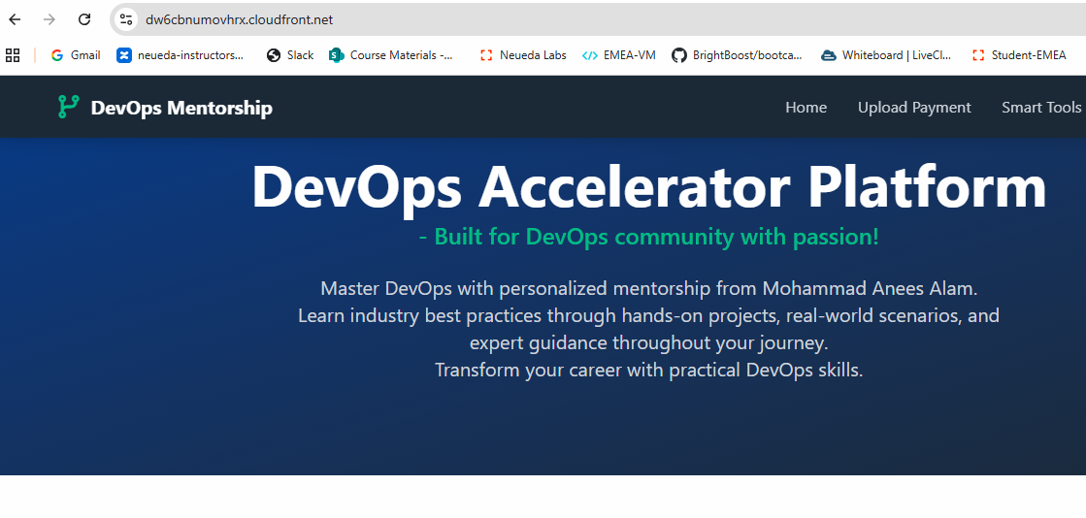

Now Let’s Try to upload the PDF from the form.

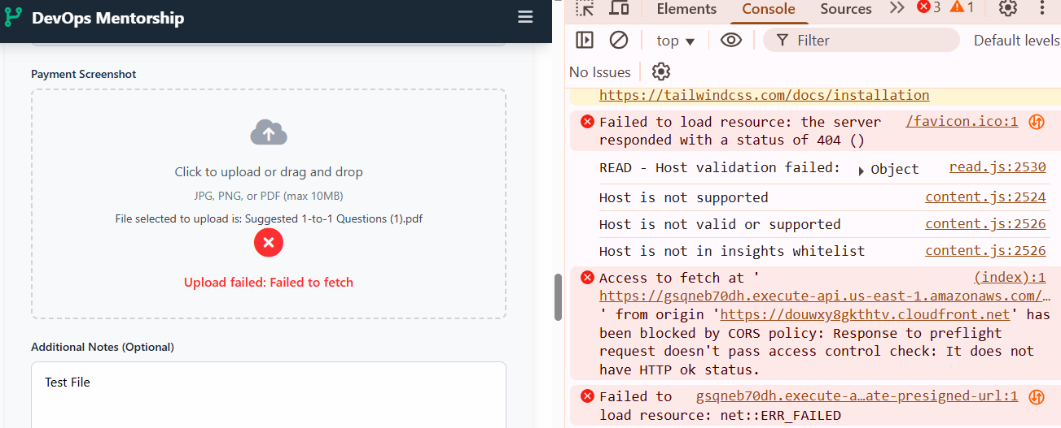

We are getting CORS Policy Error

To resolve this CORS error we need to set its permission in the bucket.

Open devops-accelerator-upload-bucket and set CORS permission.

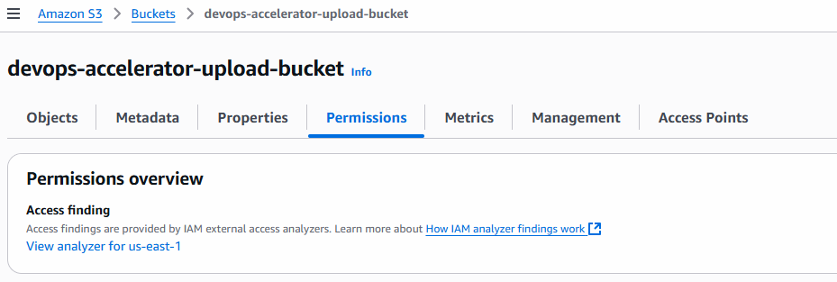

Scroll down and search for CORS

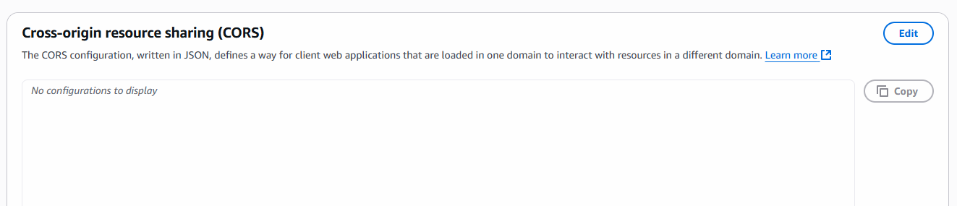

Click on Edit and add CORS permission.

[

{

"AllowedHeaders": [

"*"

],

"AllowedMethods": [

"GET",

"PUT",

"POST",

"DELETE",

"HEAD"

],

"AllowedOrigins": [

"*"

],

"ExposeHeaders": []

}

]

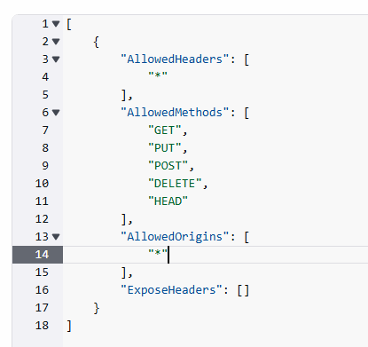

Save the Changes.

If still you are getting an error. Then

Goto > aws> Apis > devops-accelerator-api > click on it

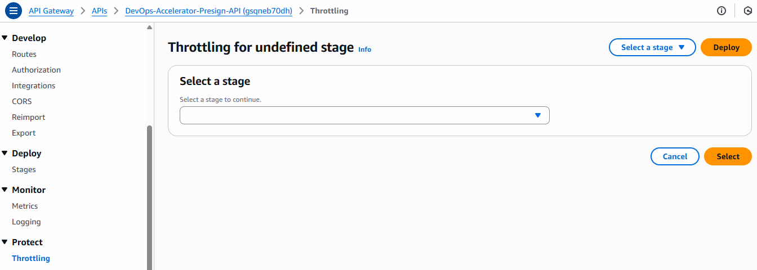

Select Stage – click on that and select Default.

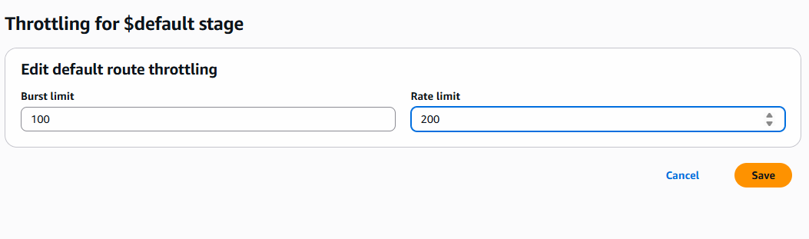

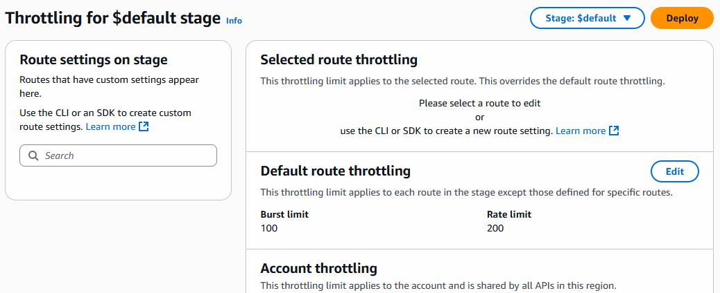

Let’s Try to upload again.

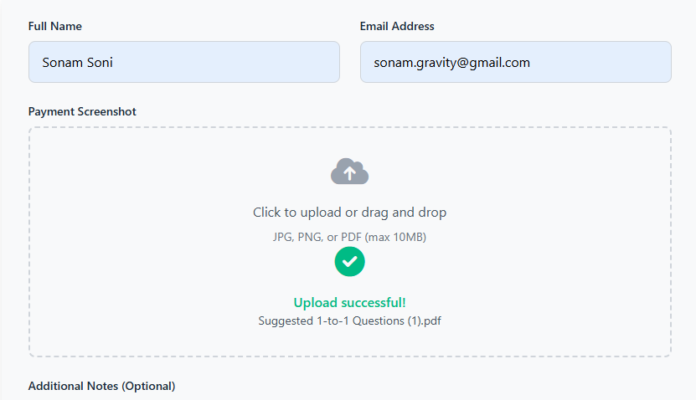

Check your bucket to see the upload

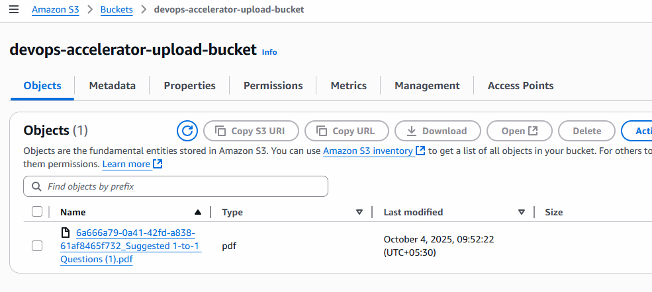

Check logs in the cloud watch

