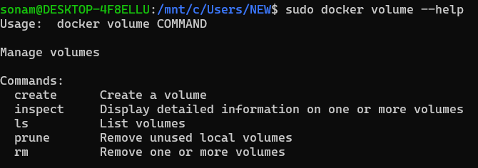

Let’s Create Volume:

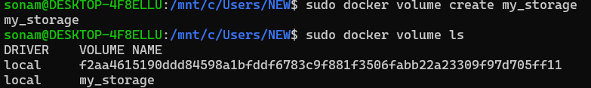



sudo docker run -d --name my-nginx -v my_storage:/usr/share/nginx/html -p 80:80 nginx

my_storage:/usr/share/nginx/html (this is the bound location where the volume is mounted for nginx)

check running containers: sudo docker ps

Let’s add some content to this volume.

I want to go inside the container and want to add some content to the volume.

