Let’s implement Basic Operations with React

Create one react application, open app using VS code

Run the same using npm start command

In src folder create one folder named component and create 3 component files.

Customerlist.js, customerdetail.js and customerform.js

Also add bootstrap to your application.

We are adding Customer List to app component whereas customerdetails and customerform in customer List compnet

props

CustomerDetail

CustomerList

Parent to child communication

props

CustomerForm

CustomerList

Customer list can pass values to customer form using props but form cannot pass value to customerlist directly.

We can create one method in customerlist pass it using props to customerform and then call method from customerform to pass data from child to parent.

App.js

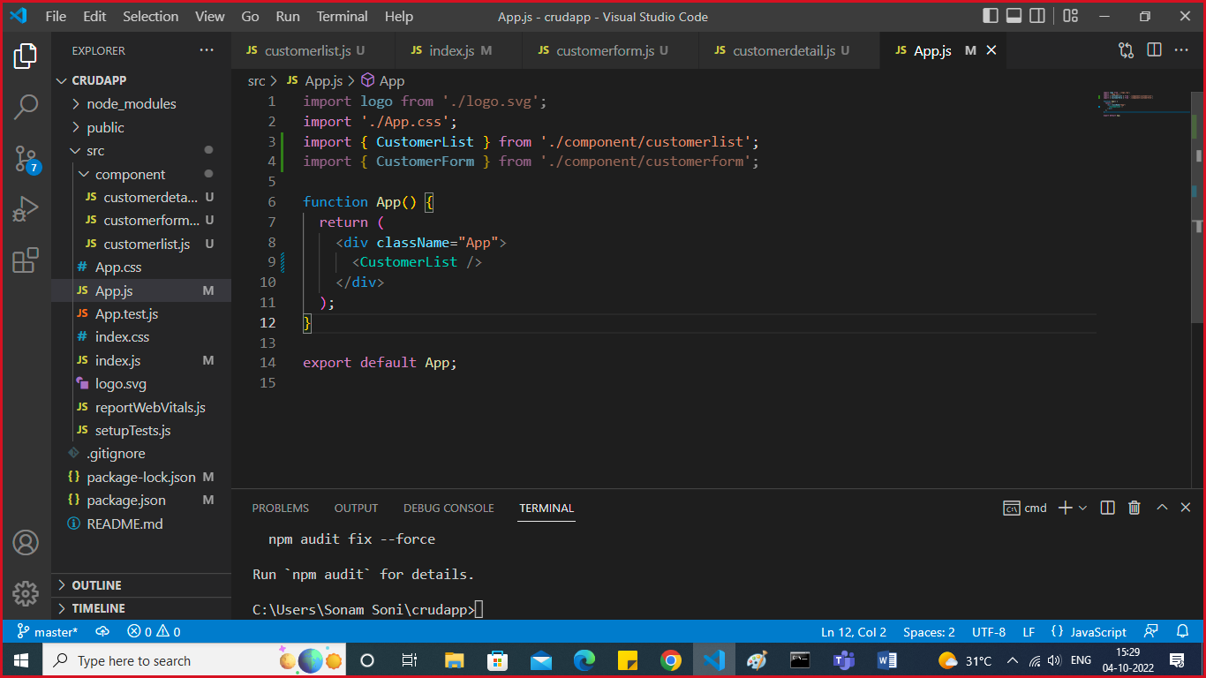

CustomerList.js

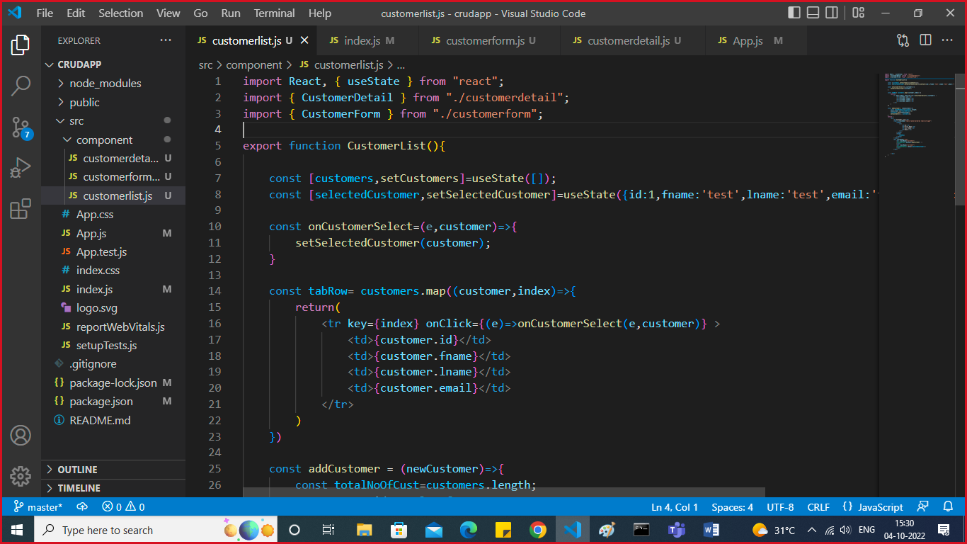

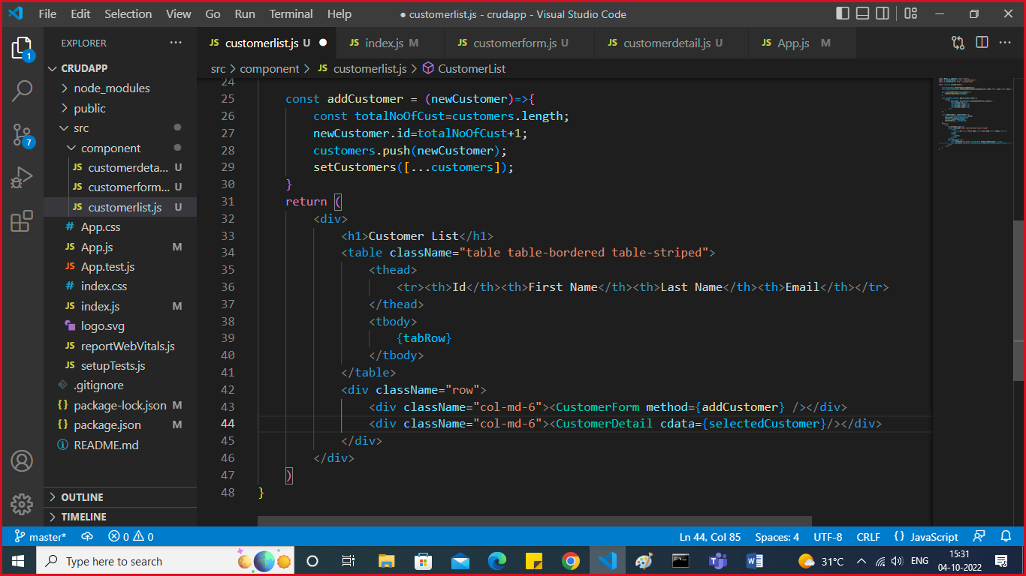

CustomerDetails.js

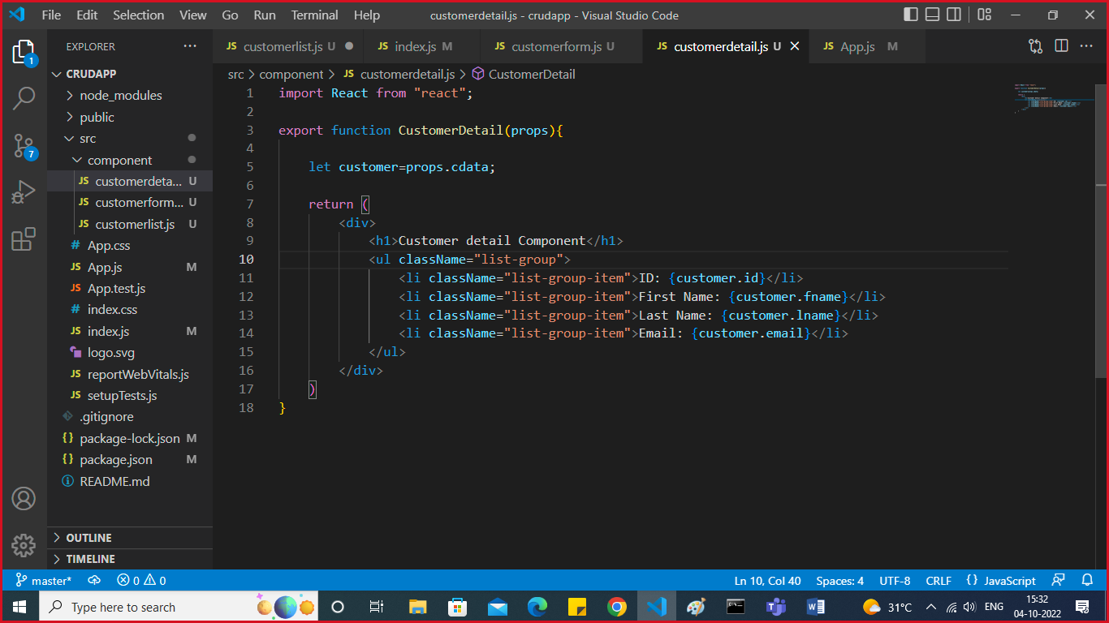

CustomerForm.js

