SwitchDemo

Let’s create a component

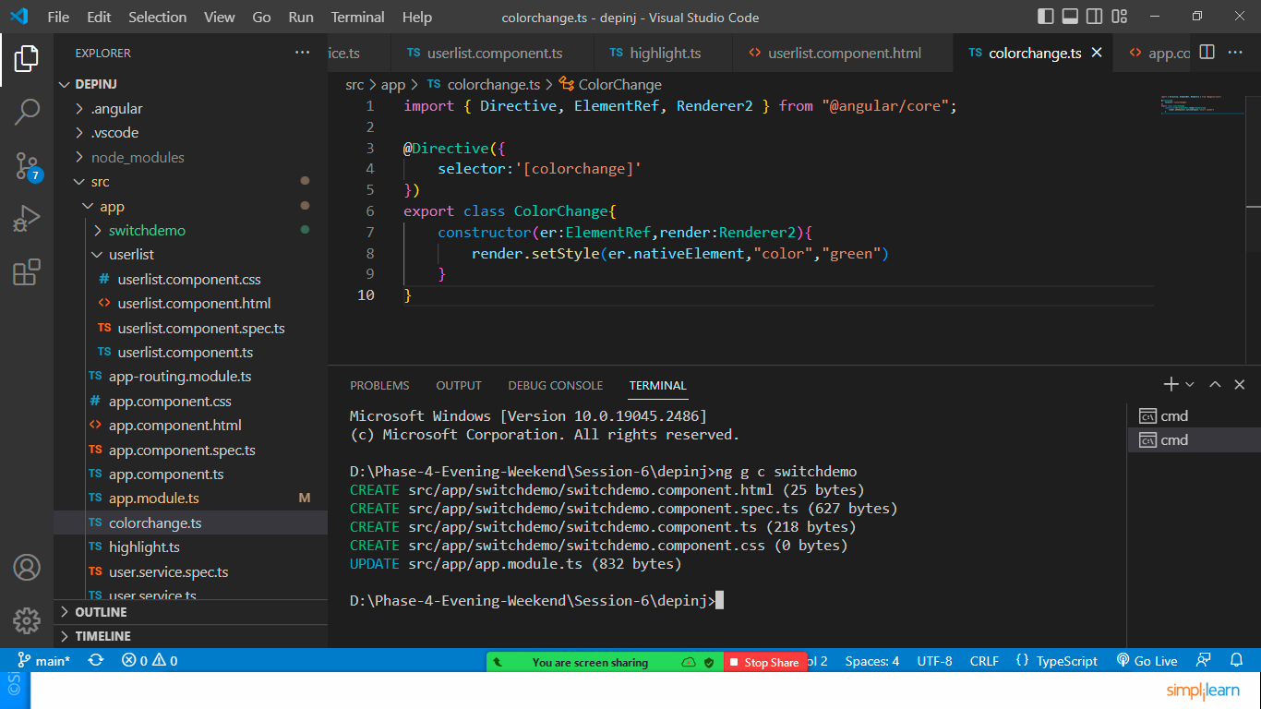

Edit switchdemo.component.ts file

export class SwitchdemoComponent {

  num:number=0;

}

If you want to use ngModel then include formsModule in app.module.ts file

import { FormsModule } from '@angular/forms';

imports: [

    BrowserModule,

    AppRoutingModule,

    HttpClientModule,

    FormsModule

  ],

Edit switchdemo.component.html file

<h1>Switch Demo</h1>

Enter Any Number between 1-7: <input type="text" [(ngModel)]="num">

<div [ngSwitch]="num">

    <div \*ngSwitchCase="1"><h3>Today is Monday</h3></div>

    <div \*ngSwitchCase="2"><h3>Today is Tuesday</h3></div>

    <div \*ngSwitchCase="3"><h3>Today is Wednesday</h3></div>

    <div \*ngSwitchCase="4"><h3>Today is Thursday</h3></div>

    <div \*ngSwitchCase="5"><h3>Today is Friday</h3></div>

    <div \*ngSwitchCase="6"><h3>Today is Saturday</h3></div>

    <div \*ngSwitchCase="7"><h3>Today is Sunday</h3></div>

</div>

Need to include this component in app.component.html file

<div class="container">

  <app-switchdemo></app-switchdemo>

</div>

Check the output by entering numbers in textfield

