**Lesson 4 Demo 12**

**Configuring Liveness Probes**

**Objective:** To create and configure a Pod using Liveness Probes

**Tools required:** kubeadm and kubectl

**Prerequisites:** Kubernetes cluster should be installed

**Steps to be followed:**

1. Creating a Pod using Liveness Probe
2. Describing the Pod

**Step 1: Creating a Pod using Liveness Probe**

* 1. Open exec-liveness.yaml using the following command:

**vi exec-liveness.yaml**

1.2 Copy and paste the below code in the exec-liveness.yaml file:

**apiVersion: v1**

**kind: Pod**

**metadata:**

**labels:**

**test: liveness**

**name: liveness-exec**

**spec:**

**containers:**

**- name: liveness**

**image: k8s.gcr.io/busybox**

**args:**

**- /bin/sh**

**- -c**

**- touch /tmp/healthy; sleep 30; rm -rf /tmp/healthy; sleep 600**

**livenessProbe:**

**exec:**

**command:**

**- cat**

**- /tmp/healthy**

**initialDelaySeconds: 5**

**periodSeconds: 5**

* 1. Create a Pod using the following command:

**kubectl create -f exec-liveness.yaml**

* 1. Enter the following command to get the Pod status:

**kubectl get pod**

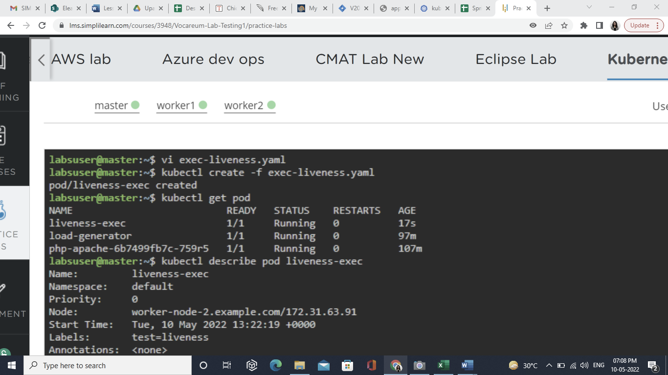

**Step 2: Describing the Pod**

2.1 Describe the Pod by using the following command:

**kubectl describe pod liveness-exec**

