**Lesson 4 Demo 8**

**Container Resources**

**Objective:** To configure memory requests and limits for the Containers

**Tools required:** kubeadm, kubectl, kubelet, and etcd

**Prerequisites:** A Kubernetes cluster must be set up (follow steps of Lesson 2 Demo 1)

Steps to be followed:

1. Creating a ResourceQuota
2. Defining the LimitRange
3. Verifying the ResourceQuota

**Step 1: Creating a ResourceQuota**

1. Write the following code in the **resourcequota.yaml** file.

**apiVersion: v1**

**kind: ResourceQuota**

**metadata:**

**name: object-counts**

**spec:**

**hard:**

**configmaps: "10"**

**persistentvolumeclaims: "4"**

**pods: "2"**

**replicationcontrollers: "20"**

**secrets: "10"**

**services: "10"**

**services.loadbalancers: "2"**

1. Create a **test** namespace for the **ResourceQuota.**

**kubectl create namespace test**

1. Create a **ResourceQuota** using the following command:

**kubectl create -f resourcequota.yaml -n test**

**Step 2: Defining the LimitRange**

1. Write the following code in the **limit.yaml** file.

**apiVersion: v1**

**kind: LimitRange**

**metadata:**

**name: limit-mem-cpu-per-container**

**spec:**

**limits:**

**- max:**

**cpu: "800m"**

**memory: "1Gi"**

**min:**

**cpu: "100m"**

**memory: "99Mi"**

**default:**

**cpu: "700m"**

**memory: "900Mi"**

**defaultRequest:**

**cpu: "110m"**

**memory: "111Mi"**

**type: Container**

1. Run the following command to create the **LimitRange**:

**kubectl create -f limit.yaml -n test**

**kubectl get limitrange -n test**

**Step 3: Verifying the ResourceQuota**

1. Run the following command to verify the **ResourceQuota**:

**kubectl get resourcequota -n test**

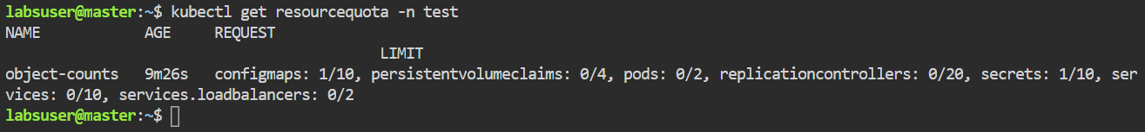

As seen in the screenshot above, the **ResourceQuota** has been successfully created to manage memory requests and limits for Containers.