**Lesson 5 Demo 1**

**Understanding Kube-Scheduler**

**Objective:** To create a custom Kubernetes scheduler for the Pods

**Tools required:** kubeadm, kubectl, kubelet, and etcd

**Prerequisites:** A Kubernetes cluster must be set up (follow steps of Lesson 2 Demo 1)

Steps to be followed:

1. Creating a custom scheduler
2. Creating a Pod using lab-scheduler

**Step 1: Creating a custom scheduler**

1. Navigate to the manifests folder.

**cd /etc/kubernetes/manifests**

1. Add the following code to the **lab-kube-scheduler.yaml** file:

**apiVersion: v1**

**kind: Pod**

**metadata:**

**labels:**

**component: kube-scheduler**

**tier: control-plane**

**name: lab-scheduler**

**namespace: kube-system**

**spec:**

**containers:**

**- command:**

**- kube-scheduler**

**- --bind-address=127.0.0.1**

**- --scheduler-name=lab-scheduler**

**- --kubeconfig=/etc/kubernetes/scheduler.conf**

**- --leader-elect=false**

**- --port=10260**

**image: k8s.gcr.io/kube-scheduler:v1.20.11**

**imagePullPolicy: IfNotPresent**

**livenessProbe:**

**failureThreshold: 8**

**httpGet:**

**host: 127.0.0.1**

**path: /healthz**

**port: 10260**

**scheme: HTTPS**

**initialDelaySeconds: 10**

**timeoutSeconds: 15**

**name: lab-scheduler**

**resources:**

**requests:**

**cpu: 100m**

**volumeMounts:**

**- mountPath: /etc/kubernetes/scheduler.conf**

**name: kubeconfig**

**readOnly: true**

**hostNetwork: true**

**priorityClassName: system-node-critical**

**volumes:**

**- hostPath:**

**path: /etc/kubernetes/scheduler.conf**

**type: FileOrCreate**

**name: kubeconfig**

**status: {}**

|  |
| --- |
| Note: Use **sudo** if you get an error when writing a file. |

1. Run the following command to create the **lab-scheduler**:

**kubectl apply -f lab-kube-scheduler.yaml**

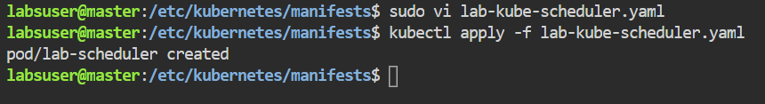

1. To verify the newly created scheduler, use the following command:

**kubectl get pods -A | grep scheduler**

The **lab-scheduler** has been successfully created and is running.

**Step 2: Creating a Pod using lab-scheduler**

1. Create a folder named **Deployments** and navigate into it.

**sudo mkdir deployments**

**cd deployments/**

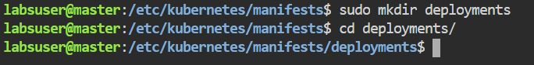

1. Add the following code to the **lab-scheduler-pod.yaml** file:

**apiVersion: v1**

**kind: Pod**

**metadata:**

**name: nginx**

**spec:**

**containers:**

**- image: nginx**

**name: nginx**

**schedulerName: lab-scheduler**

1. Use the following command to create the **Pod**:

**kubectl apply -f lab-scheduler-pod.yaml**

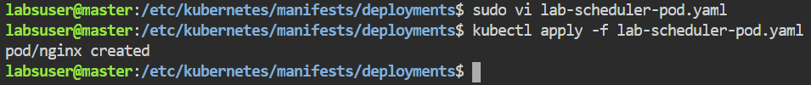

1. To verify the scheduler name for the newly created **Pod**, use the following command:

**kubectl edit pod nginx**

As shown in the configuration file above, the **lab-scheduler** has been successfully added to the previously created **Nginx** Pod.