**Lesson 7 Demo 1**

**Using hostPath**

**Objective:** To create a hostPath volume to mount files from a Pod to the file system of the host node

**Tools required:** kubeadm, kubectl, kubelet, and etcd

**Prerequisites:** A Kubernetes cluster must be set up (follow steps of Lesson 2 Demo 1)

Steps to be followed:

1. Creating a Pod using hostPath
2. Creating files within the Pod
3. Accessing files created on other nodes

**Step 1: Creating a Pod using hostPath**

1. To create a **hostPath** as a volume, write the following code in the **hostpath.yaml** file:

**apiVersion: v1**

**kind: Pod**

**metadata:**

**name: httpd-vol**

**spec:**

**containers:**

**- image: docker.io/httpd**

**name: httpd-container**

**volumeMounts:**

**- mountPath: /data**

**name: httpd-volume**

**volumes:**

**- name: httpd-volume**

**hostPath:**

**path: /tmp/data**

1. Use the following command to create a **hostPath**:

**kubectl apply -f hostpath.yaml**

The Pod with a volume **hostPath** is successfully created.

**Step 2: Creating files within the Pod**

1. To initiate a shell session within the **httpd-vol** Pod, use the following command:

**kubectl exec -it httpd-vol bash**

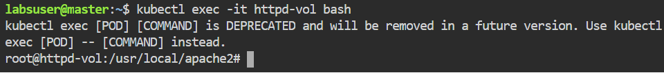

|  |
| --- |
| Note: We're now inside the **httpd-vol** Pod. |

1. Run the following commands to create a folder and multiple files inside the Container that can be accessed by other nodes:

**cd /data/**

**touch file{1..10}.txt**

Use **ls** command to list the files in the **/data** directory.

|  |
| --- |
| Note: To quit the shell, use the **exit** command. |

**Step 3: Accessing files created on other nodes**

1. Run the following command to find out on which node is the Pod running:

**kubectl get pods -o wide**

1. The **httpd-vol** Pod is currently running on **worker-node-2**. Navigate to the terminal of **worker node 2**.

1. Navigate to the **/data** directory.

**cd /tmp/**

**ls**

**cd data**

1. Verify if the files created previously are accessible in the **worker-node-2**.

**ls**

Because of the volume **hostPath**, all files are now accessible on **worker-node-2**, as seen in the screenshot above.