4.7 Docker Compose



This section will guide you to**:**

* Run an SSH Docker container on Docker compose using which you can have an auto deployment script. This can be later deployed to Jenkins application.

This guide has two subsections, namely**:**

4.7.1 Docker Compose Operations

4.7.2 Pushing the code to GitHub repositories

*Docker is already installed in your lab. (Refer MEAN: Lab Guide - Phase 4)*

**Step 4.7.1:** Docker Compose Operations

* Open the terminal
* Download the docker-compose executable
* Type the commands given below:

**sudo curl -L "https://github.com/docker/compose/releases/download/1.24.0/docker-compose-$(uname -s)-$(uname -m)" -o /usr/local/bin/docker-compose**

**sudo chmod +x /usr/local/bin/docker-compose**

**docker-compose version**

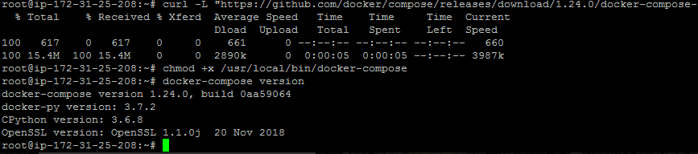

* Create **Dockerfile** using **vim Dockerfile** command to prepare Docker image using the content below:

**FROM centos:latest**

**RUN cd /etc/yum.repos.d/**

**RUN sed -i 's/mirrorlist/#mirrorlist/g' /etc/yum.repos.d/CentOS-\***

**RUN sed -i 's|#baseurl=http://mirror.centos.org|baseurl=http://vault.centos.org|g' /etc/yum.repos.d/CentOS-\***

**RUN yum install -y openssh-server**

**RUN mkdir /var/run/sshd**

**RUN useradd -c "SSH User" -m sshuser**

**RUN echo "sshuser:sshuser" | chpasswd**

**RUN ssh-keygen -t rsa -f /etc/ssh/ssh_host_rsa_key -q -N ""**

**EXPOSE 22**

**CMD ["/usr/sbin/sshd","-D"]**

* Create a docker-compose.yml file using the following commands:

**touch docker-compose.yml**

**vi docker-compose.yml**

* Add the content mentioned below in the docker-compose.yml file:

**version: "2.0"**

**services:**

**sshd:**

**build: .**

**image: centos-sshd:latest**

**ports:**

**- "2222:22"**

* Start Docker containers using the commands below:
* Type **docker-compose up -d**
* Type **docker-compose ps**
* Connect to the SSH server

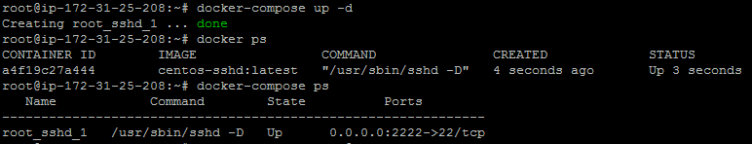

* Type **ssh -p 2222 sshuser@localhost**

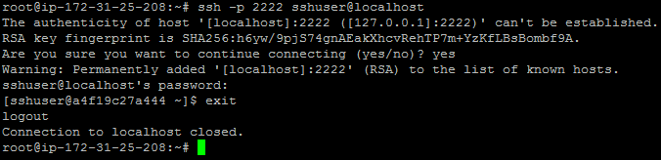

Give the password:  sshuser

* Stop the server
* Type **docker-compose down**
* Type **docker-compose ps**

**Step 4.7.2:** Pushing the code to GitHub repositories

Open your command prompt and navigate to the folder where you have created your files.

cd <folder path>

Initialize your repository using the following command:

git init

Add all the files to your git repository using the following command:

git add .

Commit the changes using the following command:

git commit . -m “Changes have been committed.”

Push the files to the folder you created initially using the following command:

git push -u origin master