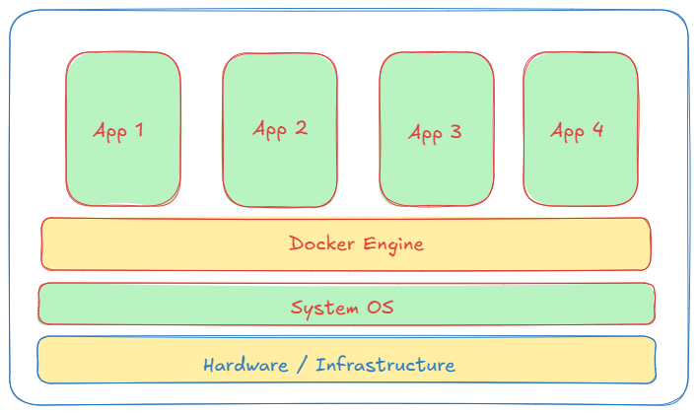How Docker Works

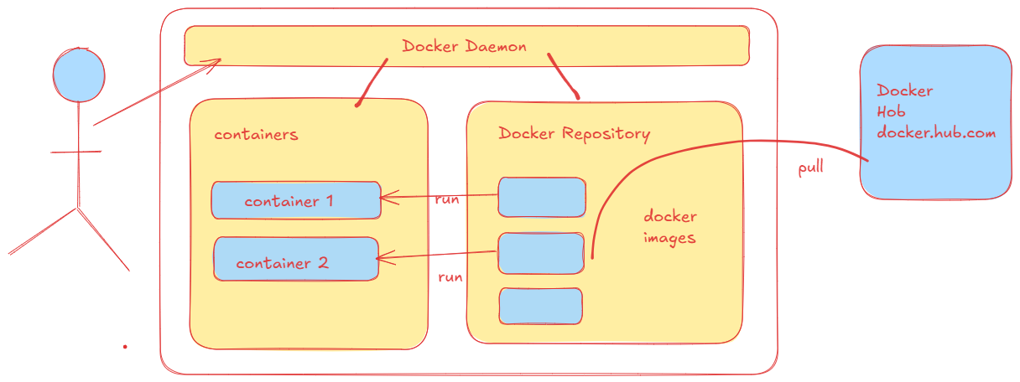

To work with the docker install Docker Desktop Locally or else you can install docker in your wsl using apt install commands.

Once it is installed start the engine. Once engine is started you can execute below command.

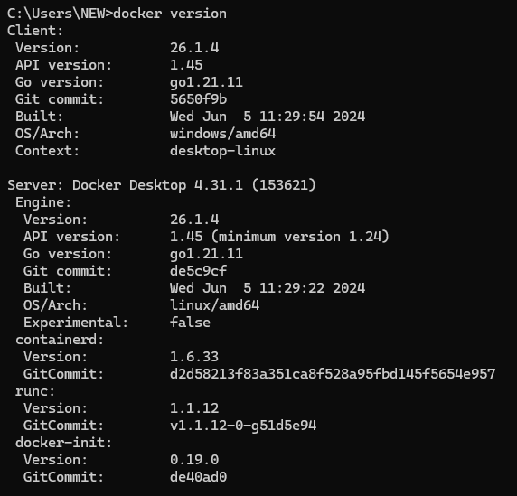

If you are getting both client and server details means you can understand server is running as expected.

Pull Some images

Docker pull hello-world (pull image)

Docker images (verify the pulled images)

Let’s Run container

docker run --name mycontainer -p 80:80 hello-world

verify containers: docker ps (this command will show only running containers)

docker ps –a (show all containers)

docker stop name-of –the-container

docker rm name-of-container

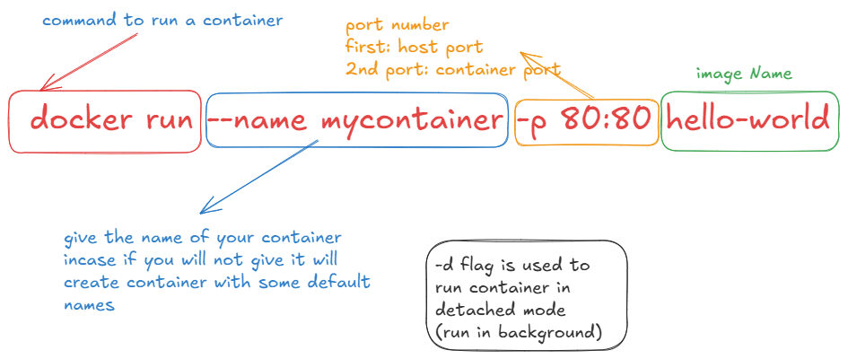

Creating Docker Files

FROM: Its base Image, like you want to use Ubuntu or any other os

**FROM Ubuntu:20.04**

RUN: it Executes in a new Layer on the top of the current image

**RUN apt-get update && apt-get install –y python3**

CMD: Provides defaults for some existing containers. Give instructions

**CMD [“python3”,”app.py”]**

EXPOSE:

Expose the service at which port no

**Expose 8080**

ADD copy the file

**ADD src file destination-file**

COPY copy from the local locations

**COPY src desc**

Let’s Create One example for the same::

Create one folder named Project1

Cd project1

Create 1 file index.html and add some sample HTML code

Create Dockerfile without any extention. Add

FROM nginx:alpine

COPY index.html /usr/share/nginx/html

EXPOSE 80

Now create Image: docker build –t portfolio .

Build command to build image, -t for target to save image, . is indication root location for Docker file

Verify images: docker images

Run images in container: docker run --name portfolio_container -d -p 8080:80 portfolio

Verify running containers: docker ps

Check in browser localhost:8080