- Go to the Magicbricks website.
- Select the city of New Delhi and enter the locality name "Safdarjung Enclave".
- Select all Residential Property Types on Sale.
- Write a scraper in Python that pulls information for each of the resulting properties and organizes them into a clean PostgreSQL table. Make sure to document all steps clearly.

=> Refer MagicBrick.py file.
In this, code is there with required explanation.
Following steps are involved:
- Importing the required modules.
- Establishing connection with PostgreSQL db.
- Scraping data from MagicBrick website.
- Inserting the data in db.
- Closing the db connection.

- Plot basic descriptive stats and charts to visualize the key attributes of the data, the distribution and completeness. Identify any patterns that stand out. More the description the better.
=>
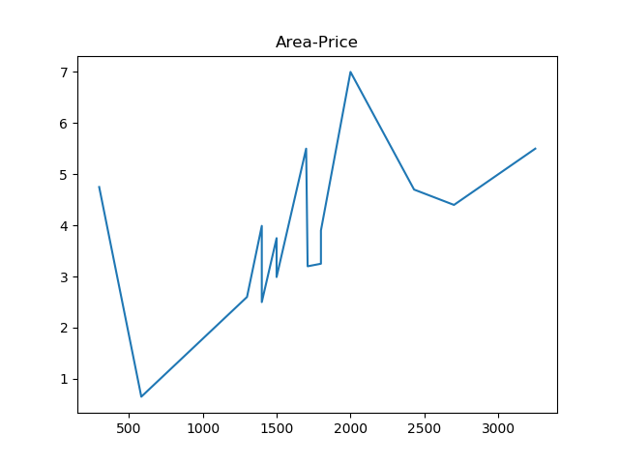
In the above graph, plotting is done on the area(in sqft) VS price(in Crores). We can have estimation of price according to area on the basis of this graph,
In this graph, one property is having so high price instead of having less area.

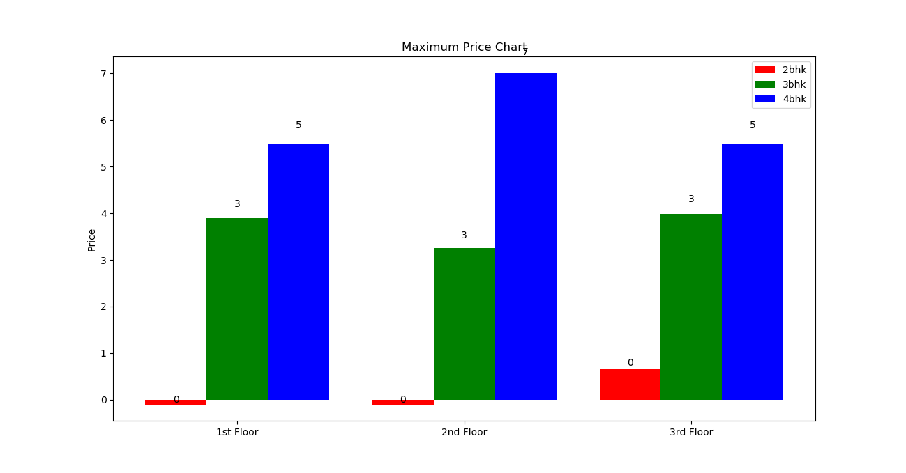

This graph shows the maximum prices of "Safdarjung Enclave" area in Delhi.
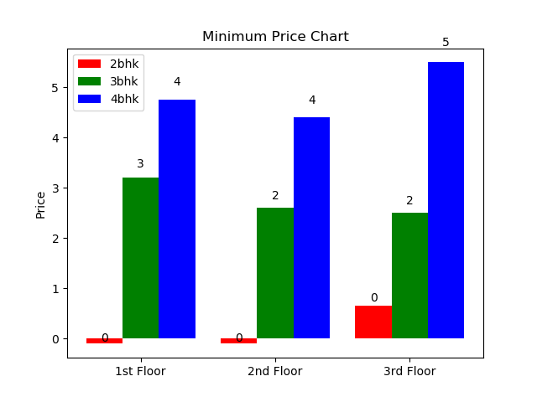

This graph shows the minimum prices of "Safdarjung Enclave" area in Delhi.

These 3 graphs can help to predict the price of new property.
- Draft the next set of steps you would take to model an estimate of the true market value of a new property in this locality with certain characteristics (say 3 BHK, 2,000 sq feet, flat on the 3rd floor).

From the max price and min price chart produced, we can estimate the price of newly added property. In one chart we can have details of area and how old is the property VS price and throgh that, we can estimate appropriate value for the property.

- Extract the geocoordinates of the property.
- How would you be able to use that to improve the accuracy of the model?
Geocordinates will give the accuracy for the place person want to buy.
It will help in estimating the price beacuse according to surrounding price vary.

- Include other localities in New Delhi in the scraper to improve the model estimates.
Due to lack of time, I have not included this. But we can achieve in the same way as the 1st scraper. We need to include links of other localities or we can have locality name which is to be included, then we can pass that in webDriver and scrap the required information.
- What are the limitations of this approach? How would you overcome them?
If we will have more locaties then the price difference will be more. We can overcome this by including fill values by including the rates of property which exists in that place.

