Introduction
Credit risk assessment is one of the most critical functions in retail banking. When a customer applies for a loan, the bank must evaluate the likelihood of repayment — approving too freely leads to financial losses, while being overly restrictive means losing viable customers. This project analyses a real-world credit dataset to identify the borrower and loan characteristics that most strongly predict default, with the goal of providing data-driven insights that can support smarter, more consistent lending decisions.

Data
The dataset used in this analysis is the Credit Risk Dataset sourced from Kaggle (https://www.kaggle.com/datasets/laotse/credit-risk-dataset). It contains 32,581 records and 12 features capturing borrower demographics, financial profile, and loan characteristics. The target variable, loan_status, indicates whether a borrower defaulted (1) or not (0). Key features include annual income, employment length, loan amount, interest rate, loan intent, loan grade, and credit history length — variables that collectively reflect a borrower's capacity and willingness to repay.

Data Cleaning
An initial inspection revealed missing values in two columns: person_emp_length (895 missing) and loan_int_rate (3,116 missing).
For person_emp_length, missing values were filled with 0, reflecting borrowers with no recorded employment history — a defensible assumption consistent with unemployment or recent entry into the workforce.
For loan_int_rate, rows were removed after confirming that the default rate within the missing subset (20.67%) closely mirrored the overall dataset default rate (21.82%), indicating the data was missing at random. Removal therefore introduced minimal bias. Following cleaning, the dataset contains 29,465 records with a default rate of 21.94%.
Outlier Treatment
Outliers are data points that fall outside the range of realistic or expected values. Left unaddressed, extreme values can distort model training and lead to misleading predictions.
An inspection revealed extreme values in three columns. person_age contained a maximum value of 144 years, person_emp_length reached 123 years, and person_income had a maximum of $2,039,784 — far beyond what would be expected for a retail loan applicant. These were identified as likely data entry errors rather than genuine records.
Realistic upper thresholds were applied: 90 years for age, 60 years for employment length, and $150,000 for annual income. The income threshold was validated using the IQR method, which suggested a cutoff of approximately $140,000 — consistent with the chosen value. After applying the correct filters, 1,038 rows (3.52% of the dataset) were removed. The default rate shifted marginally from 21.94% to 22.37%, confirming that outlier removal introduced no material bias. The final cleaned dataset contains 28,427 records.
Key Finding: Prior Default History as a Risk Indicator
A cross-tabulation of historical default status against current loan outcomes reveals a striking pattern. Borrowers with no prior default on record defaulted at a rate of 18.9%, while those with a prior default on file defaulted at 38.7% — more than double the rate. This finding strongly supports the inclusion of credit history as a core feature in any risk assessment model, and suggests that lending institutions should apply heightened scrutiny to applicants with a recorded history of default, regardless of their current financial profile.

Exploratory Data Analysis
To understand the patterns driving loan default, five key relationships were examined across the cleaned dataset.
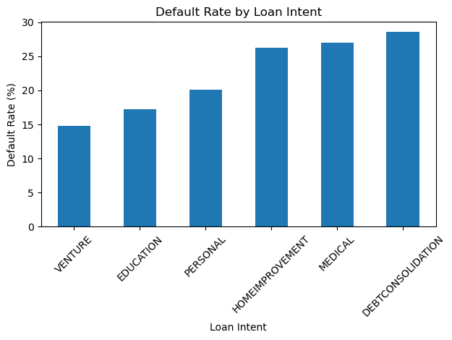
Default Rate by Loan Intent Debt consolidation loans carry the highest default rate at 29%, while venture loans are the lowest at 15%. This pattern is intuitive — borrowers consolidating debt are likely already financially stretched, whereas those taking venture loans may have more deliberate financial planning behind their decision. Banks should apply stricter assessment criteria to debt consolidation applicants as a baseline practice.
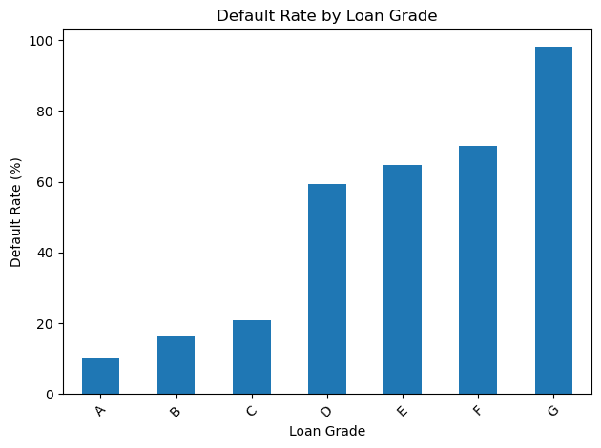 Default Rate by Loan Grade Default rates increase sharply with declining loan grade. Grade A borrowers default at approximately 10%, while Grade G borrowers default at nearly 100%. A clear risk threshold emerges at Grade D, where default rates exceed 60%. Banks should apply significantly stricter approval criteria for Grade D and below, and consider these applications high risk by default.
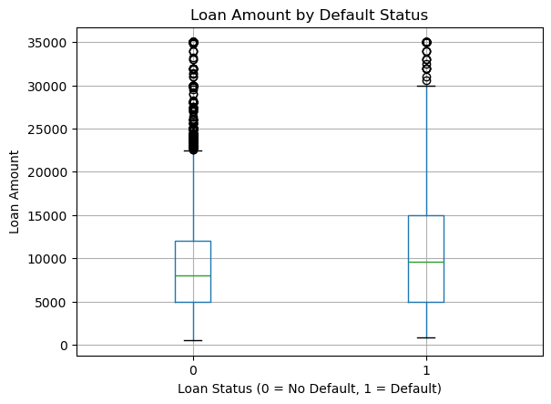

Loan Amount by Default Status The distribution of loan amounts is nearly identical between defaulters and non-defaulters, with medians around $8,000–$10,000 for both groups. This suggests that loan amount alone is not a reliable predictor of default risk and should not be used in isolation when making lending decisions.
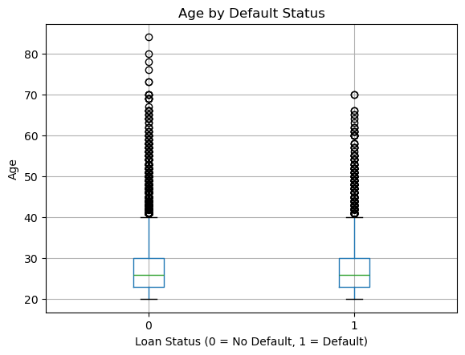

Age by Default Status The age distribution shows minimal difference between defaulters and non-defaulters, with both groups centred around a median of approximately 25–26 years. Age does not appear to be a strong standalone predictor in this dataset, though it may contribute value in combination with other features during modelling.
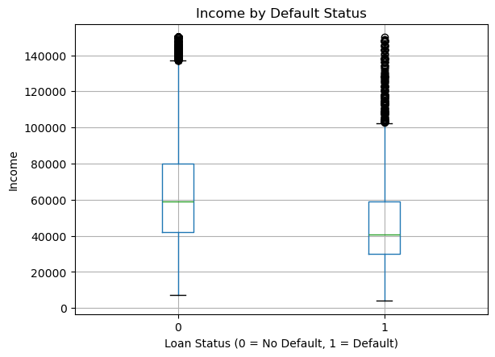
Income by Default Status A clear income gap exists between the two groups. Non-defaulters have a median income of approximately $60,000, while defaulters sit closer to $40,000. Lower income is associated with higher default risk, suggesting that income should be weighted heavily alongside other factors — particularly loan grade and prior default history — when assessing borderline applications.

