Name: - Sonam Abrol

Module 02 Lab

10-07-2019

Screen Shot of putty

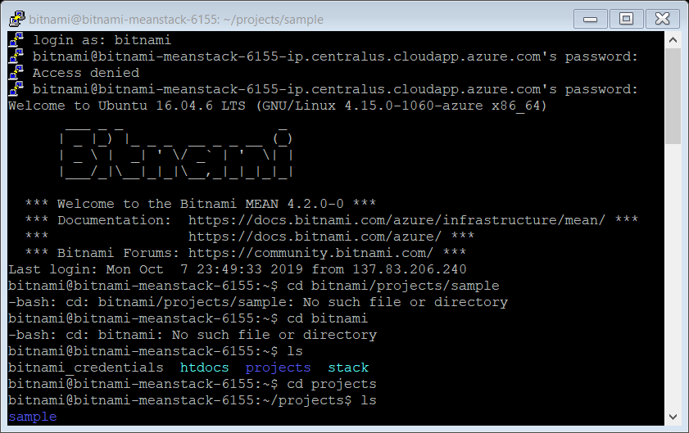

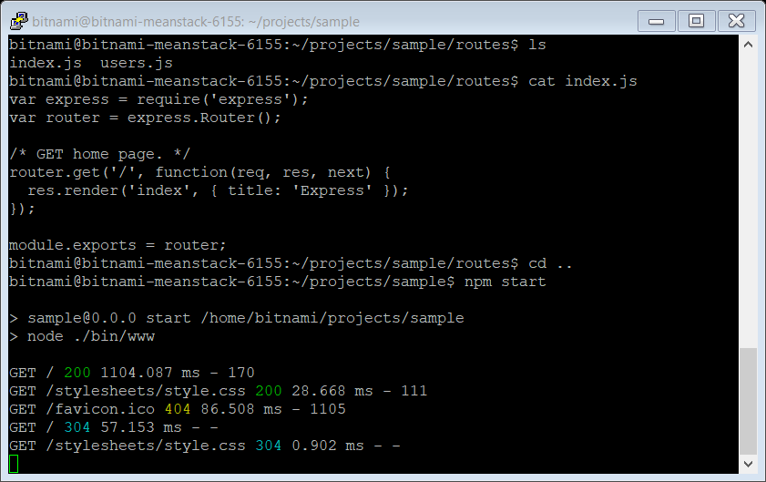

Screen shot

Port :- <http://23.99.176.159:3000/>

