Name: - Sonam Abrol

Module 02 Project

10-9-2019

# Introduction

What is a cloud database? In cloud database services are built and accessed through a cloud platform. In cloud database we don’t have to buy any expensive physical hardware’s. Cloud database similarly performs the same functions as a traditional database but with better functions and flexibility. There are many benefits for using cloud platforms for distributed database management.

# First Benefit (Ease to use and time saving)

IT industry has changed the way of business. Now people shop over the internet and they trust on online shopping for saving their time. This change in the business has let the companies think about the fastest way they can do business over the internet. Before to access the company, database software needed to be installed, but time has changed now. Employees used to waste so much time to install software on their computer. Companies were paying so much money to employees and spending so much money for these software’s. Now companies save so time by using readymade available resources provided by cloud platforms. Companies prefers to use the cloud database so that they can access the information stored in their database without wasting any time.

# Second Benefit (Money saving)

Second advantage of using a cloud database is that it saves a lot of money to IT companies. Companies does not need to invest money in setting up their own data centers. Also, it requires so much money and extra technical resources to manage traditional databases. Moreover, after setting up a data center, the company will need to buy the software’s as well and their maintenance is also required. Companies were paying so much money to employees and spending so much money for these software’s to access the company database. Now companies save lots of money by using cloud platforms because everything is readymade and man power is not required to mange these databases.

# Third Benefit (Scalability)

“Cloud databases can expand their storage capacities on run-time to accommodate changing needs. Organizations only pay for what they use.” (IBM 2019). Companies can scale up and scale down any time based on their needs. In platforms like Azure and AWS it automatically scales up and scales down based on the company needs. Now companies don’t need to worry about for paying extra for something that they are not even using.

# Fourth Benefit (Disaster recovery)

It is very important for companies to have backup plan incase of any accidents. “Cloud disaster recovery (cloud DR) is a backup and restore strategy that involves storing and maintaining copies of electronic records in a cloud computing environment as a security measure. The goal of cloud DR is to provide an organization with a way to recover data and/or implement failover in the event of a man-made or natural catastrophe.” (Raffo 2016). Almost all the cloud platforms have these DR options available.

Below is the Diagram for Sharding with Amazon relational database service. This diagram shows how auto scaling and distributed DBMS works in AWS.

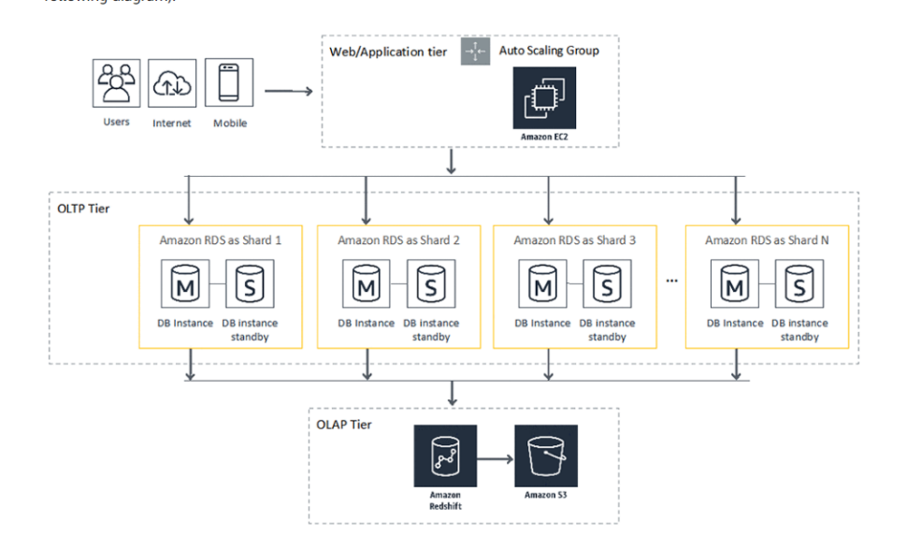

# Conclusion

Cloud platforms can be used with distributed database for handling large volume of data. It enhances reliability, elasticity, availability, scalability and all these capabilities are provided at low cost with enhanced performance compared to the traditional infrastructure. Most of the big companies like Gap, Facebook and list just goes on are adapting cloud platforms to fulfill their needs. There are many great advantages of using cloud platforms.

**References**

Engdahl, S. (2008). Blogs. Retrieved October 9, 2019, from <https://aws.amazon.com/blogs/database/sharding-with-amazon-relational-database-service/>.

Raffo, D. (2016, July). What is cloud disaster recovery (cloud DR)? - Definition from WhatIs.com. Retrieved October 9, 2019, from <https://searchdisasterrecovery.techtarget.com/definition/cloud-disaster-recovery-cloud-DR>.

Dobran, B. (2019, February 5). 9 Benefits of Disaster Recovery in Cloud Computing. Retrieved October 9, 2019, from <https://phoenixnap.com/blog/cloud-disaster-recovery-solutions>.

IBM. (n.d.). What is a cloud database? Retrieved October 9, 2019, from <https://www.ibm.com/cloud/learn/what-is-cloud-database>.

Turner, J., Cawley, C., Stojanov, Z., & Schwartz, B. S. B. (2015, August 28). A Cloud Database Adds Up to More Benefits. Retrieved October 9, 2019, from <https://tech.co/news/math-can-business-benefit-cloud-database-2015-08>.