Task 02: Decision Making & Logic Building
Student Name: Sonam Gothad
College Name: ____________________
Branch: Cyber Security
Internship: Cyber Security Summer Internship

Part A: Even or Odd Checker
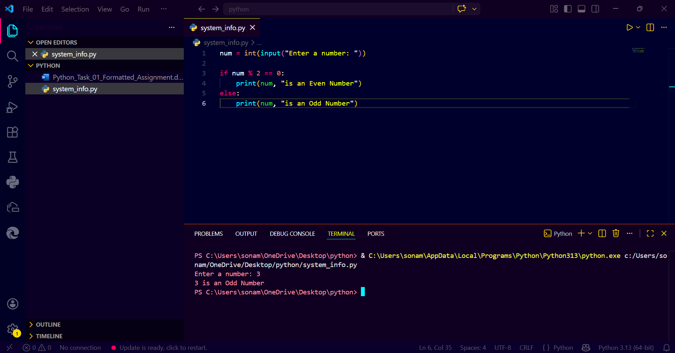

Part B: Largest of Three Numbers
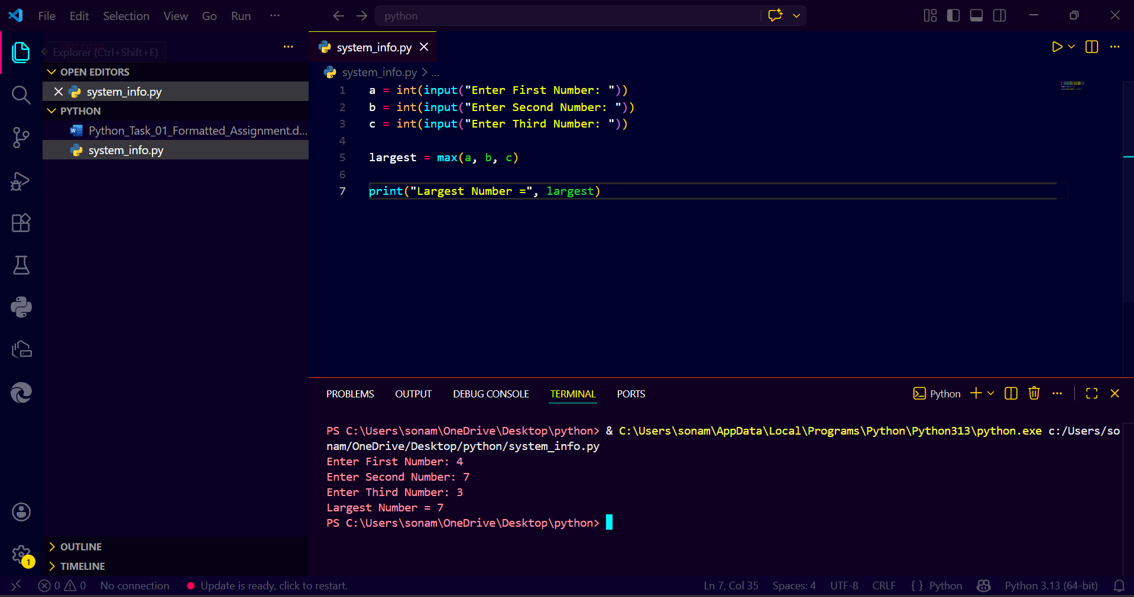

Part C: Student Grade Calculator
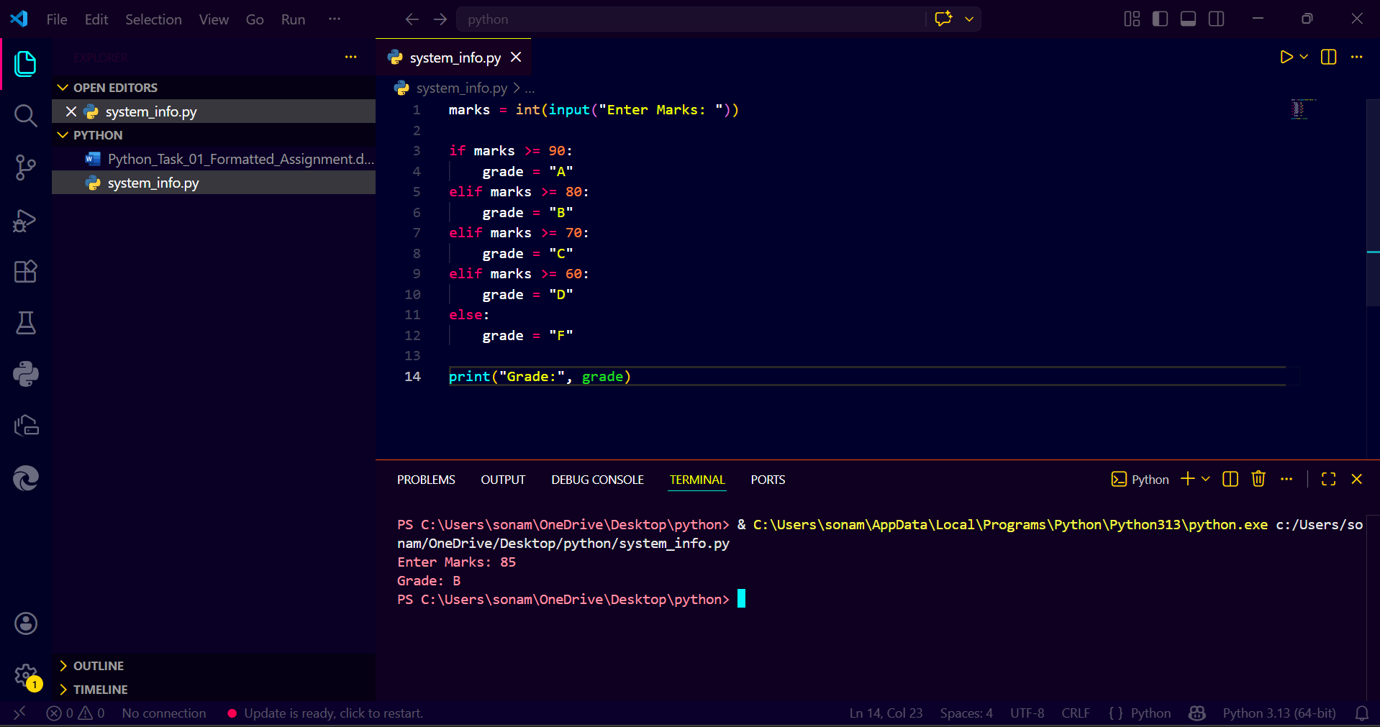

Part D: Simple Login Validation
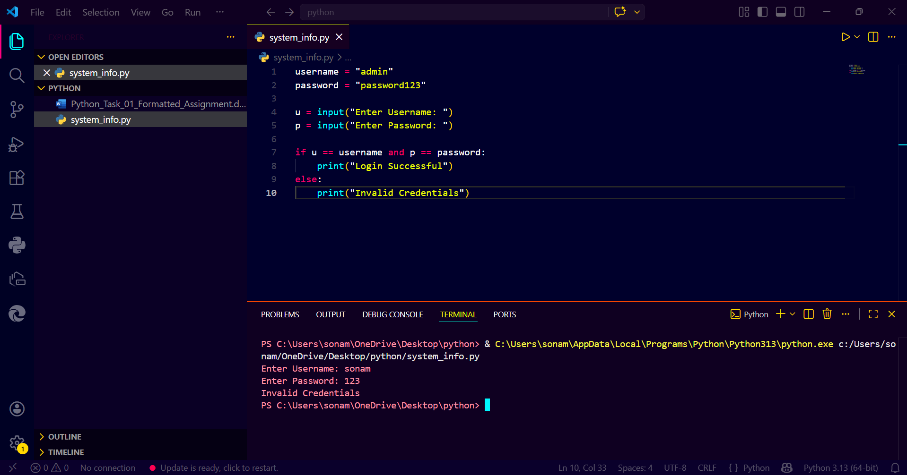
Part E: Mini Cyber Security Challenge
