PYTHON AND C PROGRAMMING - TASK 01
Student Name: Sonam Gothad
College Name: ____________________
Branch: Cyber Security
Internship: Cyber Security Summer Internship

Part B: Create Your First Python Program
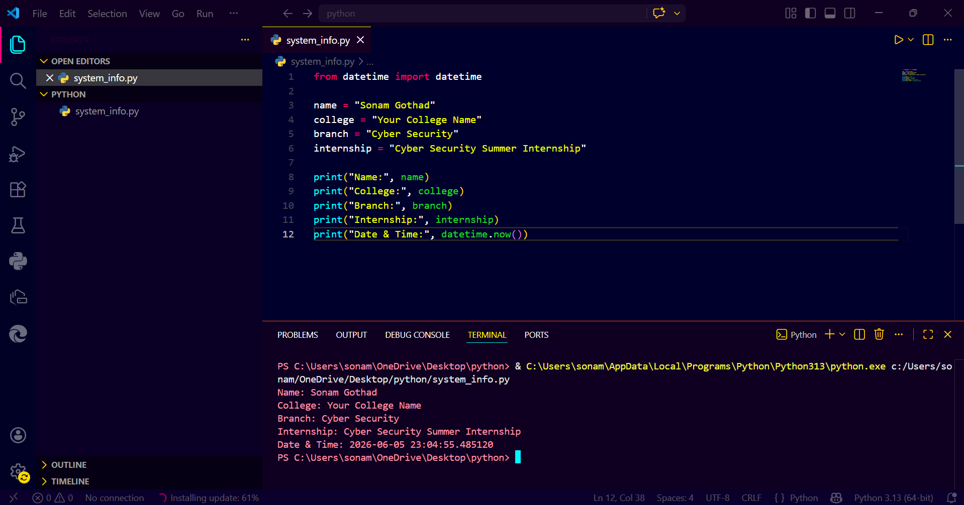
Part C: User Input Program
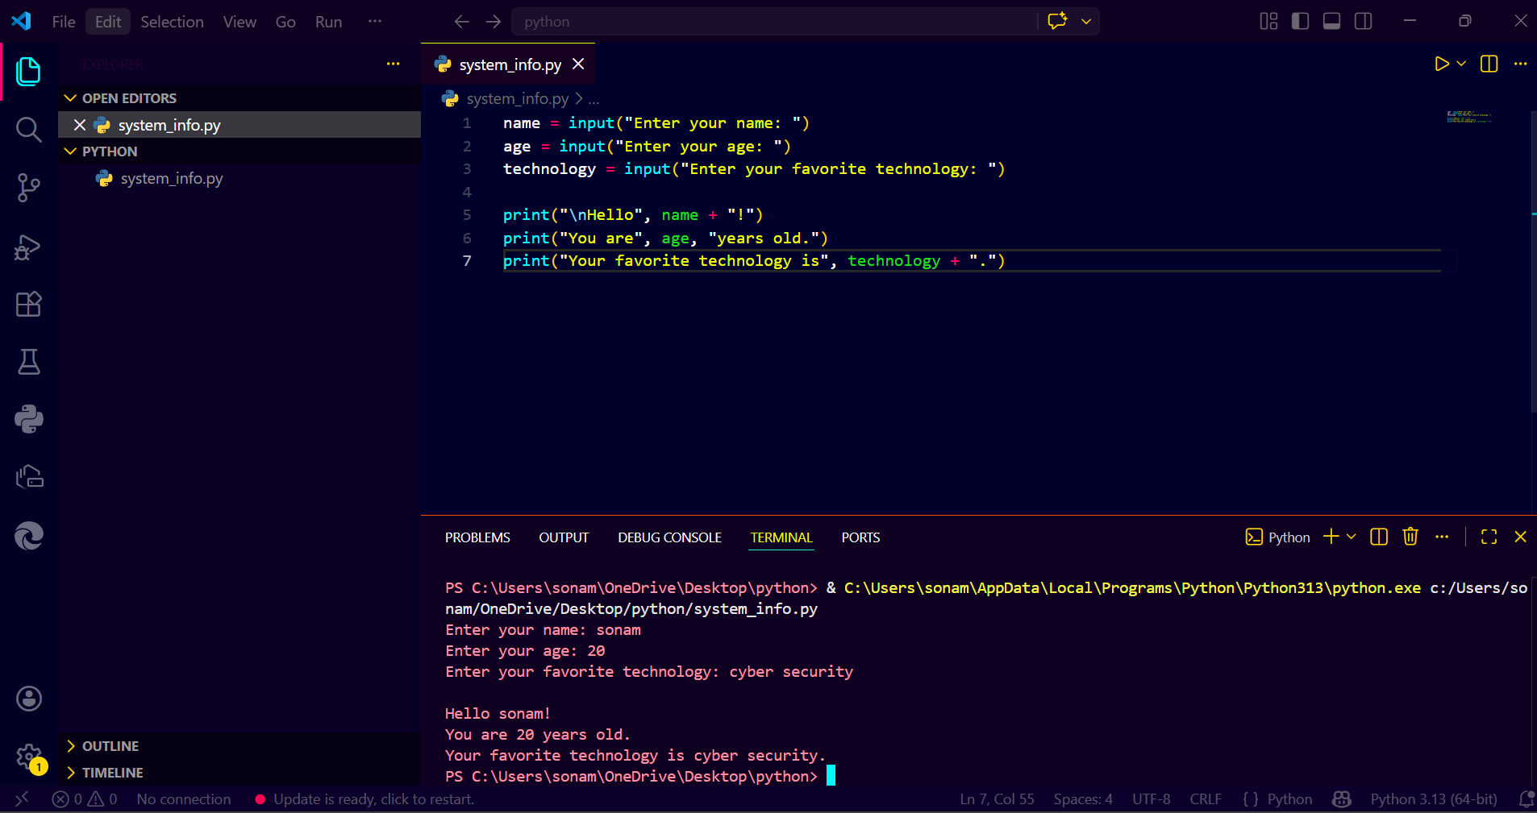

Part D: Basic Calculator

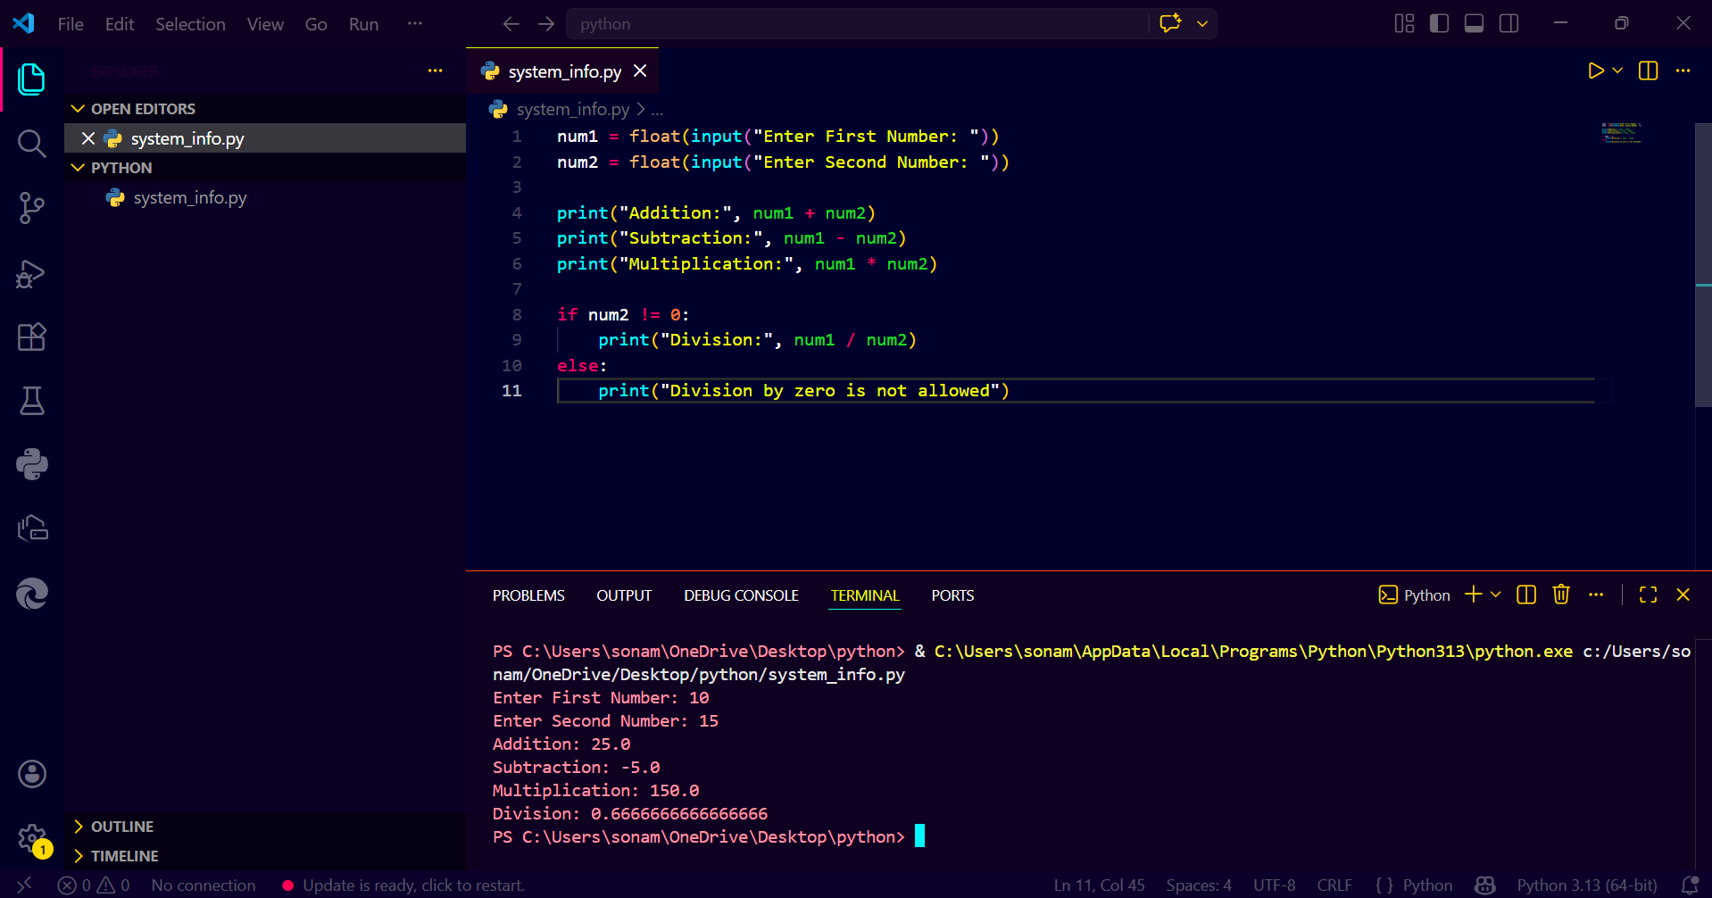
Part E: System Information Challenge
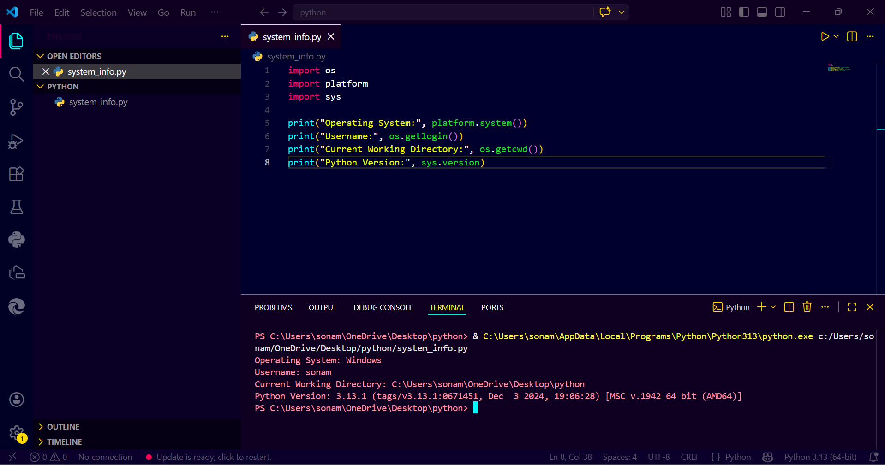

README Summary
This task covers Python fundamentals including variables, input/output, arithmetic operations, and system information modules.

