**Analysis of Tesla’s Sales Performance**

Ahien C. Djouka, Namrata G. Kakade, Sonam Gupta, Suparna V. Dawalkar, Yash Bhaiya

Harrisburg University

Advised by

Dr. Marvine Hamner

Abstract

The case study from March, 2015 written by Frank T. and David R. addresses the success and the future possible speculations about Tesla Motors. With the increasing competition in the production of electric cars, Elon Musk, the CEO of Tesla, has been trying to figure out the factors that affected the sales performance of Tesla, in the past few years. The goal of this project is to analyze what variables are potential to affect the sales performance of Tesla cars. We have collected the historical data for oil prices, stock prices, prices of other electric cars in the market and many more, in order to analyze the correlation among these factors. Further, we build a multiple linear regression model on Tesla’s sales and oil prices as well as test the hypothesis we have claimed.

Keywords: normalization, regression analysis, correlation analysis

**Analysis of Tesla’s Sales Performance**

Elon Musk is a very successful entrepreneur and has stake at three firms SolarCity, SpaceX and Tesla Motors. Being the CEO of Tesla Motors Inc., Elon Musk thinks Tesla Motors as a legacy out of his other firms, as per the case study by Rothaermel and King (2015), suggests. The CEO of Tesla, has few speculations whether Tesla business pattern be sustainable, or will it continue to hold on its fame in the constantly increasing competition in the production of electric cars. He wants to plan and take action in order to make sure Tesla will be successful over years.

With the expansion of Tesla around the globe, majority of sales occur in USA where other international car companies of alternate energy have created quite a competitive market. The US government has been working on offering various incentives to the electric car companies so that a better infrastructure could be built for the adaption process of using electric cars since the oil prices have been sky-rocketing.

**Research Question**

In contemplation of the conjecture made by Elon Musk, this project aims to analyze the potential factors that might affect or have affected the sales performance of Tesla cars by building statistical models on the past sales data.

Further sections in the paper will explain the steps taken to collect the data, what type of data has been considered towards the analysis, the hypothesis we have proposed, the statistical model built following with the verification analysis of such a model.

# Related Work

With the falling oil prices, there has been quite a hype around the market of electric vehicles and the other cars. Along with the other car companies, electric car companies such as Tesla, Nissan Leaf, Toyota Prius etc., have been worried about their sales with the decrease in oil prices. After the careful review of the sales performance of several cars and electric vehicles, it has been concluded that with the fall in oil prices, the high priced electric cars might not be affected but the hybrid or the plugin electric vehicles such as Volt, Bolt, Leaf and many such may face problems since they are not fully electric vehicles like Tesla cars. Hybrid cars will be affected more since they use gas to power the engine as per elaborated in Opinion (2015).

## Data Collection

In order to answer the research question as stated above, the following data has been gathered:

**Yahoo Finance:** We obtained the stock prices of Tesla Motors Inc. (Nasdaq Code- TSLA) for the time period starting from January 2011 through March 2016 from Yahoo Finance. The raw data contained daily data with a few missing data points. The raw data consists of the following fields (all prices are in US dollars):

* Date - Date for which the stock price is provided
* Open – Opening stock price ($)
* High – Highest stock price for the day ($)
* Low – Lowest stock price for the day ($)
* Close – Closing stock price ($)
* Adjusted Close – Adjusted closing stock price. An adjusted closing price is a stock’s closing price on any given day of trading that has been amended to include any distributions and corporate actions that occurred at any time prior to the next day’s open, as described in Investopedia (2016).

**U.S Energy Information Administration**: We obtained crude oil and conventional gasoline prices from the U.S Energy and Information Administration for the years January 2011 through March 2016. The raw dataset contains the following fields that are of interest to us for the analysis:

* Date - Date for which the gasoline/oil price is provided
* New York Harbor Conventional Gasoline Regular Spot Price FOB (Dollars per Gallon)
* U.S. Gulf Coast Conventional Gasoline Regular Spot Price FOB (Dollars per Gallon)

**Electric Vehicle Sales Information**: We acquired the sales of electric vehicles provided by ‘InsideEVs’ which tracks all the plug-in sales for the United States by auto maker and brand. The data is provided as the number of units of individual cars sold per month, for the duration of January 2011 to March 2016.

We have the data for the following models of electric and hybrid vehicles, that includes the Tesla Model S, and Tesla Model X whose sales are of particularly important towards the analysis:

* Tesla Model S, Chevrolet Volt, Nissan Leaf, Ford Fusion Energi, Tesla Model X, Ford C-Max Energi, Audi A3 Sprtbk e-tron, Fiat 500 e, BMW x5 xDrive40e, BMW i3, Hyundai Sonata PHV, VW e-Golf, Chevrolet Spark EV, Volvo XC90, Porsche Cayenne S-E,Cadillac ELR, Ford Focus Electric, Kia Soul EV, BMW i8, Smart ED, Mercedes B250, Porsche Panamera S-E, Mercedes S550H PHV, Toyota Prius PHV, Mitsubishi i-MiEV, Other, Mercedes B-Class ED, Porsche 918 Spyder, Honda Accord PHV, Toyota RAV4 EV, Honda Fit EV.

Technical Approach

**The Plan**

In our project, we plan to analyze Tesla’s sales and how they are impacted by external factors namely the fluctuations in oil prices as well as the money spent on other electric cars in general. At first we will analyze and observe our data to see whether it meets the conditions to follow all the assumptions of a linear regression model such as population size, normality and minimized skewness.

After collecting and reorganizing the data we have a final dataset with 45 observations for the monthly sales of Tesla, the monthly oil prices and the substitute for unit prices for the time period from June 2012 to March 2016. In order to remove the impact of the difference in scale we standardize the data and run our model with the standardized dataset.

To analyze how oil prices will affect the sales of the cars, the data collected for oil prices have two different prices for different locations, i.e., New York harbor and US Gulf Coast (dollars/gallon). The average of these prices for both locations is considered. We formulated the normalization of oil prices as the ratio of mean of oil prices for each month to average of 6 years of oil prices. Mathematically, it can be represented as follows:

Normalization (oil prices) = Mean of all months’ oil prices / Average of 6 years’ oil prices

We normalize stock prices as well using the following formula (we don’t have stock price in the model anymore – we used sales):

Price Paid Per Unit of Car by Months: One of our inputs in the Regression and correlation analysis was the price paid per unit of electric cars. The data can be seen below and this would make it difficult to use the data.

The data obtained was secondary data that gave sale by months and below table is the aggregate of the Year this data was then normalized to create the input data by months

The original cost of all cars as depicted below the outliers such as the Porsche 918 Spyder and Others were removed from the calculation as they were outliers or undeterminable

|  |  |  |  |  |  |  |  |  |  |  |  |  |  |  |  |  |  |  |  |  |  |  |  |  |  |  |  |  |  |  |  |  |  |  |  |  |  |  |  |  |  |  |  |  |  |  |  |  |  |  |  |  |  |  |  |  |  |  |  |  |  |  |  |  |  |  |  |  |  |  |  |  |  |  |  |  |  |  |  |  |  |  |  |  |  |  |  |  |  |  |  |  |  |  |  |  |  |  |  |  |  |  |  |  |  |  |  |  |  |  |  |  |  |  |  |  |  |  |  |  |  |  |  |  |  |  |  |  |  |  |  |  |  |  |  |  |  |  |  |  |  |  |  |  |  |  |  |  |  |  |  |  |  |  |  |  |  |  |  |  |  |  |  |  |  |  |  |  |  |  |  |  |  |  |  |  |  |  |  |  |  |  |  |  |  |  |  |  |  |  |  |  |  |  |  |  |  |  |  |  |  |  |  |  |  |  |  |  |  |  |  |  |  |  |  |  |  |  |  |  |  |  |  |  |  |  |  |  |  |  |  |  |  |  |  |  |  |  |  |  |  |  |  |  |  |  |  |  |  |  |  |  |  |  |  |  |  |  |  |  |  |  |  |  |  |  |  |  |  |  |  |  |  |  |  |  |  |  |  |  |  |  |  |  |  |  |  |  |
| --- | --- | --- | --- | --- | --- | --- | --- | --- | --- | --- | --- | --- | --- | --- | --- | --- | --- | --- | --- | --- | --- | --- | --- | --- | --- | --- | --- | --- | --- | --- | --- | --- | --- | --- | --- | --- | --- | --- | --- | --- | --- | --- | --- | --- | --- | --- | --- | --- | --- | --- | --- | --- | --- | --- | --- | --- | --- | --- | --- | --- | --- | --- | --- | --- | --- | --- | --- | --- | --- | --- | --- | --- | --- | --- | --- | --- | --- | --- | --- | --- | --- | --- | --- | --- | --- | --- | --- | --- | --- | --- | --- | --- | --- | --- | --- | --- | --- | --- | --- | --- | --- | --- | --- | --- | --- | --- | --- | --- | --- | --- | --- | --- | --- | --- | --- | --- | --- | --- | --- | --- | --- | --- | --- | --- | --- | --- | --- | --- | --- | --- | --- | --- | --- | --- | --- | --- | --- | --- | --- | --- | --- | --- | --- | --- | --- | --- | --- | --- | --- | --- | --- | --- | --- | --- | --- | --- | --- | --- | --- | --- | --- | --- | --- | --- | --- | --- | --- | --- | --- | --- | --- | --- | --- | --- | --- | --- | --- | --- | --- | --- | --- | --- | --- | --- | --- | --- | --- | --- | --- | --- | --- | --- | --- | --- | --- | --- | --- | --- | --- | --- | --- | --- | --- | --- | --- | --- | --- | --- | --- | --- | --- | --- | --- | --- | --- | --- | --- | --- | --- | --- | --- | --- | --- | --- | --- | --- | --- | --- | --- | --- | --- | --- | --- | --- | --- | --- | --- | --- | --- | --- | --- | --- | --- | --- | --- | --- | --- | --- | --- | --- | --- | --- | --- | --- | --- | --- | --- | --- | --- | --- | --- | --- | --- | --- | --- | --- | --- | --- | --- | --- | --- | --- | --- | --- | --- | --- | --- | --- | --- | --- | --- | --- | --- | --- | --- | --- | --- | --- |
| |  |  |  |  |  |  |  |  |  | | --- | --- | --- | --- | --- | --- | --- | --- | --- | | Car Model | Average | 2010 | 2011 | 2012 | 2013 | 2014 | 2015 | 2016 | | Audi A3 Sprtbk e-tron | $ 37,900 | 0 | 0 | 0 | 0 | 0 | 98 | 907 | | BMW i3 | $ 43,395 | 0 | 0 | 0 | 0 | 6092 | 11024 | 762 | | BMW i8 | $ 141,695 | 0 | 0 | 0 | 0 | 555 | 2265 | 171 | | BMW x5 xDrive40e | $ 63,095 | 0 | 0 | 0 | 0 | 0 | 892 | 839 | | Cadillac ELR | $ 64,995 | 0 | 0 | 0 | 12 | 1310 | 1024 | 262 | | Chevrolet Spark EV | $ 25,995 | 0 | 0 | 0 | 2310 | 1145 | 2629 | 607 | | Chevrolet Volt | $ 33,995 | 326 | 7671 | 23461 | 23094 | 18805 | 15393 | 3987 | | Fiat 500 e | $ 32,780 | 0 | 0 | 0 | 2310 | 5132 | 6194 | 840 | | Ford C-Max Energi | $ 32,645 | 0 | 0 | 2374 | 7154 | 11550 | 7591 | 1450 | | Ford Focus Electric | $ 29,995 | 0 | 0 | 680 | 1738 | 1964 | 1582 | 257 | | Ford Fusion Energi | $ 34,775 | 0 | 0 | 0 | 6089 | 11550 | 9750 | 2751 | | Honda Accord PHV | $ 39,780 | 0 | 0 | 0 | 526 | 449 | 64 | 0 | | Honda Fit EV | $ 36,625 | 0 | 0 | 93 | 569 | 0 | 0 | 0 | | Hyundai Sonata PHV | $ 35,435 | 0 | 0 | 0 | 0 | 0 | 160 | 650 | | Kia Soul EV | $ 32,800 | 0 | 0 | 0 | 0 | 718 | 1015 | 220 | | Mercedes B250e | $ 42,375 | 0 | 0 | 0 | 0 | 0 | 0 | 161 | | Mercedes B-Class ED | $ 41,450 | 0 | 0 | 0 | 0 | 774 | 1906 | 0 | | Mercedes S550H PHV | $ 96,575 | 0 | 0 | 0 | 0 | 0 | 118 | 38 | | Mitsubishi i-MiEV | $ 23,845 | 0 | 80 | 588 | 1029 | 196 | 115 | 8 | | Nissan LEAF | $ 29,860 | 19 | 9674 | 9819 | 22610 | 28087 | 17269 | 2931 | | Other | $ - | 0 | 0 | 0 | 0 | 0 | 34 | 0 | | Porsche 918 Spyder | $ 845,000 | 0 | 0 | 0 | 0 | 0 | 203 | 0 | | Porsche Cayenne S-E | $ 78,250 | 0 | 0 | 0 | 0 | 200 | 1034 | 562 | | Porsche Panamera S-E | $ 94,250 | 0 | 0 | 0 | 86 | 879 | 380 | 83 | | Smart ED | $ 25,750 | 0 | 0 | 0 | 923 | 2594 | 1387 | 172 | | Tesla Model S | $ 88,700 | 0 | 0 | 2650 | 17650 | 16689 | 25202 | 6390 | | Tesla Model X | $ 81,200 | 0 | 0 | 0 | 0 | 0 | 214 | 2400 | | Toyota Prius PHV | $ 14,686 | 0 | 0 | 12750 | 12088 | 13264 | 4191 | 23 | | Toyota RAV4 EV | $ 49,800 | 0 | 0 | 192 | 1096 | 1184 | 0 | 0 | | Volvo XC90 | $ 69,095 | 0 | 0 | 0 | 0 | 0 | 86 | 580 | | VW e-Golf | $ 29,815 | 0 | 0 | 0 | 0 | 714 | 4232 | 612 | |

The next step is to run a multiple linear regression model using the tool R. The input to the model are monthly sales of Tesla as the response variable and monthly oil prices along with money spent on substitute electric cars as the explanatory variables. Here is the resulting model from our first iteration:

T.Sales = -1.055e-10 – 0.14 x oil price + 0.48 x substitute.unit.price

For this first iteration, an evaluation of the model using the F-test gave us:

Estimate Std. Error t value Pr(>|t|)

(Intercept) -1.055e-10 1.226e-01 0.000 1.0000

oil.price -1.383e-01 2.798e-01 -0.494 0.6238

Substitute.unit.price 4.796e-01 2.798e-01 1.714 0.0939 .

---

Residual standard error: 0.8227 on 42 degrees of freedom

Multiple R-squared: 0.3683, Adjusted R-squared: 0.3382

F-statistic: 12.24 on 2 and 42 DF, p-value: 6.474e-05

So even if the model as a whole is significant, the oil price variable is not significant to the model so we re-run it without the oil price and following are the results:

T.Sales = -9.812e-11 + 0.6 x substitute.unit.price

This second iteration is significant as a whole and has the substitute unit price significant as well – with a much lower p-value:

Estimate Std. Error t value Pr(>|t|)

(Intercept) -9.812e-11 1.216e-01 0.000 1

Substitute.unit.price 6.038e-01 1.216e-01 4.967 1.13e-05 ***

---

Residual standard error: 0.8154 on 43 degrees of freedom

Multiple R-squared: 0.3646, Adjusted R-squared: 0.3498

F-statistic: 24.67 on 1 and 43 DF, p-value: 1.127e-05

We notice a slight increase in the Adjusted R-squared from 34% to 35%. From this analysis we can say that given our dataset, each unit increase in the standardized substitute prices give us an increase of 0.6 units in the standardized Tesla monthly sales on average. The intercept being extremely minimal, this means when the substitute sales are zero, according to this model, the Tesla sales are zero as well. The point worth noting is that the intercept is not significant (p-value is 1) but this is often the case in regression analysis.

The value of Adjusted R-squared being 35% indicates that 35% of the variability in the Tesla monthly sales is explained by the model. Therefore, it is safe to assume that there are still several other factors, outside of this analysis, responsible for the movements in the Tesla monthly sales. Given the fact that our value of Adjusted R-squared is quite low, we cannot attribute all the remaining factors to random events.

Hypothesis and its Testing

After building the model that shows us the relationship between Tesla’s sales and substitute unit prices, we can now check whether this relationship is significant. We claim as hypothesis that there is a significant positive relationship between Tesla sales and the unit prices of substitute cars. The F-test results confirm that the relationship is significant (p-value is minimal).

We compute a 95% confidence interval for the coefficient of the substitute unit price. The result is [0.35: 0.85]. Hence, we are 95% confident that one-unit increase in the standardized substitute unit price leads to an increase ranging from 0.35 to 0.85 units in standardized Tesla sales on average. Since the 95% confidence interval does not include zero, it is safe to say that there is a positive relationship between Tesla sales and substitute unit prices. These results justify our logic that an increase in the price of a substitute product would most likely lead to an increase in sales for that product.

**Test and Evaluation**

We test our approach and ensure that it is valid by observing the distribution of the Tesla sales and figure out whether it is normal or nearly normal. Our dataset is the “entire population” since it includes every sale (that we could reasonable account for) since the beginning of Tesla. The dataset we are using counts 45 observations which by the rule of thumb is considered to be a large-sized dataset since n is greater than 30.

Looking at the histogram and the box plot, we see that the sales distribution is right skewed with three outliers. We could have removed the outliers in order to perform the analysis on a dataset with a better fit to a normal distribution but we chose not to. These 3 outliers actually represent the most recent sales numbers. Despite the fact that they are outliers in this particular dataset, they represent the beginning of an upward trend for Tesla sales. We expect these values to become more mainstream in the upcoming months so we chose to keep them in the model to run the analysis. Given the fact that the size of our dataset is large enough and the distribution shows some skewness but not extensive, we proceed with our analysis by considering our dataset to be nearly normal. To summarize our analysis, the points are as follows:

1. Tesla sales nearly normal with very recent upward trend
2. It was a good start but not complete for lack of other variables that could improve the model
3. We support our hypothesis as it shows significant positive relationship between substitute unit price and Tesla sales.

**Results**

[Like all sections of your paper, references start on their own page. The references page that follows is created using the Citations & Bibliography feature, available on the References tab. This feature includes a style option that formats your references for APA 6th Edition. You can also use this feature to add in-text citations that are linked to your source, such as those shown at the end of this paragraph and the preceding paragraph. To customize a citation, right-click it and then click Edit Citation.] (Last Name, Year)

**Conclusion**

[Like all sections of your paper, references start on their own page. The references page that follows is created using the Citations & Bibliography feature, available on the References tab. This feature includes a style option that formats your references for APA 6th Edition. You can also use this feature to add in-text citations that are linked to your source, such as those shown at the end of this paragraph and the preceding paragraph. To customize a citation, right-click it and then click Edit Citation.] (Last Name, Year)

**Future Work**

Our model was sound in itself but the adjusted R-squared obtained tells us that there is more to the story. So any potential future work would look into which variables would add more value to the model that can better describe the sales performance of Tesla. One possible example might be the sales of cars that Tesla considers to be its competitors. Indeed, while our analysis was conducted with the assumption of Tesla cars to be a part of the greater group of electric cars, the company associates itself more with luxury than with electric/hybrid vehicle manufacturers. Therefore any analysis that would include sales information on such competitors could bring more value to the model.

References

InsideEVs, http://insideevs.com/monthly-plug-in-sales-scorecard/

Opinion, (2015) <http://insideevs.com/opinion-oil-prices-electric-vehicles/>

U.S. Energy Information Administration, <https://www.eia.gov/petroleum/gasdiesel/>

Yahoo Finance,<http://finance.yahoo.com/>

Musk, E. and Wheeler J. (2015). Q4'15 Tesla Update Letter. *Tesla Financial Statements*, Page 1

Last Name, F. M. (Year). Article Title. *Journal Title*, Pages From - To.

Last Name, F. M. (Year). *Book Title.* City Name: Publisher Name.

<http://www.greencarreports.com/news/1080871_electric-car-price-guide-every-2015-2016-plug-in-car-with-specs-updated>

<http://www.autotrader.com/car-news/honda-reveals-price-of-electric-fit-136323>

<http://insideevs.com/monthly-plug-in-sales-scorecard/>

Basic cost google search

All Car Costs are average of all models per 2016 as per the publications above

Formula Used and then the Rendered chart below

Footnotes

1[Add footnotes, if any, on their own page following references. For APA formatting requirements, it’s easy to just type your own footnote references and notes. To format a footnote reference, select the number and then, on the Home tab, in the Styles gallery, click Footnote Reference. The body of a footnote, such as this example, uses the Normal text style. (Note: If you delete this sample footnote, don’t forget to delete its in-text reference as well. That’s at the end of the sample Heading 2 paragraph on the first page of body content in this template.)]

Tables

Table 1

[Table Title]

|  |  |  |  |  |
| --- | --- | --- | --- | --- |
| Column Head | Column Head | Column Head | Column Head | Column Head |
| Row Head | 123 | 123 | 123 | 123 |
| Row Head | 456 | 456 | 456 | 456 |
| Row Head | 789 | 789 | 789 | 789 |
| Row Head | 123 | 123 | 123 | 123 |
| Row Head | 456 | 456 | 456 | 456 |
| Row Head | 789 | 789 | 789 | 789 |

Note: [Place all tables for your paper in a tables section, following references (and, if applicable, footnotes). Start a new page for each table, include a table number and table title for each, as shown on this page. All explanatory text appears in a table note that follows the table, such as this one. Use the Table/Figure style, available on the Home tab, in the Styles gallery, to get the spacing between table and note. Tables in APA format can use single or 1.5 line spacing. Include a heading for every row and column, even if the content seems obvious. A default table style has been setup for this template that fits APA guidelines. To insert a table, on the Insert tab, click Table.]

Figures

Figure 1. [Include all figures in their own section, following references (and footnotes and tables, if applicable). Include a numbered caption for each figure. Use the Table/Figure style for easy spacing between figure and caption.]

For more information about all elements of APA formatting, please consult the APA Style Manual, 6th Edition.

As you can see with the chart the Average Price Paid of the Electric Cars increases around December 2012 6 months after Tesla has entered the market even though the average cost paid per tesla remains the same.

The chart also shows that there is an upward trend in the Price Paid per electric vehicles that may be attributed to the number of new models being added.

Other than the outliers not included the early data for 2010 is also not included as there were no breakdowns available and the early industry trends would distort the data due to the novelty sales to early adopters.

Apendix

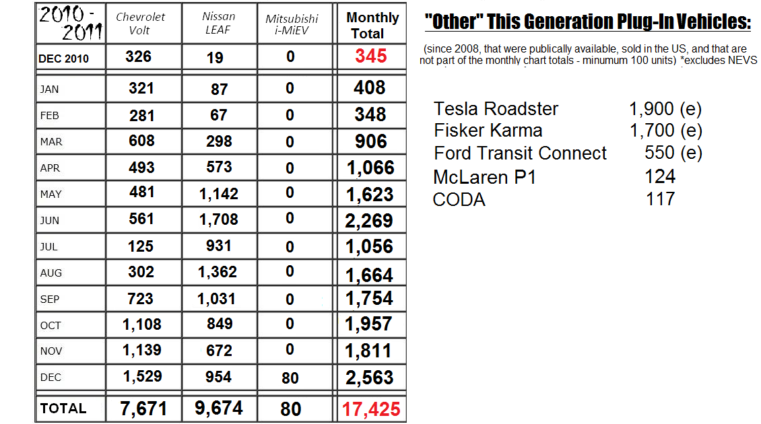

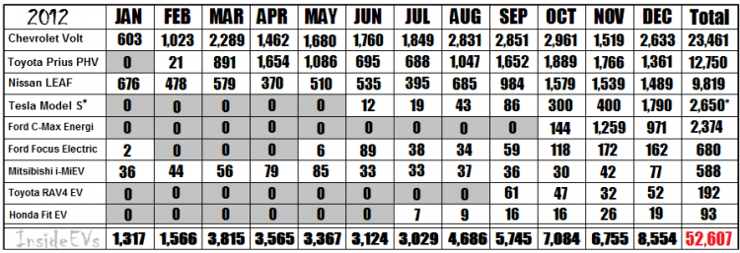

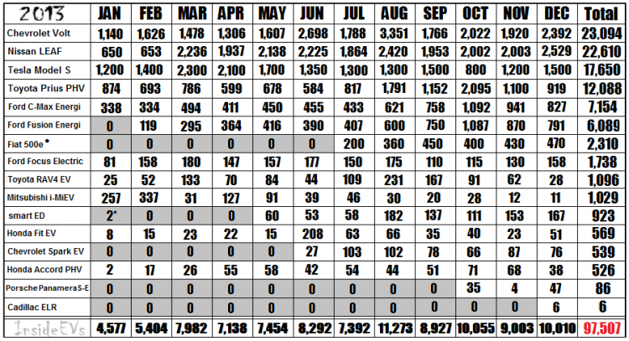

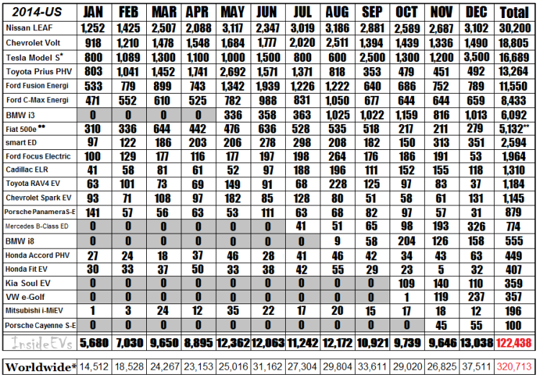

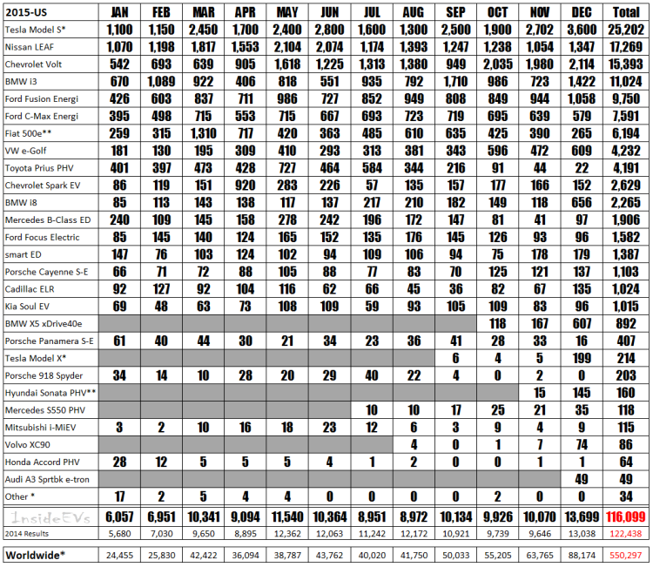

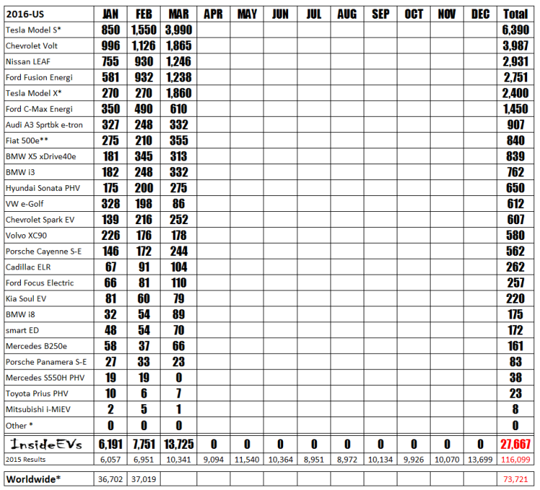

|  |  |  |  |  |  |  |  |  |  |  |  |  |
| --- | --- | --- | --- | --- | --- | --- | --- | --- | --- | --- | --- | --- |
|  | 2010 | | | | | | | | | | | |
|  | Jan | Feb | Mar | Apr | May | Jun | Jul | Aug | Sep | Oct | Nov | Dec |
| Price Per Unit Tesla |  |  |  |  |  |  |  |  |  |  |  | $ - |
| Price Per Unit All Electric minus outliers |  |  |  |  |  |  |  |  |  |  |  | $ 33,767 |
| All (-) Tesla Price Per Unit |  |  |  |  |  |  |  |  |  |  |  | $ 33,767 |

|  |  |  |  |  |  |  |  |  |  |  |  |  |
| --- | --- | --- | --- | --- | --- | --- | --- | --- | --- | --- | --- | --- |
|  | 2011 | | | | | | | | | | | |
|  | Jan | Feb | Mar | Apr | May | Jun | Jul | Aug | Sep | Oct | Nov | Dec |
| Price Per Unit Tesla | $ - | $ - | $ - | $ - | $ - | $ - | $ - | $ - | $ - | $ - | $ - | $ - |
| Price Per Unit All Electric minus outliers | $ 33,113 | $ 33,199 | $ 32,635 | $ 31,772 | $ 31,085 | $ 30,882 | $ 30,349 | $ 30,610 | $ 31,564 | $ 32,201 | $ 32,461 | $ 32,139 |
| All (-) Tesla Price Per Unit | $ 33,113 | $ 33,199 | $ 32,635 | $ 31,772 | $ 31,085 | $ 30,882 | $ 30,349 | $ 30,610 | $ 31,564 | $ 32,201 | $ 32,461 | $ 32,139 |

|  |  |  |  |  |  |  |  |  |  |  |  |  |
| --- | --- | --- | --- | --- | --- | --- | --- | --- | --- | --- | --- | --- |
|  | 2012 | | | | | | | | | | | |
|  | Jan | Feb | Mar | Apr | May | Jun | Jul | Aug | Sep | Oct | Nov | Dec |
| Price Per Unit Tesla | $- | $- | $- | $- | $- | $88,700 | $88,700 | $88,700 | $88,700 | $88,700 | $88,700 | $88,700 |
| Price Per Unit All Electric minus outliers | $31,589 | $32,189 | $28,709 | $24,382 | $26,877 | $28,980 | $29,258 | $29,474 | $28,624 | $30,215 | $30,913 | $41,432 |
| All (-) Tesla Price Per Unit | $31,589 | $32,189 | $28,709 | $24,382 | $26,877 | $28,750 | $28,883 | $28,926 | $27,711 | $27,629 | $27,275 | $28,923 |

|  |  |  |  |  |  |  |  |  |  |  |  |  |
| --- | --- | --- | --- | --- | --- | --- | --- | --- | --- | --- | --- | --- |
|  | 2013 | | | | | | | | | | | |
|  | Jan | Feb | Mar | Apr | May | Jun | Jul | Aug | Sep | Oct | Nov | Dec |
| Price Per Unit Tesla | $88,700 | $88,700 | $88,700 | $88,700 | $88,700 | $88,700 | $88,700 | $88,700 | $88,700 | $88,700 | $88,700 | $88,700 |
| Price Per Unit All Electric minus outliers | $43,413 | $44,553 | $46,804 | $47,254 | $43,445 | $40,409 | $40,161 | $36,112 | $39,201 | $33,333 | $37,366 | $38,870 |
| All (-) Tesla Price Per Unit | $27,320 | $29,117 | $29,845 | $29,977 | $30,074 | $30,981 | $29,966 | $29,430 | $29,680 | $28,714 | $29,810 | $30,475 |

|  |  |  |  |  |  |  |  |  |  |  |  |  |
| --- | --- | --- | --- | --- | --- | --- | --- | --- | --- | --- | --- | --- |
|  | 2014 | | | | | | | | | | | |
|  | Jan | Feb | Mar | Apr | May | Jun | Jul | Aug | Sep | Oct | Nov | Dec |
| Price Per Unit Tesla | $88,700 | $88,700 | $88,700 | $88,700 | $88,700 | $88,700 | $88,700 | $88,700 | $88,700 | $88,700 | $88,700 | $88,700 |
| Price Per Unit All Electric minus outliers | $39,486 | $39,197 | $37,551 | $36,303 | $33,596 | $39,477 | $35,174 | $35,942 | $46,861 | $43,551 | $41,603 | $48,905 |
| All (-) Tesla Price Per Unit | $31,471 | $30,409 | $29,821 | $29,065 | $28,961 | $31,592 | $31,208 | $33,233 | $34,505 | $36,767 | $35,067 | $35,045 |
|  |  | | | | | | | | | | | |
|  | 2015 | | | | | | | | | | | |
|  | Jan | Feb | Mar | Apr | May | Jun | Jul | Aug | Sep | Oct | Nov | Dec |
| Price Per Unit Tesla | $88,700 | $88,700 | $88,700 | $88,700 | $88,700 | $88,700 | $88,700 | $88,700 | $88,682 | $88,684 | $88,686 | $88,307 |
| Price Per Unit All Electric minus outliers | $45,637 | $45,488 | $48,108 | $44,549 | $45,627 | $49,448 | $46,141 | $44,350 | $50,473 | $47,288 | $51,003 | $56,782 |
| All (-) Tesla Price Per Unit | $35,928 | $36,898 | $35,482 | $34,354 | $34,287 | $34,863 | $36,827 | $36,813 | $37,914 | $37,461 | $37,184 | $44,635 |

|  |  |  |  |  |  |  |  |  |  |  |  |  |
| --- | --- | --- | --- | --- | --- | --- | --- | --- | --- | --- | --- | --- |
|  | 2016 | | | | | | | | | | | |
|  | Jan | Feb | Mar | Apr | May | Jun | Jul | Aug | Sep | Oct | Nov | Dec |
| Price Per Unit Tesla | $86,892 | $87,587 | $86,315 |  |  |  |  |  |  |  |  |  |
| Price Per Unit All Electric minus outliers | $47,570 | $50,770 | $58,905 |  |  |  |  |  |  |  |  |  |
| All (-) Tesla Price Per Unit | $38,885 | $39,484 | $38,517 |  |  |  |  |  |  |  |  |  |