



**Hospital Management System**

IST 659

Sonamgyalpo Sherpa

Praneshwar Srinivasan

Neel Samant

**Project Summary**

Our project focusses on the creation of a Database for hospital administration to manage its records of Doctors, Patients, clinics as well as the Medicines prescribed in the clinics that are situated in various regions, which will allow the doctors to efficiently keep track of the patients as well as patients to find the nearest clinic as well as the available medicines. How can the administration efficiently manage the records? How can the patients easily get the information about the availability of medicines in the stores? How can the doctors keep track of the current health of their patients? Our project aims to create a system that answers the above questions and more.

Our system will be consisting of a Database having all the information about the Doctors working for the hospital, the dynamic data of the patients visiting the hospital, the clinics (branches of the hospital), the departments that each of the clinics consist of and the medicines available in the clinics as well as those prescribed by the doctors to their patients. We will be designing portals for the doctors, patients and the administration which will serve their respective purposes.

The entities that are a part of our database have irregular volumes of data. For example, there are just a few departments in the hospital but on the other hand, there are a huge number of patients. Our goal is to improve the User experience between all the users of this system as they can easily interact online and exchange information. The patients can easily query the system to look for the nearest clinics based on the location as well as the availability of a certain department in that clinic. The system will also help the administration to keep a track of all the stakeholders in the Hospital.

As most of the hospitals and medical institutions still prefer physical records to this day, there is an issue of loss of data as well as wastage of space. By using our system, this issue can be easily rectified as the data stored in an electronic form is less prone to data loss. Furthermore, patients find it difficult to locate the nearest clinics with a doctor that can address their issues. It is also impossible to check for the availability of the drugs prescribed to them in the medical stores. With the creation of the patient portal, all these issues can be easily avoided. Physical records also restrict the doctor from effectively keeping track of their patients which may result in dire consequences for the patients. The doctors also find it extremely difficult to keep track of the drugs prescribed to the patients. In short, our system will help to automate the operation of a Medical institute and make it convenient for all the entities involved.

The design report that we have made, consists of the basic summary of the system that we have designed, its functions and objectives as well as the information of all the entities and their attributes that have been considered for the project. We have also constructed the Entity relationship diagram showing the relationships and the dependencies of various entities in the system. Furthermore, we have also stated all the business rules that have not been specified in the ER diagram. Finally, we have stated all the major questions that could be answered by using our system as well as those that could still be left unanswered.

**Project Table**

|  |  |
| --- | --- |
| **Objects** | **Description** |
|  |  |
| **DOCTOR** | The entity which describes the attributes of the doctors employed in all clinics across the regions |
| Doctor ID | Unique/Primary Key identifier of the “Doctor” entity. |
| License Number | License Number of the Doctor |
| Name | Name of the Doctor |
| Experience | No. of Years of experience in the field for the Doctor |
| Designation | Designation/title of the doctor |
| Department | Department in which the doctor works |
| Email ID | Work Email id of the Doctor |
| Phone number | Work Phone Number of the Doctor |
| Clinic ID | Foreign key linked to the clinic table |
| Department ID | Foreign key linked to the department table |
|  |  |
| **PATIENT** | Entity which describing the attributes of the patients that come into all clinics across the regions |
| Patient ID | Unique / Primary Key identifier of the “Patient” entity |
| Name | Name of the Patient |
| Age | Age of the Patient |
| Address | Address of the Patient |
| City | City in which the patient presently resides |
| Zip | Zip code of the location he stays in. |
| Email | Email – ID with which the Patient has registered with the Hospital |
| Phone number | Phone Number of the patients |
| Patient issue | The particular issue that the patient comes in with |
| Existing medical condition | Existing Medical condition of the patient if any |
| Admission date | The date the patient gets admitted |
| Discharge date | The date the patient gets discharged |
|  |  |
| **CLINIC** | Entity describing the clinics that the doctors and medicines are in and where the patients can go into |
| Clinic ID | Unique / Primary key of the “clinic” entity |
| ClinicDirector | The director in-charge of the clinic |
| Name | Name of the clinic |
| Region | Region where the clinic is located |
| City | City in which the clinic is situated |
| Zip | Zip code of the location that the clinic is situated in. |
| Patient capacity | The no of patients the clinic can hold |
| URL | The website of the clinic |
|  |  |
| **DEPARTMENT** | Entity describing the different departments in each clinic and which has a number of doctors assigned to them. |
| Department ID | Unique/Primary Key of the “Department” entity |
| Name | Name of the department |
| Department Head | The head of the department in charge of the department |
| Email | The office email id of the department |
| Phone number | The office Phone number of the department. |
| Clinic ID | Foreign key linked to the clinic table |
|  |  |
| **MEDICINES** | Entity describing the medicines that are available in each store. |
| Medicine ID | Unique/Primary identifier of the “Medicine” entity |
| Name | Name of the medicine |
| Dosage | Dosage of Medicine prescribed |
| Medicine Type | The type of the medicine |
| Medicine Department | The department that uses the medicine |
|  |  |
| **PRESCRIPTION** | Associate table which links the doctor, patient and |
| Prescription ID | Unique/Primary identifier of the “Prescription” table |
| Doctor ID | Foreign key linked to the doctor table |
| Patient ID | Foreign key linked to the patient table |
| Medicine ID | Foreign key linked to the medicine table |
| Date | Contains the date that the prescription was issued |
| Billamount | Describes the amount to be paid for the prescription. |
|  |  |
| **PHARMACY** |  |
| Pharmacy ID | Unique/Primary identifier of the “Pharmacy” table |
| Clinic ID | Foreign key linked to the clinic table |
| Pharmacist | The person in charge of the pharmacy |
| PharmacyEmail | The email contact details for the pharmacy |
| PharmacyPhoneNo | The phone no for the pharmacy |

**Entity Relationship Diagram**

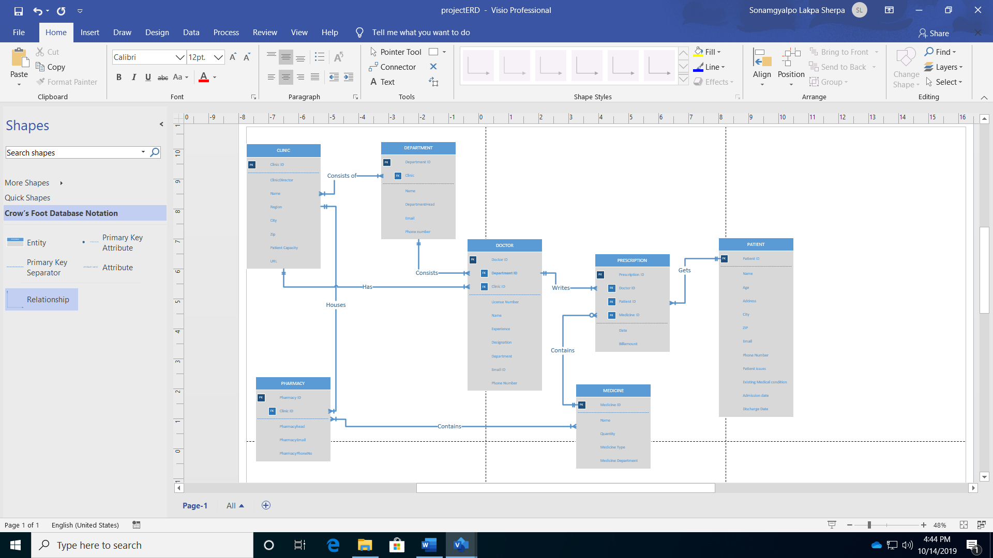

**Business rules**

1. Doctors can treat zero or more patients and patients is treated by one or more doctors.
2. Clinic consists at least one or more departments. A department is there in at least one or more clinics.
3. Clinic can have one or more doctors and a doctor can be at one or more clinics.
4. Department consists of one or more doctor; A doctor can work for only one department.
5. A doctor can write a prescription for one or medicines; A medicine can be prescribed by one or more doctors.
6. A patient can get a prescription for one or more medicine and medicines can be prescribed to one or more patients.
7. A clinic houses only one pharmacy; A pharmacy can be at only one clinic.
8. Pharmacy contains zero or medicines; A medicine can be found at one or more pharmacy.

**Assumptions**

1. A doctor has a single specialization.
2. A patient who registers will be treated by at least one doctor.
3. A medicine that is registered will be available in at least one clinic.
4. When the clinic starts at least one doctor is employed.
5. A medicine that is available in the clinic is always in stock.

**Major data questions**

1. How many Doctors have been employed by the hospital?
2. How many Patients have been registered in the hospital?
3. How many medicines are available according to the dosage in a pharmacy?
4. How many patients are being treated by a doctor?
5. How many patients are a being treated in a particular clinic?
6. How many clinics have been opened in densely populated regions?
7. Which clinic has the greatest number of patients registered?
8. How many Doctors are grouped in a department?