Profile Management Module

1. Profile Schema Design
- Designed Candidate Profile model.
- Designed Employer Profile model.
Candidate Profile Fields
- Skills
- Education
- Experience
- Expected Salary
- Soft Delete Status
Employer Profile Fields
- Company Name
- Domain
- Company Size
- Verification Status
- Soft Delete Status
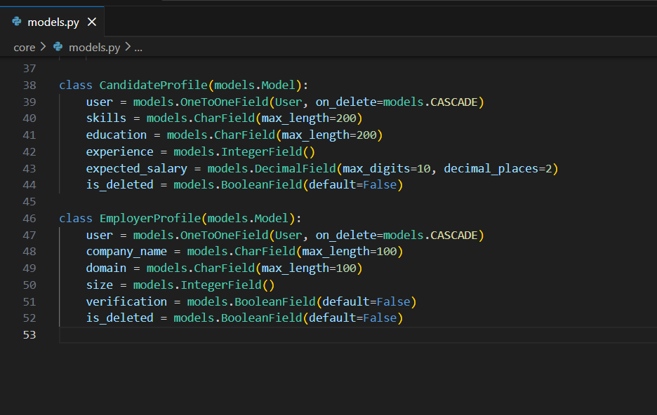

2. Model Implementation
- Implemented CandidateProfile model.
- Implemented EmployerProfile model.
- Successfully generated and applied database migrations.
- Implemented One-to-One relationship between User and Profile models.
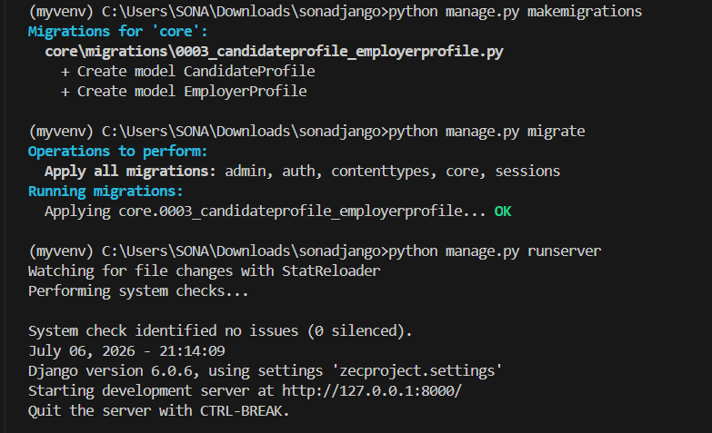
3. CRUD APIs
Candidate Profile APIs
- Create Profile API
- View Profile API
- Update Profile API
- Delete Profile API
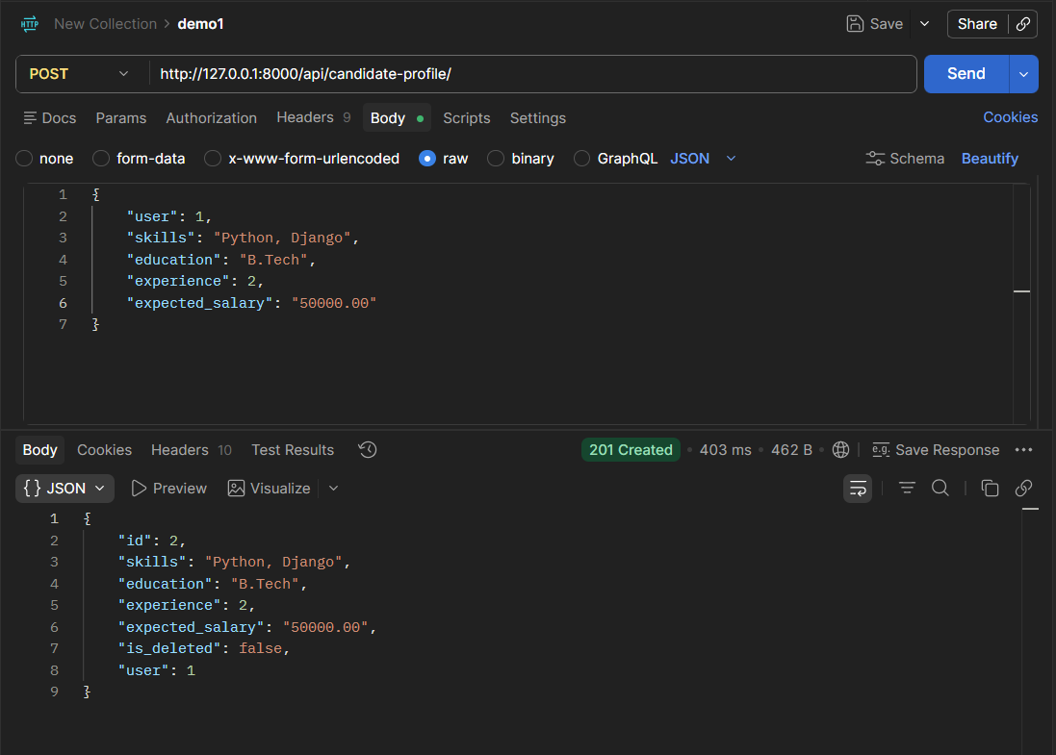

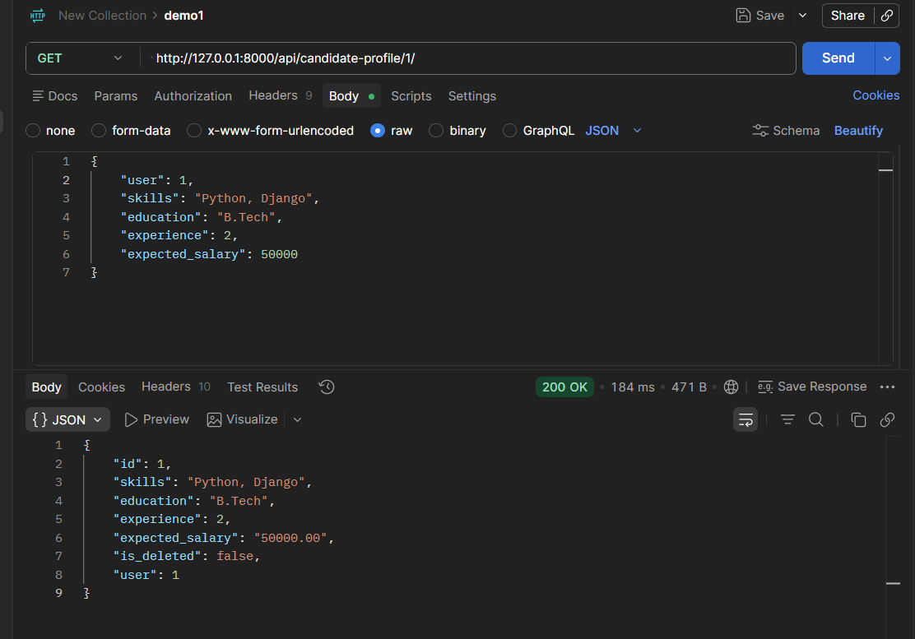

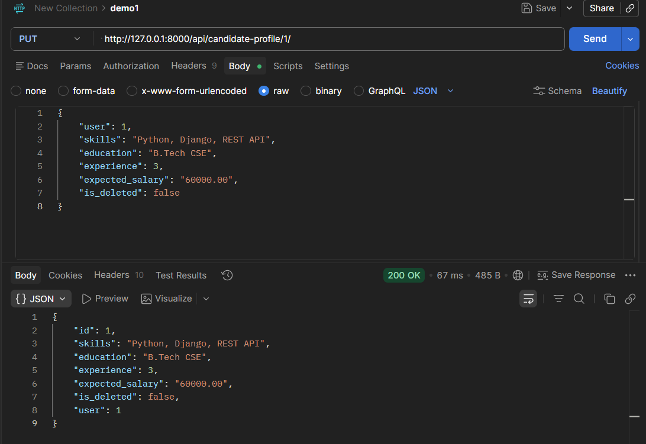

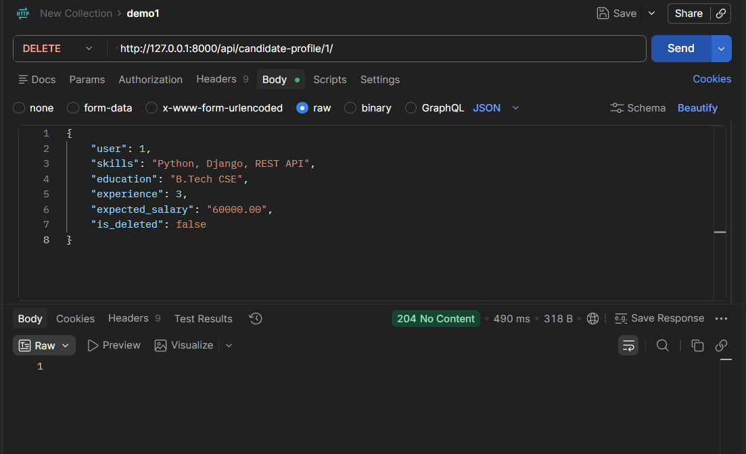

Employer Profile APIs
- Create Profile API
- View Profile API
- Update Profile API
- Delete Profile API
- Successfully tested all CRUD operations using Postman.
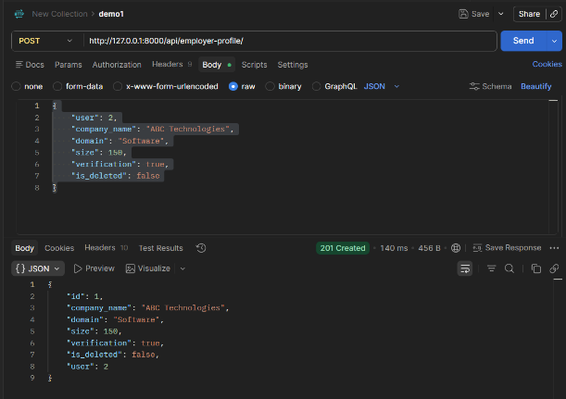

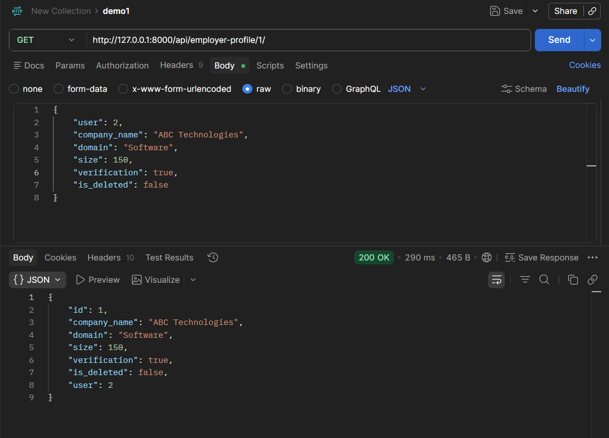

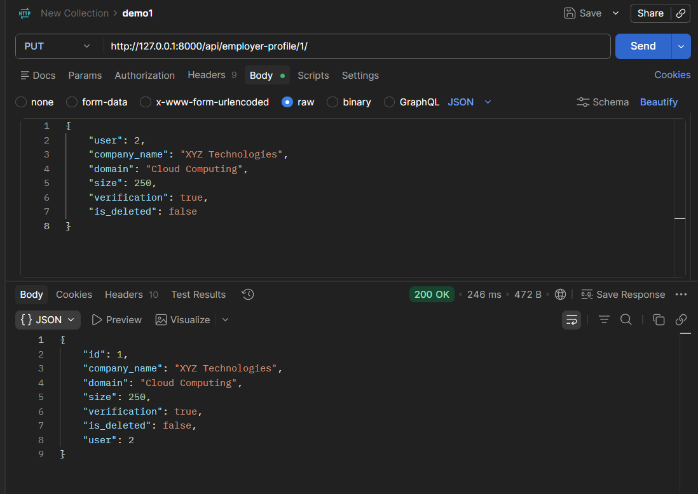

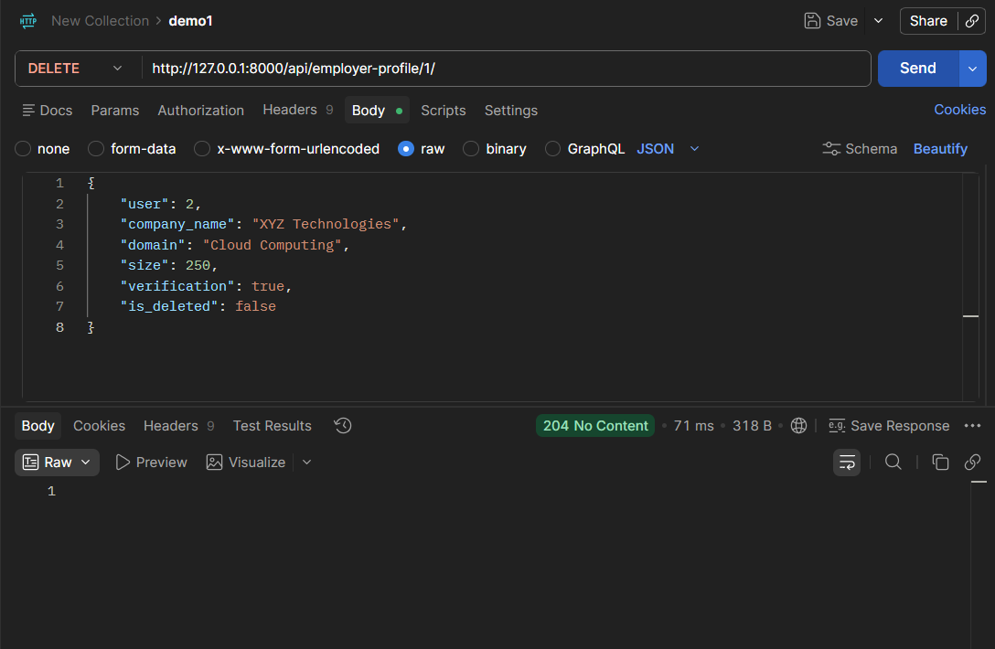

4. Validation Rules
Candidate Profile Validation
- Implemented validation to ensure Expected Salary cannot be negative.
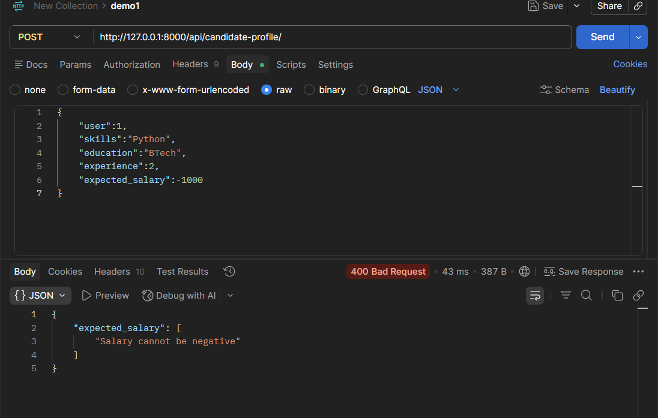

Employer Profile Validation
- Implemented validation to ensure Company Size must be greater than zero.

